

**MANAV RACHNA UNIVERSITY, FARIDABAD**

**Department of Computer Science and Technology**

**Course: B.Tech(CST) Semester:IV Subject: Programming for Problem Solving using Python(CSW208B) Session: 2020-21**

**ADITI SINGH,1065**

***Lab 4-5:*** *Operation on Tuples : hands-on practice*

***Learning Outcome*:** *Student will be able to implement Tuple and List:*

***Blooms Taxonomy Level****: BT1, BT2,BT3*

**Tuple**

1. Write a Python program to create a tuple.

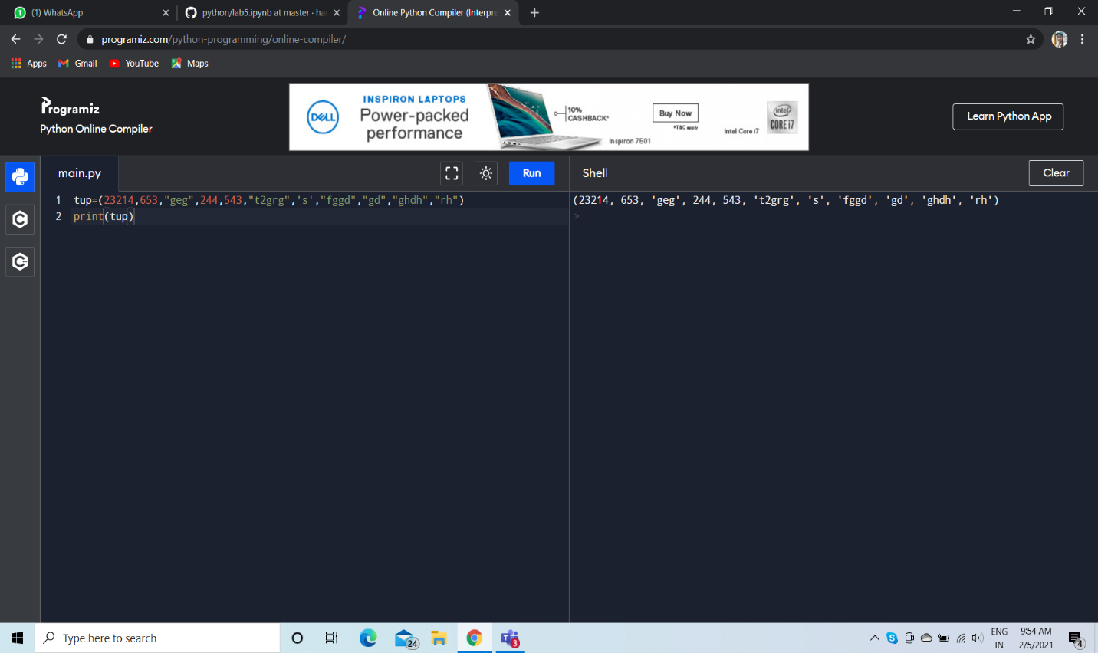

1. Write a Python program to create a tuple with different data types.

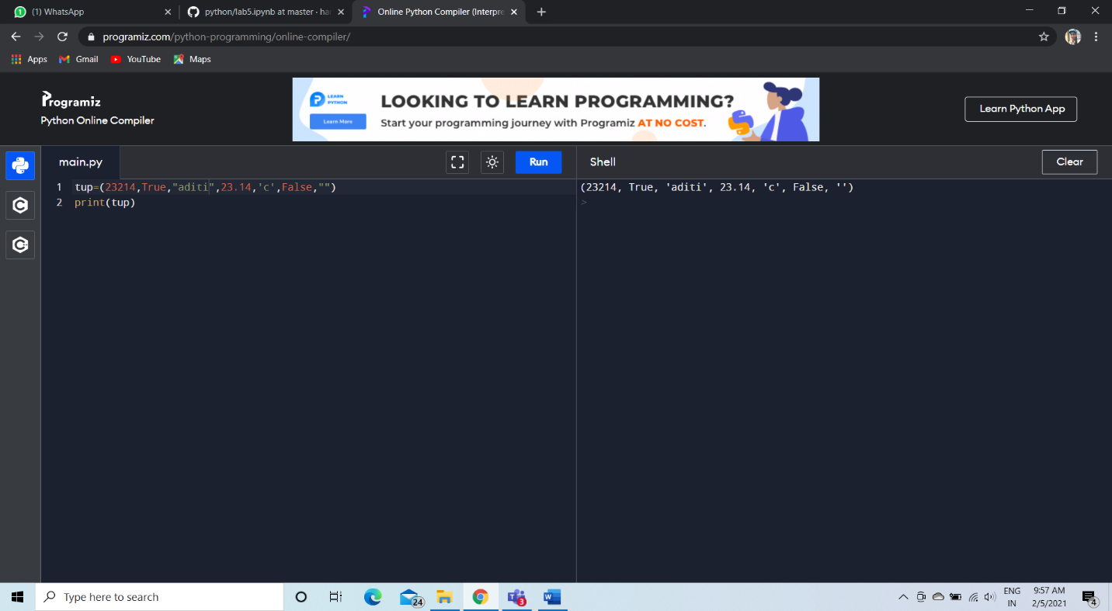

1. Write a Python program to create a tuple with numbers and print one item.

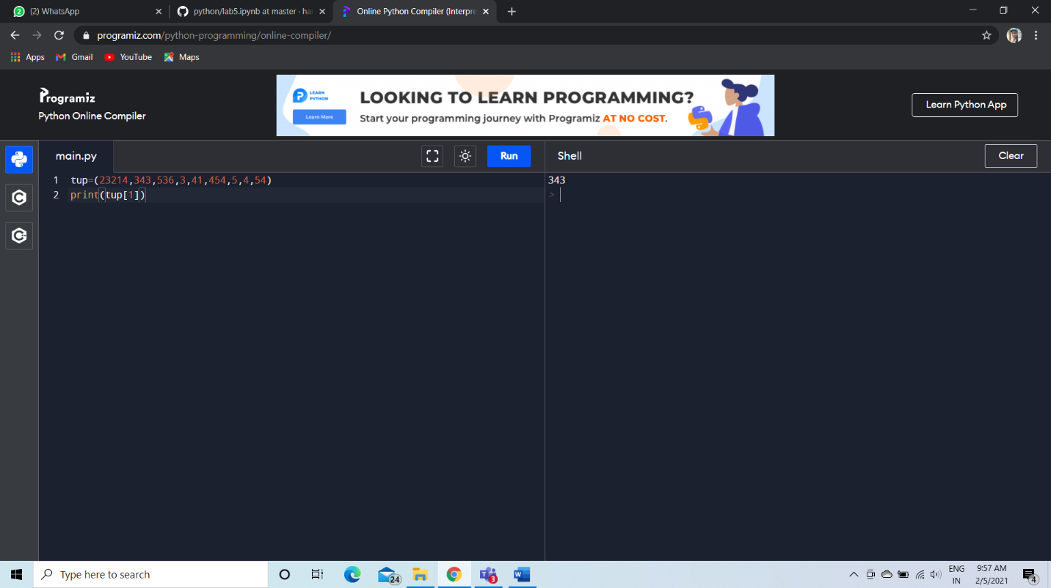

1. Write a Python program to unpack a tuple in several variables.

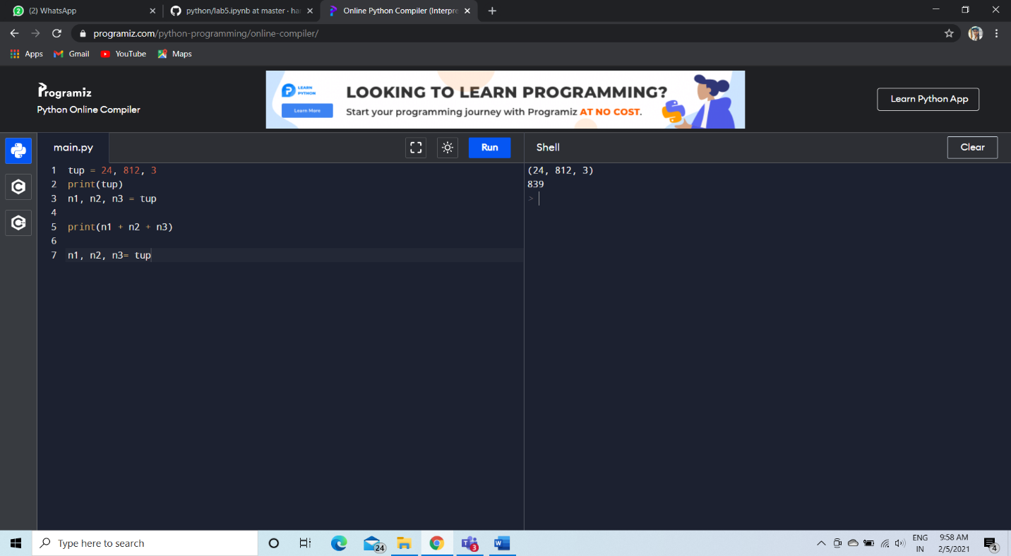

1. Write a Python program to add an item in a tuple.

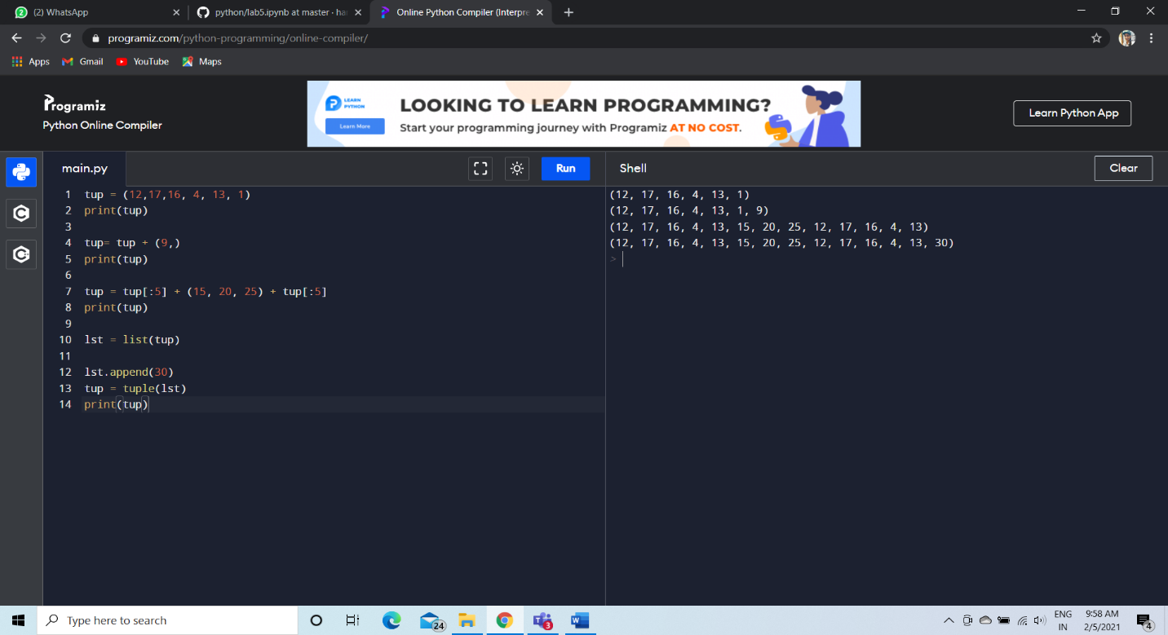

1. Write a Python program to convert a tuple to a string.

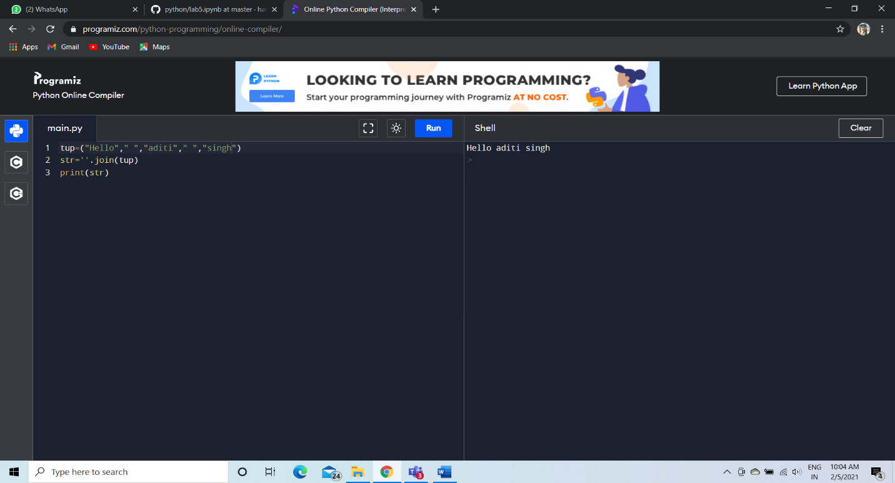

1. Write a Python program to get the 4th element and 4th element from last of a tuple.

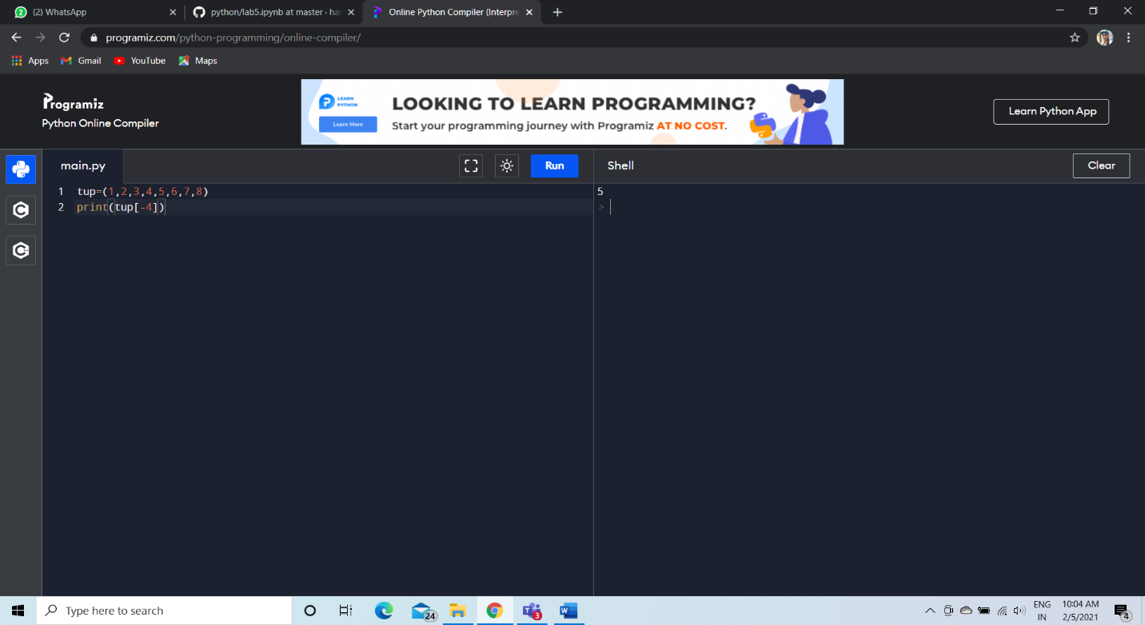

1. Write a Python program to find the repeated items of a tuple.

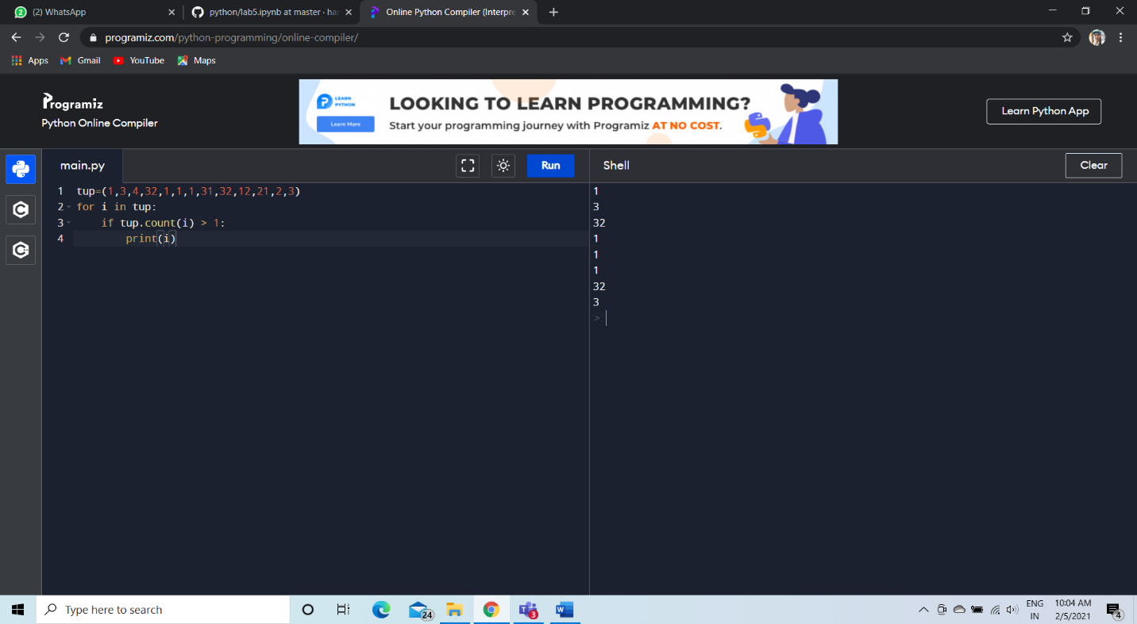

1. Write a Python program to check whether an element exists within a tuple.

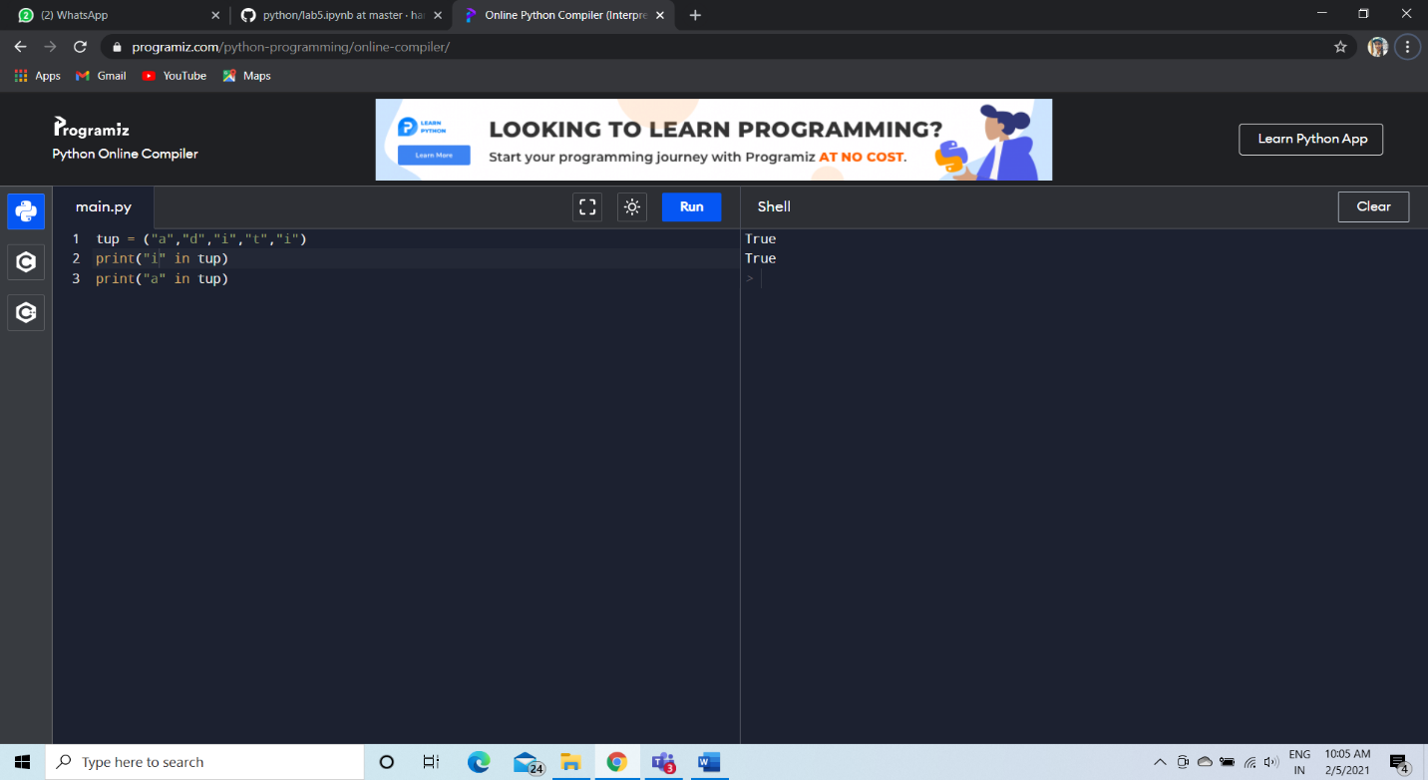

1. Write a Python program to convert a list to a tuple.

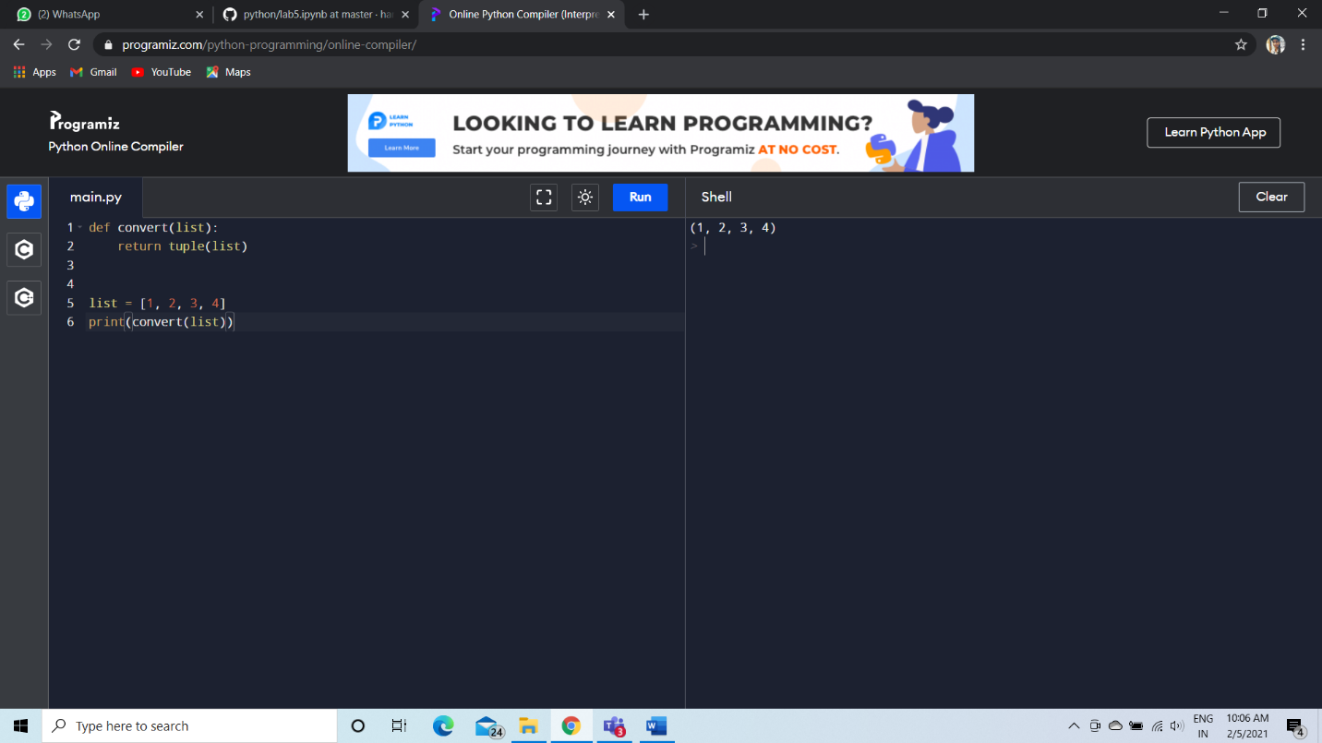

1. Write a Python program to remove an item from a tuple.

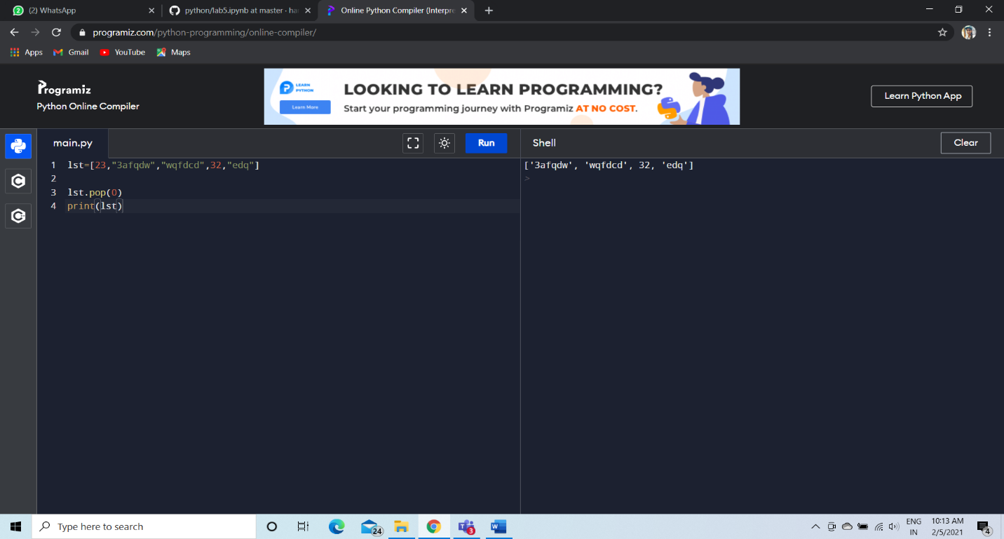

1. Write a Python program to slice a tuple

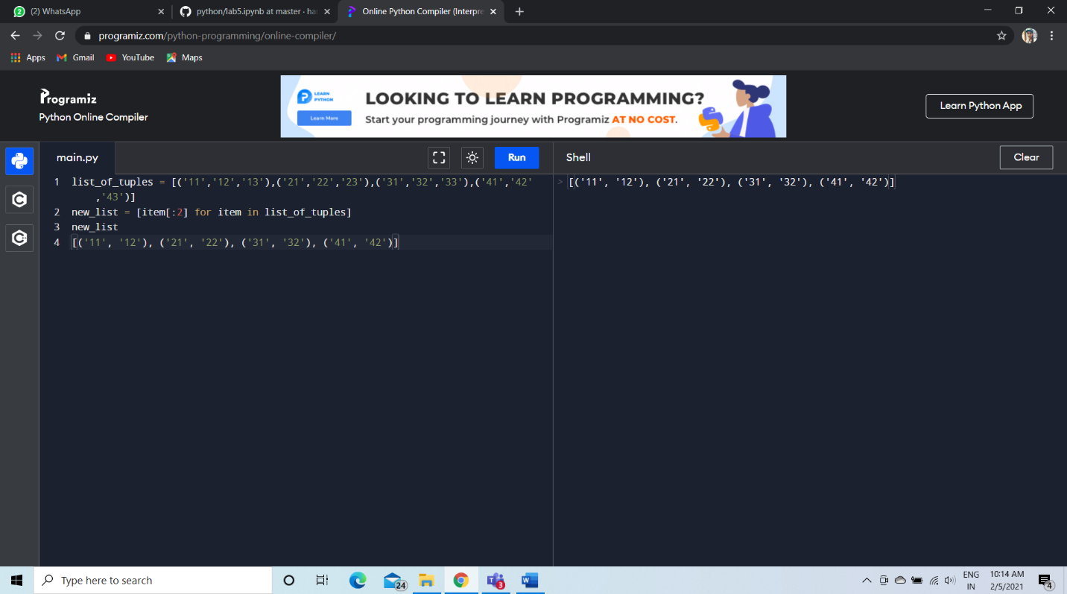

1. Write a Python program to find the index of an item of a tuple.

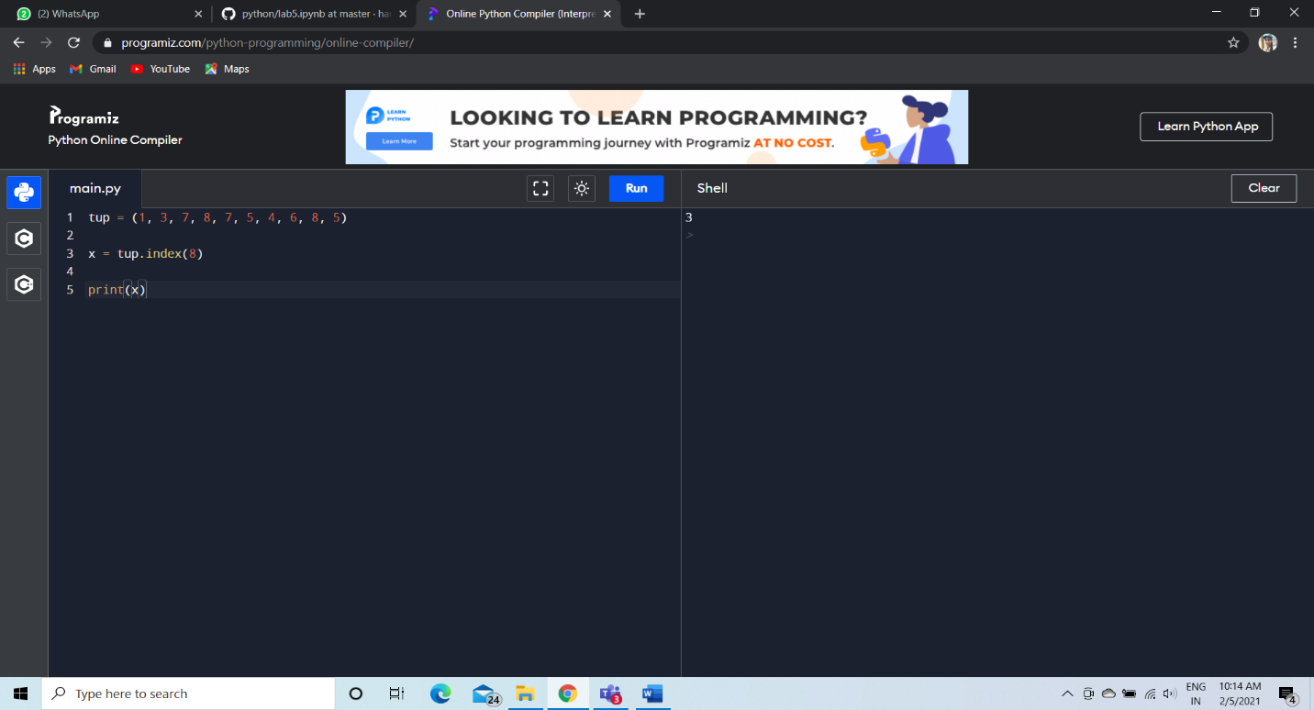

1. Write a Python program to find the length of a tuple.

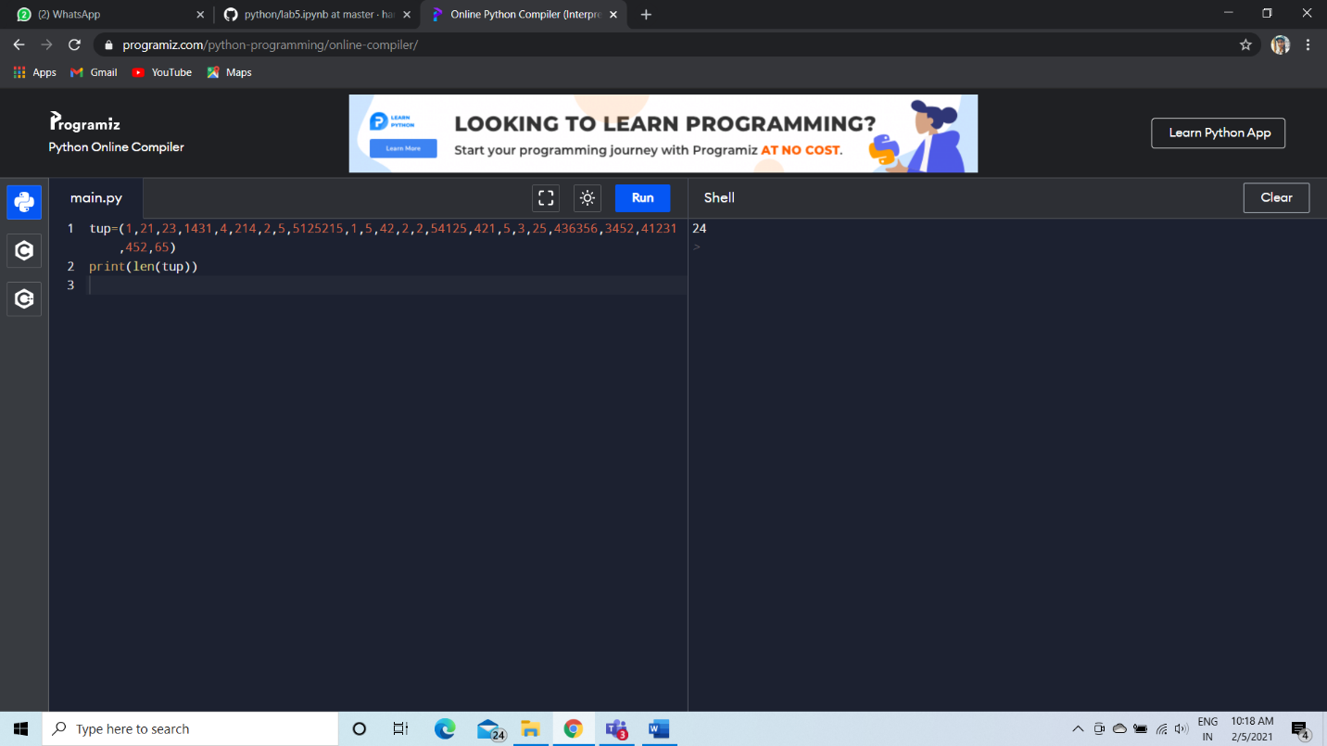

1. Write a Python program to reverse a tuple.



