

**MANAV RACHNA UNIVERSITY, FARIDABAD**

**Department of Computer Science and Technology**

**ADITI SINGH,1065, 4B**

**Course: B.Tech(CST) Semester:IV Subject: Programming for Problem Solving using Python(CSW208B) Session: 2020-21**

***Lab 4-5:*** *Operation on Tuples and List: hands-on practice*

***Learning Outcome*:** *Student will be able to implement Tuple and List:*

***Blooms Taxonomy Level****: BT1, BT2,BT3*

List

1. Write a Python program to sum all the items in a list.

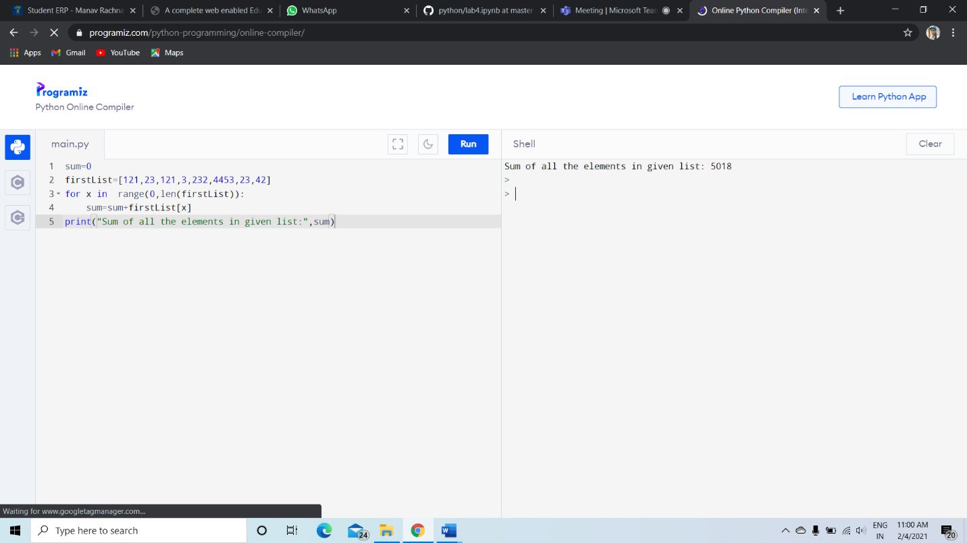

1. Write a Python program to multiplies all the items in a list.

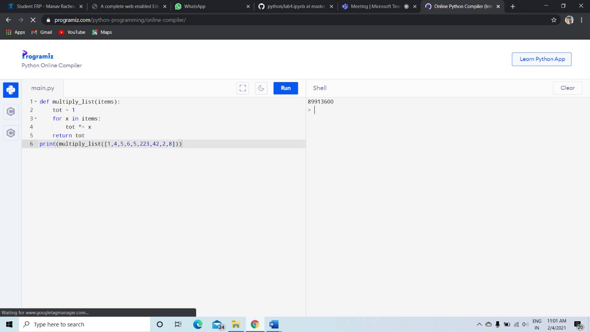

1. Write a Python program to get the largest number from a list

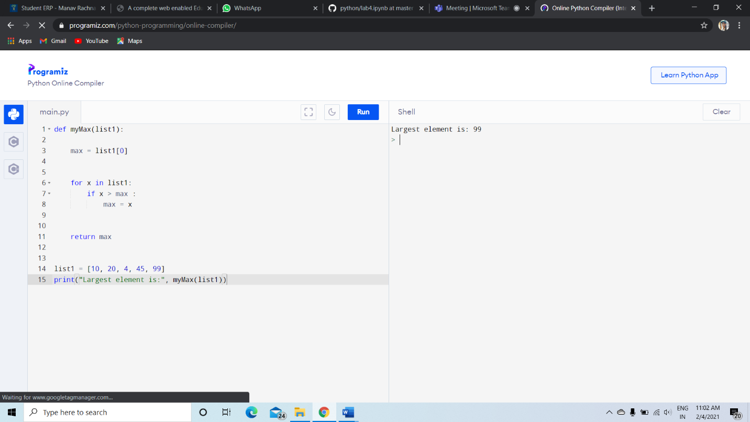

1. Write a Python program to get the smallest number from a list.

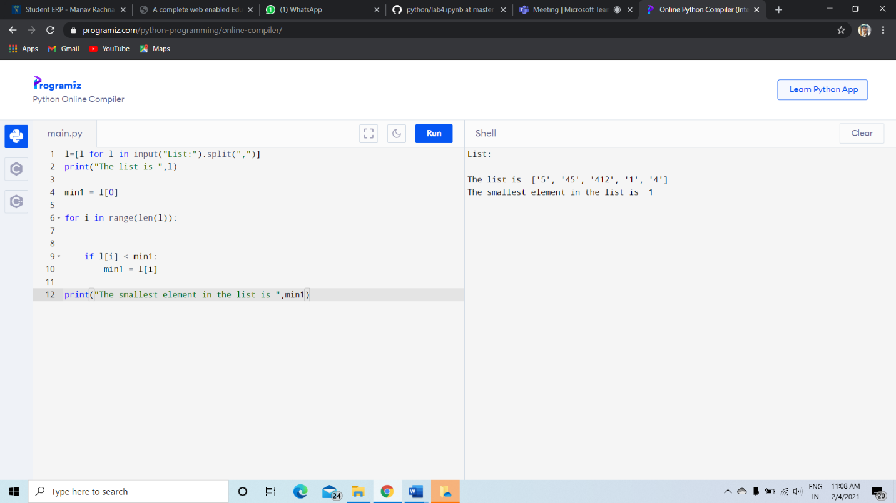

1. Write a Python program to count the number of strings where the string length is 2 or more and the first and last character are same from a given list of strings   
   Sample List : ['abc', 'xyz', 'aba', '1221']  
   Expected Result : 2  
   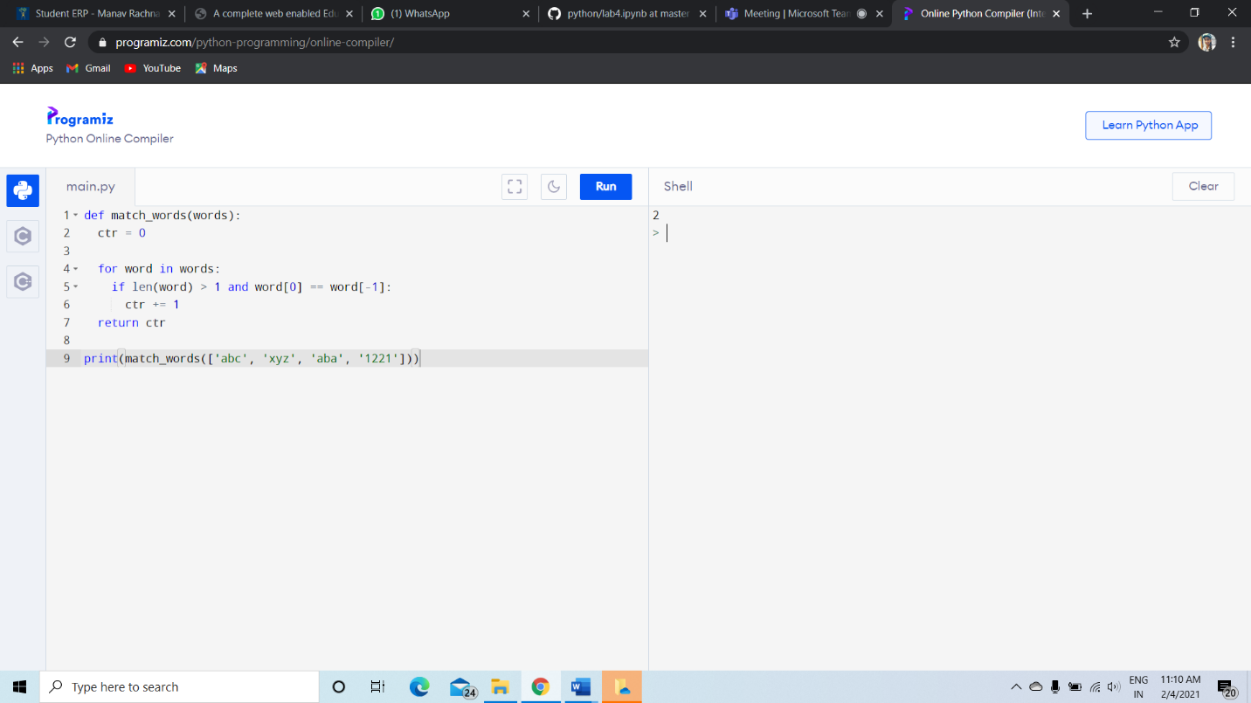

**6.** Write a Python program to get a list, sorted in increasing order by the last element in each tuple from a given list of non-empty tuples.    
Sample List : [(2, 5), (1, 2), (4, 4), (2, 3), (2, 1)]

Expected Result : [(2, 1), (1, 2), (2, 3), (4, 4), (2, 5)]

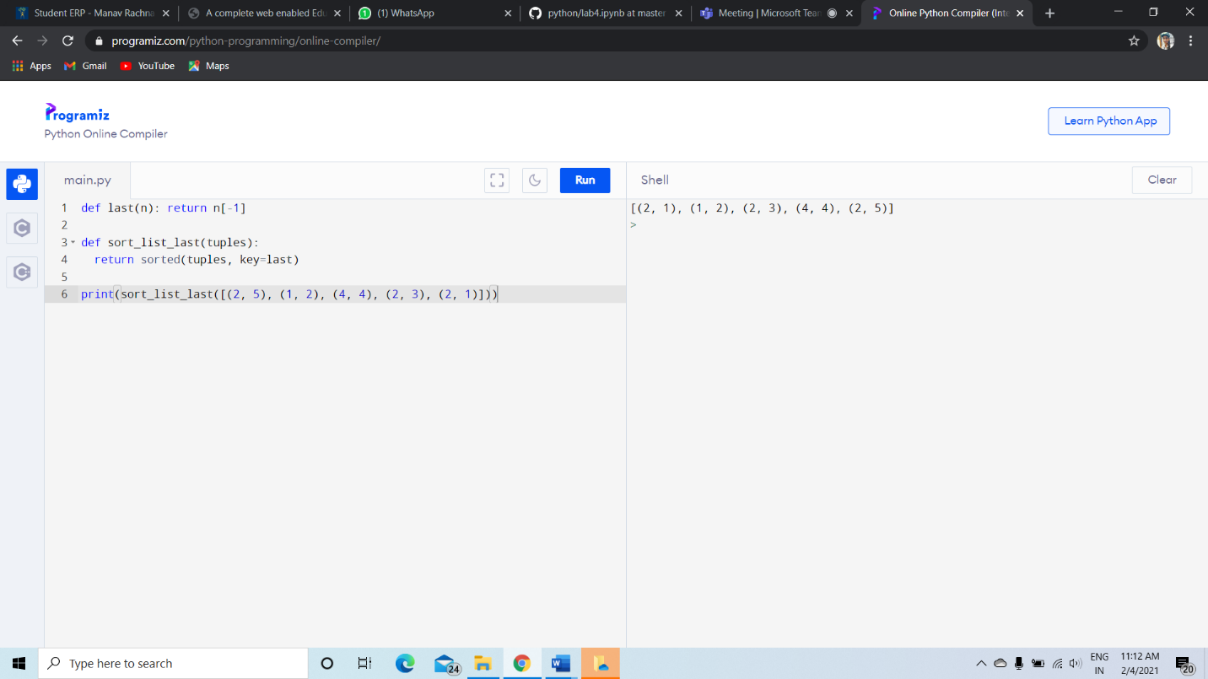  
**7.**Write a Python program to remove duplicates from a list.

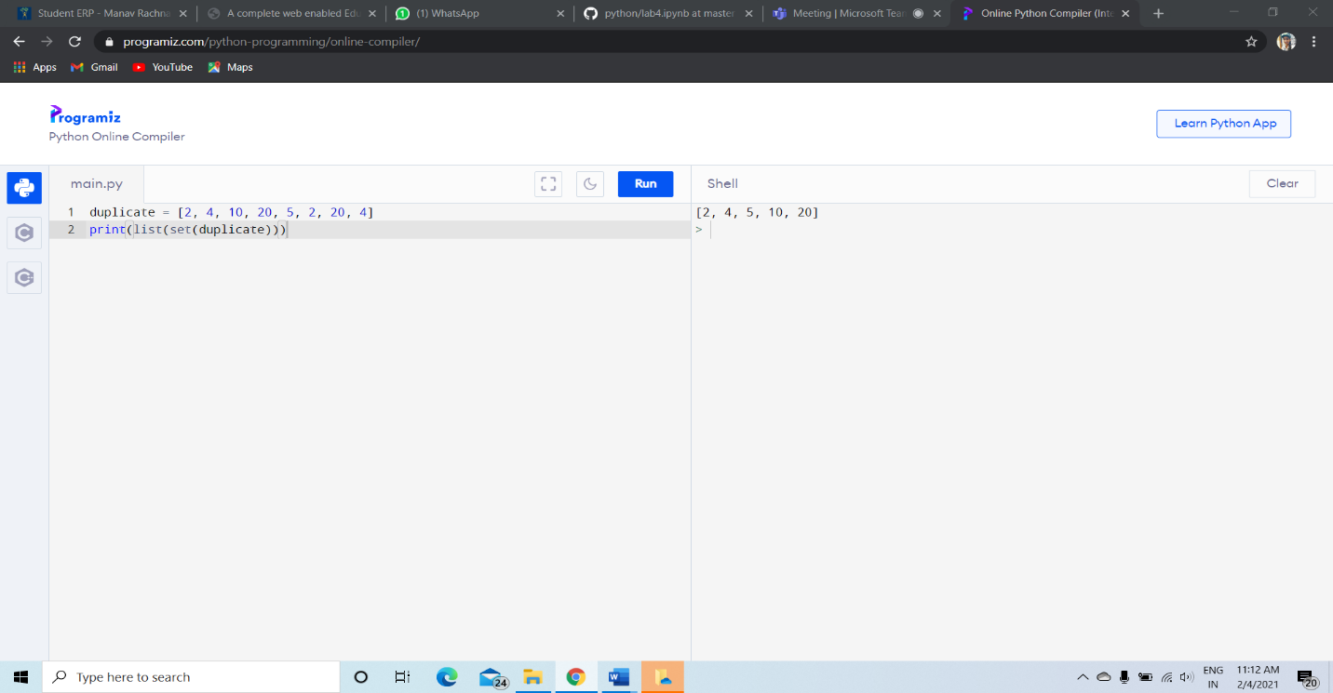

**8.**Write a Python program to check a list is empty or not.

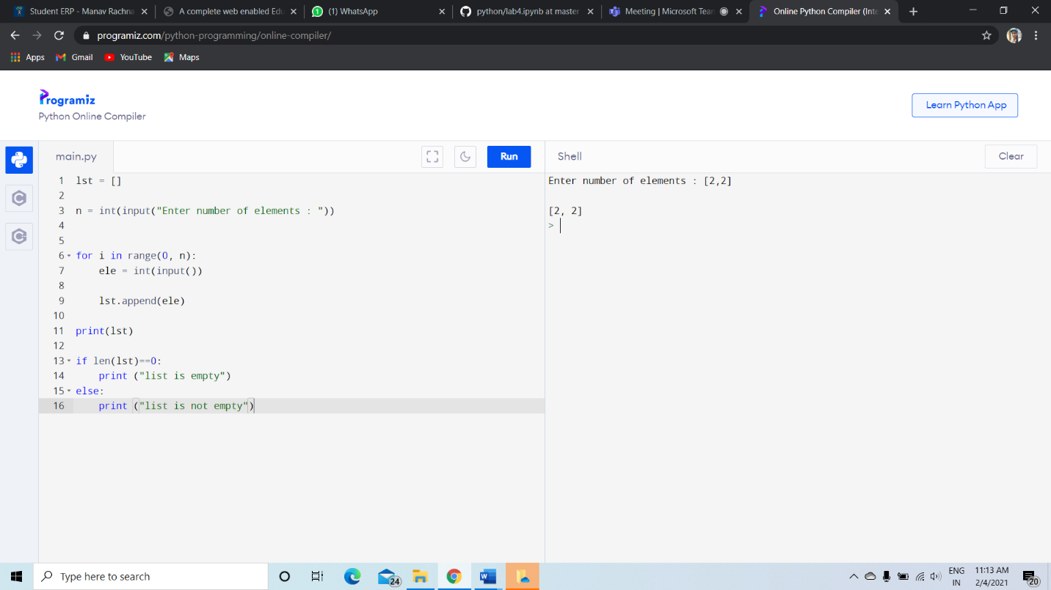

**9.**Write a Python program to clone or copy a list.

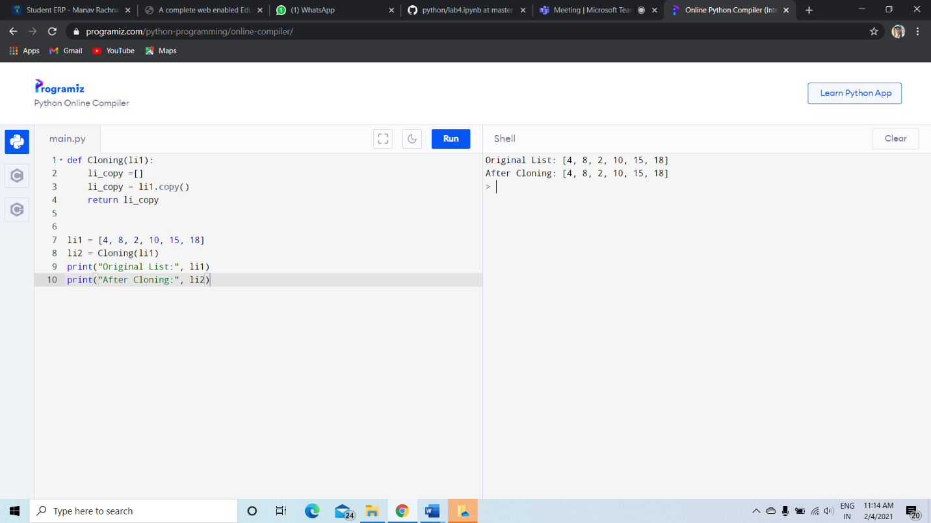

**10.**Write a Python program to find the list of words that are longer than n from a given list of words.

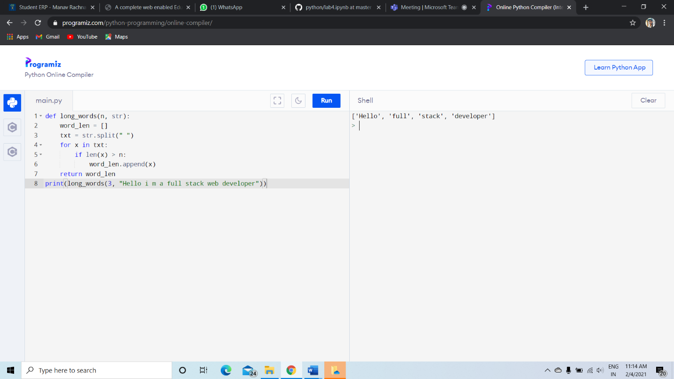

**11.**Write a Python function that takes two lists and returns True if they have at least one common member.

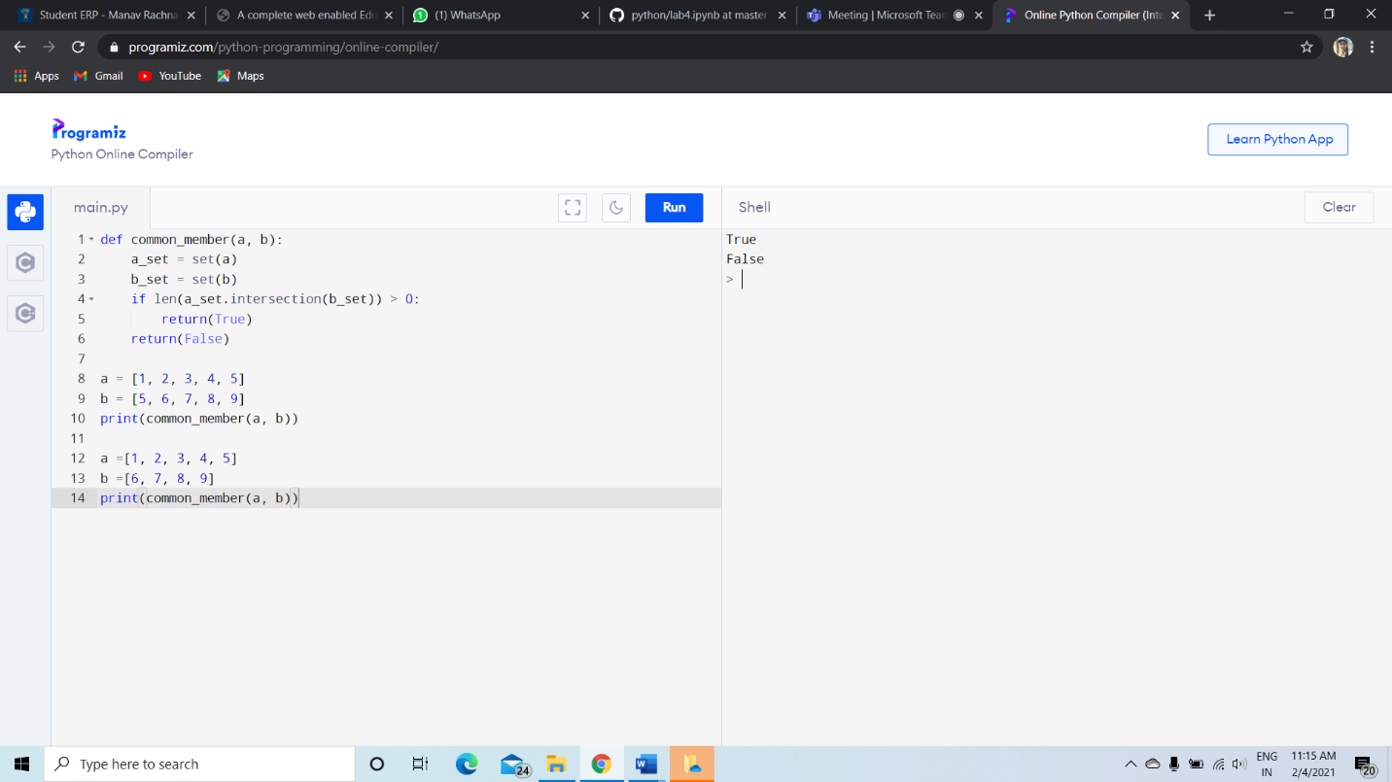

**12.**Write a Python program to print a specified list after removing the 0th, 4th and 5th elements.    
Sample List : ['Red', 'Green', 'White', 'Black', 'Pink', 'Yellow']  
Expected Output : ['Green', 'White', 'Black']



