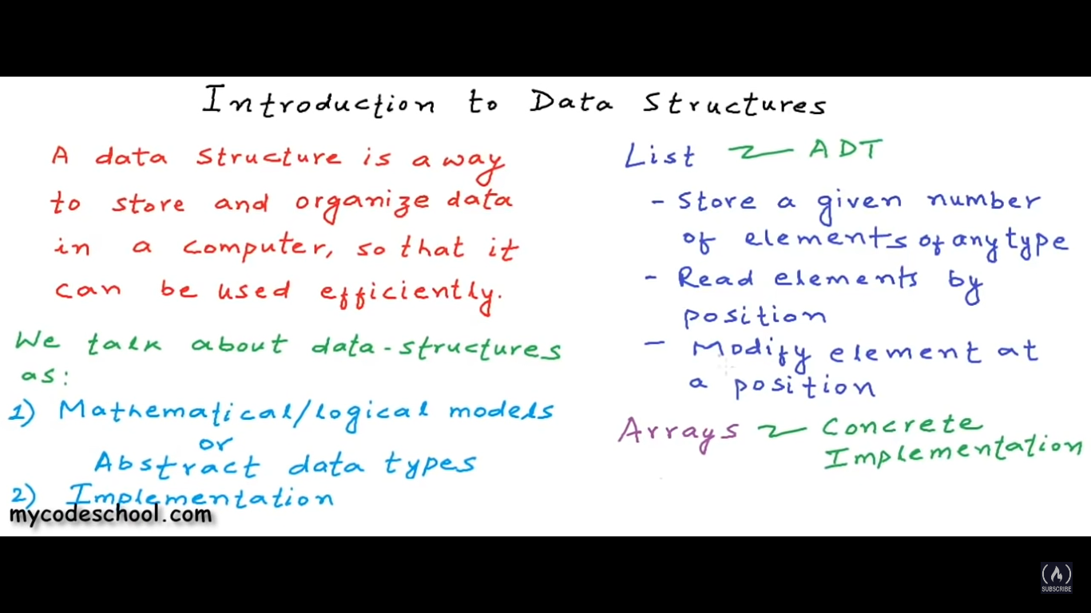

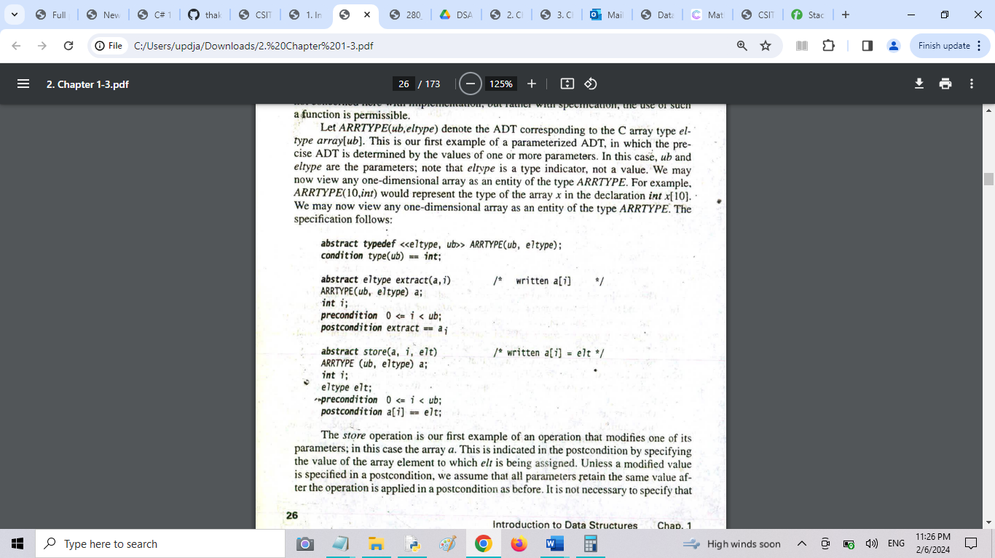

#include <stdio.h>

int MAXSIZE = 8;

int stack[8];

int top = -1;

/\* Check if the stack is full\*/

int isfull(){

   if(top == MAXSIZE)

      return 1;

   else

      return 0;

}

/\* Function to insert into the stack \*/

int push(int data){

   if(!isfull()) {

      top = top + 1;

      stack[top] = data;

   } else {

      printf("Could not insert data, Stack is full.\n");

   }

}

/\* Main function \*/

int main(){

   int i;

   push(44);

   push(10);

   push(62);

   push(123);

   push(15);

   printf("Stack Elements: \n");

   // print stack data

   for(i = 0; i < 8; i++) {

      printf("%d ", stack[i]);

   }

   return 0;

}

