**Tribhuvan University**

**Institute of Science and Technology**

**Prithvi Narayan Campus, Pokhara**

**Midterm Exam, Falgun 18, 2080**

Bachelor Level / Third Semester / Science Full marks: 30

Computer Science and Information Technology Pass marks: 12

Numerical Methods (CSC 207) Time: 1.5 hours

**SET A**

Candidates are required to give their answers in their own words as far as practicable.

The figures in the margin indicate full marks.

**Group A**

**Attempt any one question [1*10=10]**

1. What is root finding problem for non-linear equations? Write an algorithm to approximate the root of non-linear equation using Secant method. Compute the cubic root of ex – x2 +3x – 2 =0, using Secant method.

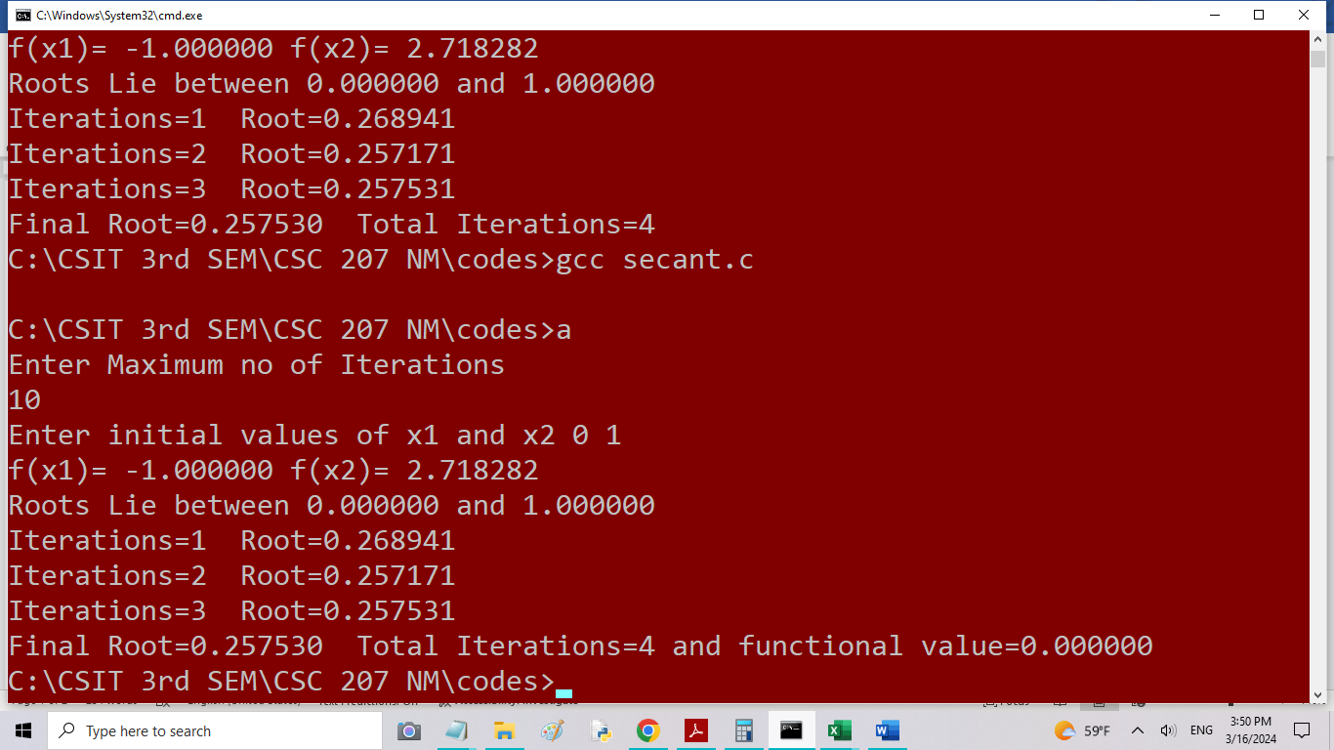

1. Discuss the importance of interpolation and write the differences between interpolation and regression methods. Based on following information, interpolate the value of e­1.5, using Lagrange’s second order polynomial method.

|  |  |  |  |  |
| --- | --- | --- | --- | --- |
| X | 0 | 1 | 2 | 3 |
| ex | 1 | 2.7183 | 7.3891 | 20.0855 |

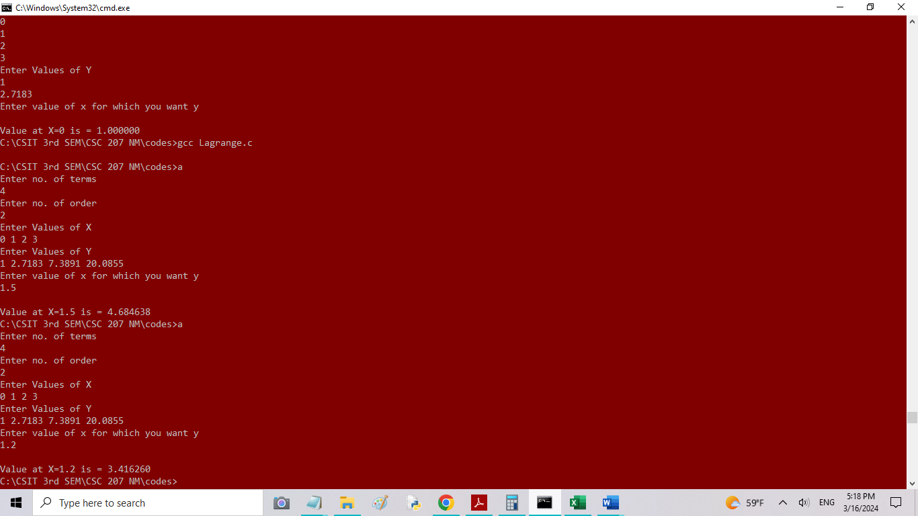

**Group B**

**Attempt any four questions [4*5=20]**

1. Briefly describe the characteristics of numerical methods with examples.
2. What is convergence in numerical methods? Compare the convergences in bisection, Newton-Rapson and secant methods for finding the root of non-linear equations.
3. Find the root of x sinx + cosx = 0, using bisection method with error tolerance up to four decimal places.

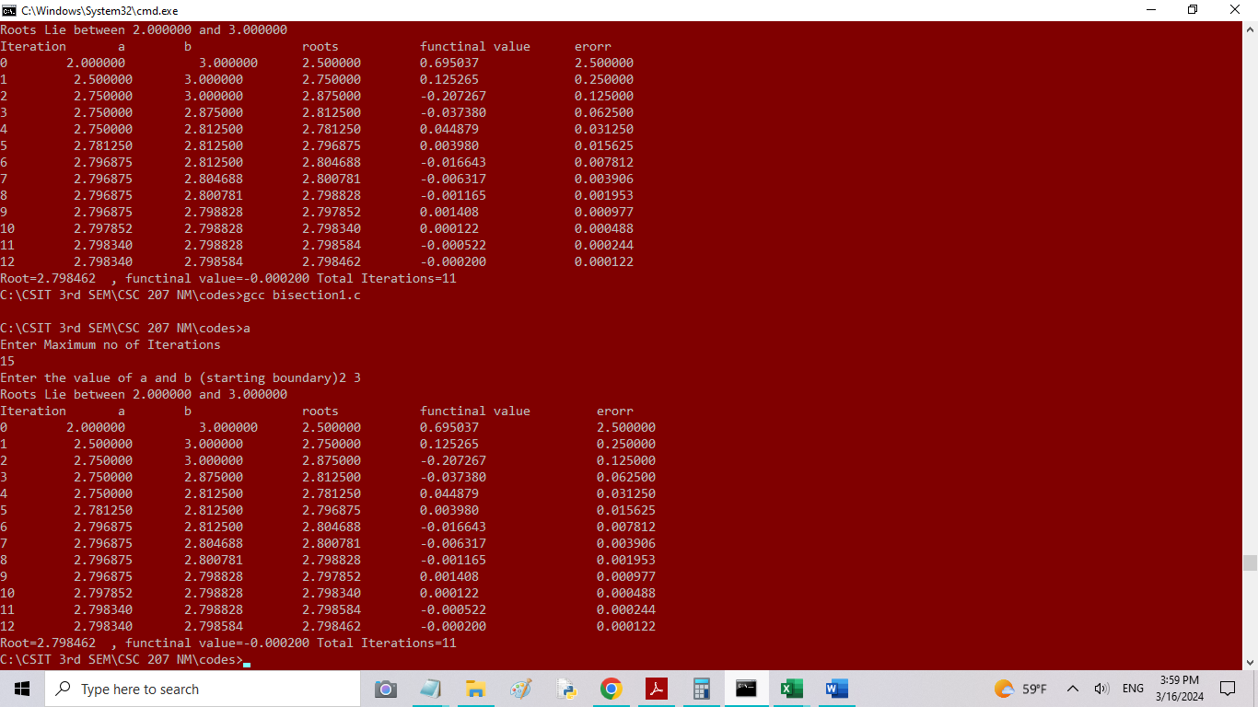

1. Compare and contrast interpolation and regression methods. Find the linear regression coefficients for the following observations using OLS method.

|  |  |  |  |  |  |  |
| --- | --- | --- | --- | --- | --- | --- |
| X | 0 | 1 | 2 | 5 | 7 | 9 |
| Y=f(x) | 1 | 0.891 | 0.708 | 0.562 | 0.447 | 0.355 |
|  |  |  |  |  |  |  |

|  |  |  |  |  |  |
| --- | --- | --- | --- | --- | --- |
| x | y | lny | x2 | x*lny | xy |
| 0 | 1 | 0 | 0 | 0 | 0 |
| 1 | 0.891 | -0.11541 | 1 | -0.11541 | 0.891 |
| 2 | 0.708 | -0.34531 | 4 | -0.69062 | 1.416 |
| 5 | 0.562 | -0.57625 | 25 | -2.88127 | 2.81 |
| 7 | 0.447 | -0.8052 | 49 | -5.63638 | 3.129 |
| 9 | 0.355 | -1.03564 | 81 | -9.32074 | 3.195 |
| 24 | 3.963 | -2.87781 | 160 | -18.6444 | 11.441 |
| **Exponential** | **b** | **-0.11146** | **OLS** |  |  |
|  | **A** | **-0.03381** | **b** | -0.06892 |  |
|  | **a** | **0.966754** | **a** | 0.936188 |  |

1. Find the cube root of 35, using Newton-Rapson method.

