**Tribhuvan University**

**Institute of Science and Technology**

**Prithvi Narayan Campus, Pokhara**

**Midterm Exam, Falgun 18, 2080**

Bachelor Level / Third Semester / Science Full marks: 30

Computer Science and Information Technology Pass marks: 12

Numerical Methods (CSC 207) Time: 1.5 hours

**SET B**

Candidates are required to give their answers in their own words as far as practicable.

The figures in the margin indicate full marks.

**Group A**

**Attempt any one question [1*10=10]**

1. Discuss the root finding problem for non-linear equations in general and write an algorithm to approximate the root of non-linear equations using bisection method. Compute the root of x2 + tanx + ex =0, using bisection method, correct up to three decimal places.

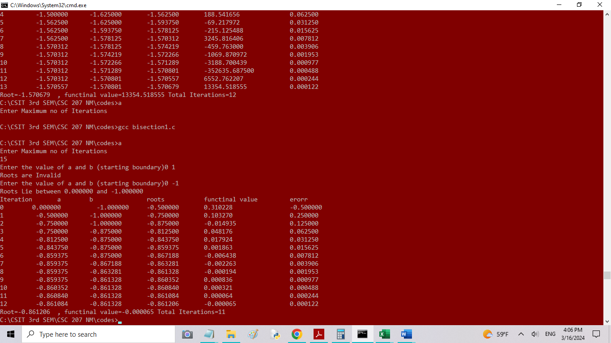

1. Compare and contrast interpolation and regression methods. Find the regression coefficients for the following observations using exponential best fit curve.

|  |  |  |  |  |  |  |
| --- | --- | --- | --- | --- | --- | --- |
| X | 0 | 1 | 2 | 5 | 7 | 9 |
| Y=f(x) | 1 | 0.891 | 0.708 | 0.562 | 0.447 | 0.355 |

|  |  |  |  |  |  |
| --- | --- | --- | --- | --- | --- |
| X | y | lny | x2 | x*lny | xy |
| 0 | 1 | 0 | 0 | 0 | 0 |
| 1 | 0.891 | -0.11541 | 1 | -0.11541 | 0.891 |
| 2 | 0.708 | -0.34531 | 4 | -0.69062 | 1.416 |
| 5 | 0.562 | -0.57625 | 25 | -2.88127 | 2.81 |
| 7 | 0.447 | -0.8052 | 49 | -5.63638 | 3.129 |
| 9 | 0.355 | -1.03564 | 81 | -9.32074 | 3.195 |
| 24 | 3.963 | -2.87781 | 160 | -18.6444 | 11.441 |
| **B** | **-0.11146** |  | **OLS** |  |  |
| **A** | **-0.03381** |  | **b** | **0.001074** |  |
| **A** | **0.966754** |  | **a** | **0.656204** |  |

**Group B**

**Attempt any four questions [4*5=20]**

1. What is convergence in numerical methods? Compare the convergences in bisection, Newton-Rapson and secant methods for finding the root of non-linear equations.
2. Describe error propagation taking examples from multiplication and division cases.
3. Find the cubic root of 65, using Newton-Rapson method.

1. Find the estimates of f(1.8), using second and third order polynomials of Newton’s divided difference method.

|  |  |  |  |  |
| --- | --- | --- | --- | --- |
| X | 1 | 2 | 3 | 4 |
| F(x) | 0 | 7 | 26 | 63 |

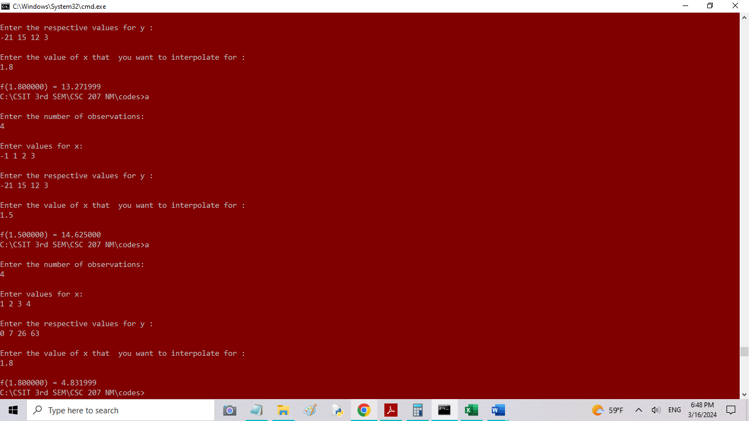

1. Write a short note on fixed point iteration method with an example and algorithm to find root of non-linear equations.