
COLLEGE: PRIYADARSHINI COLLEGE OF ENGINEERING
NAME: SHARON VAIDYA
BRANCH: IT
YEAR: 3RD
SEM: 5TH
SECTION: B
ROLLNO: 248
SUBJECT: DBMS
TITLE: STUDENT INFORMATION MANAGEMENT SYSTEM (MINI PROJECT)
GUIDED BY: PROF. RUSHIKA JAIS

1. Introduction
The Student Information Management System (SIMS) is a relational database application that stores, organizes and retrieves student-related academic information. The project uses MySQL as the RDBMS and provides a browser-based interface for common CRUD operations. The design uses multiple related tables instead of storing all information in one large student table, which makes dependencies and relationships explicit.

2. Problem Statement
Educational institutions maintain student records across admissions, programs, courses and academic enrollment. A poorly structured system can create duplicate data, inconsistent values and difficult reporting. The problem is to design a normalized relational database and a simple web application that supports controlled CRUD operations and demonstrates core DBMS laboratory concepts in MySQL.

3. Objectives
- Design a structured relational database for students, programs, departments, courses, instructors and enrollments.
- Apply normalization and integrity constraints to reduce redundancy and maintain valid relationships.
- Implement CRUD operations through an HTML/CSS/JavaScript interface backed by Node.js and MySQL.
- Demonstrate SQL functions, operators, joins, grouping, ordering, indexes, subqueries and views.
- Demonstrate transactions, backup/recovery procedures, users/roles/privileges, stored programs and triggers.

4. Coverage of the Supplied DBMS Lab Manual
The manual lists 12 experiments. The first six are shown on page 2, experiments 7-12 on page 3. [DBMS Lab Manual, pp. 2-3]
Exp. | Manual Topic | Implemented in Project | File(s)
1 | DDL | CREATE TABLE, ALTER, DROP, RENAME | sql/03_queries.sql
2 | DML | INSERT, UPDATE, DELETE, TRUNCATE, SELECT | sql/03_queries.sql
3 | Functions | Number, aggregate, character, conversion, date | sql/03_queries.sql
4 | Operators | Arithmetic, logical, comparison, special, set | sql/03_queries.sql
5 | Joins | Inner, outer, natural, self, non-equi, cross | sql/03_queries.sql
6 | GROUP/HAVING/ORDER/Index | Grouping, HAVING, ordering, indexes | sql/03_queries.sql + schema
7 | Subqueries / Views | Scalar, IN, EXISTS, correlated, views | sql/03_queries.sql + 04
8 | Constraints | NOT NULL, UNIQUE, CHECK, PK, FK, DEFAULT | sql/01_schema.sql
9 | Backup/Recovery + TCL | mysqldump, restore, COMMIT, ROLLBACK, SAVEPOINT | sql/05 + 07
10 | DB/Admin/DCL | Database, users, roles, GRANT, REVOKE | sql/00 + 06
11 | PL/SQL | MySQL stored function/procedure equivalent | sql/04_views_procedures_triggers.sql
12 | Triggers | Insert/update/delete audit and validation triggers | sql/04_views_procedures_triggers.sql

5. Technology Stack
Layer | Technology | Purpose
Database | MySQL / InnoDB | Persistent relational storage, constraints, joins, routines and triggers
Backend | Node.js + Express.js | REST API and server-side database access
Database Driver | mysql2 | Parameterized queries and connection pooling
Frontend | HTML5 | Semantic application structure and forms
Styling | CSS3 | Responsive dashboard layout and UI components
Client Logic | Vanilla JavaScript | Navigation, CRUD forms, fetch API and rendering
Documentation | Markdown + PDF | README, SQL notes and report
ER Diagram | Graphviz SVG/PNG | Database relationship visualization

6. System Architecture
The application follows a simple three-layer structure: browser UI -> Express REST API -> MySQL database. The browser never talks directly to MySQL. It calls API endpoints, and the server executes parameterized SQL using the mysql2 driver. This separation keeps connection details on the server and provides one place for input validation and error handling.
Browser (HTML/CSS/JS)
|
v
Express REST API (Node.js)
|
v
MySQL 8.x / InnoDB
|
+-- departments
+-- programs
+-- students
+-- instructors
+-- courses
+-- course_offerings
+-- enrollments
+-- attendance
+-- student_audit

7. ER Diagram
The entity-relationship model separates master data from transactional data. Departments own programs; programs own students and courses; course offerings connect courses to instructors for a semester; enrollments resolve the many-to-many relationship between students and course offerings; attendance depends on an enrollment. Student audit records are generated by triggers.
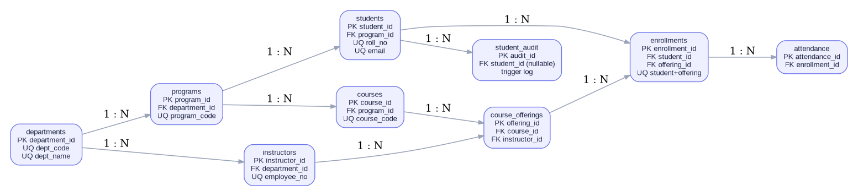
Figure 1. Entity-Relationship Diagram of the Student Information Management System

8. Database Schema
Table | Primary Key | Important Attributes / Foreign Keys
departments | department_id | dept_code, dept_name, location
programs | program_id | department_id, program_code, program_name, duration_years
students | student_id | roll_no, names, email, phone, dob, gender, admission_date, program_id, status, address fields
instructors | instructor_id | employee_no, instructor_name, email, department_id, joined_date, salary
courses | course_id | program_id, course_code, course_name, credits
course_offerings | offering_id | course_id, instructor_id, academic_year, semester, room_no
enrollments | enrollment_id | student_id, offering_id, enrollment_date, marks, grade, status
attendance | attendance_id | enrollment_id, class_date, present
student_audit | audit_id | student_id, action_type, old/new values, changed_at, changed_by

9. Normalization
The project is designed around the common 1NF, 2NF and 3NF objectives used in relational database design. Repeating groups are removed; student-to-offering enrollment is separated into its own relation; department and program descriptions are not repeated in every student row; course and instructor data are not repeated in every enrollment row. The relationship tables therefore carry foreign keys while descriptive attributes remain in their respective master tables.
For example, storing department_name inside every student row would duplicate a value that is determined by program/department. In this design, students store program_id, and program rows store department_id. This keeps the dependency chain explicit and reduces update anomalies.

10. SQL Queries and Features Implemented

10.1 DDL and DML
The schema uses CREATE TABLE for all core relations and ALTER/RENAME/DROP examples are placed in the lab query script. DML examples include INSERT, UPDATE and DELETE; SELECT demonstrates retrieval. A temporary table is used for TRUNCATE so the demonstration does not destroy project tables.
CREATE TABLE ddl_demo (demo_id INT PRIMARY KEY, demo_text VARCHAR(50));
ALTER TABLE ddl_demo ADD COLUMN remarks VARCHAR(150);
RENAME TABLE ddl_demo TO ddl_demo_renamed;
DROP TABLE ddl_demo_renamed;
INSERT INTO students (roll_no, first_name, last_name, email, program_id)
VALUES ('DEMO-001','Demo','Student','demo@example.com',1);
UPDATE students SET city='Nagpur' WHERE roll_no='DEMO-001';
DELETE FROM students WHERE roll_no='DEMO-001';

10.2 Functions
Number functions demonstrated include ABS, EXP, POWER, MOD, ROUND, TRUNCATE and SQRT. Aggregate functions include COUNT, SUM, AVG, MAX and MIN. Character examples include UPPER, LOWER, TRIM, LENGTH, SUBSTRING, CONCAT and LPAD. Conversion uses CAST. Date examples include CURRENT_DATE, CURRENT_TIMESTAMP, DATE_ADD, LAST_DAY and TIMESTAMPDIFF. The supplied manual documents the same five broad categories of functions on pages 15-20. [DBMS Lab Manual, pp. 15-20]

10.3 Operators and Set Operations
The query script covers arithmetic (+, -, *, /), logical (AND, OR, NOT), comparison (=, !=, <, >, <=, >=), and special operators such as BETWEEN, IS NULL, IN, LIKE, EXISTS, ANY and ALL. Set queries include UNION and UNION ALL plus INTERSECT and EXCEPT for MySQL versions that support them.

10.4 Joins
The project demonstrates INNER JOIN, LEFT JOIN, RIGHT JOIN, NATURAL JOIN, SELF JOIN, CROSS JOIN and a non-equi join against grade ranges. The manual describes joins as combining records from two or more tables using common values and lists inner/outer/natural join topics. [DBMS Lab Manual, pp. 24-25]

10.5 GROUP BY, HAVING, ORDER BY and Indexing
SELECT p.program_name, COUNT(s.student_id) AS student_count
FROM programs p
LEFT JOIN students s ON s.program_id=p.program_id
GROUP BY p.program_id, p.program_name
HAVING COUNT(s.student_id) >= 2
ORDER BY student_count DESC;
CREATE INDEX idx_students_name ON students(last_name, first_name);
The manual explains GROUP BY/HAVING and ORDER BY on pages 30-32 and describes indexing as an ordered set of pointers intended to speed data access. [DBMS Lab Manual, pp. 30-32]

10.6 Subqueries and Views
SELECT * FROM enrollments
WHERE marks > (SELECT AVG(marks) FROM enrollments);
CREATE VIEW vw_student_directory AS
SELECT s.roll_no, CONCAT(s.first_name,' ',s.last_name) AS student_name,
p.program_name, d.dept_name
FROM students s
JOIN programs p ON p.program_id=s.program_id
JOIN departments d ON d.department_id=p.department_id;
The manual defines subqueries as SELECT statements embedded in another statement and describes WHERE, HAVING, FROM and operator-based placements. It also describes views as virtual tables based on stored SQL. [DBMS Lab Manual, pp. 33-35]

10.7 Constraints
The schema uses NOT NULL, UNIQUE, CHECK, PRIMARY KEY, FOREIGN KEY and DEFAULT constraints. Foreign keys use ON UPDATE and ON DELETE actions where appropriate. The manual explains constraints as rules that can reject invalid data and lists the same constraint types. [DBMS Lab Manual, pp. 26-29]

10.8 Transactions, Backup and Recovery
START TRANSACTION;
INSERT INTO students (... ) VALUES (...);
SAVEPOINT before_status_change;
UPDATE students SET status='Inactive' WHERE roll_no='TXN-001';
ROLLBACK TO SAVEPOINT before_status_change;
COMMIT;
# logical backup
mysqldump -u root -p --routines --triggers --single-transaction sims_db > sims_backup.sql
The manual describes COMMIT, SAVEPOINT and ROLLBACK as transaction control operations on pages 40-41. [DBMS Lab Manual, pp. 40-41] The project maps those concepts to MySQL InnoDB and adds a mysqldump-based logical backup workflow.

10.9 Users, Roles, GRANT and REVOKE
The administrative SQL file contains optional commands for creating a read-only role, an application CRUD role, an application user, GRANT statements and REVOKE. These commands are intentionally separate from the main setup because they require administrative privileges. The manual covers user creation, privileges, GRANT, REVOKE and roles on pages 42-45. [DBMS Lab Manual, pp. 42-45]

10.10 PL/SQL Section Mapped to MySQL Stored Programs
The supplied manual lists "Study & Implementation of PL/SQL" as Experiment 11, but the provided 46-page file does not contain a detailed PL/SQL experiment section after the Experiment 10 material. [DBMS Lab Manual, pp. 2-3] Because the requested database is MySQL, this project implements the same programming idea using a MySQL stored function and stored procedure with IF logic and SIGNAL-based error reporting. This is a platform translation, not an attempt to execute Oracle PL/SQL in MySQL.
CREATE FUNCTION fn_student_age(p_dob DATE)
RETURNS INT
DETERMINISTIC
BEGIN
IF p_dob IS NULL THEN RETURN NULL; END IF;
RETURN TIMESTAMPDIFF(YEAR, p_dob, CURRENT_DATE);
END;

10.11 SQL Triggers
The project implements BEFORE INSERT validation and AFTER INSERT/UPDATE/DELETE audit triggers. This demonstrates automatic database-side actions and provides a visible example through the student_audit table. The supplied manual lists SQL Triggers as Experiment 12 but does not provide a detailed experiment section in the visible 46-page content, so the project implements the feature directly in MySQL.

11. Web Application
The website exposes a dashboard, student records, departments, courses, enrollments and reports. The Student Records screen provides Create, Read, Update and Delete operations. Forms submit JSON to the Express API, which performs parameterized SQL statements against MySQL.
Screen | Main Purpose
Dashboard | Summary counts, recent students and DBMS coverage
Students | Search, Create, Update and Delete
Departments | Department records with GROUP BY-based student counts
Courses | Course listing joined to program and department
Enrollments | Many-to-many student/course offering records
Reports | Department strength and above-average student report

Code:

HTML:
<!doctype html>
<html lang="en">
<head>
<meta charset="utf-8">
<meta name="viewport" content="width=device-width, initial-scale=1">
<title>Student Information Management System</title>
<link rel="stylesheet" href="styles.css">
</head>
<body>
<div class="app-shell">
<aside class="sidebar">
<div class="brand">
<div class="brand-mark">S</div>
<div><strong>SIMS</strong><span>DBMS Mini Project</span></div>
</div>
<nav>
<button class="nav-item active" data-view="dashboard">Dashboard</button>
<button class="nav-item" data-view="students">Students</button>
<button class="nav-item" data-view="departments">Departments</button>
<button class="nav-item" data-view="courses">Courses</button>
<button class="nav-item" data-view="enrollments">Enrollments</button>
<button class="nav-item" data-view="reports">Reports</button>
</nav>
<div class="sidebar-footer">
<div class="pill">MySQL + Express</div>
<small>CRUD • SQL Lab Coverage</small>
</div>
</aside>

<main class="main">
<header class="topbar">
<div>
<div class="eyebrow">DATABASE MANAGEMENT SYSTEM</div>
<h1 id="page-title">Dashboard</h1>
</div>
<div class="top-actions">
<span id="mode-badge" class="status-badge">LIVE DATABASE</span>
<button class="primary-btn" id="new-student-btn">+ Add Student</button>
</div>
</header>

<div id="notice" class="notice hidden"></div>
<section id="view-dashboard" class="view active-view"></section>
<section id="view-students" class="view"></section>
<section id="view-departments" class="view"></section>
<section id="view-courses" class="view"></section>
<section id="view-enrollments" class="view"></section>
<section id="view-reports" class="view"></section>
</main>
</div>

<dialog id="student-dialog">
<form method="dialog" id="student-form">
<div class="dialog-head">
<div><div class="eyebrow">CRUD FORM</div><h2 id="dialog-title">Add Student</h2></div>
<button type="button" class="icon-btn" id="close-dialog">×</button>
</div>
<input type="hidden" id="student_id">
<div class="form-grid">
<label>Roll No<input required id="roll_no"></label>
<label>First Name<input required id="first_name"></label>
<label>Last Name<input required id="last_name"></label>
<label>Email<input type="email" required id="email"></label>
<label>Phone<input id="phone"></label>
<label>Date of Birth<input type="date" id="dob"></label>
<label>Gender<select id="gender"><option value="">Select</option><option>Male</option><option>Female</option><option>Other</option></select></label>
<label>Admission Date<input type="date" id="admission_date"></label>
<label>Program<select required id="program_id"></select></label>
<label>Status<select id="status"><option>Active</option><option>Inactive</option><option>Graduated</option><option>Suspended</option></select></label>
<label>City<input id="city" value="Nagpur"></label>
<label>State<input id="state" value="Maharashtra"></label>
<label>PIN Code<input id="pin_code"></label>
<label class="full">Address<input id="address_line"></label>
</div>
<div class="dialog-actions">
<button type="button" class="secondary-btn" id="cancel-dialog">Cancel</button>
<button type="submit" class="primary-btn">Save Student</button>
</div>
</form>
</dialog>
<script src="app.js"></script>
</body>
</html>

CSS:
:root {
--bg: #f4f7fb;
--panel: #ffffff;
--ink: #162033;
--muted: #687386;
--line: #dfe5ef;
--accent: #4b58f0;
--accent2: #eef0ff;
--success: #1f8f5f;
--danger: #c83b45;
--shadow: 0 16px 40px rgba(31, 45, 75, .08);
}
* {
box-sizing: border-box
}
body {
margin: 0;
font-family: Inter, ui-sans-serif, system-ui, -apple-system, Segoe UI, Roboto, Arial, sans-serif;
background: var(--bg);
color: var(--ink)
}

button,
input,
select {
font: inherit
}
.app-shell {
display: grid;
grid-template-columns: 245px 1fr;
min-height: 100vh
}
.sidebar {
background: #12172a;
color: #fff;
padding: 24px 16px;
display: flex;
flex-direction: column
}
.brand {
display: flex;
gap: 12px;
align-items: center;
padding: 4px 8px 26px;
border-bottom: 1px solid rgba(255, 255, 255, .12)
}
.brand-mark {
width: 38px;
height: 38px;
border-radius: 12px;
display: grid;
place-items: center;
background: #5c66ff;
font-weight: 800
}
.brand strong {
display: block;
font-size: 17px;
letter-spacing: .08em
}
.brand span {
font-size: 11px;
color: #aeb7cf;
display: block;
margin-top: 2px
}
.sidebar nav {
padding-top: 20px;
display: grid;
gap: 6px
}
.nav-item {
border: 0;
background: transparent;
color: #b7c0d6;
text-align: left;
padding: 11px 12px;
border-radius: 10px;
cursor: pointer
}
.form-grid {
display: grid;
grid-template-columns: repeat(2, 1fr);
gap: 13px
}
.form-grid label {
font-size: 12px;
color: #616c80;
display: grid;
gap: 6px
}
.form-grid .full {
grid-column: 1/-1
}
.dialog-head {
display: flex;
justify-content: space-between;
align-items: flex-start;
margin-bottom: 18px
}
.dialog-head h2 {
margin: 5px 0 0
}
.dialog-actions {
display: flex;
justify-content: flex-end;
gap: 9px;
margin-top: 18px
}
.dialog-actions button {
min-width: 110px
}
dialog {
border: 0;
border-radius: 17px;
padding: 0;
width: min(760px, 92vw);
box-shadow: 0 24px 80px rgba(13, 20, 38, .25)
}
@media(max-width:650px) {
.metric-grid {
grid-template-columns: 1fr 1fr
}
.form-grid {
grid-template-columns: 1fr
}
.form-grid .full {
grid-column: auto
}
.topbar h1 {
font-size: 24px
}
}

Javascript:
const demoPrograms = [
{ program_id: 1, program_name: 'B.Tech Information Technology', program_code: 'IT', dept_code: 'IT', dept_name: 'Information Technology' },
{ program_id: 2, program_name: 'B.Tech Computer Science', program_code: 'CSE', dept_code: 'CSE', dept_name: 'Computer Science' },
{ program_id: 3, program_name: 'B.Tech Electronics & Telecommunication', program_code: 'ENTC', dept_code: 'ENTC', dept_name: 'Electronics & Telecommunication' }
];
let demoStudents = [
{ student_id: 1, roll_no: 'IT2026-001', first_name: 'Aarav', last_name: 'Patil', email: 'aarav@example.com', program_id: 1, program_name: 'B.Tech Information Technology', dept_code: 'IT', status: 'Active', city: 'Nagpur' },
{ student_id: 2, roll_no: 'CSE2026-014', first_name: 'Meera', last_name: 'Kulkarni', email: 'meera@example.com', program_id: 2, program_name: 'B.Tech Computer Science', dept_code: 'CSE', status: 'Active', city: 'Nagpur' },
{ student_id: 3, roll_no: 'IT2026-025', first_name: 'Rohan', last_name: 'Joshi', email: 'rohan@example.com', program_id: 1, program_name: 'B.Tech Information Technology', dept_code: 'IT', status: 'Active', city: 'Wardha' },
{ student_id: 4, roll_no: 'ENTC2026-006', first_name: 'Isha', last_name: 'Deshmukh', email: 'isha@example.com', program_id: 3, program_name: 'B.Tech Electronics & Telecommunication', dept_code: 'ENTC', status: 'Inactive', city: 'Amravati' },
{ student_id: 5, roll_no: 'CSE2026-031', first_name: 'Kabir', last_name: 'Shah', email: 'kabir@example.com', program_id: 2, program_name: 'B.Tech Computer Science', dept_code: 'CSE', status: 'Active', city: 'Nagpur' }
];
const demoDepartments = [
{ dept_code: 'IT', dept_name: 'Information Technology', location: 'Nagpur', student_count: 12 },
{ dept_code: 'CSE', dept_name: 'Computer Science', location: 'Nagpur', student_count: 9 },
{ dept_code: 'ENTC', dept_name: 'Electronics & Telecommunication', location: 'Nagpur', student_count: 7 },
{ dept_code: 'ME', dept_name: 'Mechanical Engineering', location: 'Nagpur', student_count: 5 }
];
const demoCourses = [
{ course_code: 'IT301', course_name: 'Database Management Systems', credits: 4, program_name: 'B.Tech Information Technology', dept_code: 'IT' },
{ course_code: 'IT302', course_name: 'Design and Analysis of Algorithms', credits: 4, program_name: 'B.Tech Information Technology', dept_code: 'IT' },
{ course_code: 'CSE305', course_name: 'Operating Systems', credits: 4, program_name: 'B.Tech Computer Science', dept_code: 'CSE' },
{ course_code: 'ENTC310', course_name: 'Microcontrollers', credits: 3, program_name: 'B.Tech Electronics & Telecommunication', dept_code: 'ENTC' }
];

const state = { demo: false, view: 'dashboard', programs: demoPrograms, students: demoStudents };
const $ = s => document.querySelector(s);
const $$ = s => [...document.querySelectorAll(s)];

function setMode(demo) {
state.demo = demo;
const badge = $('#mode-badge');
badge.textContent = demo ? 'DEMO DATA' : 'LIVE DATABASE';
badge.classList.toggle('demo', demo);
}
function notice(msg) { const n = $('#notice'); n.textContent = msg; n.classList.remove('hidden'); setTimeout(() => n.classList.add('hidden'), 5000) }
async function api(url, options = {}) {
try { const r = await fetch(url, options); if (!r.ok) throw new Error(await r.text()); return await r.json(); }
catch (e) { state.demo = true; setMode(true); return null; }
}

function nav(view) {
state.view = view;
$$('.nav-item').forEach(b => b.classList.toggle('active', b.dataset.view === view));
$$('.view').forEach(v => v.classList.remove('active-view'));
$(`#view-${view}`).classList.add('active-view');
$('#page-title').textContent = view.charAt(0).toUpperCase() + view.slice(1);
if (view === 'dashboard') renderDashboard();
if (view === 'students') renderStudents();
if (view === 'departments') renderDepartments();
if (view === 'courses') renderCourses();
if (view === 'enrollments') renderEnrollments();
if (view === 'reports') renderReports();
}

async function getDashboard() {
const data = await api('/api/dashboard');
if (data) { setMode(false); return data; }
return { totals: { students: demoStudents.length, departments: demoDepartments.length, programs: demoPrograms.length, courses: 18, enrollments: 46 }, recent: demoStudents.slice().reverse() };
}
async function renderDashboard() {
const d = await getDashboard();
const t = d.totals;
$('#view-dashboard').innerHTML = `
<div class="metric-grid">
${metric('Students', t.students)}${metric('Departments', t.departments)}${metric('Programs', t.programs)}${metric('Courses', t.courses)}${metric('Enrollments', t.enrollments)}
</div>
<div class="grid-2">
<div class="panel"><div class="section-head"><h2>Recent Students</h2><span class="muted">Last 8 records</span></div>
<div class="table-wrap"><table class="data-table"><thead><tr><th>Roll No</th><th>Name</th><th>Program</th><th>Status</th></tr></thead><tbody>
${(d.recent || []).map(s => `<tr><td><strong>${s.roll_no}</strong></td><td>${s.name || ((s.first_name || '') + ' ' + (s.last_name || ''))}</td><td>${s.program_name || '-'}</td><td><span class="tag">${s.status || 'Active'}</span></td></tr>`).join('')}
</tbody></table></div>
</div>
<div class="panel"><div class="section-head"><h2>DBMS Coverage</h2><span class="muted">Lab Manual</span></div>
${['DDL & DML', 'Functions & Operators', 'Joins', 'GROUP BY / HAVING / INDEX', 'Subqueries & Views', 'Constraints', 'Transactions', 'Users / Roles / DCL', 'Stored Programs & Triggers'].map(x => `<div class="list-card"><span>${x}</span><span class="tag">Implemented</span></div>`).join('')}
</div>
</div>
<div class="footer-note">Use the sidebar to inspect the relational data and reports. The website uses parameterized SQL in the Node/Express API.</div>`;
}
function metric(label, value) { return `<div class="metric"><div class="label">${label}</div><div class="value">${value}</div></div>` }

async function renderStudents() {
const live = await api('/api/students');
if (live) state.students = live; else state.students = demoStudents;
$('#view-students').innerHTML = `
<div class="panel"><div class="section-head"><h2>Student Records</h2><button class="primary-btn" onclick="openStudent()">+ Add Student</button></div>
<div class="search-row"><input id="student-search" placeholder="Search roll no, name or email"><select id="student-status"><option value="">All status</option><option>Active</option><option>Inactive</option><option>Graduated</option><option>Suspended</option></select><button class="secondary-btn" id="student-filter">Filter</button></div>
<div id="student-table"></div>
</div>`;
renderStudentTable(state.students);
$('#student-filter').onclick = async () => { const s = $('#student-search').value.trim(), status = $('#student-status').value; let data = await api('/api/students?search=' + encodeURIComponent(s) + '&status=' + encodeURIComponent(status)); if (data) state.students = data; else state.students = demoStudents.filter(x => (!s || (x.roll_no + x.first_name + x.last_name + x.email).toLowerCase().includes(s.toLowerCase())) && (!status || x.status === status)); renderStudentTable(state.students); };
}
function renderStudentTable(list) {
$('#student-table').innerHTML = `<div class="table-wrap"><table class="data-table"><thead><tr><th>Roll No</th><th>Student</th><th>Program</th><th>Department</th><th>Email</th><th>Status</th><th>Actions</th></tr></thead><tbody>${list.length ? list.map(s => `<tr><td><strong>${s.roll_no}</strong></td><td>${s.first_name} ${s.last_name}</td><td>${s.program_name || '-'}</td><td>${s.dept_code || '-'}</td><td>${s.email}</td><td><span class="tag">${s.status}</span></td><td><div class="row-actions"><button class="mini-btn" onclick='openStudent(${JSON.stringify(s)})'>Edit</button><button class="mini-btn delete" onclick="deleteStudent(${s.student_id})">Delete</button></div></td></tr>`).join('') : `<tr><td colspan="7"><div class="empty">No student records found.</div></td></tr>`}</tbody></table></div>`;
}

async function renderDepartments() {
let data = await api('/api/departments'); if (!data) data = demoDepartments;
$('#view-departments').innerHTML = `<div class="panel"><div class="section-head"><h2>Departments</h2><span class="muted">GROUP BY + LEFT JOIN</span></div><div class="two-col">${data.map(d => `<div class="report-card"><h3>${d.dept_code} - ${d.dept_name}</h3><div class="stat-strip"><span class="stat-chip">${d.location || 'Nagpur'}</span><span class="stat-chip">${d.student_count} students</span></div><div class="bar" style="margin-top:10px"><span style="width:${Math.min((Number(d.student_count) / 15) * 100, 100)}%"></span></div></div>`).join('')}</div></div>`;
}
async function renderCourses() {
let data = await api('/api/courses'); if (!data) data = demoCourses;
$('#view-courses').innerHTML = `<div class="panel"><div class="section-head"><h2>Courses</h2><span class="muted">INNER JOIN course / program / department</span></div><div class="table-wrap"><table class="data-table"><thead><tr><th>Code</th><th>Course</th><th>Credits</th><th>Program</th><th>Dept</th></tr></thead><tbody>${data.map(c => `<tr><td><strong>${c.course_code}</strong></td><td>${c.course_name}</td><td>${c.credits}</td><td>${c.program_name}</td><td><span class="tag">${c.dept_code}</span></td></tr>`).join('')}</tbody></table></div></div>`;
}
async function renderEnrollments() {
let data = await api('/api/enrollments');
if (!data) data = demoStudents.map((s, i) => ({ roll_no: s.roll_no, student_name: s.first_name + ' ' + s.last_name, course_code: ['IT301', 'IT302', 'CSE305'][i % 3], course_name: ['DBMS', 'DAA', 'Operating Systems'][i % 3], academic_year: '2026-27', semester: 'IV', grade: ['A', 'A+', 'B+'][i % 3], status: 'Enrolled' }));
$('#view-enrollments').innerHTML = `<div class="panel"><div class="section-head"><h2>Enrollments</h2><span class="muted">Many-to-many relationship</span></div><div class="table-wrap"><table class="data-table"><thead><tr><th>Roll No</th><th>Student</th><th>Course</th><th>Year</th><th>Semester</th><th>Grade</th><th>Status</th></tr></thead><tbody>${data.map(e => `<tr><td>${e.roll_no}</td><td>${e.student_name}</td><td>${e.course_code} - ${e.course_name}</td><td>${e.academic_year}</td><td>${e.semester}</td><td>${e.grade || '-'}</td><td><span class="tag">${e.status}</span></td></tr>`).join('')}</tbody></table></div></div>`;
}
async function renderReports() {
let dept = await api('/api/reports/department-strength'); if (!dept) dept = demoDepartments;
let top = await api('/api/reports/top-students'); if (!top) top = demoStudents.map((s, i) => ({ roll_no: s.roll_no, name: s.first_name + ' ' + s.last_name, average_marks: 88 - i * 3 }));
$('#view-reports').innerHTML = `<div class="report-grid"><div class="panel"><div class="section-head"><h2>Department Strength</h2><span class="muted">GROUP BY / HAVING</span></div>${dept.map(d => `<div class="list-card"><span>${d.dept_code} - ${d.dept_name}</span><strong>${d.student_count}</strong></div>`).join('')}</div><div class="panel"><div class="section-head"><h2>Above-Average Students</h2><span class="muted">View + subquery</span></div>${top.slice(0, 8).map(x => `<div class="list-card"><span>${x.roll_no} - ${x.name}</span><strong>${Number(x.average_marks).toFixed(1)}</strong></div>`).join('')}</div></div><div class="panel" style="margin-top:14px"><div class="section-head"><h2>Representative SQL</h2><span class="muted">MySQL</span></div><pre class="code">SELECT d.dept_code, COUNT(s.student_id) AS student_count\nFROM departments d\nLEFT JOIN programs p ON p.department_id=d.department_id\nLEFT JOIN students s ON s.program_id=p.program_id\nGROUP BY d.department_id, d.dept_code\nHAVING COUNT(s.student_id) &gt;= 1\nORDER BY student_count DESC;</pre></div>`;
}

async function populatePrograms() {
let p = await api('/api/programs'); if (!p) p = demoPrograms; state.programs = p;
$('#program_id').innerHTML = p.map(x => `<option value="${x.program_id}">${x.program_name}</option>`).join('');
}
function openStudent(student = null) {
populatePrograms().then(() => {
const f = ['student_id', 'roll_no', 'first_name', 'last_name', 'email', 'phone', 'dob', 'gender', 'admission_date', 'program_id', 'status', 'city', 'state', 'pin_code', 'address_line'];
$('#student-form').reset(); $('#student_id').value = ''; $('#dialog-title').textContent = student ? 'Edit Student' : 'Add Student';
f.forEach(k => { if (student && document.getElementById(k)) document.getElementById(k).value = student[k] ?? ''; });
$('#student-dialog').showModal();
});
}
async function deleteStudent(id) {
if (!confirm('Delete this student record?')) return;
if (state.demo) { demoStudents = demoStudents.filter(s => s.student_id !== id); state.students = demoStudents; renderStudentTable(state.students); notice('Deleted in demo mode.'); return; }
const r = await api('/api/students/' + id, { method: 'DELETE' }); if (r && r.message) { notice('Student deleted.'); renderStudents(); } else notice('Delete failed.');
}
$('#student-form').addEventListener('submit', async e => {
e.preventDefault();
const ids = ['roll_no', 'first_name', 'last_name', 'email', 'phone', 'dob', 'gender', 'admission_date', 'program_id', 'status', 'city', 'state', 'pin_code', 'address_line'];
const data = Object.fromEntries(ids.map(id => [id, $('#' + id).value || null]));
const id = Number($('#student_id').value || 0);
if (state.demo) {
if (id) { demoStudents = demoStudents.map(s => s.student_id === id ? { ...s, ...data, program_name: state.programs.find(p => p.program_id == data.program_id)?.program_name || s.program_name, dept_code: state.programs.find(p => p.program_id == data.program_id)?.dept_code || s.dept_code } : s) }
else demoStudents.unshift({ ...data, student_id: Math.max(...demoStudents.map(s => s.student_id)) + 1, program_name: state.programs.find(p => p.program_id == data.program_id)?.program_name || '', dept_code: state.programs.find(p => p.program_id == data.program_id)?.dept_code || '' });
$('#student-dialog').close(); renderStudents(); notice(id ? 'Updated in demo mode.' : 'Created in demo mode.'); return;
}
const r = await api(id ? '/api/students/' + id : '/api/students', { method: id ? 'PUT' : 'POST', headers: { 'Content-Type': 'application/json' }, body: JSON.stringify(data) });
if (r && r.student_id) { $('#student-dialog').close(); renderStudents(); notice(id ? 'Student updated.' : 'Student created.'); }
else notice('Save failed. Check required fields and constraints.');
});
$('#new-student-btn').onclick = () => openStudent(); $('#close-dialog').onclick = () => $('#student-dialog').close(); $('#cancel-dialog').onclick = () => $('#student-dialog').close();
$$('.nav-item').forEach(b => b.onclick = () => nav(b.dataset.view));

(async () => { const h = await api('/api/health'); setMode(!h); nav('dashboard'); })();

SQL:
-- Student Information Management System - master MySQL setup

-- ===== 00_create_database.sql =====
-- Experiment 1: DDL - database creation
DROP DATABASE IF EXISTS sims_db;
CREATE DATABASE sims_db CHARACTER SET utf8mb4 COLLATE utf8mb4_unicode_ci;
USE sims_db;

-- ===== 01_schema.sql =====
USE sims_db;

-- Core normalized relational schema.
CREATE TABLE departments (
department_id INT UNSIGNED AUTO_INCREMENT PRIMARY KEY,
dept_code VARCHAR(10) NOT NULL UNIQUE,
dept_name VARCHAR(100) NOT NULL UNIQUE,
location VARCHAR(80) NOT NULL DEFAULT 'Nagpur'
) ENGINE=InnoDB;

CREATE TABLE programs (
program_id INT UNSIGNED AUTO_INCREMENT PRIMARY KEY,
department_id INT UNSIGNED NOT NULL,
program_code VARCHAR(15) NOT NULL UNIQUE,
program_name VARCHAR(120) NOT NULL UNIQUE,
duration_years TINYINT UNSIGNED NOT NULL DEFAULT 4,
CONSTRAINT chk_program_duration CHECK (duration_years BETWEEN 1 AND 6),
CONSTRAINT fk_program_department FOREIGN KEY (department_id)
REFERENCES departments(department_id)
ON UPDATE CASCADE ON DELETE RESTRICT
) ENGINE=InnoDB;

CREATE TABLE enrollments (
enrollment_id INT UNSIGNED AUTO_INCREMENT PRIMARY KEY,
student_id INT UNSIGNED NOT NULL,
offering_id INT UNSIGNED NOT NULL,
enrollment_date DATE NOT NULL DEFAULT (CURRENT_DATE),
marks DECIMAL(5,2) NULL,
grade VARCHAR(2) NULL,
status ENUM('Enrolled','Completed','Dropped') NOT NULL DEFAULT 'Enrolled',
CONSTRAINT uq_enrollment UNIQUE (student_id, offering_id),
CONSTRAINT chk_marks CHECK (marks IS NULL OR marks BETWEEN 0 AND 100),
CONSTRAINT fk_enrollment_student FOREIGN KEY (student_id)
REFERENCES students(student_id)
ON UPDATE CASCADE ON DELETE CASCADE,
CONSTRAINT fk_enrollment_offering FOREIGN KEY (offering_id)
REFERENCES course_offerings(offering_id)
ON UPDATE CASCADE ON DELETE RESTRICT
) ENGINE=InnoDB;

CREATE TABLE attendance (
attendance_id BIGINT UNSIGNED AUTO_INCREMENT PRIMARY KEY,
enrollment_id INT UNSIGNED NOT NULL,
class_date DATE NOT NULL,
present BOOLEAN NOT NULL DEFAULT TRUE,
CONSTRAINT uq_attendance UNIQUE (enrollment_id, class_date),
CONSTRAINT fk_attendance_enrollment FOREIGN KEY (enrollment_id)
REFERENCES enrollments(enrollment_id)
ON UPDATE CASCADE ON DELETE CASCADE

INSERT INTO programs (department_id, program_code, program_name, duration_years) VALUES
(1,'IT','B.Tech Information Technology',4),
(2,'CSE','B.Tech Computer Science',4),
(3,'ENTC','B.Tech Electronics & Telecommunication',4),
(4,'ME','B.Tech Mechanical Engineering',4);

INSERT INTO instructors (employee_no, instructor_name, email, department_id, joined_date, salary) VALUES
('EMP001','Dr. Anil Verma','anil.verma@example.com',1,'2021-07-01',72000),
('EMP002','Dr. Neha Kulkarni','neha.kulkarni@example.com',2,'2020-08-17',78000),
('EMP003','Prof. Rakesh Patil','rakesh.patil@example.com',3,'2022-01-10',69000),
('EMP004','Prof. Priya Joshi','priya.joshi@example.com',4,'2019-06-20',66000);

INSERT INTO courses (program_id, course_code, course_name, credits) VALUES
(1,'IT301','Database Management Systems',4),
(1,'IT302','Design and Analysis of Algorithms',4),
(1,'IT303','Computer Networks',4),
(1,'IT304','Software Engineering',3),
(1,'IT305','Web Technology',3),
(2,'CSE301','Database Management Systems',4),
(2,'CSE302','Operating Systems',4),
(2,'CSE303','Computer Networks',4),
(3,'ENTC301','Microcontrollers',3),
(3,'ENTC302','Digital Communication',4),
(4,'ME301','Thermodynamics',4),
(4,'ME302','Manufacturing Processes',4);

INSERT INTO course_offerings (course_id, instructor_id, academic_year, semester, room_no) VALUES
(1,1,'2026-27','IV','IT-401'),
(2,1,'2026-27','IV','IT-402'),
(3,1,'2026-27','IV','IT-403'),
(4,1,'2026-27','IV','IT-404'),
(5,1,'2026-27','IV','IT-LAB'),
(6,2,'2026-27','IV','CSE-401'),
(7,2,'2026-27','IV','CSE-402'),
(8,2,'2026-27','IV','CSE-403'),
(9,3,'2026-27','IV','E-401'),
(10,3,'2026-27','IV','E-402'),
(11,4,'2026-27','IV','ME-401'),
(12,4,'2026-27','IV','ME-402');

INSERT INTO students (roll_no, first_name, last_name, email, phone, dob, gender, admission_date, program_id, status, address_line, city, state, pin_code) VALUES
('IT2026-001','Aarav','Patil','aarav.patil@example.com','9876500001','2006-03-14','Male','2026-07-10',1,'Active','Wardha Road','Nagpur','Maharashtra','440015'),
('IT2026-002','Sneha','Deshmukh','sneha.deshmukh@example.com','9876500002','2006-08-12','Female','2026-07-10',1,'Active','Manish Nagar','Nagpur','Maharashtra','440015'),
('IT2026-003','Yash','Shinde','yash.shinde@example.com','9876500003','2006-05-27','Male','2026-07-10',1,'Active','Trimurti Nagar','Nagpur','Maharashtra','440022'),
('CSE2026-014','Meera','Kulkarni','meera.kulkarni@example.com','9876500014','2006-01-21','Female','2026-07-10',2,'Active','Dharampeth','Nagpur','Maharashtra','440010'),
('CSE2026-015','Kabir','Shah','kabir.shah@example.com','9876500015','2006-11-03','Male','2026-07-10',2,'Active','Sadar','Nagpur','Maharashtra','440001'),
('CSE2026-016','Diya','Pande','diya.pande@example.com','9876500016','2006-09-09','Female','2026-07-10',2,'Inactive','Bajaj Nagar','Nagpur','Maharashtra','440010'),
('ENTC2026-006','Isha','Deshmukh','isha.deshmukh@example.com','9876500021','2006-04-18','Female','2026-07-10',3,'Active','Manewada','Nagpur','Maharashtra','440024'),
('ME2026-004','Om','Joshi','om.joshi@example.com','9876500031','2006-02-28','Male','2026-07-10',4,'Active','Wathoda','Nagpur','Maharashtra','440008');

INSERT INTO enrollments (student_id, offering_id, marks, grade, status) VALUES
(1,1,91,'A+','Completed'),
(1,2,88,'A','Completed'),
(1,3,84,'A','Completed'),
(2,1,86,'A','Completed'),
(2,2,81,'A','Completed'),
(2,3,79,'B+','Completed'),
(3,1,74,'B+','Completed'),
(4,6,92,'A+','Completed'),
(4,7,89,'A','Completed'),
(5,6,87,'A','Completed'),
(6,6,71,'B+','Completed'),
(7,9,90,'A+','Completed'),
(8,11,76,'B+','Completed');

INSERT INTO attendance (enrollment_id, class_date, present) VALUES
(1,'2026-08-01',1),(1,'2026-08-03',1),(1,'2026-08-05',0),
(2,'2026-08-01',1),(2,'2026-08-03',1),(2,'2026-08-05',1),
(4,'2026-08-01',1),(4,'2026-08-03',0),(4,'2026-08-05',1),
(8,'2026-08-01',1),(8,'2026-08-03',1);

-- ===== 04_views_procedures_triggers.sql =====
USE sims_db;
IF v_count = 0 THEN
SIGNAL SQLSTATE '45000' SET MESSAGE_TEXT='Student not found';
ELSE
SELECT * FROM vw_student_directory WHERE student_id=p_student_id;
SELECT fn_student_age(dob) AS age_years FROM students WHERE student_id=p_student_id;
END IF;
END$$
DELIMITER ;

-- Stored procedure call example:
-- CALL sp_get_student_report(1);

-- Demonstration queries:
-- SHOW TRIGGERS FROM sims_db;
-- SELECT * FROM student_audit ORDER BY audit_id DESC;

Output:
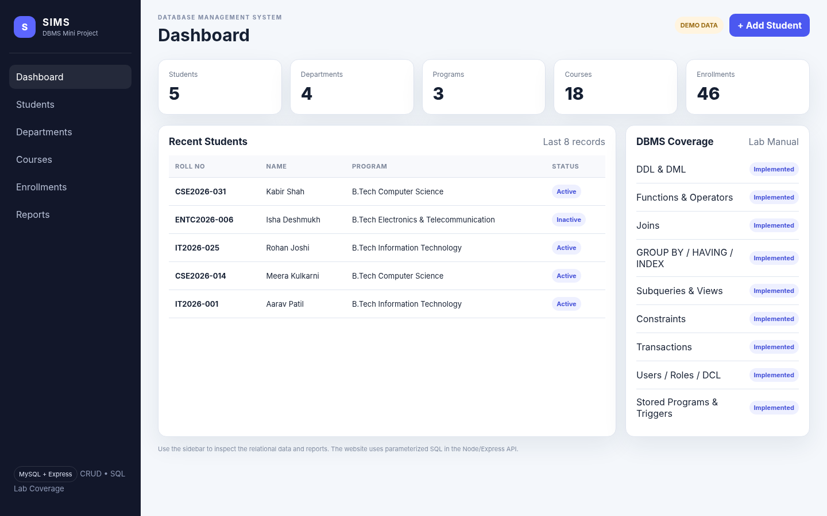
Figure 2. Dashboard screen showing database summary and DBMS coverage
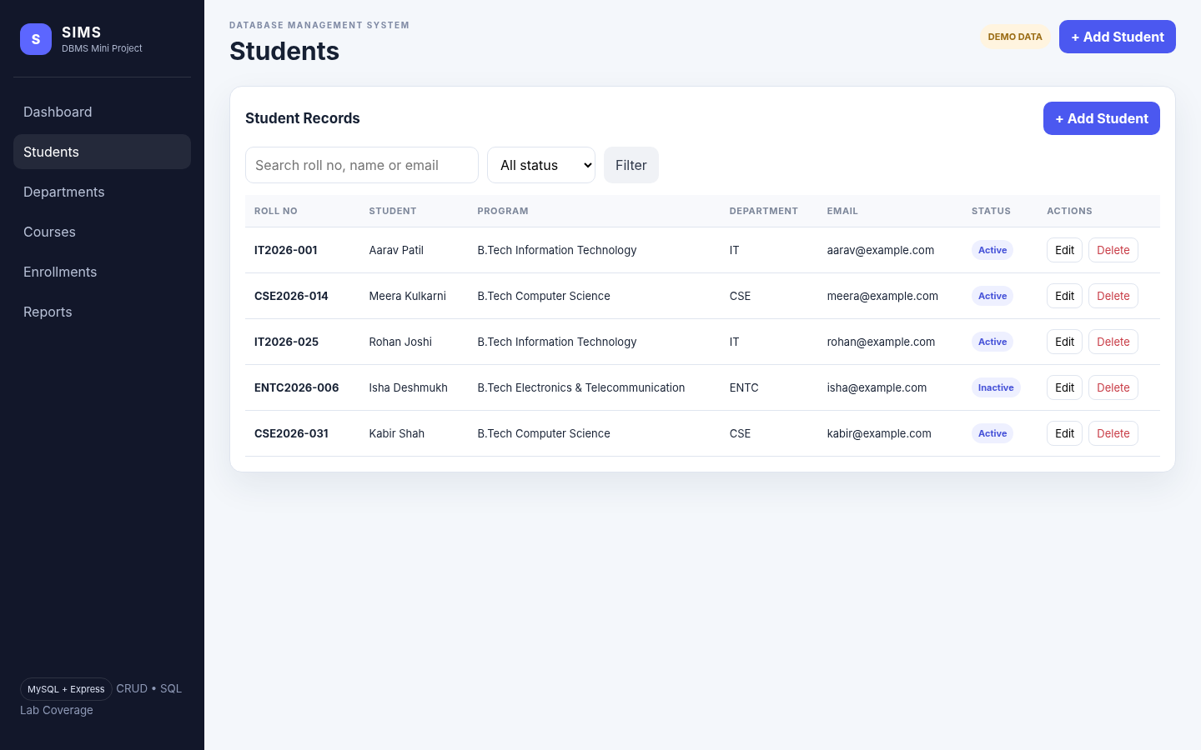
Figure 3. Student CRUD screen with search/filter and action buttons

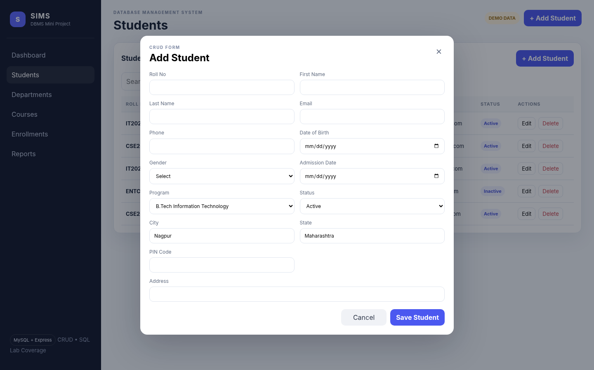
Figure 4. Add Student form used for Create operations
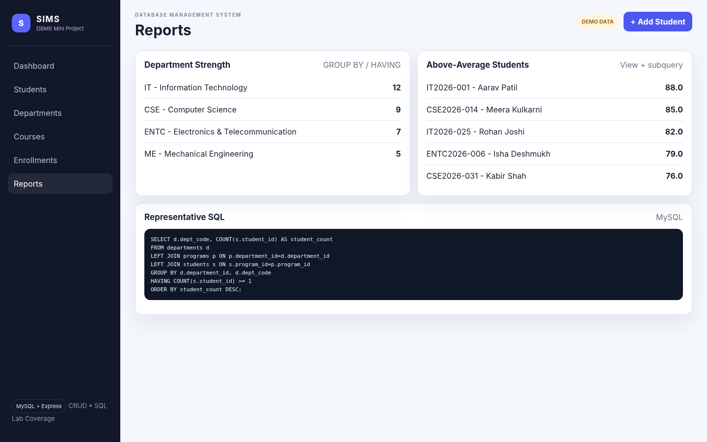
Figure 5. Reports screen demonstrating grouped and subquery-backed results

12. Testing and Validation
Test Case | Expected Result | Implementation
Create student with valid data | Record inserted | POST /api/students
Create duplicate roll number | Rejected by UNIQUE constraint | students.roll_no
Create invalid PIN | Rejected by CHECK/trigger | chk_pin_code + trigger
Update student | Existing row changed | PUT /api/students/:id
Delete student | Record removed subject to FK rules | DELETE /api/students/:id
Search students | Matching records displayed | GET /api/students?search=...
Group report | Department counts grouped and filtered | GROUP BY + HAVING
Audit trigger | Audit row written automatically | student_audit
Rollback transaction | Uncommitted change undone | ROLLBACK / SAVEPOINT
Database backup | SQL dump file created | mysqldump
Static browser validation was performed against the generated interface with demo data because the build environment did not have a local MySQL server installed. The project itself is configured for MySQL and includes all setup scripts; live database behavior should be verified after MySQL is installed and the schema scripts are executed.

13. Conclusion
The Student Information Management System combines database design, SQL programming and a web interface in one deliverable. It provides a normalized schema, relational integrity through constraints and foreign keys, practical CRUD functionality, and a lab-oriented SQL script that covers the concepts listed in the supplied DBMS manual. MySQL-specific translations are used where the manual contains Oracle terminology, while the original experiment topics are preserved.

14. Future Scope
- Add authentication and role-based permissions to the web interface.
- Add marks/grade entry forms, attendance dashboards and PDF report generation.
- Add pagination, server-side validation and audit-log viewer in the UI.
- Deploy the Node.js application with a managed MySQL instance and environment-based secrets.
- Add automated integration tests against a disposable MySQL test database.

Github Link: https://github.com/vanshboss123/student_information_management_system_mini_project/tree/main/student_information_management_system

