PROJECT REPORT
Summer Training — Power BI

Project Title | Superstore Sales Performance Analysis
Student Name | Rishav Thakur
Roll Number | 2419362
Course & Batch | B. Tech CSE (2028)
Department | Computer Science & Engineering
Institute | CGC University Mohali
Training Period | 08/06/2026 to 06/07/2026
Submission Date | 06 July 2026
Guided By | Dr. Ashima & Mrs. Mandeep

1. Declaration

I hereby declare that the project report entitled "Superstore Sales Performance Analysis" submitted in partial fulfilment of the Summer Training Programme is an original piece of work carried out by me. The data used in this report has been collected from publicly available sources. The dashboards, visuals shown in this report have been independently created by me in Microsoft Power BI Desktop.

I further confirm that this report or any part of it has not been submitted previously for any academic award.

Signature: 
Name: Rishav Thakur
Date: 06 / 07 / 2026
2. Abstract

This project presents an interactive Superstore Sales Performance Dashboard developed in Microsoft Power BI to help sales managers and business analysts monitor sales performance and make informed decisions. The dashboard provides insights into sales, profit, discounts, customer segments, regions, and product categories in a single view.

The project uses the Superstore Sales Dataset in CSV format, containing sales transaction records with key fields such as Order Date, Category, Region, Sales, Profit, Discount, Quantity, and Segment. The dataset was already clean, and a Profit Percentage column was created for additional analysis.

Power BI features such as Power Query, DAX, KPI cards, bar charts, pie charts, line charts, maps, and slicers were used to build an interactive dashboard. Cross-filtering between visuals enables users to analyze data efficiently.

The dashboard helps identify top-performing regions and categories, monitor yearly sales trends, evaluate profitability, and support data-driven business decisions. It provides a clear and user-friendly overview of business performance for effective analysis.

3. Introduction

3.1 Background
This project belongs to the Retail Analytics domain, where businesses analyze sales data to improve performance and make better decisions. Data visualization helps convert complex data into easy-to-understand charts and dashboards. Organizations use interactive dashboards to monitor key metrics such as sales, profit, discounts, and customer trends, enabling faster and more informed business decisions.

3.2 Problem Statement
This dashboard is designed for sales managers and business analysts to monitor sales performance efficiently. Earlier, sales, profit, and regional performance data were scattered and difficult to analyze quickly. The dashboard provides all key business insights in one place, making it easier to identify trends, compare performance, and make informed business decisions.

3.3 Objectives
- Connect and clean the raw dataset using Power Query.
- Create a star schema data model with proper relationships.
- Develop custom DAX measures for sales and profit analysis.
- Build an interactive dashboard using multiple visualizations.
- Enable cross-filtering for detailed data analysis.
- Publish the dashboard to Power BI Service.
- Analyze sales performance across regions, categories, and customer segments to support business decision-making.

4. Dataset Description

4.1 Data Source

Source Name | Kaggle
Dataset Name | Superstore Sales Dataset
File Format | CSV
Number of Records | 10,194 rows
Number of Columns | 23 columns
Time Period Covered | 2023–2026
Download Link | https://www.kaggle.com/datasets/vivek468/superstore-dataset-final

4.2 Key Fields / Columns

Column Name | Data Type | Description / Role in Analysis
Order ID | Text | Unique identifier for each order.
Order Date | Date | Used for yearly sales and profit analysis.
Category | Text | Used to compare sales across product categories.
Sub-Category | Text | Used to analyze profit by product type.
Region | Text | Used to analyze sales by region.
State | Text | Used to display profit on the map.

4.3 Data Quality Issues & Cleaning Steps
- Data Quality Check : Checked Dataset for missing Values and no significant null value.
- Handled null values — Checked all columns for null Values and replacing blanks where required.
- Changed data types — Convert column in appropriate data type such as integer, text, decimal.
- Renamed Columns — Updated column names where required to improve readability & understanding.
- Created calculated columns — Created additional fields such as salary category for better visualization and analysis
- Data validation – Verified that the cleaned dataset was accurate and ready for Power BI visuals.

5. Data Modelling

5.1 Schema Design

Schema Type | Star Schema
Fact Table | Superstore Sales – contains Sales, Profit, Quantity, Discount, Order Date, Category, Region, Segment, and other order details.
Date Dimension | Order Date, Year, Quarter, Month
Product Dimension | Product Name, Category, Sub-Category
Customer & Region Dimension | Customer Name, Segment, Region, State
Relationships | All dimension tables joined to the Sales Fact Table using common keys; One-to-Many; Single filter direction.

5.2 Model Diagram
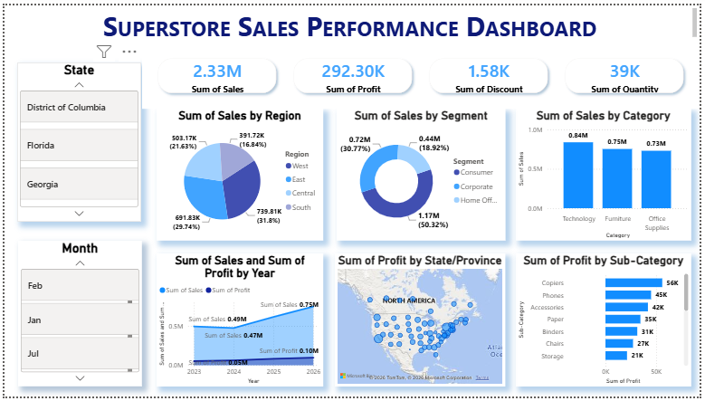

6. Dashboard & Visuals

6 Page 1 — Summary / Overview
Visuals used on this page:
- KPI Cards — Total Sales, Total Profit, Total Discount, Total Quantity
- Pie Chart — Sales by Region
- Donut Chart — Sales by Segment
- Column Charts — Sales by Category, Discount by Category
- Line Chart — Sales and Profit by Year
- Map — Profit by State/Province
- Horizontal Bar Chart — Profit by Sub-Category
- Slicers — State, Month

7. Key Findings & Insights

- Finding 1: The South region recorded the highest sales (31.8% of total sales), while the Central region contributed the lowest sales (16.8%).
- Finding 2: The Consumer segment generated the highest sales (1.17M), contributing over 50% of total sales.
- Finding 3: Technology was the best-performing product category with 0.84M in sales, followed by Furniture and Office Supplies.
- Finding 4: Sales showed a consistent upward trend from 2023 to 2026, indicating continuous business growth.
- Finding 5: Copiers was the most profitable sub-category (56K profit), while Storage generated the lowest profit among the displayed sub-categories.

8. Learnings & Challenges

8.1 Skills Learned
- Connected and loaded CSV data using Power Query.
- Created custom Profit Percentage and Month column using DAX.
- Built interactive dashboards using KPI cards, charts, maps, and slicers.
- Applied cross-filtering to improve data analysis.
- Learned to present business insights using Power BI visualizations.

8.2 Challenges Faced
- Understanding the appropriate visualizations for different types of data.
- Creating the Profit Percentage and Month DAX column correctly.
- Arranging dashboard visuals to make the report clear and user-friendly.
- Choosing meaningful KPIs and charts to effectively represent business performance.

9. Conclusion

This project successfully addressed the problem of analyzing sales data by presenting key business information through an interactive Power BI dashboard. The dashboard enables sales managers and business analysts to monitor sales, profit, customer segments, and regional performance in a simple and efficient manner. It supports better decision-making by providing clear visual insights and interactive filtering options. Given more time, additional features such as drill-through pages, advanced DAX measures, and predictive analytics could be incorporated to enhance the dashboard further. This project also improved my practical understanding of Power BI, data visualization, and business intelligence concepts.

10. References

- Microsoft Power BI Documentation
https://learn.microsoft.com/en-us/power-bi/
- Superstore Sales Dataset (Kaggle)
https://www.kaggle.com/datasets/vivek468/superstore-dataset-final
- DAX Guide
https://dax.guide/
- Power Query M Reference
https://learn.microsoft.com/en-us/powerquery-m/
- Microsoft Learn: Power BI Training
https://learn.microsoft.com/en-us/training/powerplatform/power-bi/
- OpenAI ChatGPT was used for assistance in understanding Power BI concepts and improving project documentation
https://chat.openai.com

END OF REPORT

