**COURSE OFFERED BY COMPUTER SCIENCE & APPLICATION**

**About Us**

**Department of Computer Science & Applications**

Department of Computer Science & Application, Arni University carries a vision of crafting next-gen IT professionals who can take up industry challenges effectively. The department renders cutting-edge education ranging from the expertise in traditional software development -to- modern computing technologies. Fully-equipped industry-sponsored labs, industry-aligned curriculum, and accreditations and validations by top companies such as **Microsoft, HPE, IBM, Oracle, Red Hat, etc.** give our students an exclusive edge over others.

**Scope**

**Scope and Career after MCA (Master of Computer Application)**

Application Developer

Cloud Architect

Web Designer/ Developer

Software Developer or Software Programmer

Hardware Engineer

Data Scientist

Software Consultant

Ethical Hacking

Software Tester

IT Manager

Network Administrator

Game Developing

Cyber Security.

Research

Competitive Exams (JRF & NET/GATE)

**Scope and Career after BCA (Bachelor of Computer Application)**

Web Developer

Database Administrator

Software Developer

Computer Programmer

System Engineer

Computer Systems Analyst

System Administrator/ IT Administrator

Computer Scientist

Security & Surveillance

Financial Institutions

Banks

**Scope and Career after Multimedia & Animation**

VFX Artists

Motion Designers

Animators

Gameplay Animators

Special Effects Artists

3D Animators.

Advertising

Online and Print News Media

Film & Television

Cartoon production

Theater

Video Gaming

E-learning

**Courses Detail**

* **BCA**
* **Specializations**
* General
* Multimedia & Animation

**ELIGIBILITY CRITERIA**

10+2 passed any stream with obtained at least 45% marks any categories.

**DURATION**

* 3 Years
* **B-Vocational (**Multimedia & Animation**)**

**ELIGIBILITY CRITERIA**

10+2 passed any stream with obtained at least 45% marks any categories.

**DURATION**

* 3 Years
* **MCA**
* The program is designed to build programming skills for developing efficient and resource optimized software/website/cloud/mobile applications.

**ELIGIBILITY CRITERIA**

* Passed BCA/ B.Sc./ PGDCA/ B.Com./ B.A. with Mathematics at 10+2 level or at graduation level (with additional bridge courses as per the norms of the concerned University) obtained at least 55% marks (45% marks in case of candidates belonging to reserved category).

**DURATION**

* 2 Years
* **Integrated MCA**

The program is designed to build programming skills for developing efficient and resource optimized software/website/cloud/mobile applications.

**ELIGIBILITY CRITERIA**

Integrated MCA is a dual degree course after 10+2 passed obtained at least 45% marks any categories student get admission in 1st year.

**DURATION**

* 5 Years
* **Ph.D.**

**ELIGIBILITY CRITERIA**

Candidates must have passed their Master degree (MCA/MSC-IT/CS/M.Phil from a recognized state/private/deemed or central university with at least 55% marks. If candidates cleared NET/SET/GATE those candidates exempt for entrance exam.

Add New Menu (Facilities)

Submenu

E-Library

Computer Labs

Add New Menu (Achievements)

Submenu

* Student Achievements

Sunny Sharma (UGC.NET Qualified-2019)

* Faculties Achievements

Add New Menu (Events)

Photos

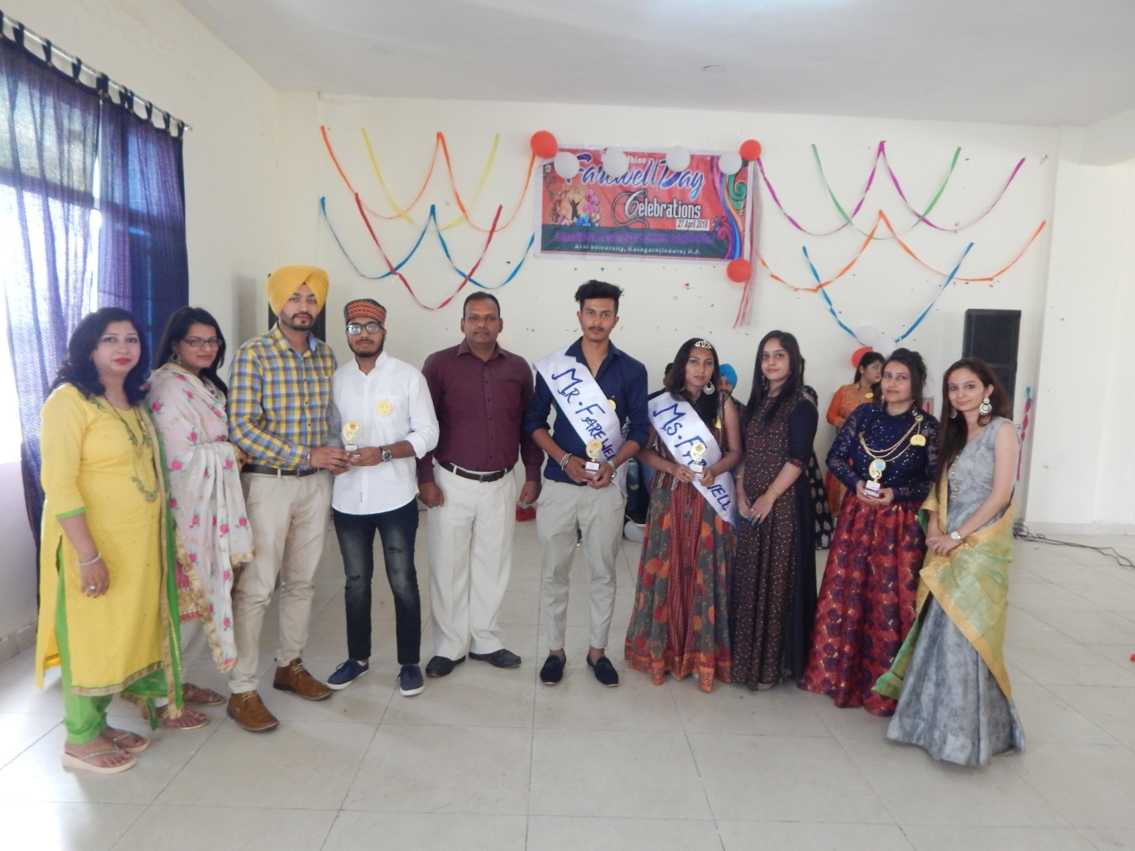

Farewell Party

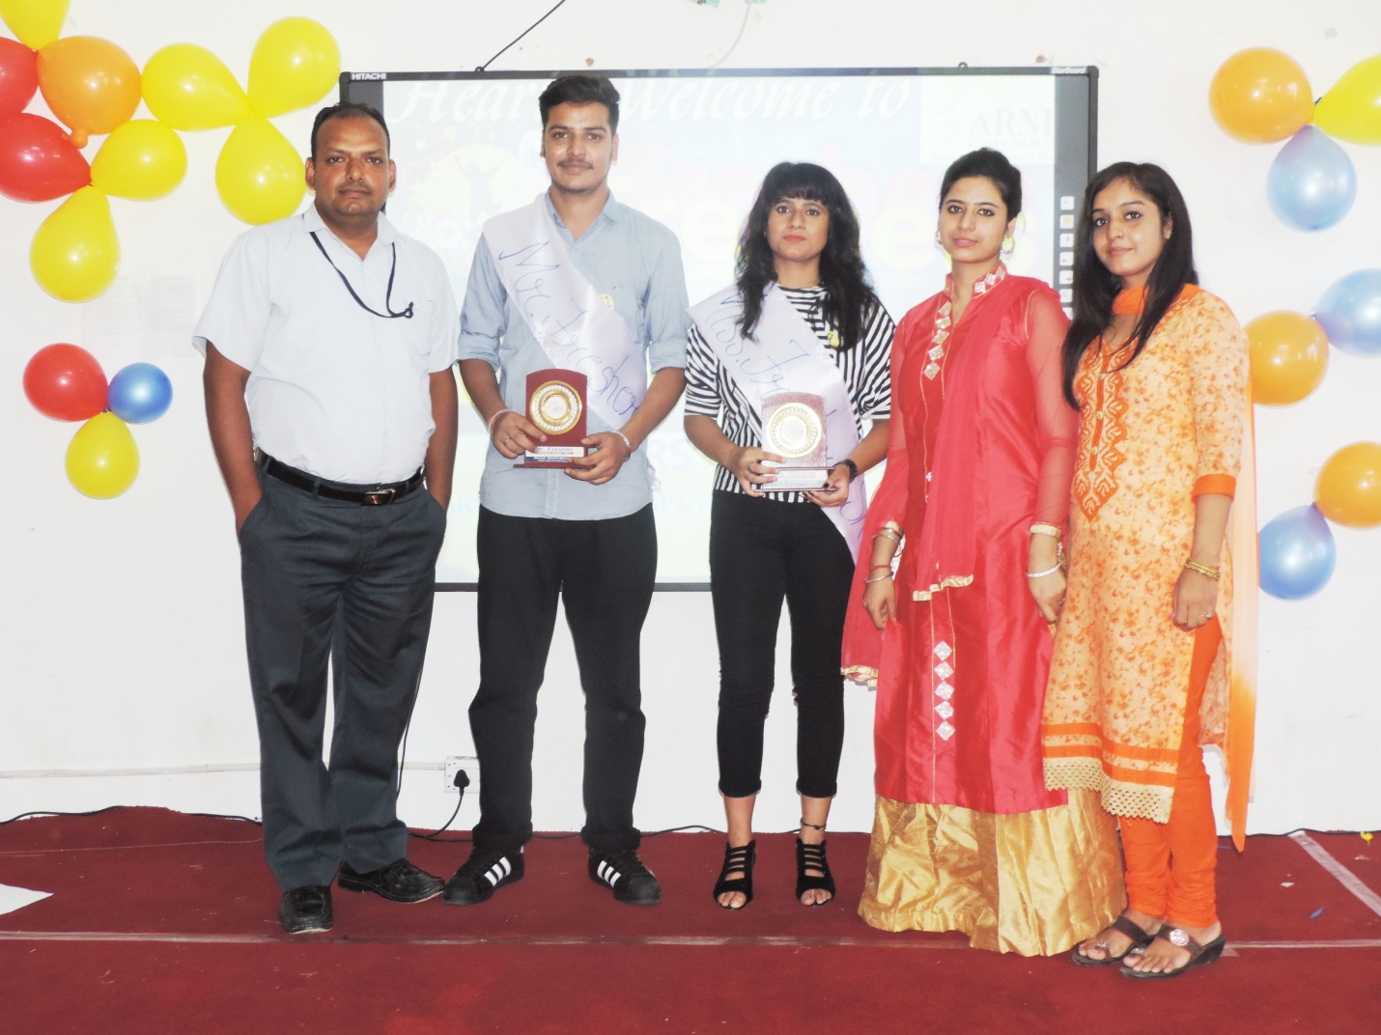

Fresher CSA

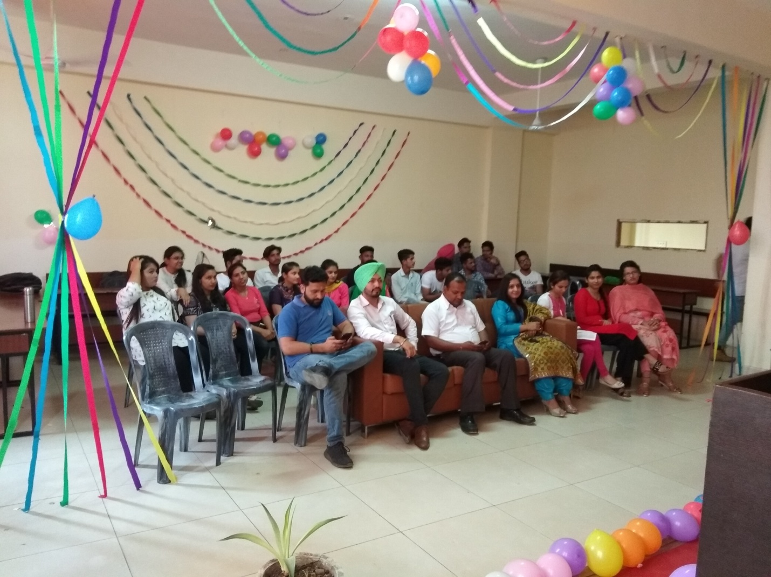

Teacher’s Day Celebration

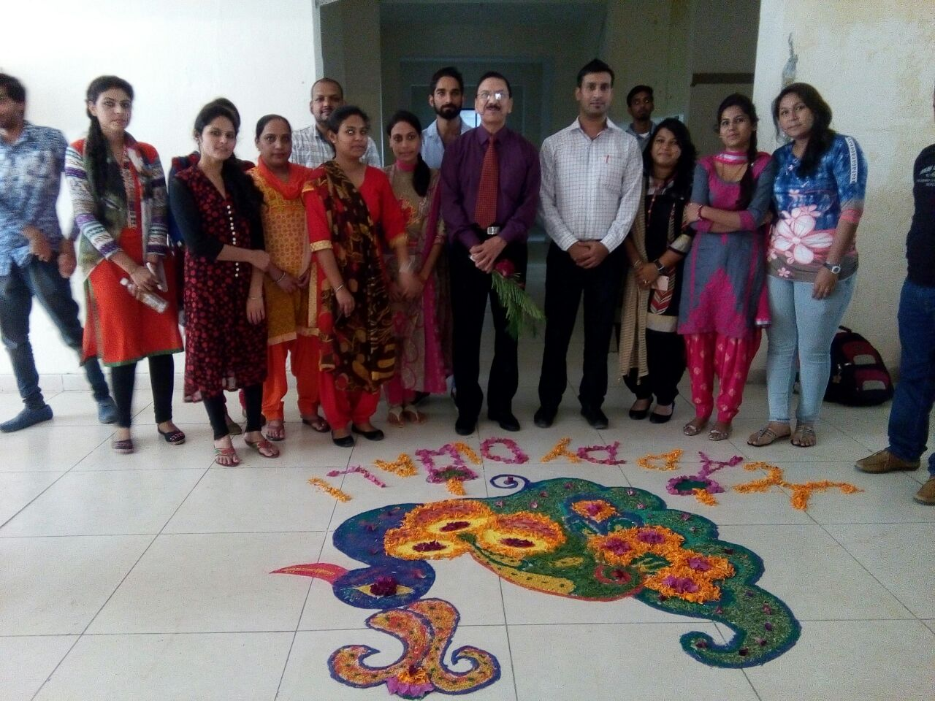

Rangoli Celebration

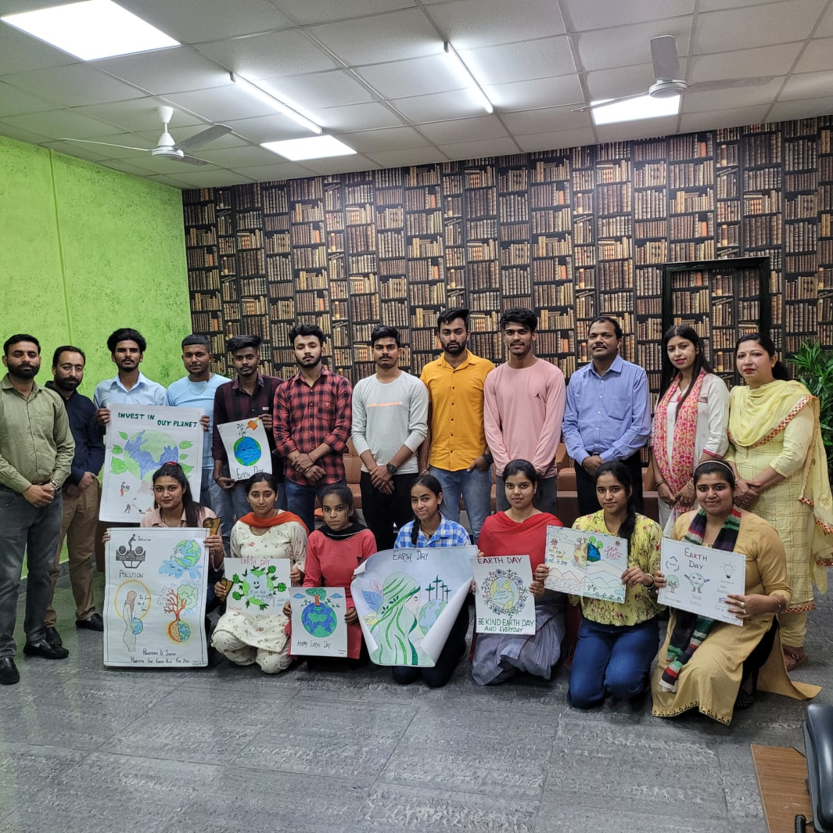

Drawing Competition

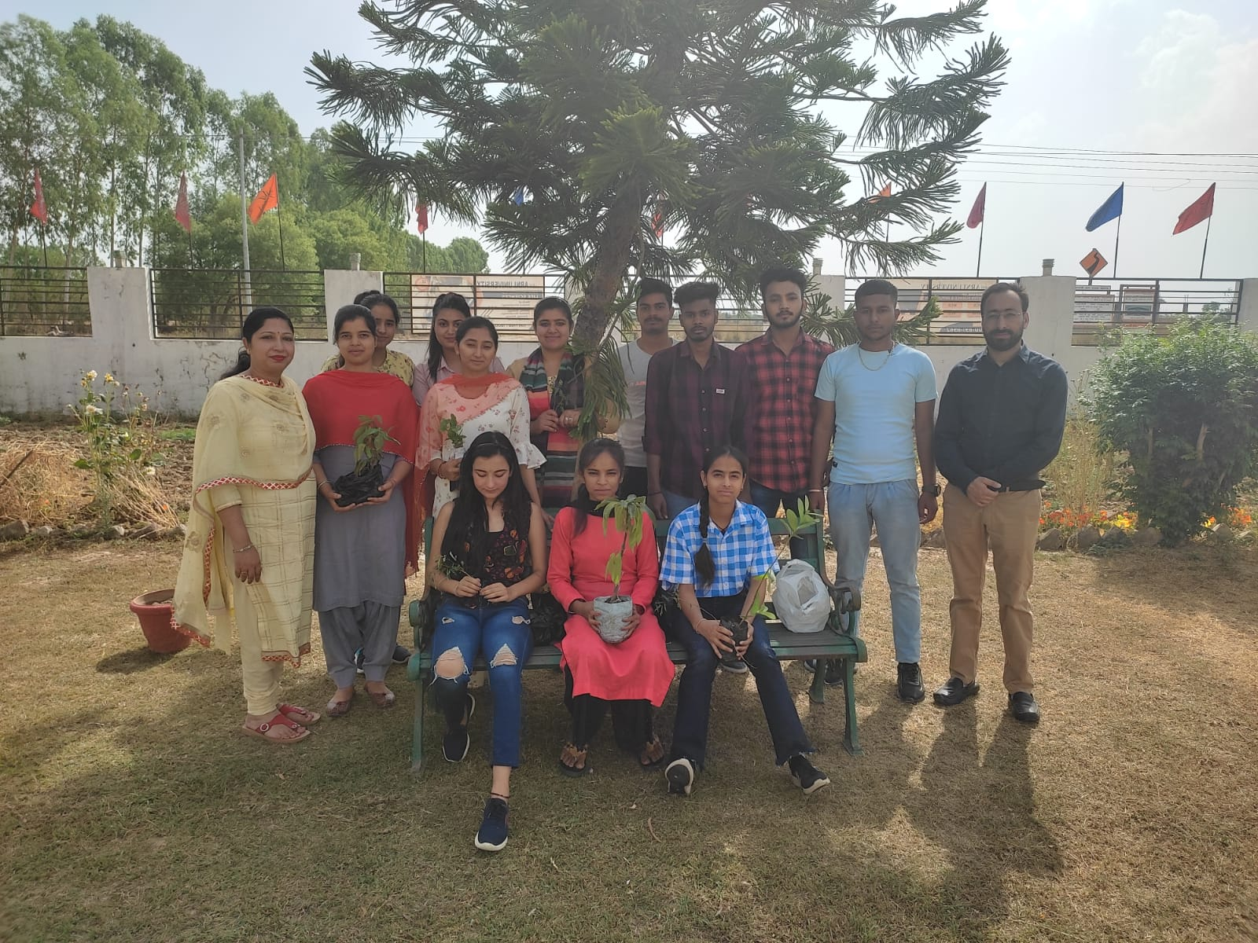

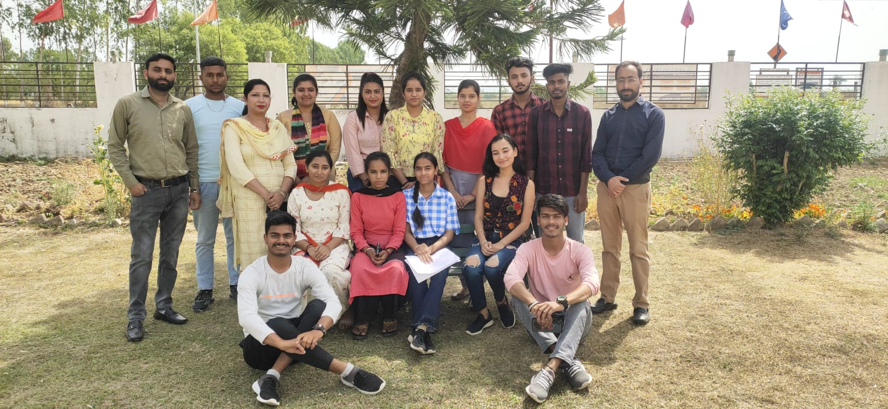

Earth Day Celebration