OPEN BELLOW URL

step 1. https://dashboard.ngrok.com/get-started/setup

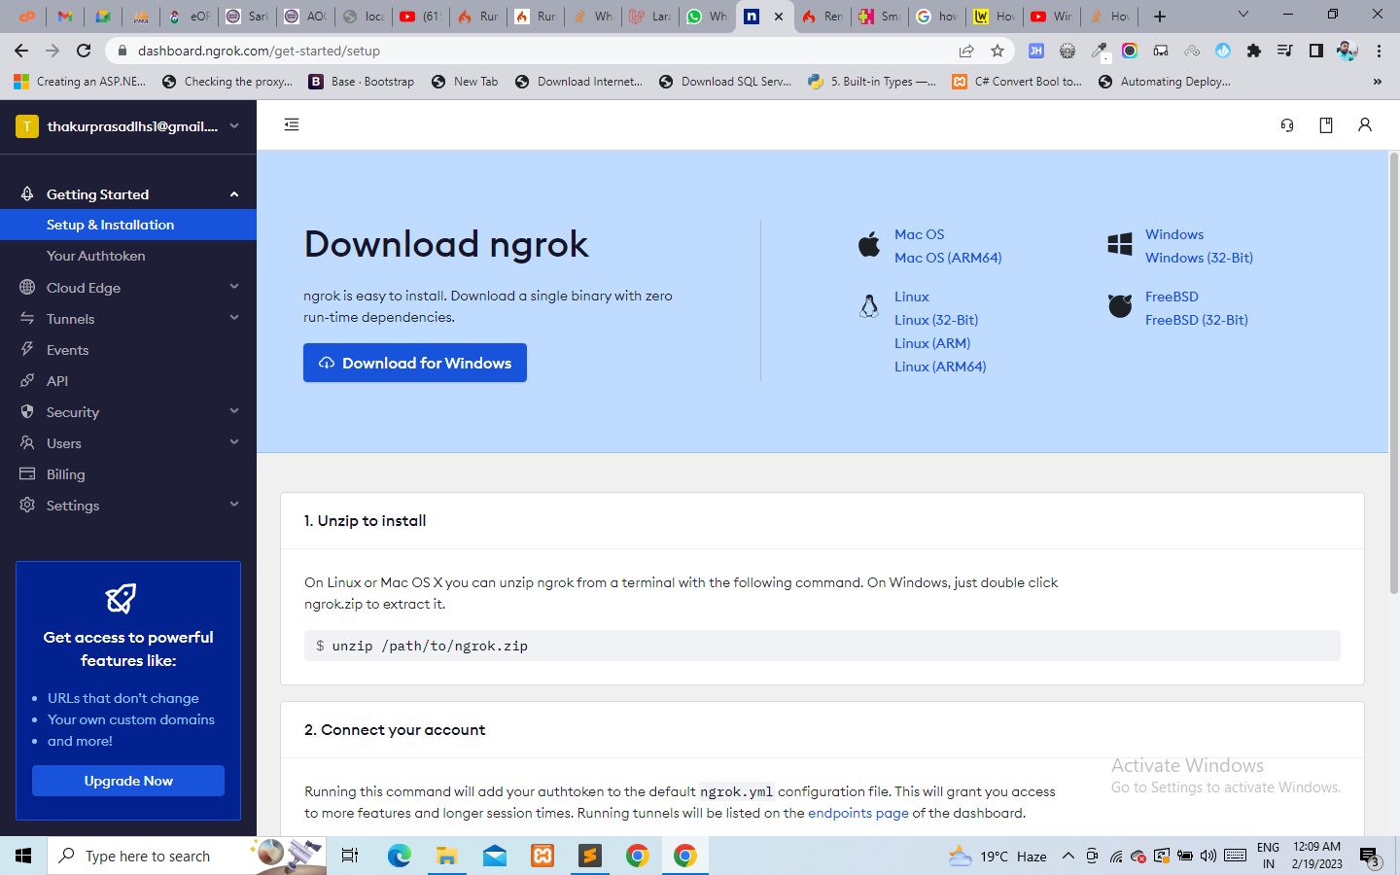

Step2. Connect your account

And copy authtoken form your connected account.

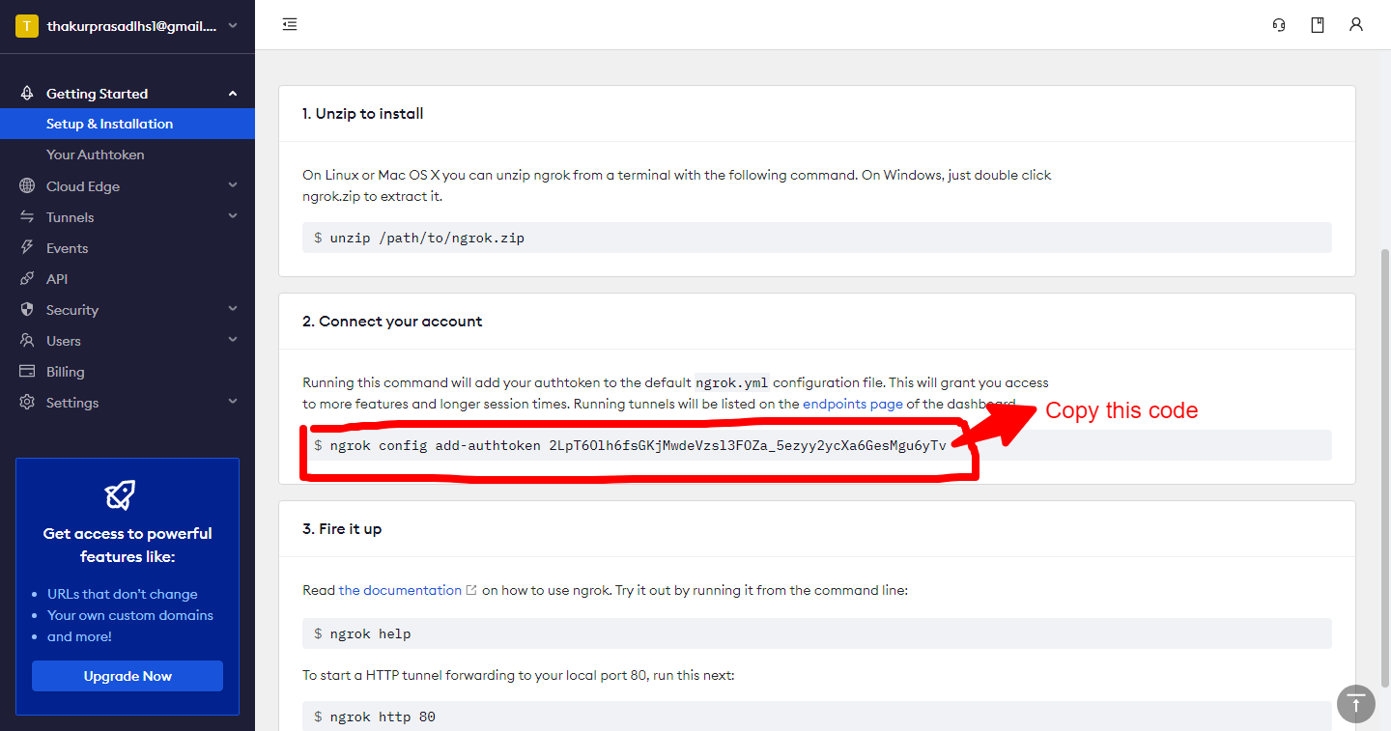

Step3. Open cmd line

Window + R

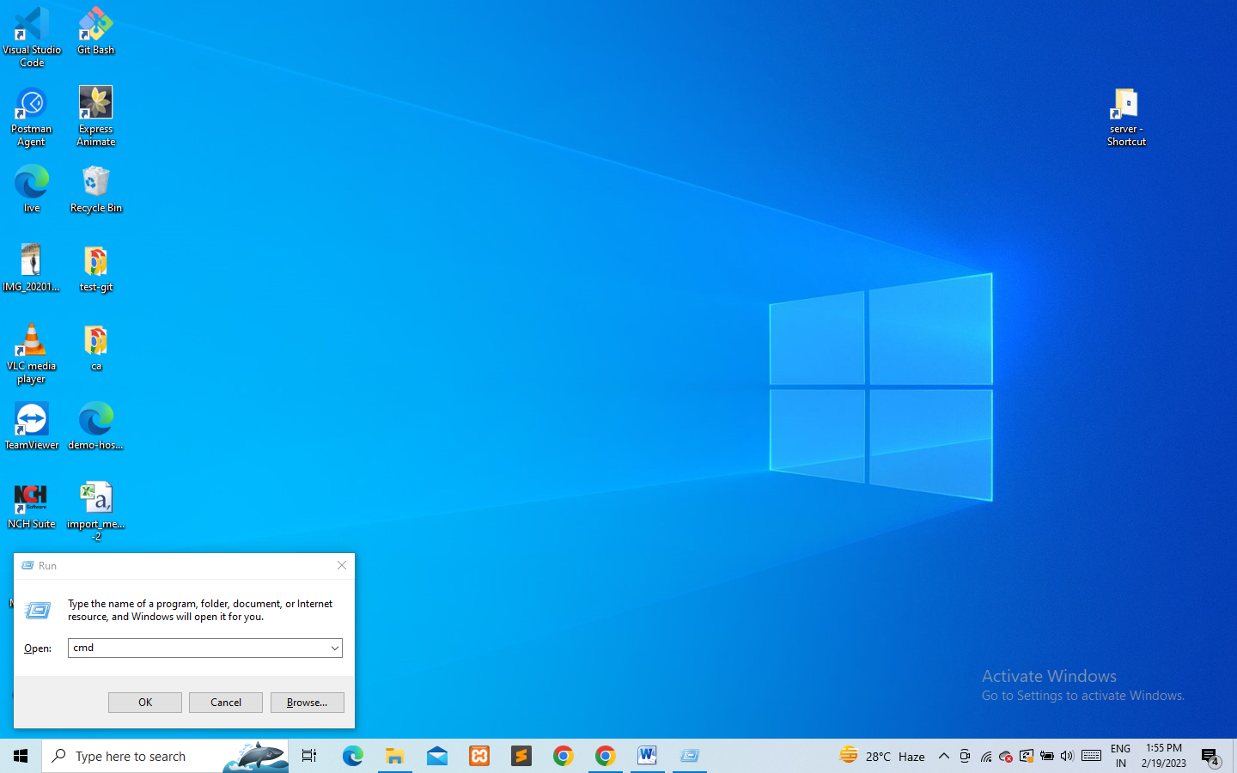

And type **cmd** then click ok button