**A .Bookmarking Table**

We have discuss some points related to "[AMY-46](http://jira.hibbertnet.com/browse/AMY-46)" and "Dashboard design" as below as:

|  |
| --- |
| [AMY-46](http://jira.hibbertnet.com/browse/AMY-46) : **Integration of Java API Functions/Hooks for Tracking/Bookmarking** |

As per given " **moduleplayer.js**" file ,we are getting the json for case study below as:

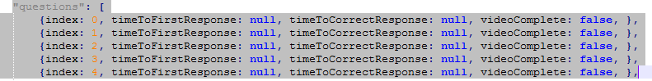

For this below the point :

Add tracking within the modules to track individual and overall times a video was played within a module"**JavaScript API Function: VIDEOSTATS (var string)"**

1.We have received json with this variable value **as boolean ,**so we are not track toindividual and overall times a video was played within a module.

2.If some user leave the page in module so we are not able to " so we are not track toindividual and overall times a video was played within a module and also not able to capture for this point:

"**Add tracking within the modules to time how long a user spends on each page/slide** "

**Dashboard design**

**1.Under Reader Training Tab**

i) We are able to get count for "**Total Core Training Completion Count".**

ii**)** Can you please provide for work flow for ORT core. Can you please how they work on our site? So that we are able to cover this point "**Training are able to get count for " ORT Core Training Completion Counts".**

**iii)** Can you please provide for work flow for LTR core. Can you please how they work on our site? So that we are able to cover this point "**Training are able to get count for " LTR Core Training Completion Counts".**

**2) Module Accuracy Tab**

**3) Module Tracking Tab:**

**B.DASHBOARD TABLE**

|  |  |
| --- | --- |
|  | User name: k1@yopmail.com |
|  | User id: 171203  select * from SS_PERSON where email_address like '%k1@yopmail.com%';  1.**module first time hit**:  a. select * from SS_MODULE where PERSON_ID=171203;  **select person_id,module,to_char(STARTED,'DD-MON-RR HH12:MI:SS AM') from SS_MODULE where person_id=171203;**  2."**module-1 of page first tm hit"**  select * from ss_module_page where PERSON_ID=171203;  select person_id,module_no,page_id,to_char(created_on,'DD-MON-RR HH12:MI:SS AM') ,to_char(updated_on,'DD-MON-RR HH12:MI:SS AM')from ss_module_page where person_id=171203; |

**i."First time same page hit Module-1 Slide1/Page1"**

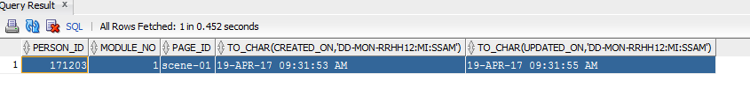

**ii."Second time same page hit Module-1 Slide Page1"**

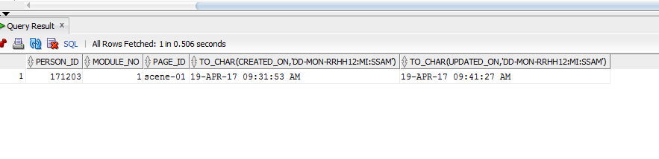

**2 ."Module-3 hit first tm"**

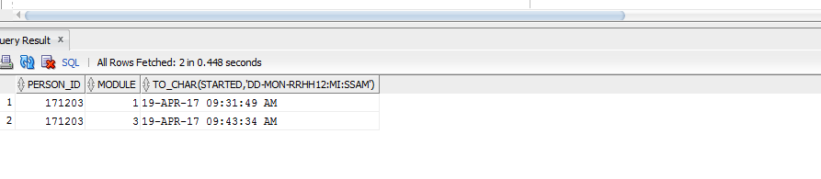

**3."Module-3 slide1/page1 first tm hit"**

select person_id,module_no,page_id,to_char(created_on,'DD-MON-RR HH12:MI:SS AM') ,to_char(updated_on,'DD-MON-RR HH12:MI:SS AM')from ss_module_page where person_id=171203;

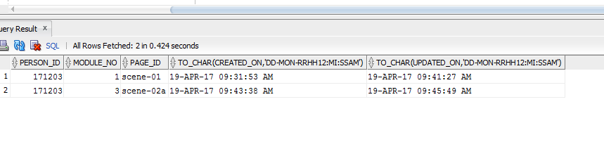

**ii)" Module-3 slide1/page1 second tm hit slide "**

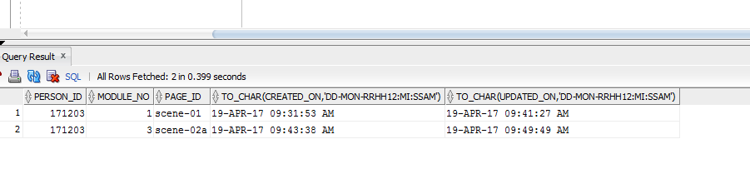

**4. Case-Study:Hit module3 first Time**

SELECT * FROM SS_USER_CASE_INFO where PERSON_ID=171203;

select person_id,module_no,to_char(created_on,'DD-MON-RR HH12:MI:SS AM'),case_id,response,result ,latency from ss_user_case_info where person_id=171203;

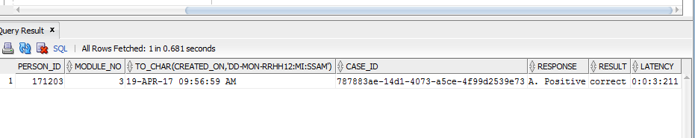

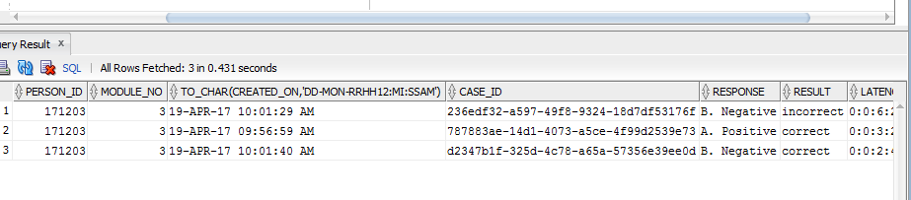

**5:SS_MODULE_IST_COUNT**

**Note: select * from SS_MODULE_ISI_COUNT Table of used**

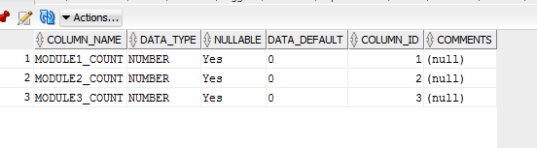

**Note: Can you please confirm this table of used?**

**C: Capture the SS_USER_CASE_INFO AT Time BookMarking at bookmark Insert Time**

**userCase:**

d2347b1f-325d-4c78-a65a-57356e39ee0d}}A. Positive}}incorrect}}0:0:22:467

**New Module Integration with case Study :**

sending String in modules:(chapterIndex+slideIndex+QuestionIndex)