**TABLE OF CONTENTS**

Page #

1.0 Project Set Up 1

1.1 SVN & Jenkin Url 1

1.2 Credential Testing/Production Server 1

1.3 Database Credential 1

2.0 Gift Reward Status Page 2

2.1 Login IntelPrize Management Screen 2

2.2 Gift Reward Screen 2

3.0 Intel Prize Management SetUp On Local Machine 3

3.1 Step For Set Up 3

3.2 Gift Reward Belongs Tables 4

1. **Project Information**

**1.1 SVN And Jenkin URL ( OLD** PCR- 170307101950 **)**

**SVN -**

**svn://hgsun72/repository/projects/IntelPrizeManagement/branches/PCR_170307101950_Intel_IREP_Website_SSO_Integration**

**Jenkin**

**http://tcc-tcdev01:10005/job/IntelPrizeManagement_10106/configure**

**1.2 Credential Testing/Production Server**

Testing -

<https://retailedgerewards.qa.emarketingtool.com/> [bfell@hibbertgroup.com](mailto:bfell@hibbertgroup.com)/Asbury1955

Production -

<https://retailedgerewards.com/> [John.Russojr@bestbuy.com](mailto:John.Russojr@bestbuy.com) /Ruso7923##

[shawn.dodman@memoryexpress.com](mailto:shawn.dodman@memoryexpress.com) / Exodus11!

[bfell@hibbertgroup.com](mailto:bfell@hibbertgroup.com) / Asbury2017!

**1.3 Database Credential**

**REPTU and REPP**

: rthakur_ipw/hgrt17s in

1. **Gift Reward Status Page**

**2.1 Login IntelPrize Management Screen**

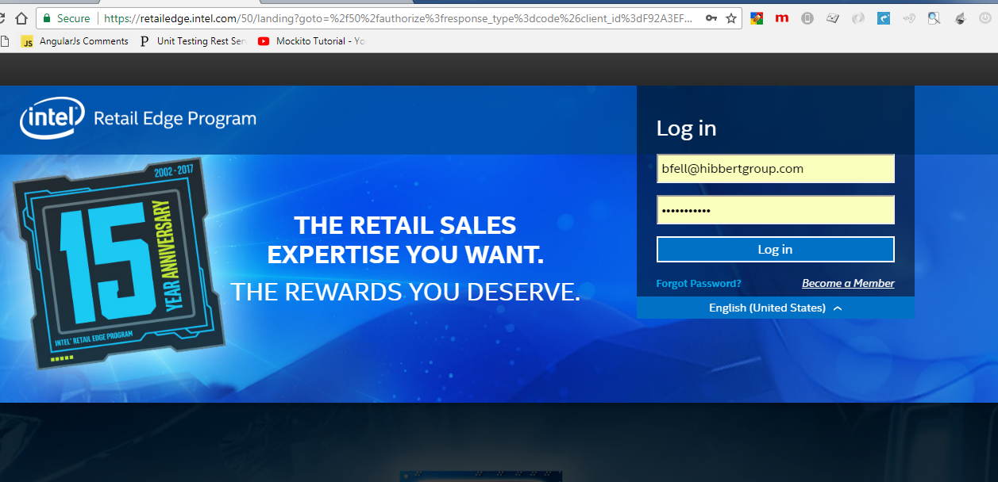

**2.2 After login Hit Below Url**

<https://retailedgerewards.com/>

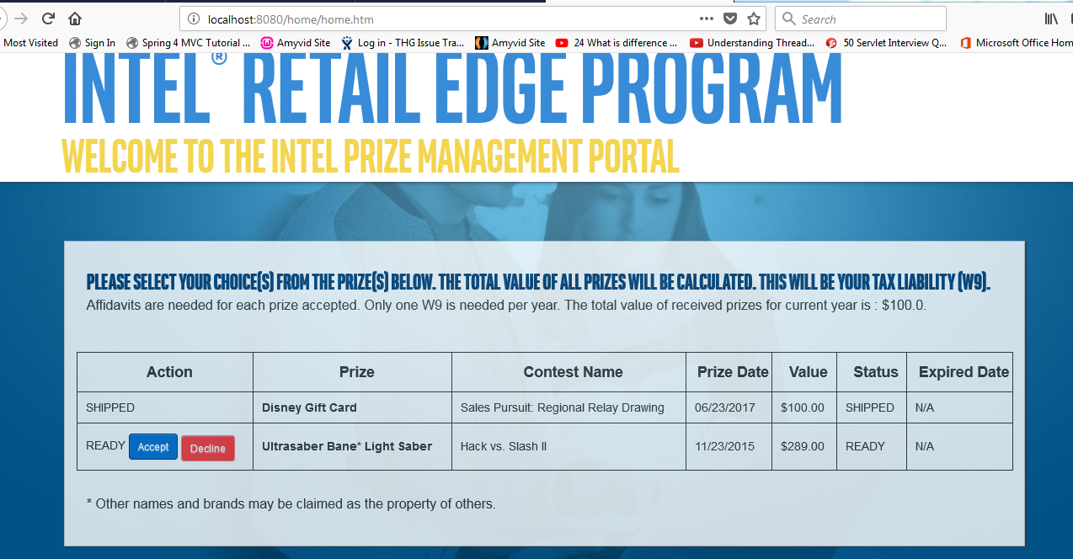

1. **Intel Prize Management Set Up On Local Machin**

**3.1 Step For Step Up Below As**

Step a. First run SQL Query For change Status : update HGAPPIPW.THGIPW_IREP_PRIZE_POOL set AWARDED_IND='ready' where item_number='333313-001-111';

COMMIT;

Step b. Need To Modifies below Files of JSP and Java.

* src/com/thg/intel/web/controller/HomeController.java
* src/com/thg/intel/web/controller/PrizeController.java
* WebContent/WEB-INF/jsp/site/acceptConfirmation.jsp
* WebContent/WEB-INF/jsp/site/acceptConfirmUsa.jsp
* WebContent/WEB-INF/jsp/site/address.jsp
* WebContent/WEB-INF/jsp/site/home.jsp
* WebContent/WEB-INF/jsp/site/taxForm.jsp

Example As: **Java Page Changes**

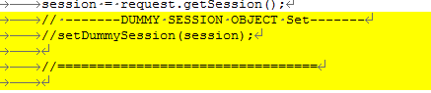

Example As: **JSP Page Changes**





**3.2 Gift Reward Belongs Tables**

* *THGIPW_IREP_PRIZE_POOL*
* *THGIPW_IREP_PRIZES*
* *THGIPW_AFFIDAVIT*

*select * from thgipw_irep_prize_pool;*

*select * from HGAPPIPW.thgipw_irep_prizes*

**Note :**

* *THGIPW_IREP_PRIZE_POOL Tb contains the Status Of Prize*
* *PRIZE_SQUENCE is Used Now Uniqueness (NEW PP-* [171212151543](http://itms.hibbertnet.com/pcr.action?pcrReq=171212151543) *)*

Hibernate:

*SELECT this_.ITEM_NUMBER AS ITEM1_2_0_, this_.CONTEST_NAME AS CONTEST2_2_0_,*

*this_.PRIZE_DESCRIPTION AS PRIZE3_2_0_, this_.PRIZE_DATE AS PRIZE4_2_0_,*

*this_.RSP_EXPIRE_DATE AS RSP5_2_0_, this_.PRIZE_NAME AS PRIZE6_2_0_,*

*this_.RSP_ID AS RSP7_2_0_, this_.TIME_SENSITIVE_PRIZE AS TIME8_2_0_,this_.PRIZE_VALUE AS PRIZE9_2_0_ FROM thgipw_irep_prizes this_ WHERE this_.RSP_ID =? AND this_.PRIZE_VALUE IS NOT NULL ORDER BY this_.PRIZE_DATE DESC*

Hibernate:

*SELECT this_.RSP_ID AS RSP1_1_0_, this_.ITEM_NUMBER AS ITEM2_1_0_, this_.LAST_UPDATE AS LAST3_1_0_, this_.RSP_EXPIRE_DATE AS RSP4_1_0_, this_.RSP_RANK AS RSP5_1_0_, this_.AWARDED_IND AS AWARDED6_1_0_ FROM thgipw_irep_prize_pool this_ WHERE this_.RSP_ID =? AND lower(this_.ITEM_NUMBER)=?*

**3.3 Gift Reward Confirmation Screen**

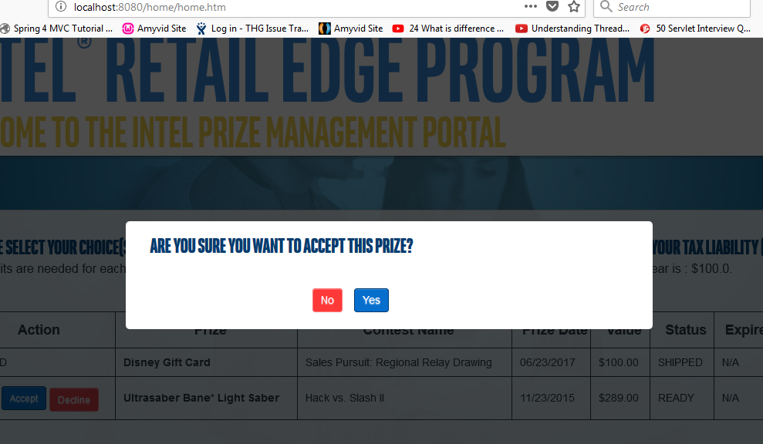

**3.3 Affidative Screen**

?

**3.4 Address Screen**

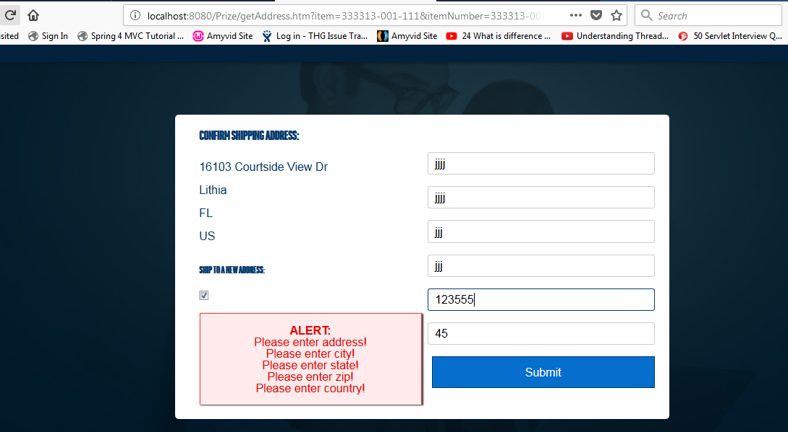

* Address Request URL - @RequestMapping(value = "/Prize/address.htm", method = RequestMethod.POST)
* Table Comes In Picture ‘THGIPW_ADDRESS ’

Eg : select * from THGIPW_ADDRESS where RSP_ID='354391';

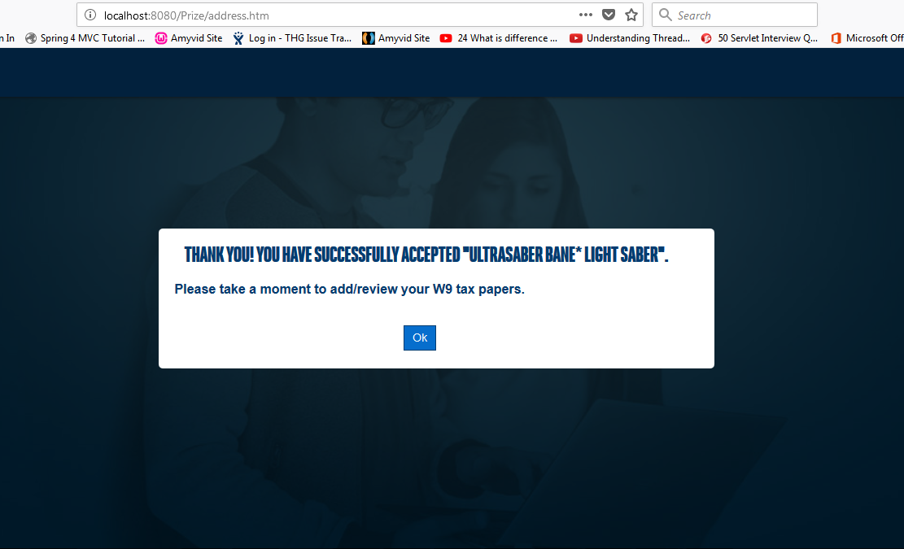

THGIPW_IREP_W9

URL- @RequestMapping(value = "/Prize/w9Workflow.htm", method = RequestMethod.GET)

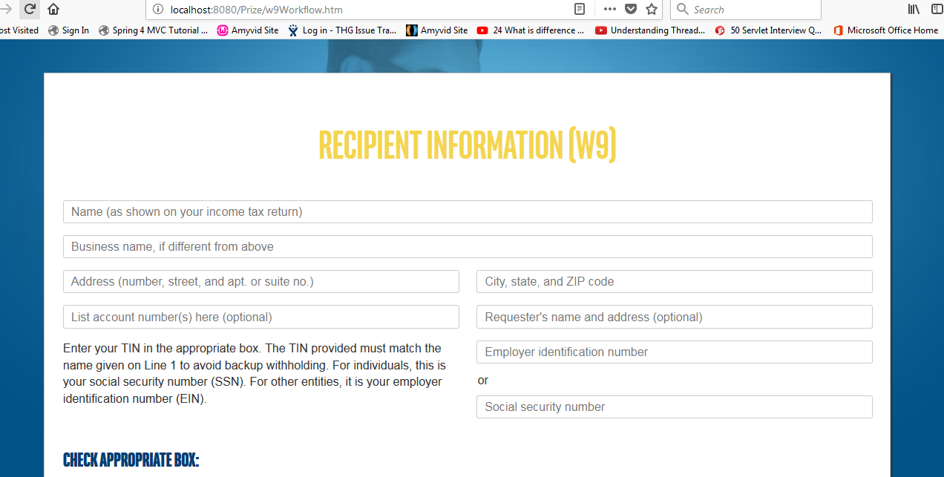

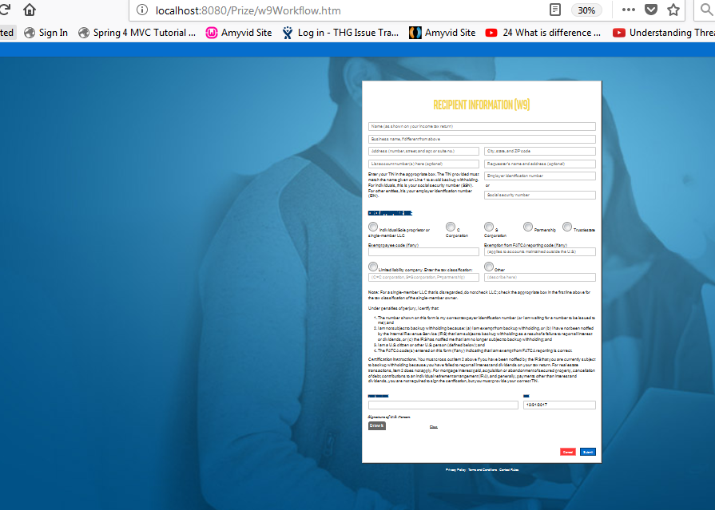

@RequestMapping(value = "/Prize/w9WorkflowSubmit.htm", method = RequestMethod.POST)

Table info- THGIPW_IREP_W9