Admin - Search Flow
- We have input two parameters in admin search form below as
- email-address : dKark
- state : Georgia
- Search Query –
- SELECT sp.PERSON_ID FROM HGAPPLIL.SS_PERSON sp WHERE (UPPER (sp.EMAIL_ADDRESS ) like UPPER ('dKark%' ) ) UNION SELECT sa.PERSON_ID FROM HGAPPLIL.SS_ADDRESS sa WHERE (UPPER (sa.STATE_CODE ) like UPPER ('GA%' ) );
- LRT USER Query –
- SELECT P.PERSON_ID,P.FIRST,P.LAST,P.EMAIL_ADDRESS FROM HGAPPLIL.SS_PERSON P WHERE P.PERSON_ID IN (SELECT LR.PERSON_ID FROM HGAPPLIL.SS_LRT_USER LR WHERE LR.COMPLTION_FLAG='Y' AND LR.PERSON_ID IN(SELECT sp.PERSON_ID FROM HGAPPLIL.SS_PERSON sp WHERE (UPPER (sp.EMAIL_ADDRESS ) like UPPER ('dKark%' ) ) UNION SELECT sa.PERSON_ID FROM HGAPPLIL.SS_ADDRESS sa WHERE (UPPER (sa.STATE_CODE ) like UPPER ('GA%' ) )));
- NON - LRT USER Query
- SELECT count(M.COMPLETED) as MODULE_COUNT,P.PERSON_ID,P.FIRST,P.LAST,P.EMAIL_ADDRESS FROM HGAPPLIL.SS_PERSON P, HGAPPLIL.SS_MODULE M WHERE P.PERSON_ID=M.PERSON_ID and M.PERSON_ID IN(SELECT sp.PERSON_ID FROM HGAPPLIL.SS_PERSON sp WHERE (UPPER (sp.EMAIL_ADDRESS ) like UPPER ('dKark%' ) ) UNION SELECT sa.PERSON_ID FROM HGAPPLIL.SS_ADDRESS sa WHERE (UPPER (sa.STATE_CODE ) like UPPER ('GA%' ) )) and COMPLETED IS NOT NULL AND M.MODULE!=5 GROUP BY P.PERSON_ID, P.FIRST,P.LAST,P.EMAIL_ADDRESS;
- LRT USER+ ORT USER;
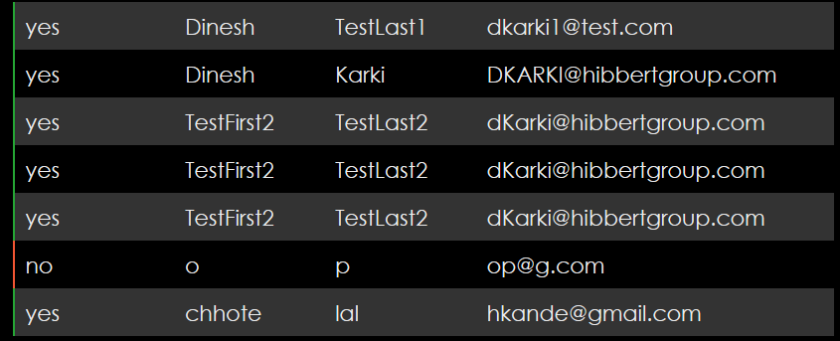

1) SELECT sp.PERSON_ID FROM HGAPPLIL.SS_PERSON sp WHERE (UPPER (sp.EMAIL_ADDRESS ) like UPPER ('Frank%' ) ) ; -- Return All Records.
2) LRT USER FIND -

(SELECT LR.PERSON_ID FROM HGAPPLIL.SS_LRT_USER LR WHERE LR.COMPLTION_FLAG='Y' AND LR.PERSON_ID IN(SELECT sp.PERSON_ID FROM HGAPPLIL.SS_PERSON sp WHERE (UPPER (sp.EMAIL_ADDRESS ) like UPPER ('Frank%' ) ))); ---0 records

LRT-"N" AND ORT USER TO FIND

2)SELECT tab1.PERSON_ID FROM (SELECT sp.PERSON_ID FROM HGAPPLIL.SS_PERSON sp WHERE (UPPER (sp.EMAIL_ADDRESS ) like UPPER ('Frank%' ) )) tab1
minus
(SELECT LR.PERSON_ID FROM HGAPPLIL.SS_LRT_USER LR WHERE LR.COMPLTION_FLAG='Y' AND LR.PERSON_ID
IN(SELECT sp.PERSON_ID FROM HGAPPLIL.SS_PERSON sp WHERE (UPPER (sp.EMAIL_ADDRESS ) like UPPER ('Frank%' ) ))) ; ---14 records.

3)STATUS LRT 'N' AND ORT USER OF NO. MODULE COMPLETE STATUS

SELECT perTab.PERSON_ID,count(M.MODULE) FROM (SELECT tab1.PERSON_ID FROM (SELECT sp.PERSON_ID FROM HGAPPLIL.SS_PERSON sp WHERE (UPPER (sp.EMAIL_ADDRESS ) like UPPER ('Frank%' ) )) tab1
minus
(SELECT LR.PERSON_ID FROM HGAPPLIL.SS_LRT_USER LR WHERE LR.COMPLTION_FLAG='Y' AND LR.PERSON_ID
IN(SELECT sp.PERSON_ID FROM HGAPPLIL.SS_PERSON sp WHERE (UPPER (sp.EMAIL_ADDRESS ) like UPPER ('Frank%' ) )))) perTab LEFT JOIN HGAPPLIL.SS_MODULE M ON perTab.PERSON_ID = M.PERSON_ID and M.MODULE!=5 group by perTab.PERSON_ID;

