FUNCTIONAL REQUIREMENTS DOCUMENT

TABLE OF CONTENTS

Page #

1.0 LILLY ICONNECT-2 LOGIN INFORMATION 1
1.1 Login & Role Page 1
1.2 Order Plced DashBoard 1
2.0 R5 IMPLEMENTATION FOR ORDER 2
2.1 ORDER FLOW OF LILLY AM (ORDER 2U SITE) 2
2.1 Order Placed In Order 2 Site 3
2.2 ORDER FLOW OF LILLY ICONNECT-2 4
2.2.1 Order Placed In IConnect-2 (HCP ) 4
2.2.2 Formulary Direct Mail Only 5
2.2.3 Difference Between Formulary Direct Mail Only / Email Only 6
2.2.4 Inventory Direct Mail Only 6
2.2.5 Difference Between Inventory Direct Mail Only / Email Only 6
3.0 HAM-5905 Lilly iConnect 2 - Order Review Ticket 5
3.1 Ordered Items Section 5

3.1.1 Unit Pack/Unit of Measure will display 5
3.1.2 Recipients Section 6
4.0 HAM-5906 Lilly iConnect 2 - Order Detail Ticket 6
5.1 TestXXX 6
5.2 TestXXX 7
5.3 TestXXX 7
5.0 HCP TABLE STRCUTURE 7
5.1 HGAPPLIL AND HGAPPLHP Schema 8
6.2 TestXXX 8
6.3 TestXXX 8
6.4 TestXXX 8
7.0 TESTXXXX 8

1.0 LILLY ICONNECT-2 LOGIN INFORMATION

Jenkin Url - http://tcc-tcdev01:10005/job/iConnect2-Thread/

1.1 Login & Role Page

Fig:1.1.a pwd:Hibbert1

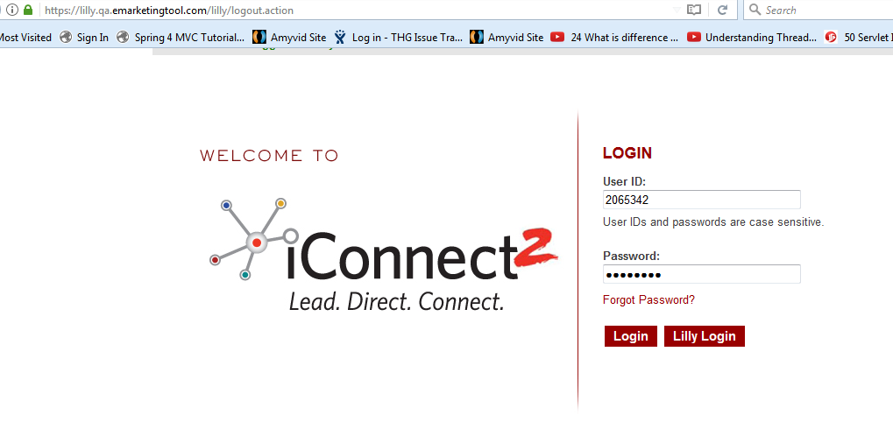

Fig:1.1.b

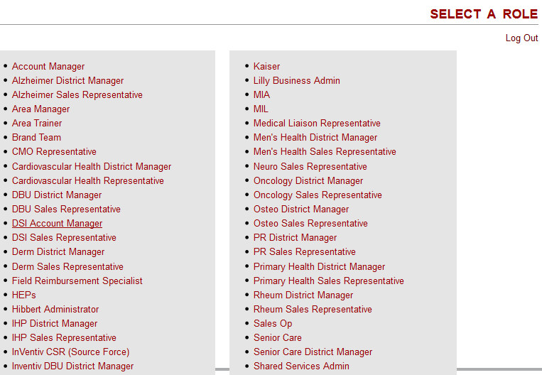

1.2 Order Plced DashBoard

Fig:1.2.a
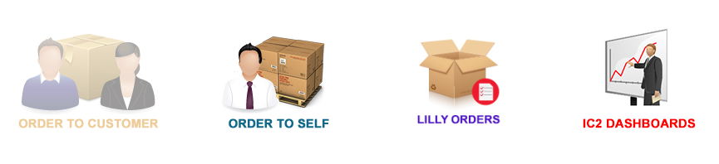

Fig:1.2

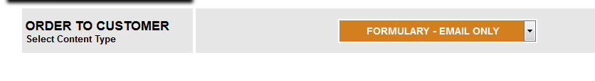

Question : default loading of customers on order to customer page after “Intervention” i.what are any filtering criteria customers display on that pages?

Question: HAM-5922 - Privileged users will have the option to ship to a customer ?
Description -

2.2 ORDER FLOW OF LILLY ICONNECT-2

2.2.1 Order Placed In IConnect-2 (HCP )

Fig- 2.0.a
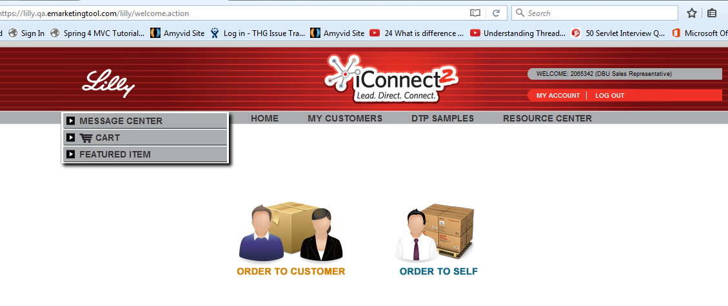

Fig:2.1.b

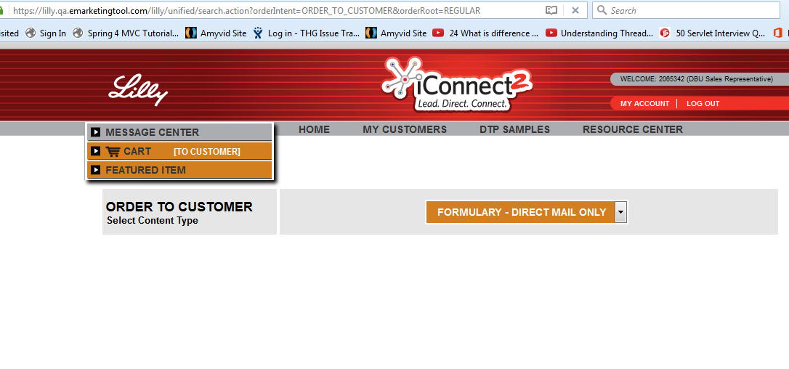

Fig:1.2.c

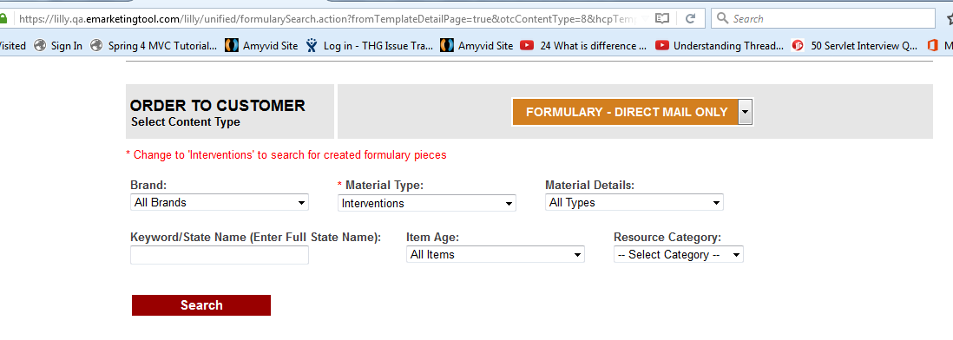

Fig:2.3.d

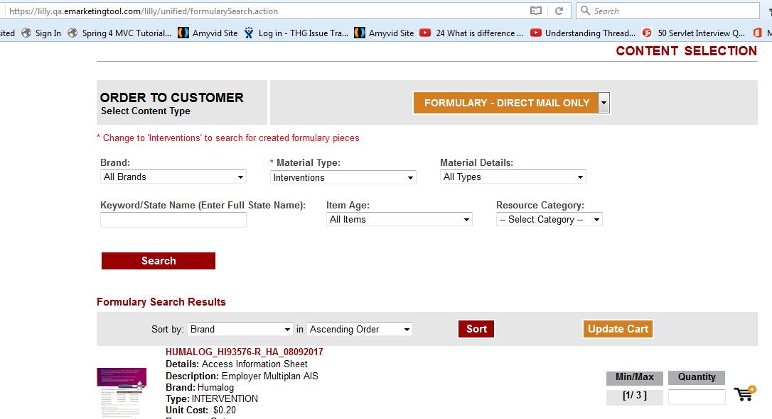

Fig:2.4.f

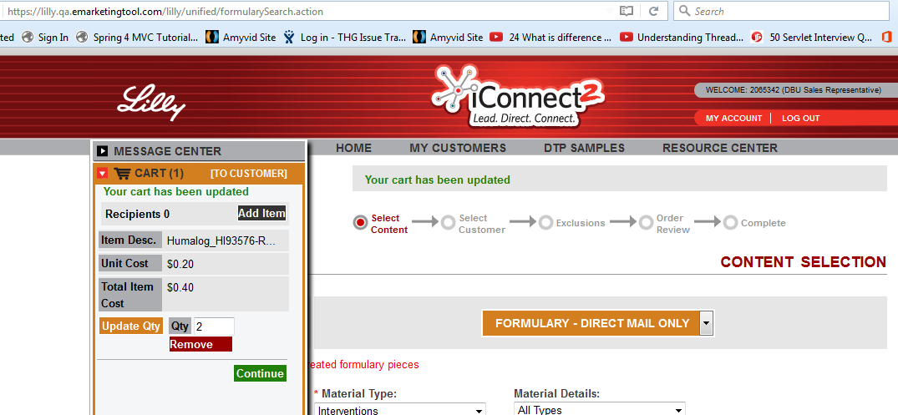

Fig:2.5.g

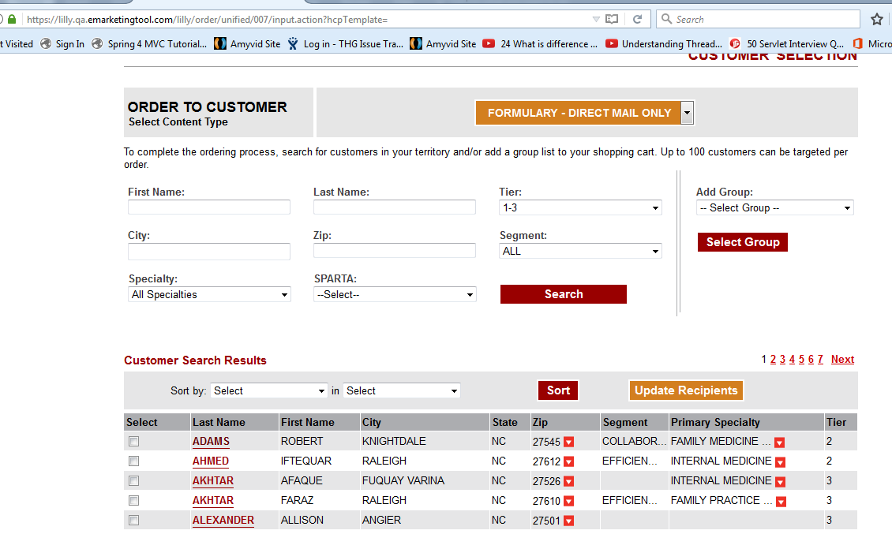

2.2.2 Formulary Direct Mail Only

Fig:2.2.a

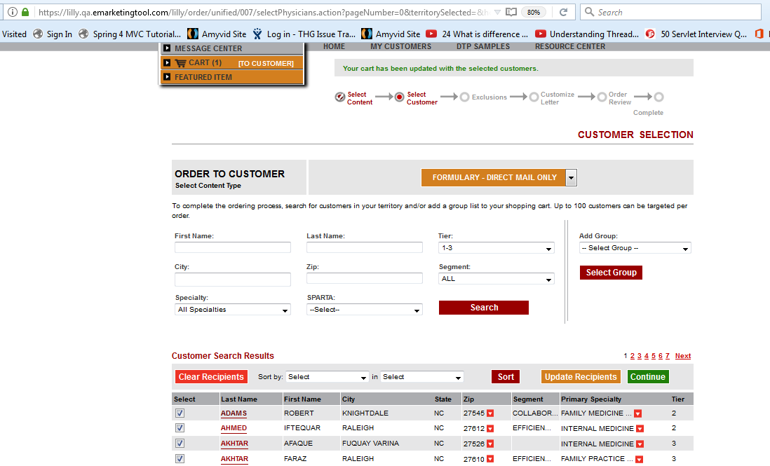

Fig:2.2.b

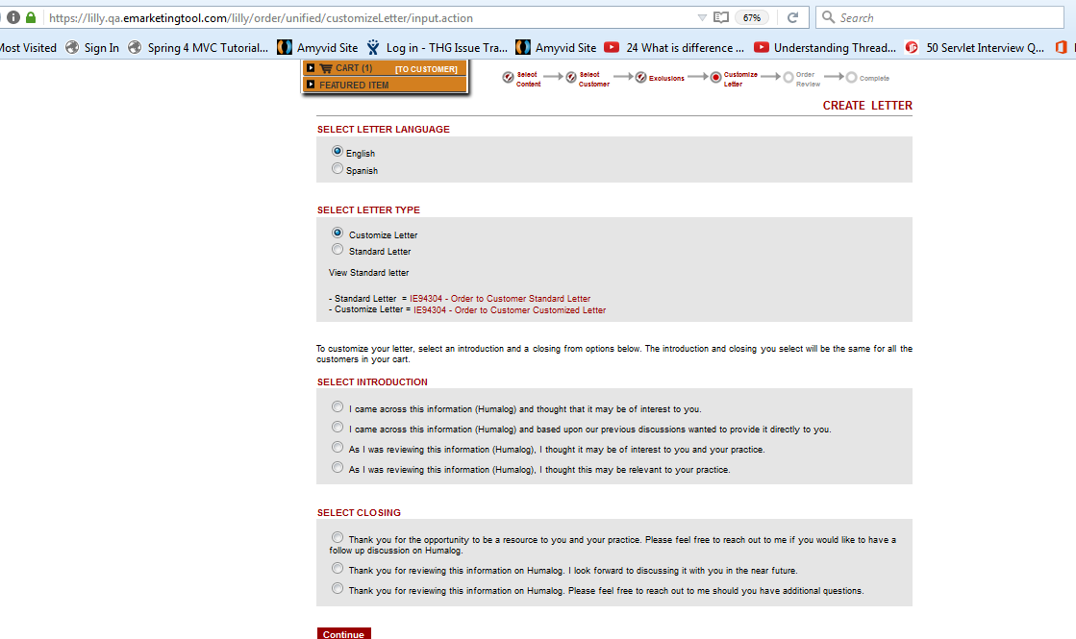

Fig:2.2.c

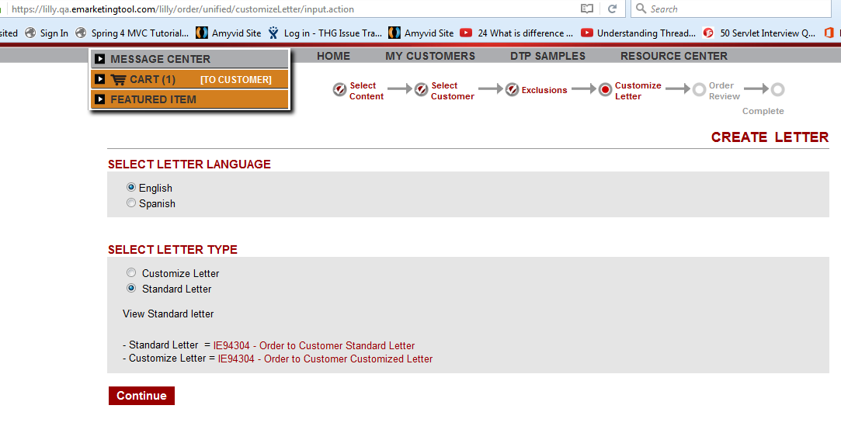

Fig:2.2.d

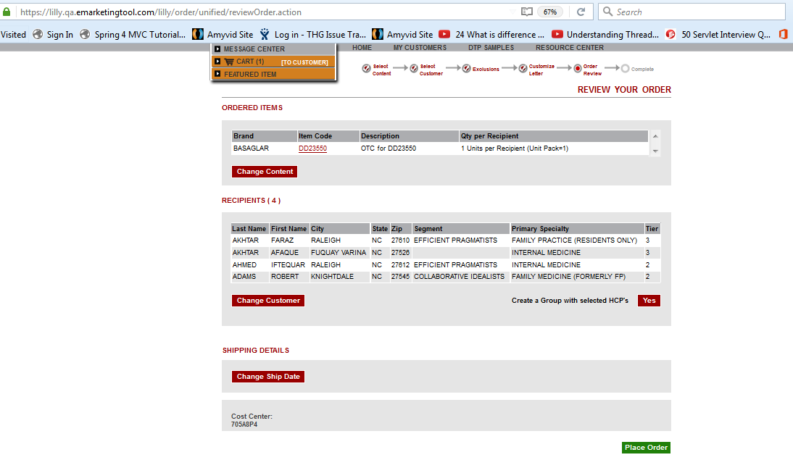

Fig:2.2.e

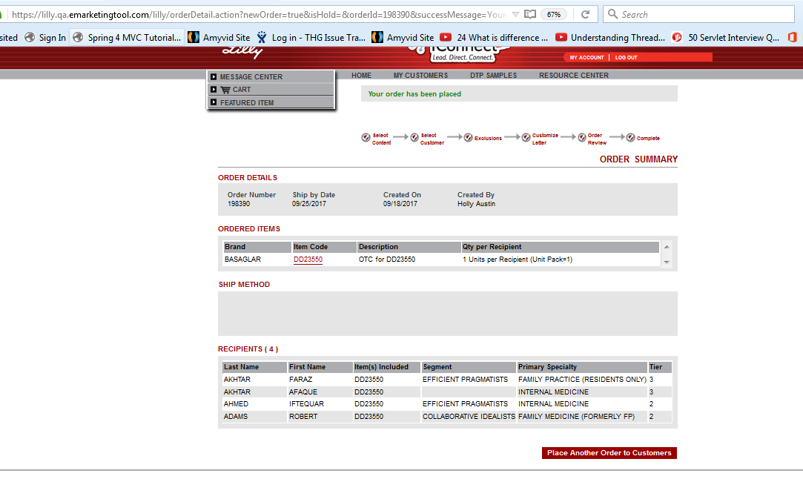

2.2.3 Difference Between Formulary Direct Mail Only / Email Only

Fig:2.3.a

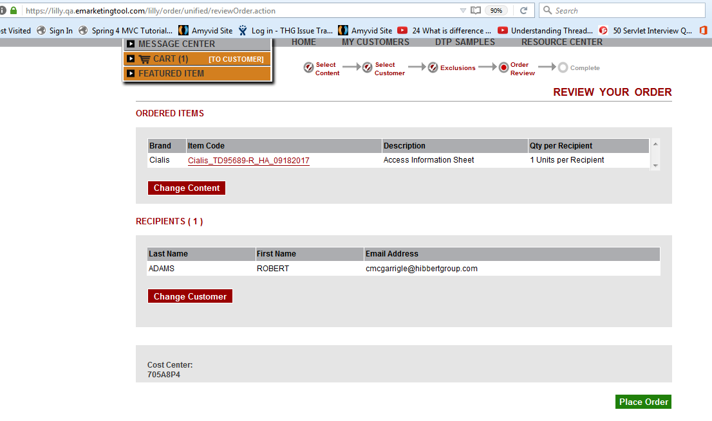

Note: Custimized option show on that product which are custiomed product if it not that time it show above screen..

2.2.4 Inventory Direct Mail Only

Fig:2.4.a

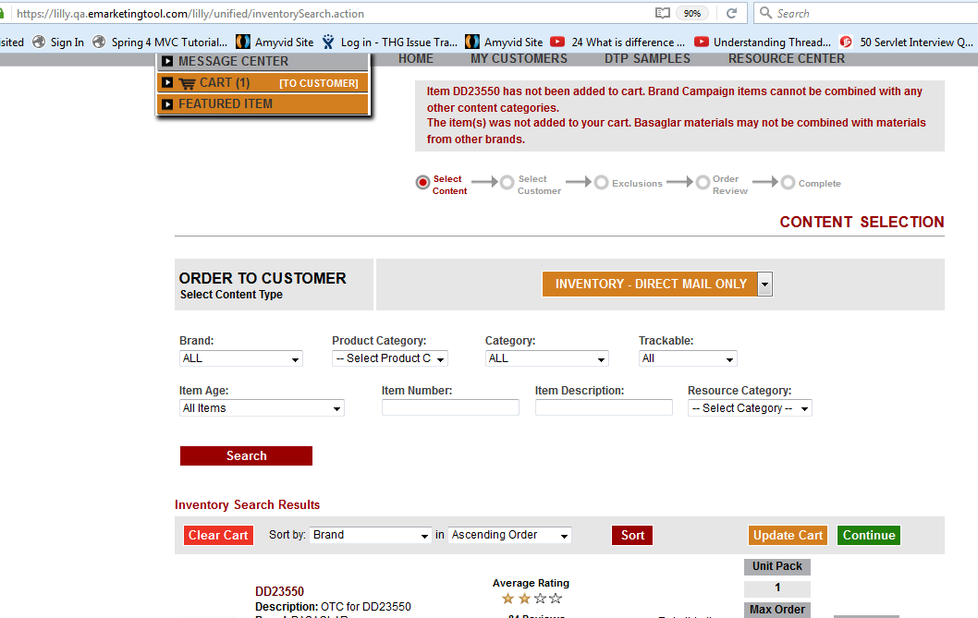

2.2.5 Difference Between Inventory Direct Mail Only / Email Only

Note: Custimized option show on that product which are custiomed product if it not that time....

2.2.6 HCP Level Resources

2.2.7 Data-Base

1) select * from LHP_APP ; -- APP_ID:57
2) select * from lhp_user where APP_ID=57 and username like '%DEV_USER%'; --Login User Info ALIGNMENT_NUMBER : NHR026152 & HIERARCHY_CODE:01 & USER_ID:26152
2.a) Single Role 2.b) Multiple Roles

2.a) Single Role:
Note : Find Privliege and Redirect on Directly Home

2.b) Multiple Role
Note : Find Privliege and Redirect on Role Page

select * from lhp_respcode where ALIGNMENT_NUMBER = 'NHR026152';-- RESPONSIBILITY_CODE:H02

select * from LHP_ROLE_RESPCODE where HIERARCHY_CODE='01' and RESPONSIBILITY_CODE='H02';-- Role_ID :count:46

select * from LHP_ROLE where role_id in(select Role_ID from LHP_ROLE_RESPCODE where HIERARCHY_CODE='01' and RESPONSIBILITY_CODE='H02') order by ROLE_DESCRIPTION;-- Role_ID :

3) Find Role correponding privilege:

3.a) Select PRIVILEGE_ID from LHP_ROLE_PRIVILEGE where role_id in(select ROLE_ID from LHP_ROLE where role_id in(select Role_ID from LHP_ROLE_RESPCODE where HIERARCHY_CODE='01' and RESPONSIBILITY_CODE='H02'))

3.b) SELECT * from LHP_PRIVILEGE where PRIVILEGE_ID in ( select PRIVILEGE_ID from LHP_ROLE_PRIVILEGE where role_id in(select ROLE_ID from LHP_ROLE where role_id in(select Role_ID from LHP_ROLE_RESPCODE where HIERARCHY_CODE='01' and RESPONSIBILITY_CODE='H02')));

Iconnect -Log _QA _Location - /disk1/www/staging/apps/iConnect2_10007/logs

2.1 Functional Requirements: HAM-5922 Lilly iConnect 2 - Ship to HCP Order Type

2.1.1 HCP Ref URL
https://qa.elilillyctsos.com/user/loginDisplay.action ( ClinicalTrialAM_10165)
Credential NewAdmin/Hibbert6

Order2u Web Application Url : https://oneconnect.qa.emarketingtool.com/user/home.action
• 1st Internal URL- http://tccapplxt3:10295/alive.jsp
• 1st Tomcat IP - 10.8.64.75
• 2nd Internal URL- http://tccapplxt4:10295/alive.jsp
• 2nd Tomcat IP – 10.8.64.77
iConAdmin/Hibbert2
Login: KurubaAdmin/Hibbert2
Svn svn://hgsun72/repository/projects/GenericPullThrough/client/LillyAM/trunk

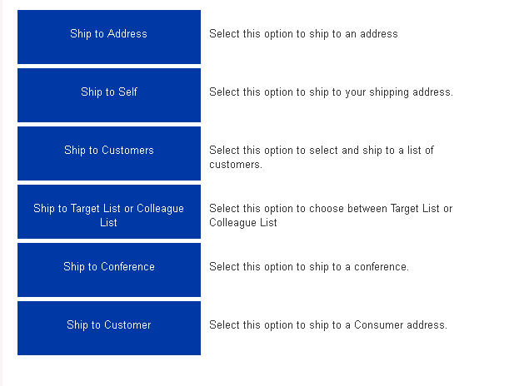

2.1.a HCP TABLE STRCUTURE
Bascou, Rich RBascou@hibbertgroup.com
RE: Resources for Lilly ic2 migration
2.1.a HGAPPLIL Schema

NEW
DB | SCHEMA | TABLE | COMMENTS
REPP | HGAPPLIL | thglil_lilly_addresses | data elements for a given HCP (eg, name, primary address, etc)
REPP | HGAPPLIL | thglil_addl_specialties | provides the specialties for a given HCP
REPP | HGAPPLIL | thglil_lilly_opt_data | opt OUT data for a given HCP (if any)
REPP | HGAPPLIL | thglil_lilly_addl_addrs | additional addresses for a given HCP (if any)
REPP | HGAPPLIL | thglil_sf_alignment | alignment data for a given HCP
REPP | HGAPPLIL | thglil_specialty_brand | specialty/brand mapping

2.1.b HGAPPLHP Schema

CURRENT
DB | SCHEMA | TABLE | COMMENTS
HIBP | HGAPPLHP | thgmkt_lilly_addresses | currently copied from REPP to HIBP each night
HIBP | HGAPPLHP | thgmkt_lilly_addl_specialties | currently copied from REPP to HIBP each night
HIBP | HGAPPLHP | thgmkt_lilly_opt_data | currently copied from REPP to HIBP each night
HIBP | HGAPPLHP | thgmkt_lilly_addl_addrs | currently copied from REPP to HIBP each night
HIBP | HGAPPLHP | thgmkt_lilly_align_data | currently copied from REPP to HIBP each night
HIBP | HGAPPLHP | thgmkt_specialty_brand | currently copied from REPP to HIBP each night

2.1.C HCP WebService

http://localhost:port/swagger-ui.html

service : http://localhost:8091/swagger-ui.html#!/hcp-search-rest-controller/loadHcpSearchDataUsingPOST

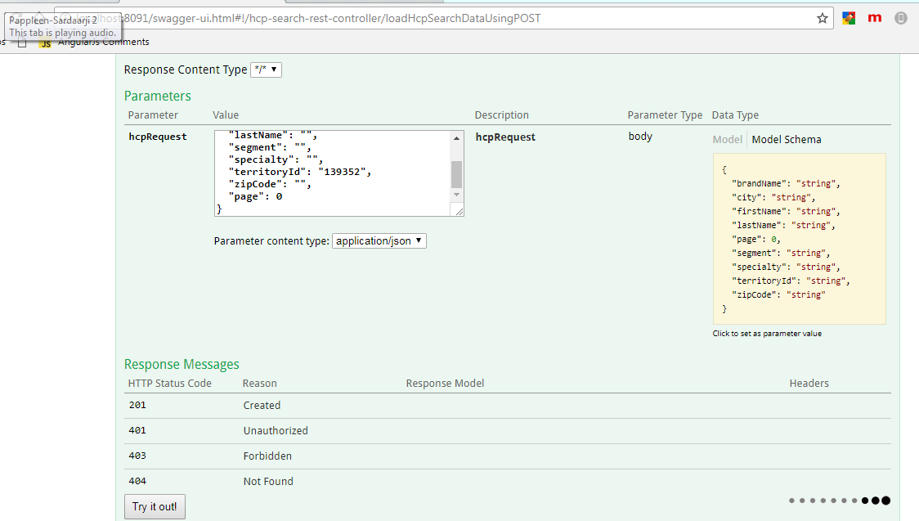

JSON BODY:

{
"brandName": "Cialis",
"city": "",
"firstName": "",
"lastName": "",
"segment": "",
"specialty": "",
"territoryId": "139140",
"zipCode": "",
"page": 0
}

Service Name: http://localhost:8091/swagger-ui.html#!/hcp-search-rest-controller/loadMutipleDataUsingGET
PartyId: 10213573 LoginUserId :673

3.0 HAM-5905 Lilly iConnect 2 - Order Review Ticket
Order-Review & OrderPlaced Flow :

THGSAM_ORDER
THGSAM_ADDRESS_MATERIAL

HGAPPWIM :-product Relate information
THGWIM_PRODUCT_CLASS
THGWIM_ITEM

THGHAF_ADDRESS_BOOK:
select * from HGAPPHAF.THGHAF_ADDRESS_BOOK where app_id='2401';

[‎9/‎21/‎2017 9:25 PM] Amin, Gunjan:
multipleAddrResult
HCPSearchAction class

thghaf_person table
user_name

Order Review Page
=======================================
1)review page
2)Itemreview.tag
3)crReview.tag
4)shippingMethodsTable.jsp

Order Placed Page
===============================
orderDetailAction.java
detail.jsp

HomePage
=====================================
Main.jsp
homePageLayout.jsp
homePageSlider.jsp

3.1 Unit Pack/Unit of Measure will display

1. Units – Unit Pack/Unit of Measure will display
Scenario - I have add 1 item with 2 quantity and adding address for multiple recipient. Then what behavior that time each of recipient 2 quantity.
2. Cost Per Unit – Privilege Based (it not display on UI so How can check)

Fig:3.1.a
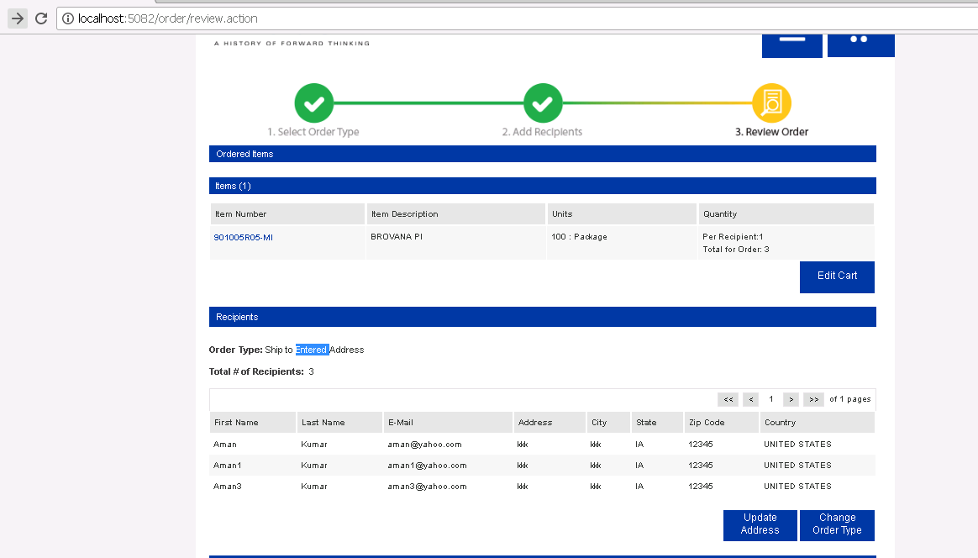

3.2 Buttons:
- Select Order Type– Will only display prior to order type selection – Is there any UI So that I confirm that ?
Fig:3.1.b
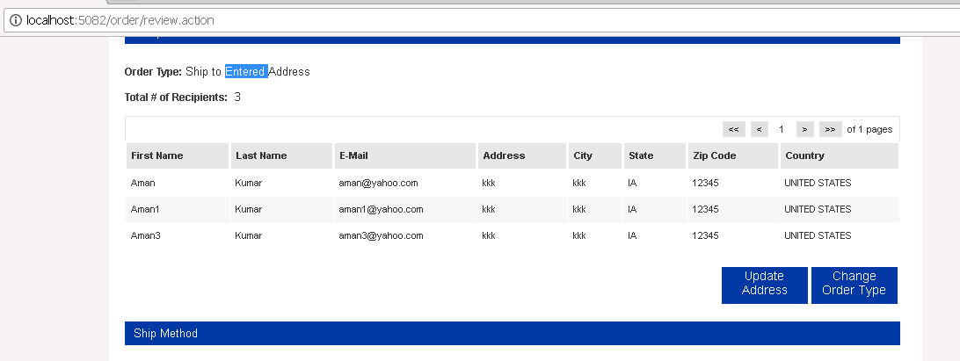

Fig:3.1.c

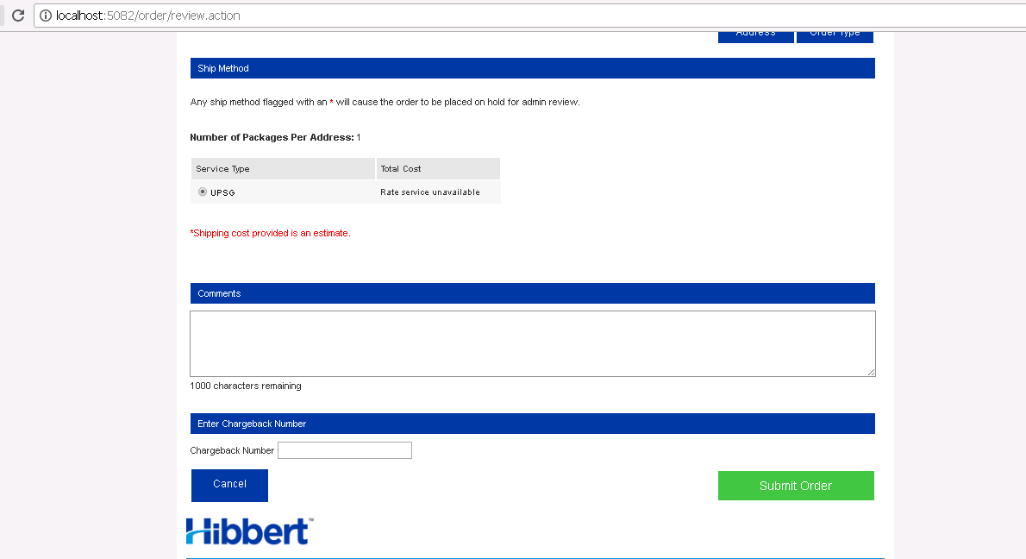

4.0 HAM-5906 Lilly iConnect 2 - Order Detail Ticket

Fig:4.0.a

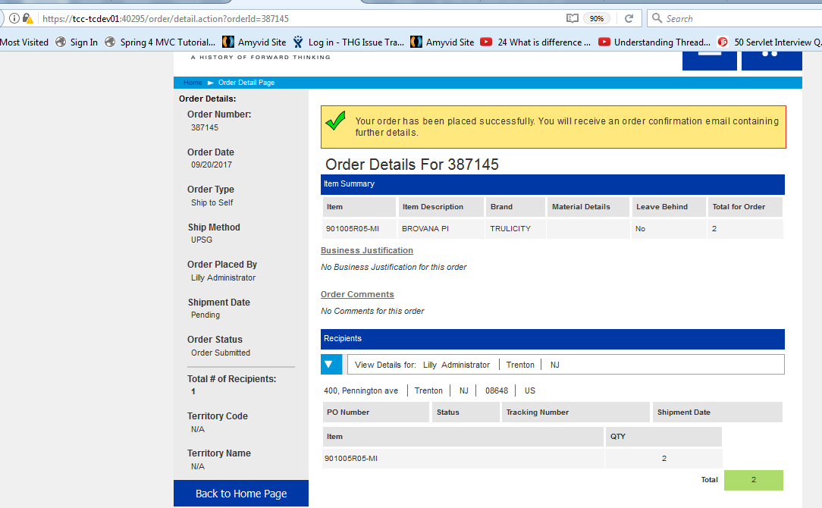

Note: All check applicable on Jsp page...
• Ordered on Behalf Of
• Hold Reason
• Conference Convention Name (for applicable orders)
• Number of Attendees (for applicable orders)

5.0 HAM-5913 Lilly iConnect 2 – Home Page

- select * from thghaf_app where app_name like '%Lilly%'; -- App Id: 2522--
- select * from THGHAF_APP_COMPANY_DIVISION where app_id=2522; -- Company_division_Id: 201—
- select * from THGHAF_COMPANY_DIVISION where COMPANY_DIVISION_ID=201;-- company_id: 221---
- select * from thghaf_person where person_id in(select person_id from thghaf_app_user where app_id=2522);
- select au.role_id from thghaf_person p,thghaf_app_user au where p.person_id = au.person_id and au.app_id = 2522 and au.active_flag=1 and p.user_name = 'LillyAdmin' and p.user_password = 'Hibbert1' and au.sso_flag=0; --- Role find Out
- select * from HGAPPHAF.THGHAF_ROLE where ROLE_ID=9497;--
- select * from HGAPPHAF.THGHAF_PRIVILEGE where PRIVILEGE_ID in(select PRIVILEGE_ID from HGAPPHAF.THGHAF_ROLE_PRIVILEGE where ROLE_ID=9497);-- Privliege Find

Fig:5.0.a Announcements Page
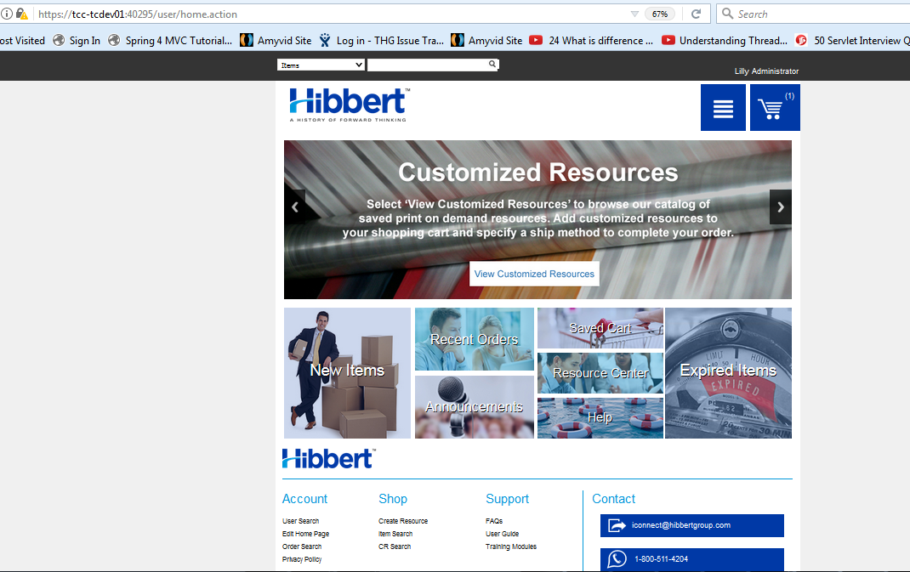

Fig:5.0.b Announcements Page

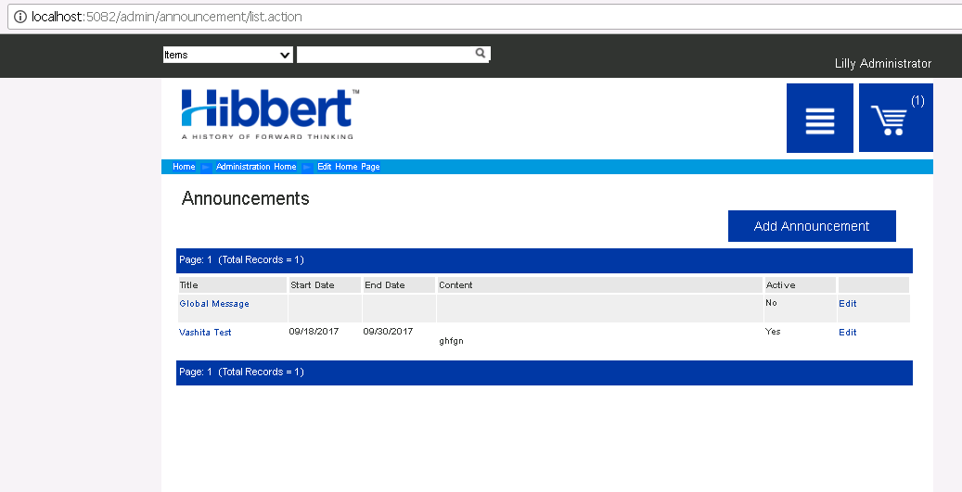
- select * from HGAPPHAF.THGHAF_APP_USER where app_id=2522;
- select * from HGAPPSAM.THGSAM_ANNOUNCEMENT_HIST where USER_ID in (168911,
168894,168912,168913);

6.0 HAM-5959 (Prevent Orders over Min/Max Quantity) Lilly iConnect 2 – Basket Page

Fig:6.0.a

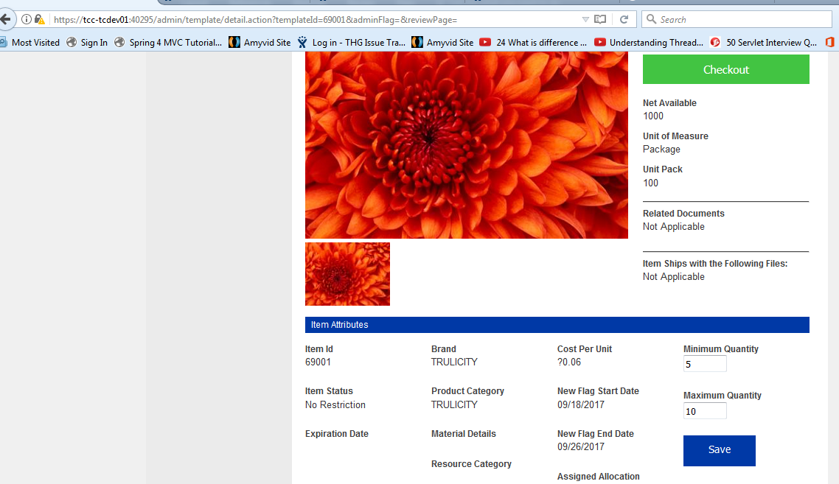

Fig:6.0.b

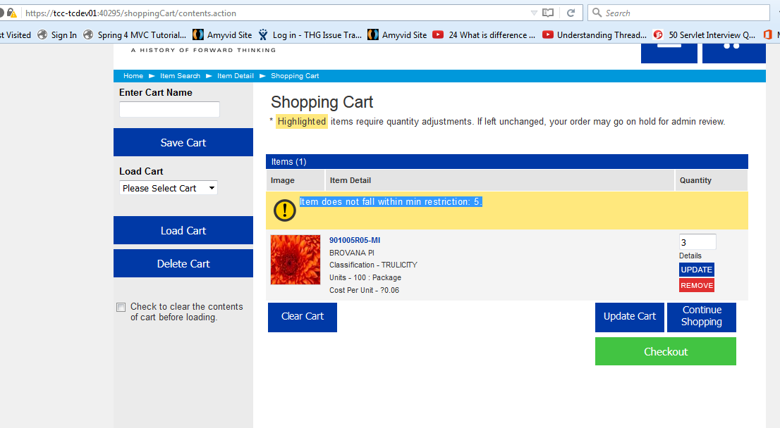

Note : If we try to add 3 quantity but we setting in rule we only enter min. quantity for this product.

6.1 Item Setting And Role Setting.
Credentional
http://tcc-tcdev01:10122/login.action
clientservices/Hibbert
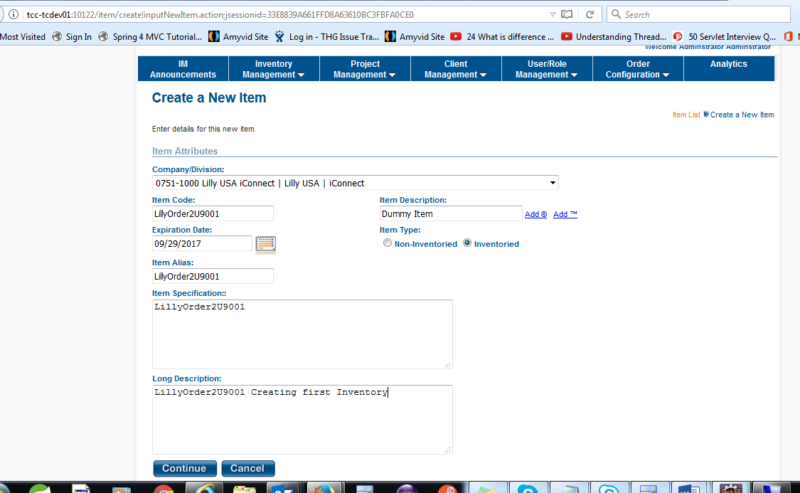

- searchx.jsp
- TEMPLATE_SEARCH:{"_appInfo":{"_appId":2522,"_companyDivisionId":201,"_environment":"DEV","_companyDivChannels":[{},{},{},{}],"_allowSettlement":false},"_productDivisionInfo":{"_productDivisionId":101,"_productDivisionName":"LILLY"},"_description":"","_longDesc":"","_approved":"ALL","_ddrTemplateFlag":"ALL","_featuredNewFlag":"ALL","_customizableStatus":"NONCUSTOMIZABLE","_activeStatus":"YES","_itemAccessCodeLabel":"Admin","_newEmailDate":true,"_efulfillableOnly":false,"_excludeEfulfillableItems":true,"_territoryInclusionExclusion":true,"_displayExpiredItem":false,"startRow":0,"maxRowCount":100,"_quickSearchKey":"","_itemAudienceOverride":true,"_mediaDigitalDownloadFlag":false,"_expiredItemByUser":false,"_user":{},"_patientEventsRestriction":false}

Template Search-
1)Searchx.jsp
2) jsp/template/result.jsp
3)itemTooltips.jsp

WEB -Service URL
===========================
- Inventory Service Location jenkin :

- http://tcc-tcdev01:10005/job/RESTfulR4InventoryServices/configure
- SVN LOCATION - svn://hgsun72/repository/projects/RESTful Services/R4InventoryServices/branches/PCR_160929152019_EA_for_adding_DDR_items_to_Scrap_Tab_UI_Web_IM
- USER GET DETAIL API - http://tcc-tcdev01:10010/restServices/getUserDetails/
Json value - {
"appName":"LillyAM",
"token":"5b886555-7259-4333-887e-7d980c1f586b"
}

- HCP360Service API URL DEV-

http://tcc-tcdev01:10298/
- http://tcc-tcdev01:10297/customize?token=1320c437-3aa5-49dc-9e03-69317b057dba&appName=LillyAM&itemCode=PC-02890-R

vi) POST /getSpecialities

{
"appName": "LillyAM",
"token": "1320c437-3aa5-49dc-9e03-69317b057dba",
"firstName": "",
"lastName": "",
"city": "",
"zipCode": "",
"segment": "",
"territoryId": "",
"specialty": null,
"brandName": [
"CIalis"
],
"partyId": null,
"addlAddressId": null,
"fromRow": 0,
"toRow": 0
}

http://www.opencodez.com/java/quartz-scheduler-with-spring-boot.htm

XmpieMasterJob
XmpieService
XmpieFileCreateJob
XmpieStatusCheckJob
XmpieReadyStatusJob
XmpieJobStatusList

select * from LHP_XMPIE_JOB_STATUS;
LHP_INTERVENTION
LHP_INTERVENTION_FIELD
lhp_xmpie
select * from LHP_PROPERTIES where PROPERTY = 'xmpie_master_cron';

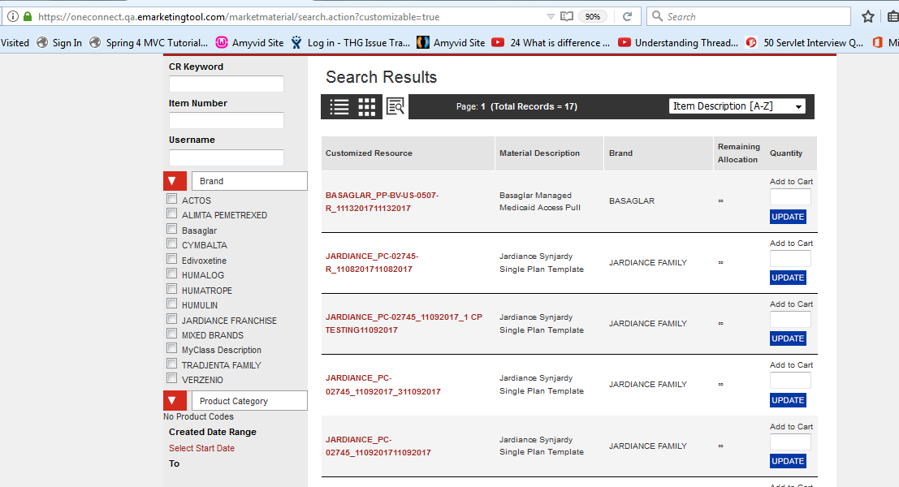

Template Search IN LillyAM - QA (APP_ID - 2401)
- HGAPPHAF - HGAPPHAF .THGHAF_APP_COMPANY_DIVISION
select * from HGAPPHAF.THGHAF_APP_COMPANY_DIVISION where app_id=2401; -- Company_division_Id:
select * as y0_ from THGDML_MARKETING_MATERIAL this_ inner join HGAPPWIM.THGWIM_ITEM i1_ on this_.TEMPLATE_ID=i1_.ITEM_ID left outer join HGAPPWIM.THGWIM_ITEM_PRODUCT_TYPE ip3_ on i1_.ITEM_ID=ip3_.ITEM_ID left outer join HGAPPWIM.THGWIM_ITEM_CATEGORY ic4_ on i1_.ITEM_ID=ic4_.ITEM_ID left outer join HGAPPWIM.THGWIM_PRODUCT_CLASS pc5_ on ic4_.PRODUCT_CLASS_ID=pc5_.PRODUCT_CLASS_ID left outer join HGAPPWIM.THGWIM_PRODUCT_CODE prodc8_ on ic4_.PRODUCT_CODE_ID=prodc8_.PRODUCT_CODE_ID left outer join HGAPPWIM.THGWIM_ITEM_ACCESS ia6_ on i1_.ITEM_ID=ia6_.ITEM_ID inner join HGAPPWIM.THGWIM_ITEM_ACCESS_CODE iac7_ on ia6_.ITEM_ACCESS_CODE_ID=iac7_.ITEM_ACCESS_CODE_ID inner join THGWIM_ITEM t2_ on this_.TEMPLATE_ID=t2_.ITEM_ID inner join HGAPPHAF.THGHAF_APP_USER au9_ on this_.CREATED_BY_ID=au9_.APP_USER_ID inner join HGAPPHAF.THGHAF_PERSON p10_ on au9_.PERSON_ID=p10_.PERSON_ID where this_.APP_ID= 2401 and i1_.COMPANY_DIVISION_ID=? and iac7_.ACTIVE_FLAG=? and iac7_.LABEL=? and iac7_.COMPANY_DIVISION_ID=? and ia6_.ACTIVE_FLAG=? and (t2_.TEMPLATE_STATIC_FLAG=? and this_.WEB_VISIBLE=?)

XMPIE-JOB

select * from HGAPPDML.THGDML_XMPIE_JOB_STATUS;
select * from THGDML_MARKETING_MATERIAL;

PCR-170825092857

STEP 5 - Iconnect Thread:

SVN:
svn://hgsun72/repository/projects/Husky/branches/iConnect2_Release_27.4

iConnect2 Thread:
/www/dev/apps/iConnect2_10007/webapps

Staging:
tccapplxt3/4/5/6 /www/staging/apps/iConnect2_10006/webapps
tccapplxt3/4 /www/staging/apps/iConnect2_10007/webapps
Production:
tccapplxp3/4/5/6 /www/prod/apps/iConnect2_10006/webapps
tccapplxp3/4 /www/prod/apps/iConnect2_10007/webapps

NOTE. When restarting or rebuilding TPTS the following steps *must* be taken:
1- Shut down TPTS-Web(iConnect2_10006) for Web.
2- Shut down TPTS-Web(iConnect2_10007) for Thread.
3-Execute svn://hgsun72/repository/projects/Husky/db/sql/utility/clean_quartz_config.sql
4- Start TPTS-Web server *first* in tccapplxt3/p3 & tccapplxt4/p4
5- After TPTS-Web has started *completely*, start TPTS-thread server only in tccapplxt3/p3
Staging:
tccapplxt3/4/5/6 /www/staging/apps/iConnect2_10006/webapps
tccapplxt3/4 /www/staging/apps/iConnect2_10007/webapps
Production:
tccapplxp3/4/5/6 /www/prod/apps/iConnect2_10006/webapps
tccapplxp3/4 /www/prod/apps/iConnect2_10007/webapps

