AIR QUALITY INTELLIGENCE
Data Analytics, Predictive Insights & Decision Support
PROJECT REPORT
AICTE | IBM SkillsBuild Data Analytics with AI Internship 2026
Prepared by
ThakurSejal
2026

Abstract
Air Quality Intelligence is a data analytics and machine learning project designed to transform air-quality monitoring observations into structured information, analytical insights and decision-support outputs. The project follows the workflow Data → Information → Insight → Decision → Action.
The project includes data profiling, cleaning, exploratory data analysis, pollutant analysis, geographic analysis, machine learning, model evaluation, KPI generation and analytical decision support.
Linear Regression and Random Forest Regression are used for pollutant-value estimation. Model performance is evaluated using MAE, RMSE and R².
The available dataset represents a current monitoring snapshot rather than a long historical time series. Therefore, this project does not claim long-term future pollution forecasting.

1. Introduction
Air-quality monitoring produces observations across different pollutants, cities and monitoring stations. Data analytics can help transform these observations into understandable patterns and decision-support information.
This project demonstrates an end-to-end analytical workflow using real air-quality monitoring data. The workflow combines descriptive analytics, visualization and machine learning.

2. Problem Statement
Air-quality datasets can contain large numbers of observations across multiple pollutants and geographic locations. Without structured preprocessing and analysis, it can be difficult to identify pollutant patterns, compare monitoring locations and generate useful analytical insights.
The project addresses this challenge through data cleaning, exploratory analysis, visualization, geographic analysis, machine learning and decision-support outputs.

3. Objectives
- Clean and preprocess the air-quality dataset.
- Understand the structure and quality of the dataset.
- Analyze pollutant and location patterns.
- Perform exploratory data analysis.
- Analyze geographic monitoring patterns.
- Develop machine-learning models for pollutant-value estimation.
- Evaluate model performance using MAE, RMSE and R².
- Generate project KPIs.
- Identify priority monitoring locations.
- Create data-driven decision-support outputs.

4. Dataset Description
The project uses the Government of India Open Government Data dataset titled 'Real time Air Quality Index from various locations', based on air-quality monitoring information.
Important fields include country, state, city, station, last_update, latitude, longitude, pollutant_id, pollutant_min, pollutant_max and pollutant_avg.
Metric | Value
Total observations | 3194
States | 30
Cities | 264
Stations | 506
Pollutant types | 7

5. Data Cleaning and Preprocessing
The dataset was inspected for missing values, duplicate records, data types and numerical consistency. Relevant numerical and categorical variables were prepared for analysis and machine learning.
The cleaned dataset was exported as 'cleaned_air_quality_data.csv'.

6. Exploratory Data Analysis
Exploratory data analysis was performed to understand pollutant coverage, average pollutant values and geographic observation patterns.
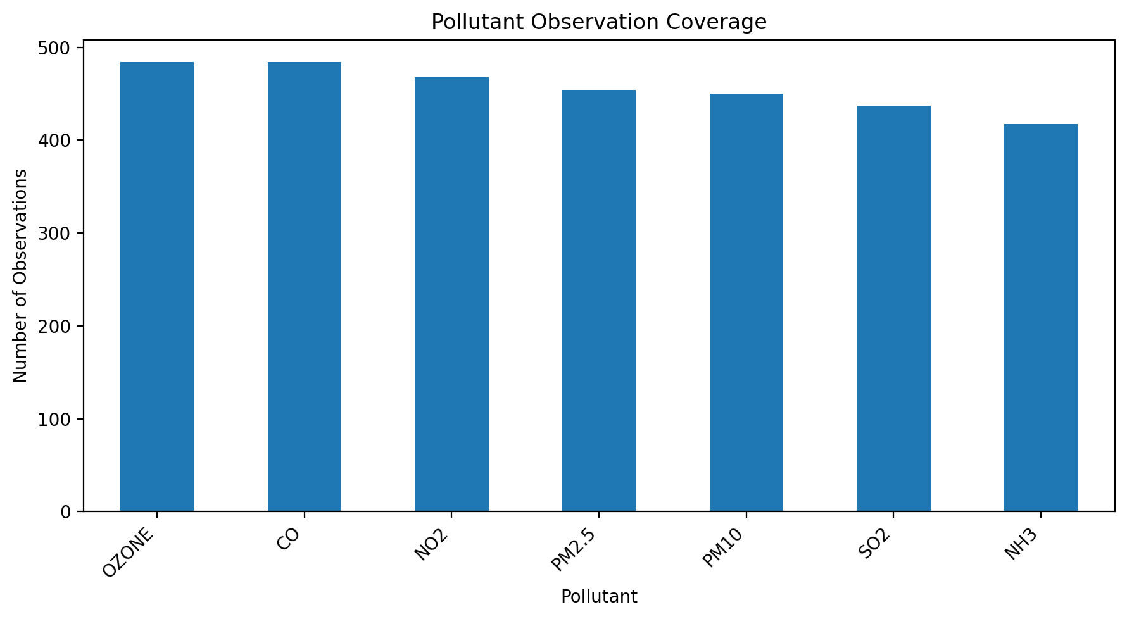
Figure 1. Pollutant observation coverage.
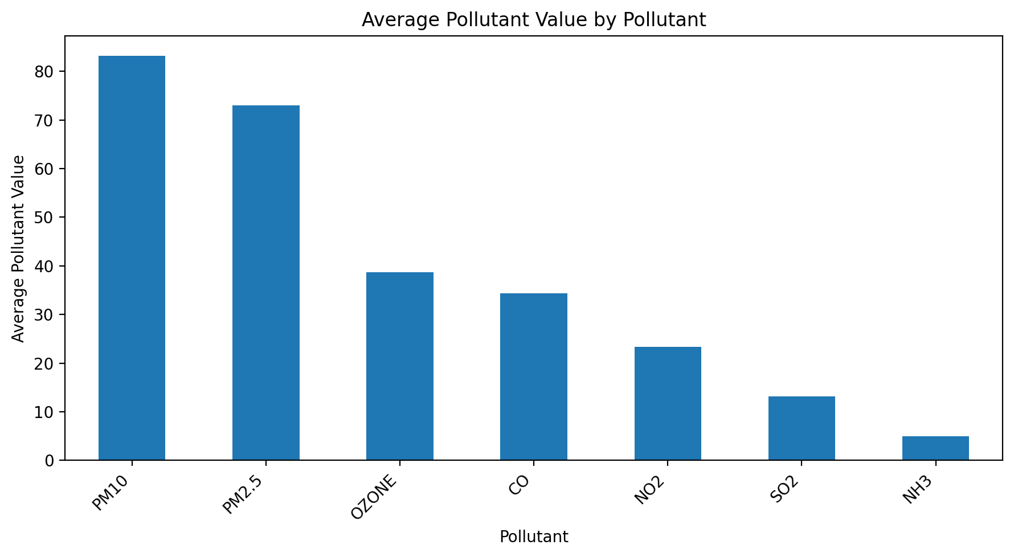
Figure 2. Average pollutant value by pollutant.

7. Time-Based Pollution Analysis
Available date/time information was examined to understand the temporal coverage of the dataset. The dataset does not represent a sufficiently long historical time series for long-term forecasting.
The available data did not provide sufficient distinct dates for a meaningful time-series visualization.

8. Geographic Hotspot and Location Analysis
State, city, station, latitude and longitude information was used to analyze monitoring coverage and location-level patterns.
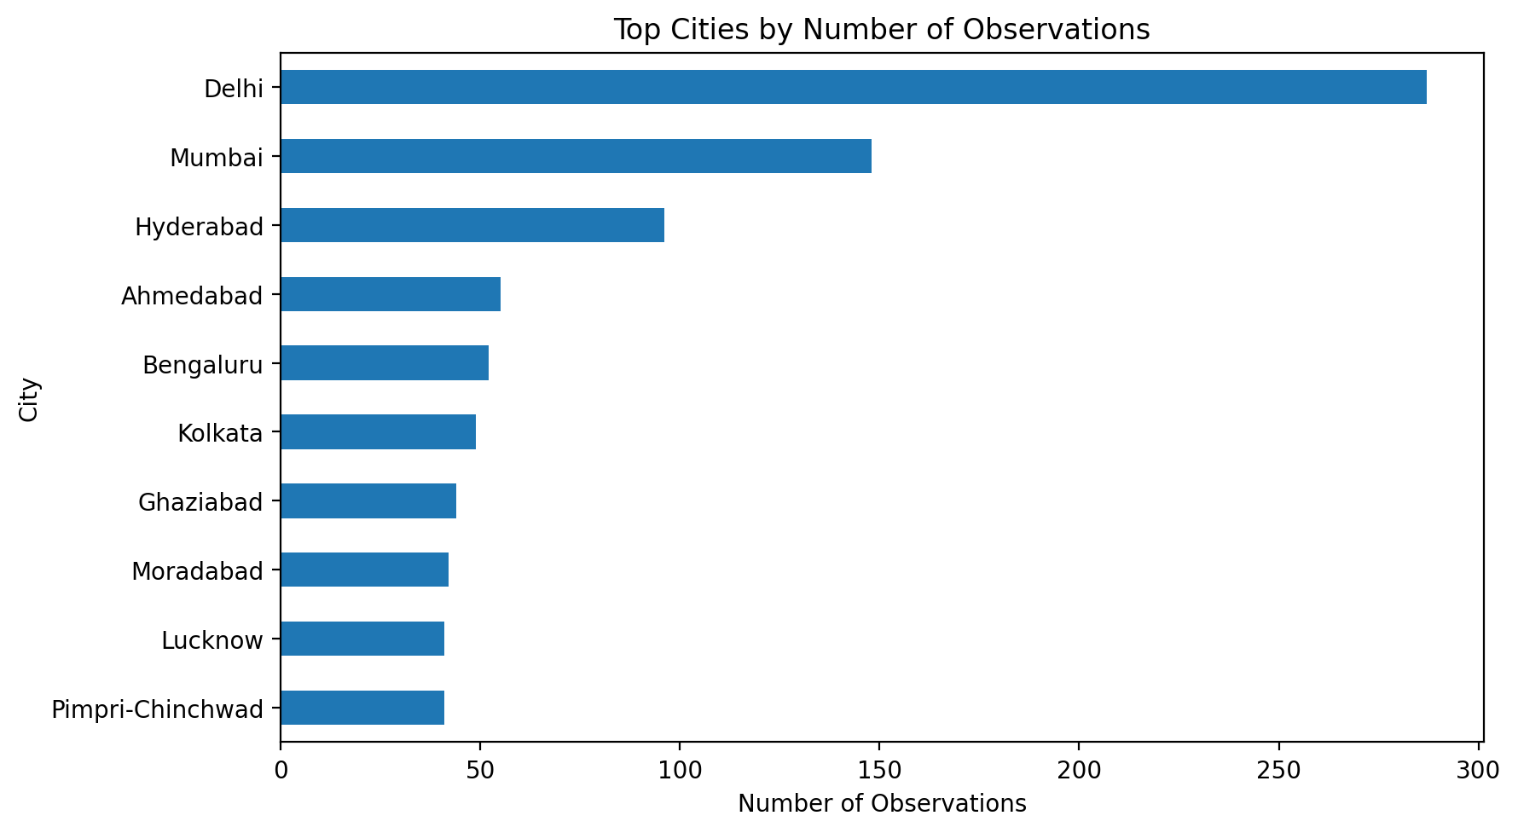
Figure 4. Top cities by number of observations.

9. Machine Learning Methodology
The machine-learning component estimates pollutant average values using available pollutant and location-related features.
The target variable is pollutant_avg. The feature set includes pollutant identity and available geographic/location variables.
The data is divided into training and testing subsets using an 80:20 split with a fixed random state.
The project evaluates the following regression algorithms:
- Linear Regression
- Random Forest Regressor
Model performance is evaluated using Mean Absolute Error (MAE), Root Mean Squared Error (RMSE) and R².

10. Model Results and Insights
The following table contains the actual model-comparison results generated by the project.
Model | Mae | Rmse | R2
Linear Regression | 22.2060 | 30.0640 | 0.4010
Random Forest | 15.0790 | 26.5340 | 0.5330
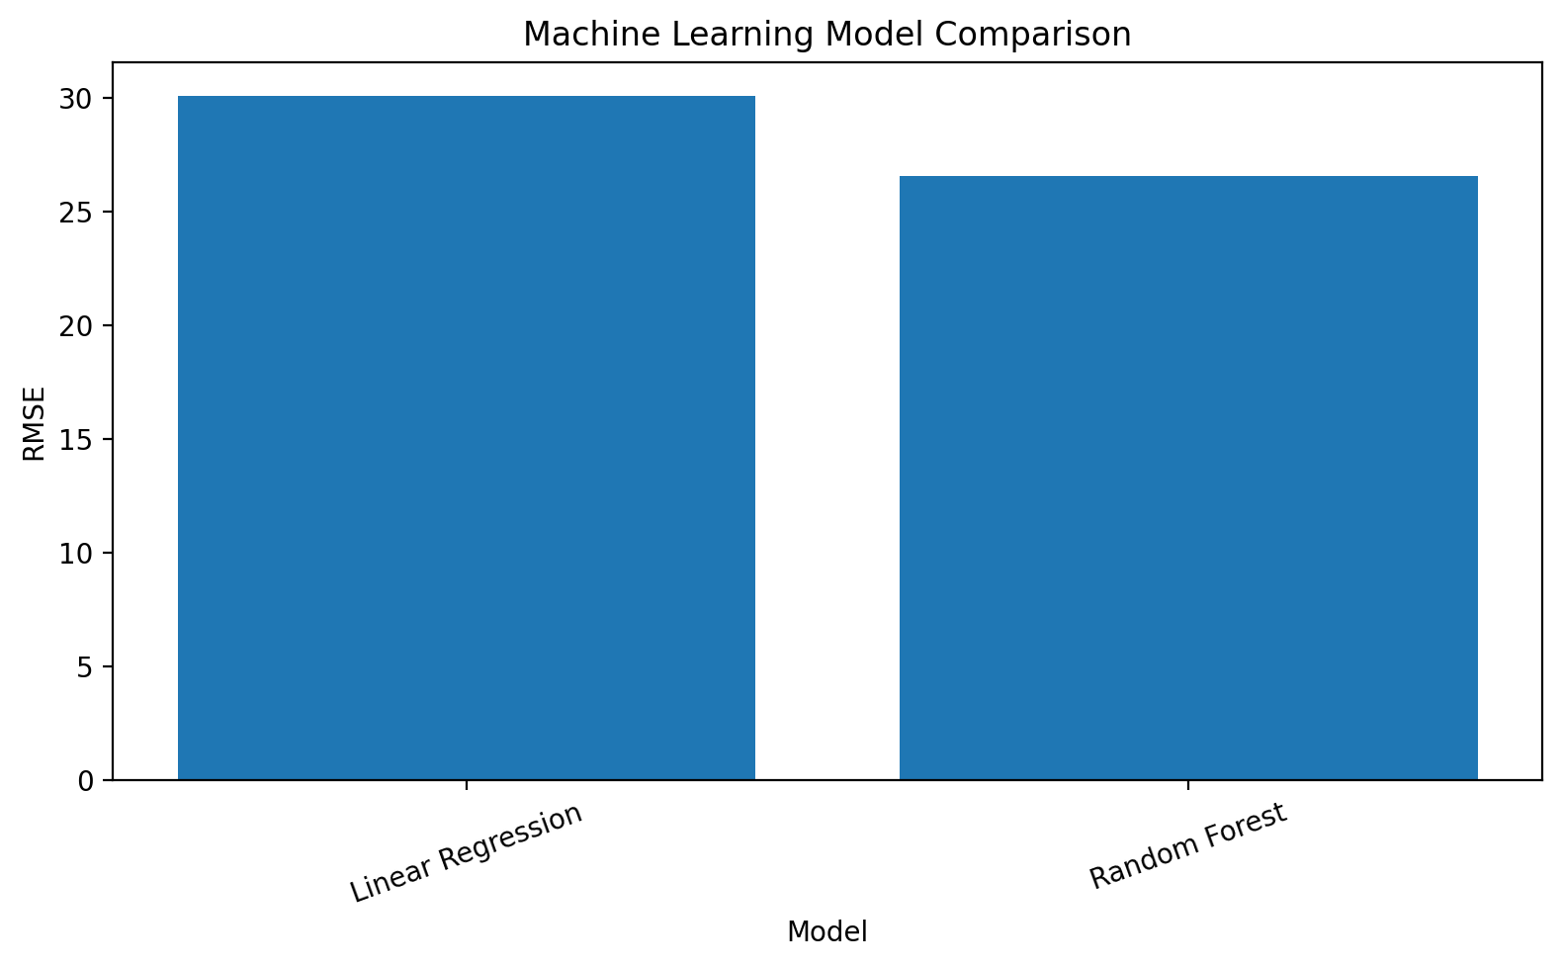
Figure 5. Machine-learning model comparison using RMSE.
The model results should be interpreted within the limitations of the available dataset. The project does not present these models as long-term future pollution forecasting systems.

11. Decision Support
A percentile-based analytical framework was created to identify relative pollutant levels within pollutant groups.
- Lower Relative Level — below the 50th percentile
- Moderate — 50th to below the 75th percentile
- High — 75th to below the 90th percentile
- Very High — 90th percentile and above
These categories are project-defined analytical signals. They are not official AQI categories and are not medical or health-risk classifications.
Priority monitoring locations generated by the project are summarized below.
State | City | Pollutant Id | High Level Records | Average Value | Maximum Value
Delhi | Delhi | PM10 | 40 | 161.600 | 249.000
Delhi | Delhi | PM2.5 | 39 | 166.615 | 255.000
Delhi | Delhi | NO2 | 27 | 56.407 | 167.000
Delhi | Delhi | CO | 25 | 63.240 | 102.000
Delhi | Delhi | OZONE | 24 | 94.625 | 264.000
Delhi | Delhi | NH3 | 16 | 8.438 | 15.000
Delhi | Delhi | SO2 | 12 | 27.833 | 44.000
Maharashtra | Mumbai | NO2 | 7 | 41.714 | 60.000
Uttar Pradesh | Ghaziabad | PM2.5 | 6 | 170.167 | 214.000
Rajasthan | Jaipur | NO2 | 6 | 48.167 | 81.000

12. Executive KPI Summary
The project generates KPI information to summarize dataset coverage and analytical scope.
Kpi | Value
Total Observations | 3194
States Covered | 30
Cities Covered | 264
Monitoring Stations | 506
Pollutant Types | 7
Higher-Level Observations | 819

13. Project Workflow
- Data collection
- Dataset profiling
- Data cleaning and quality control
- Exploratory data analysis
- Time-based analysis
- Geographic analysis
- Machine learning
- Model evaluation
- Decision support
- KPI generation
- Final visualization and output generation

14. Technologies Used
- Python
- Pandas
- NumPy
- Matplotlib
- Seaborn
- Scikit-learn
- OpenPyXL
- Google Colab

15. Sustainable Development Goals Alignment
SDG 3 — Good Health and Well-Being: Air-quality monitoring provides environmental information relevant to public well-being.
SDG 11 — Sustainable Cities and Communities: Location-based air-quality analysis supports understanding of urban environmental conditions.
SDG 13 — Climate Action: Data-driven environmental monitoring contributes to environmental awareness and analytical decision support.

16. Limitations
- The available dataset is a current snapshot rather than a long historical time series.
- The project therefore does not claim long-term time-series forecasting.
- Relative-level categories are project-defined analytical signals and not official AQI classifications.
- Model performance depends on the features and observations available in the dataset.
- Random train-test splitting may produce optimistic generalization estimates when similar station or pollutant observations occur in both subsets.

17. Future Scope
- Integrate longer historical air-quality time-series data.
- Develop genuine time-series forecasting models.
- Incorporate meteorological variables such as temperature, humidity, wind and rainfall.
- Use grouped or time-based validation for stronger model evaluation.
- Develop an interactive Power BI, Tableau or web-based dashboard.
- Automate data updates from official monitoring sources.
- Add explainable machine-learning techniques.

18. Conclusion
The Air Quality Intelligence project demonstrates a complete data-to-decision workflow using real air-quality observations.
Through data preprocessing, exploratory analysis, visualization, geographic analysis and machine learning, the project converts raw monitoring observations into structured analytical information.
The project also demonstrates how KPIs, relative-level analysis and priority monitoring outputs can support interpretation and decision-making.

19. References
- Government of India Open Government Data Platform — Real time Air Quality Index from various locations.
- Central Pollution Control Board (CPCB) — Air-quality monitoring information.
- Python scientific computing and data-analysis ecosystem.
- Scikit-learn documentation for machine-learning algorithms and evaluation metrics.

20. Project Information
Project: Air Quality Intelligence — Data Analytics, Predictive Insights & Decision Support
Prepared by: ThakurSejal
Program: AICTE | IBM SkillsBuild Data Analytics with AI Internship 2026

