**C++ Pointers**

In this tutorial, we will learn about pointers in C++ and their working with the help of examples.  
In C++, pointers are variables that store the memory addresses of other variables.

**Address in C++**

If we have a variable var in our program, &var will give us its address in the memory. For example,

**Example 1: Printing Variable Addresses in C++**

**#include  
using namespace std;  
int main()  
{  
// declare variables  
int var1 = 3;  
int var2 = 24;  
int var3 = 17;  
// print address of var1  
cout << "Address of var1: "<< &var1 << endl;  
// print address of var2  
cout << "Address of var2: " << &var2 << endl;  
// print address of var3  
cout << "Address of var3: " << &var3 << endl;  
}  
Output**

**• Address of var1: 0x7fff5fbff8ac**

**• Address of var2: 0x7fff5fbff8a8**

• **Address of var3: 0x7fff5fbff8a4***Note: You may not get the same results when you run the program.*

**C++ Pointers**

As mentioned above, pointers are used to store addresses rather than values.  
Here is how we can declare pointers.

• int *pointVar;  
Here, we have declared a pointer pointVar of the int type.  
We can also declare pointers in the following way.

• int* pointVar; // preferred syntax  
Let's take another example of declaring pointers.

• int* pointVar, p;  
Here, we have declared a pointer pointVar and a normal variable p.  
*Note: The * operator is used after the data type to declare pointers.*

**Assigning Addresses to Pointers**

Here is how we can assign addresses to pointers:  
**int* pointVar, var;  
var = 5;  
// assign address of var to pointVar pointer  
pointVar = &var;**Here, 5 is assigned to the variable var. And, the address of var is assigned to the pointVar pointer with the code pointVar = &var.

**Get the Value from the Address Using Pointers**

To get the value pointed by a pointer, we use the * operator. For example:  
**int* pointVar, var;  
var = 5;  
// assign address of var to pointVar  
pointVar = &var;  
// access value pointed by pointVar  
cout << *pointVar << endl; // Output: 5**In the above code, the address of var is assigned to pointVar. We have used the *pointVar to get the value stored in that address.  
When * is used with pointers, it's called the dereference operator. It operates on a pointer and gives the value pointed by the address stored in the pointer. That is, *pointVar = var.  
*Note: In C++, pointVar and *pointVar is completely different. We cannot do something like *pointVar = &var;*  
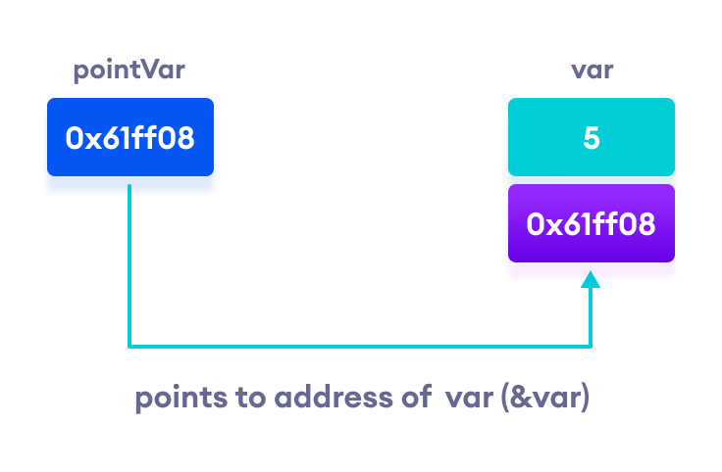  
**Working of C++ pointers**

**Changing Value Pointed by Pointers**

If pointVar points to the address of var, we can change the value of var by using *pointVar.  
For example,  
**int var = 5;  
int* pointVar;  
// assign address of var  
pointVar = &var;  
// change value at address pointVar  
*pointVar = 1;  
cout << var << endl; // Output: 1**Here, pointVar and &var have the same address, the value of var will also be changed when *pointVar is changed.

**Common mistakes when working with pointers**

Suppose, we want a pointer varPoint to point to the address of var. Then,  
**int var, *varPoint;  
// Wrong!  
// varPoint is an address but var is not  
varPoint = var;  
// Wrong!  
// &var is an address  
// *varPoint is the value stored in &var  
*varPoint = &var;  
// Correct!  
// varPoint is an address and so is &var  
varPoint = &var;  
// Correct!  
// both *varPoint and var are values  
*varPoint = var;**