Experiment No.1

Introduction of operating System:

An operating system (OS) is essential for managing and facilitating interactions between a computer's hardware and software. It provides a structured environment for executing programs and handling tasks like file management. In the context of a file experiment, the OS plays a crucial role by allowing users to create, modify, and delete files, and by organizing these files into directories or folders. It also manages file permissions, which control access rights and ensure that only authorized users can perform certain actions on files. Additionally, the OS employs a file system, such as NTFS, FAT32, or ext4, to systematically organize and store files on storage devices. During your experiment, you will observe how the OS efficiently handles these file operations and maintains an organized structure for data management.

Function of Operating System:

Certainly! Here are the key functions of an operating system relevant to a file experiment:

1. File Creation and Deletion: Allows you to create new files and remove existing

ones.

2. File Organization: Structures files in directories or folders for easy access and

management.

3. File Permissions: Controls access rights, specifying who can read, write, or execute

files.

4. File System Management: Uses a file system (like NTFS, FAT32, or ext4) to

organize and store files on storage devices.

5. File Access and Retrieval: Manages how files are accessed and retrieved from

storage efficiently.

Services of Operating System:

Here are the key services provided by an operating system:

1. Process Management: Handles the creation, scheduling, and termination of

processes.

2. Memory Management: Allocates and manages the computer's memory resources.

3. File Management: Oversees file creation, deletion, and organization.

4. Device Management: Manages input and output devices, including drivers and

interfaces.

5. User Interface: Provides a user interface (command-line or graphical) for interaction

with the system.

6. Security and Access Control: Enforces user authentication and controls access to

system resources.

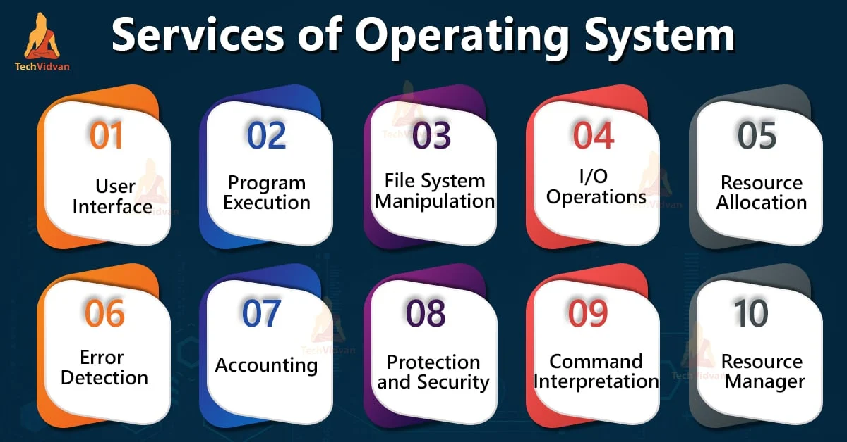

Fig 1 :operating system services

Need for Linux operating system:

Linux operating system is widely used for several compelling reasons:

1. Open Source: Linux is open source, meaning its source code is freely available for anyone to view, modify, and distribute. This fosters innovation and customization.
2. Stability and Reliability: Known for its stability and reliability, Linux is often used in environments where uptime is critical, such as servers and embedded systems.
3. Security: Linux is designed with robust security features and has a strong community of developers who quickly address vulnerabilities and provide patches.
4. Cost-Effective: Linux is free to use, reducing costs associated with licensing fees compared to proprietary operating systems.
5. Flexibility and Customization: Linux can be tailored to suit specific needs, from lightweight distributions for older hardware to powerful configurations for advanced users and servers.
6. Performance: Linux typically has a smaller footprint and can be optimized for performance, making it suitable for a wide range of hardware.
7. Community Support: A vibrant community of users and developers provides extensive support and resources, including forums, documentation, and user guides.
8. Compatibility: Linux supports a wide range of hardware architectures and offers compatibility with various software applications, including many open-source tools and enterprise solutions.

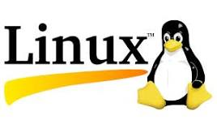

Fig 2:Linux Logo

History Of Linux Operating System:

Linux originated in 1991 when Linus Torvalds, a Finnish student, released the first version

of the Linux kernel as a free and open-source alternative to proprietary operating systems.

Initially developed as a personal project, Linux quickly garnered support from a global community of developers. By adhering to the principles of open source, it allowed continuous improvements and adaptations. Over the years, Linux evolved into a robust and versatile operating system used across various domains, from personal computers to servers and embedded systems. Its development has been driven by contributions from both individual programmers and large organizations, leading to a diverse ecosystem of distributions tailored for different needs.

Different Services and Application Of Linux Operating system :

Here are some key services and applications of the Linux operating system:

1. Web Servers: Powers popular web servers like Apache and Nginx.
2. Database Management: Supports database systems such as MySQL, PostgreSQL, and MongoDB.
3. File Servers: Provides file sharing services with tools like Samba and NFS.
4. Network Management: Manages network services with tools like iptables and Network Manager.
5. Development Environment: Used by developers for programming with support for various programming languages and development tools.
6. System Administration: Offers robust tools for system monitoring and management, such as top, hop, and system.
7. Security: Provides strong security features and tools, including SELinux and AppArmor.
8. Virtualization: Supports virtualization platforms like KVM, Docker, and VirtualBox.
9. Desktop Environments: Offers various desktop environments like GNOME, KDE, and XFCE for user interfaces.
10. Embedded Systems: Powers embedded systems and IoT devices due to its flexibility and low resource requirements.

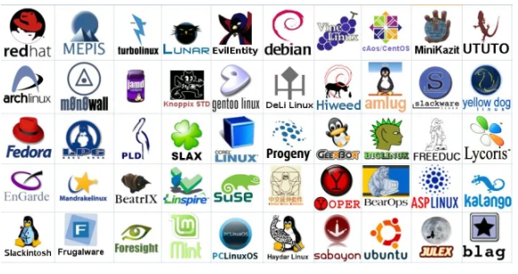

Fig 3:Linux Distribution