**Topics: Confidence Intervals**

For each of the following statements, indicate whether it is True/False. If false, explain why.

The sample size of the survey should at least be a fixed percentage of the population size in order to produce representative results.

Ans- False, the sample size can take any random variable ,also sample size of 30 is considered large but not enough to compute results.

The sampling frame is a list of every item that appears in a survey sample, including those that did not respond to questions.

Ans- True, since the population is generic by nature and the sample is a list of all items in the population.

Larger surveys convey a more accurate impression of the population than smaller surveys.

Ans- True, because conviction is based on prediction and a larger set of samples would give us the accurate impression of characteristics of the population, which would make our prediction accurate.

*PC Magazine* asked all of its readers to participate in a survey of their satisfaction with different brands of electronics. In the 2004 survey, which was included in an issue of the magazine that year, more than 9000 readers rated the products on a scale from 1 to 10. The magazine reported that the average rating assigned by 225 readers to a Kodak compact digital camera was 7.5. For this product, identify the following:

The population

Ans- 0.025

The parameter of interest

Ans- sample size, average, scale

The sampling frame

Ans- 9000

The sample size

Ans- 225

The sampling design

Ans- Kodak compact digital camera average rating

Any potential sources of bias or other problems with the survey or sample

Ans- No potential sources of bias or other problems with survey or sample

For each of the following statements, indicate whether it is True/False. If false, explain why.

If the 95% confidence interval for the average purchase of customers at a department store is $50 to $110, then $100 is a plausible value for the population mean at this level of confidence.

Ans:- True

If the 95% confidence interval for the number of moviegoers who purchase concessions is 30% to 45%, this means that fewer than half of all moviegoers purchase concessions.

Ans:- True

The 95% Confidence-Interval for *μ* only applies if the sample data are nearly normally distributed.

Ans:- False, with a large enough sample , the central limit theorem implies a normal sampling distribution of data regardless of the distribution of data.

What are the chances that 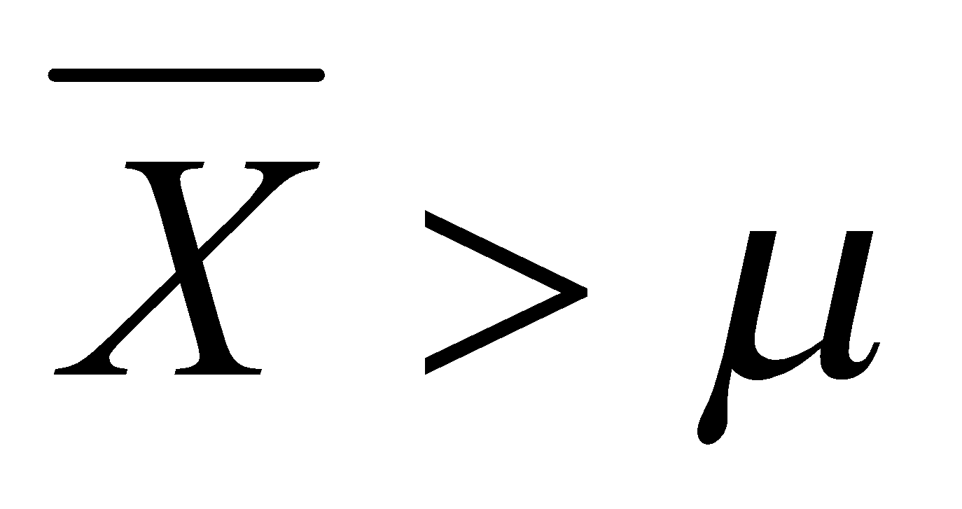?

¼

½

¾

1

Ans- 1 as the probability that the sample mean is within 1 SE of mu is roughly 68%, within two SE's is roughly 95% and within 3 is roughly 99.7%.

In January 2005, a company that monitors Internet traffic (WebSideStory) reported that its sampling revealed that the Mozilla Firefox browser launched in 2004 had grabbed a 4.6% share of the market.

If the sample were based on 2,000 users, could Microsoft conclude that Mozilla has a less than 5% share of the market?

Ans:- No microsoft cannot conclude mozilla has a less than 5% share of the market since the t value is more than the critical value of z .

WebSideStory claims that its sample includes all the daily Internet users. If that’s the case, then can Microsoft conclude that Mozilla has a less than 5% share of the market?

Ans:- Yes then microsoft can conclude that mozilla has less than 5% of share of the market because it comprises the whole population of the 4.6% market share.

A book publisher monitors the size of shipments of its textbooks to university bookstores. For a sample of texts used at various schools, the 95% confidence interval for the size of the shipment was 250 ± 45 books. Which, if any, of the following interpretations of this interval are correct?

All shipments are between 205 and 295 books.

Ans:- Incorrect all shipments are between 205 and 295 because all shipments have different confidence intervals.

95% of shipments are between 205 and 295 books.

Ans:- Correct 95% shipments are between 205 and 295 books because 95% for only these shipments is 250+or- 45.

The procedure that produced this interval generates ranges that hold the population mean for 95% of samples.

Ans:- Correct since the procedure tells us that only books from 205 -295 hold the confidence interval of 95%

If we get another sample, then we can be 95% sure that the mean of this second sample is between 205 and 295.

Ans:correct because sample is constant and has no variation over the range

We can be 95% confident that the range 160 to 340 holds the population mean.

Ans:- Incorrect because the sample cannot tell us the mean of the population.

Which is shorter: a 95% *z*-interval or a 95% *t*-interval for *μ* if we know that σ =s?

The z-interval is shorter

The t-interval is shorter

Both are equal

We cannot say

Ans :- The Z interval is shorter as it tells us the difference between the mean of distribution and data points in standard deviation.

Questions 8 and 9 are based on the following: To prepare a report on the economy, analysts need to estimate the percentage of businesses that plan to hire additional employees in the next 60 days.

How many randomly selected employers (minimum number) must we contact in order to guarantee a margin of error of no more than 4% (at 95% confidence)?

600

400

550

1000

Ans:- We have to randomly select only 600 employees at confidence level 95% with a margin of error not more than 4%.

Suppose we want the above margin of error to be based on a 98% confidence level. What sample size (minimum) must we now use?

1000

757

848

543

Ans :- The sample size for 98% confidence level we have to use sample size around 848.