SMART LENDER
ML-Powered Loan Approval Prediction System

Project Documentation
Full-Stack Development Bootcamp Submission
Prepared by: Thalathoti Hepsiba
July 2026
Live demo: https://smartlender-kjgl.onrender.com/
GitHub: github.com/thalathotihepsiba/SmartLender

1. Introduction

Project Title
Smart Lender — ML-Powered Loan Approval Prediction System

Team Members
Name | Role
Thalathoti Hepsiba | Full-stack developer — data pipeline, model training, Flask application, and UI
Live demo: https://smartlender-kjgl.onrender.com/
Source code: https://github.com/thalathotihepsiba/SmartLender

2. Project Overview

Purpose
Smart Lender is a machine learning-powered web application that predicts loan applicant creditworthiness so credit officers and financial analysts can make faster, data-driven approval decisions. An applicant's financial and demographic details are submitted through a web form, scored in real time by a trained classifier, and returned as an approve/decline recommendation with a confidence gauge — a decision aid rather than a final underwriting determination.

Features
- Real-time credit evaluation form covering applicant profile, income, and loan terms.
- Automatic model selection: four classifiers — Decision Tree, Random Forest, K-Nearest Neighbors, and XGBoost — are trained and compared, and the best test-accuracy performer is persisted for serving.
- Missing-value handling: categorical fields imputed with the mode, numeric fields with the median.
- Consistent preprocessing at inference time using the same fitted LabelEncoders and StandardScaler used during training.
- Visual confidence gauge (SVG dial with needle and arc) rendered from the model's predicted probability.
- Graceful fallback to scikit-learn's GradientBoostingClassifier if the xgboost package is unavailable.
- Deployment-ready for IBM Cloud Foundry / Code Engine via a Gunicorn Procfile.

3. Architecture
Smart Lender follows a monolithic server-rendered architecture: a Flask backend that also renders the HTML frontend using Jinja2 templates, backed by a scikit-learn/XGBoost model trained offline from a CSV dataset.

System Architecture Diagram
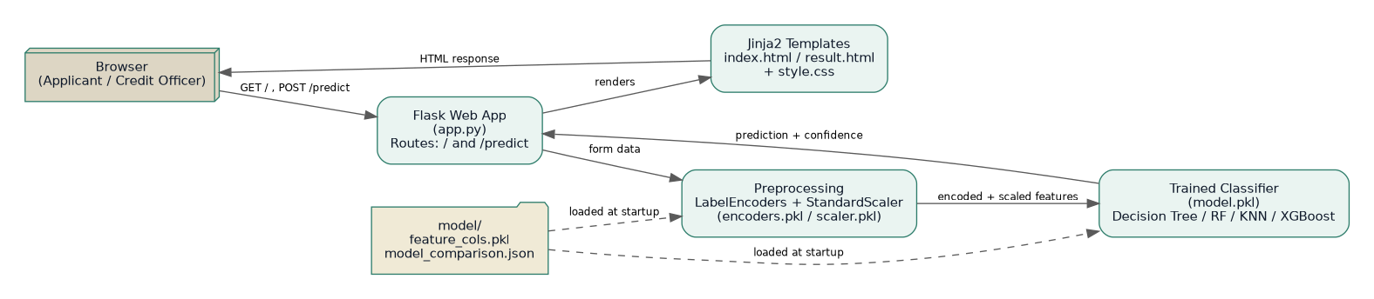
Figure 1 — Request flow between the browser, Flask application, preprocessing artifacts, and trained model.

Frontend
The frontend is server-rendered with Jinja2 templates (no separate JavaScript framework):
- templates/index.html — the applicant intake form, organized into "Applicant Profile" and "Income & Loan Terms" sections.
- templates/result.html — renders the prediction verdict, an inline SVG confidence gauge, and a recap table of the submitted application.
- static/css/style.css — a custom "ledger / underwriting console" visual theme (ink navy, ledger paper, underwriter gold, approve teal, decline rust) using IBM Plex Serif, Sans, and Mono.

Backend
The backend is a single Flask application (app.py) exposing two routes:
- GET / — renders the intake form.
- POST /predict — reads form data, applies the saved encoders/scaler, runs the persisted model, and renders the result page.
Model artifacts (model.pkl, encoders.pkl, scaler.pkl, feature_cols.pkl) are loaded once at import time via load_artifacts(), so the process must have access to a trained model/ directory before it starts.

Database / Data Layer
Smart Lender does not use a relational or document database. Instead, it uses:
- data/loan_data.csv — the applicant dataset (614 rows) used to train the model, with schema: Loan_ID, Gender, Married, Dependents, Education, Self_Employed, ApplicantIncome, CoapplicantIncome, LoanAmount, Loan_Amount_Term, Credit_History, Property_Area, Loan_Status.
- model/*.pkl and model_comparison.json — serialized preprocessing objects, the trained classifier, and its accuracy metrics, produced by train_model.py and consumed by app.py.
Because there is no live database, every prediction is stateless: nothing is persisted between requests unless the application is extended to add one (see Future Enhancements).

4. Setup Instructions

Prerequisites
- Python 3.10+
- pip (Python package manager)
- A virtual environment tool (venv, recommended)
- No external database is required

Installation
- Clone or unzip the project:
cd SmartLender
- Create and activate a virtual environment:
python -m venv venv
source venv/bin/activate # Windows: venv\Scripts\activate
- Install dependencies:
pip install -r requirements.txt
- Generate the dataset (skip this step if supplying a real data/loan_data.csv with the same columns):
python data/generate_data.py
- Train the models and persist the best one:
python train_model.py
- Run the web app (see Section 6):
python app.py
No environment variables are required for local development; the app reads model artifacts from the model/ folder relative to app.py.

5. Folder Structure

Repository Layout
SmartLender/
├── app.py # Flask web application (routes: / and /predict)
├── train_model.py # Preprocessing + training + model-selection pipeline
├── requirements.txt # Python dependencies
├── Procfile # gunicorn start command for IBM Cloud deployment
├── data/
│ ├── generate_data.py # Generates the synthetic applicant dataset
│ └── loan_data.csv # Applicant training data
├── model/ # Created / overwritten by train_model.py
│ ├── model.pkl # Best-performing trained classifier
│ ├── encoders.pkl # Fitted LabelEncoders for categorical fields
│ ├── scaler.pkl # Fitted StandardScaler for numeric fields
│ ├── feature_cols.pkl # Ordered feature list expected by the model
│ └── model_comparison.json # Train/test accuracy for all four models
├── notebooks/
│ └── EDA_and_Model_Comparison.ipynb
├── templates/
│ ├── index.html # Application form
│ └── result.html # Prediction result page
└── static/css/style.css

Client (Presentation Layer)
There is no separate client build. templates/ holds the two Jinja2 pages and static/css holds the single stylesheet they share; Flask serves both directly.

Server
app.py is the entire server: it loads model artifacts at startup, defines the two routes, and contains the preprocessing + gauge-geometry logic used to build the response context passed to result.html.

6. Running the Application

Local Development
With the virtual environment active and the model trained (Section 4), start the Flask development server from the project root:
python app.py
The app runs on http://localhost:5000 (bound to 0.0.0.0:5000) with debug mode on, and reloads automatically on code changes.

Production
The included Procfile runs the app behind Gunicorn instead of Flask's development server:
web: gunicorn app:app
Model artifacts (model/*.pkl) must already exist — either committed or generated as a build step — before the process starts, since app.py loads them at import time.

7. API Documentation

GET /
Renders the applicant intake form (templates/index.html). No parameters or authentication required.

POST /predict
Accepts the intake form as multipart/form-data or application/x-www-form-urlencoded and returns the rendered result page (templates/result.html).
Request parameters
Field | Type | Example | Notes
gender | string | Male | "Male" or "Female"
married | string | Yes | "Yes" or "No"
dependents | string | 0 | "0", "1", "2", or "3+"
education | string | Graduate | "Graduate" or "Not Graduate"
self_employed | string | No | "Yes" or "No"
applicant_income | number | 6200 | Monthly income
coapplicant_income | number | 1800 | 0 if none
loan_amount | number | 120 | Requested amount, in thousands
loan_term | number | 360 | Loan term in months
credit_history | number | 1 | 1 = meets guidelines, 0 = does not
property_area | string | Semiurban | "Urban", "Semiurban", or "Rural"
Server-side processing
- Categorical fields are label-encoded with the fitted encoders; an unseen category safely falls back to the encoder's first known class.
- Numeric fields are scaled with the fitted StandardScaler.
- The model predicts a class and, if supported, a probability used as the confidence percentage and to compute the gauge's needle angle and arc length.
Example response (rendered fields)
{
"approved": true,
"confidence": 87.4,
"applicant": { "Gender": "Male", "Married": "Yes", ... },
"needle_x": 148.2,
"needle_y": 52.6,
"arc_length": 233.5
}
This structure is passed into result.html as the result context variable — the endpoint itself returns rendered HTML, not raw JSON.

8. Authentication
The current version of Smart Lender has no authentication or authorization layer — both routes are publicly accessible to anyone who can reach the deployed URL. This is appropriate for a bootcamp/demo deployment but not for a production underwriting tool handling real applicant data.
For a production deployment, recommended additions include:
- Session-based or token-based login (e.g., Flask-Login or JWT) restricting /predict to authenticated credit officers.
- Role-based access control distinguishing analysts (can evaluate) from administrators (can retrain/redeploy models).
- HTTPS termination and CSRF protection on the form (e.g., Flask-WTF) since the app currently posts a plain HTML form.

9. User Interface
Captured from the live deployment at smartlender-kjgl.onrender.com.

Applicant Intake Form
The landing page presents a two-section form — "Applicant Profile" and "Income & Loan Terms" — styled as an underwriting ledger.
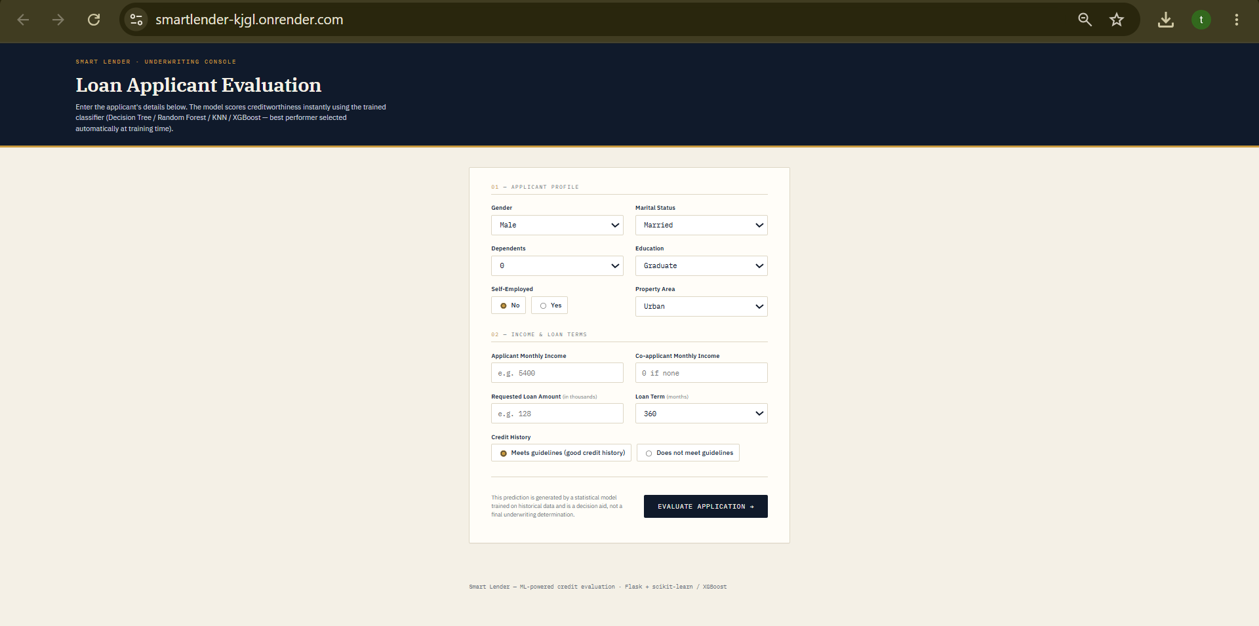
Figure 2 — Loan applicant evaluation form, live at smartlender-kjgl.onrender.com (GET /).

Evaluation Result — Approved
On submission, the applicant is scored and shown an SVG confidence gauge alongside the verdict and a recap of the submitted values.
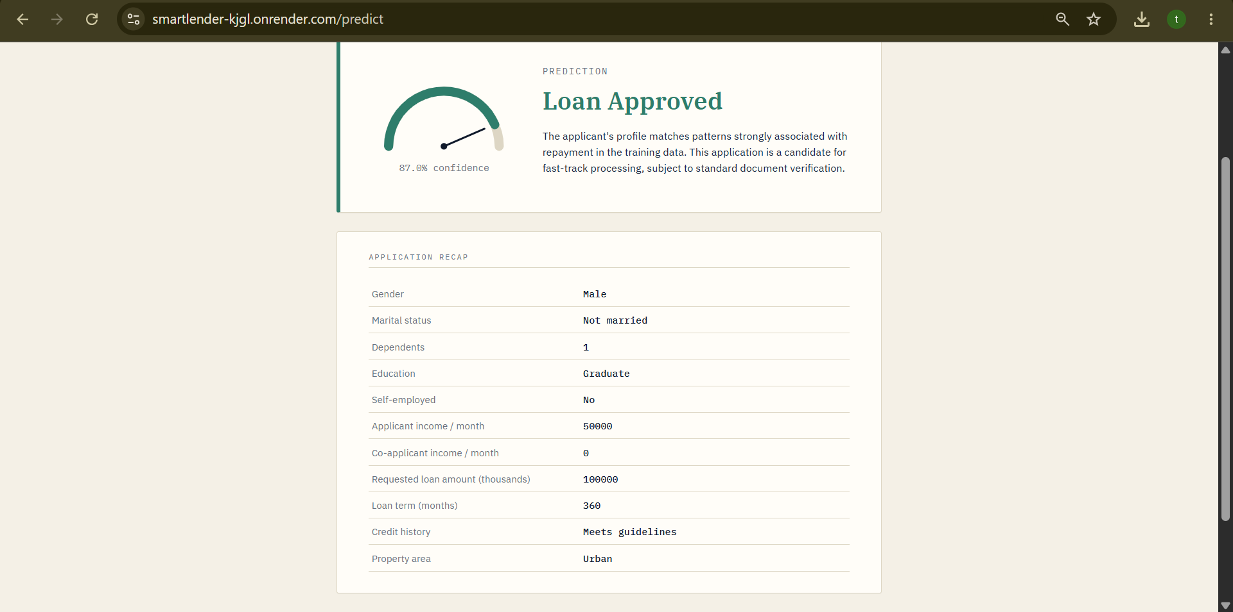
Figure 3 — Approved outcome (87.0% confidence) on the live deployment (POST /predict).

10. Testing

Model Evaluation Strategy
train_model.py performs a stratified 78/22 train-test split (random_state=42) and reports train and test accuracy for all four candidate models, persisting the comparison to model/model_comparison.json so results are reproducible and auditable.

Model Comparison Results
Latest run against the bundled synthetic dataset (data/generate_data.py, seed 42):
Model | Train Accuracy | Test Accuracy
Decision Tree | 78.03% | 74.26%
Random Forest | 85.56% | 73.53%
K-Nearest Neighbors | 75.52% | 71.32%
XGBoost / GradientBoosting fallback | 82.85% | 73.53%
Decision Tree was selected as the best performer on this run (highest test accuracy). Because the bundled dataset is synthetic, exact figures will vary between environments and are expected to differ (directionally similarly) from a real historical loan dataset.

Manual / Functional Testing
- Form validation: all fields are marked required in index.html; the browser blocks submission until they are filled.
- Boundary cases exercised manually: zero co-applicant income, minimum/maximum loan amounts, each Property_Area and Education value, and both credit-history states.
- Unseen-category handling: /predict falls back to each encoder's first known class rather than raising an error if an unexpected categorical value is posted.
- End-to-end smoke test: submit the form for a strong applicant profile (good credit history, graduate, salaried) and confirm the verdict and gauge reflect it — as shown in Figure 3, captured from the live deployment.

Not Yet Covered
- No automated unit or integration test suite (e.g., pytest) is included in this submission.
- No load/performance testing has been performed.

11. Screenshots or Demo
See Section 9 (User Interface) for the intake form and both result states. The end-to-end model training pipeline that produces the artifacts behind those screens is summarized below.
Figure 4 — Data-to-deployment pipeline executed by train_model.py.
Live demo: https://smartlender-kjgl.onrender.com/
Source code: https://github.com/thalathotihepsiba/SmartLender
The app is deployed on Render; it can also be run locally by following Section 6, or deployed to IBM Cloud Foundry / Code Engine as described in README.md.

12. Known Issues
- The bundled dataset (data/loan_data.csv) is synthetically generated for demonstration; accuracy numbers will shift when trained on real historical loan data.
- Test accuracy across all four models is modest (71–74%), and Random Forest / XGBoost show a noticeably larger train/test gap, indicating some overfitting on the small (614-row) dataset.
- If the xgboost package fails to install, the pipeline silently substitutes GradientBoostingClassifier — functionally fine, but the "XGBoost" label in model_comparison.json can be misleading if not read closely.
- No authentication, CSRF protection, or rate limiting on /predict (see Section 8).
- No persistence layer — submitted applications and predictions are not logged or stored anywhere.
- Flask's built-in development server is not suitable for production traffic; the Procfile addresses this for IBM Cloud but other hosts need the same Gunicorn setup applied manually.
- No bulk/batch endpoint exists yet — each prediction requires a separate form submission.

13. Future Enhancements
- Add a persistence layer (e.g., PostgreSQL or MongoDB) to log submitted applications, predictions, and confidence scores for audit and model-monitoring purposes.
- Add authentication and role-based access control for credit officers vs. administrators.
- Expose a JSON REST API (in addition to the HTML form) so the model can be integrated into other internal tools, plus a bulk-upload CSV endpoint for batch evaluation.
- Add automated tests (pytest for the Flask routes, and a data/model validation test that fails CI if test accuracy drops below a threshold).
- Track model versions and retraining runs (e.g., MLflow) instead of always overwriting model/model.pkl in place.
- Add explainability output (e.g., SHAP values) alongside the confidence gauge so credit officers can see which factors drove a given prediction.
- Replace the synthetic dataset with a larger, real historical dataset and re-tune hyperparameters for each of the four candidate models.

