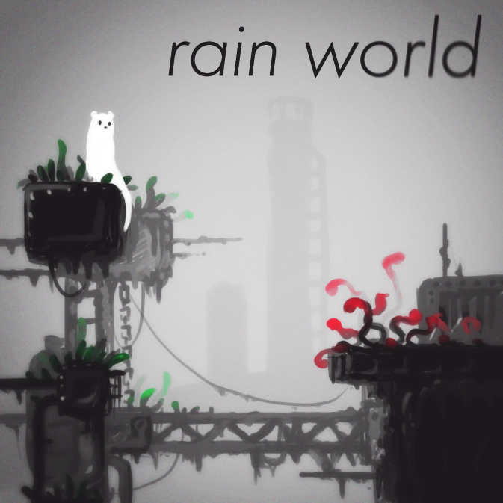
Rain World is a sneaker/action platformer under construction.
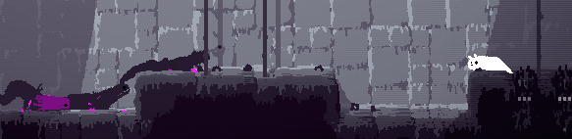
The gameplay consists of platforming and fast paced sneaking, both sneaking on your prey and sneaking in order to avoid larger creatures. A lot of focus in the development has been on enemy AI.
The player character moves a little differently from in most 2D platformers, it is not animated by traditional means but with simple physics. This is an attempt to make a character that appears a little softer, as well as an experiment with a different control scheme.
Alongside the game I'm also working on a level editor, which will allow you to make your own levels and render their graphics. Right now both game and level editor are unfinished, but it's likely that the game will be released before the level editor.
The level editor uses a voxel-like method to create graphics, and does some basic raytracing for light. If you go to the newer pages you'll see a lot of level editor related progress.
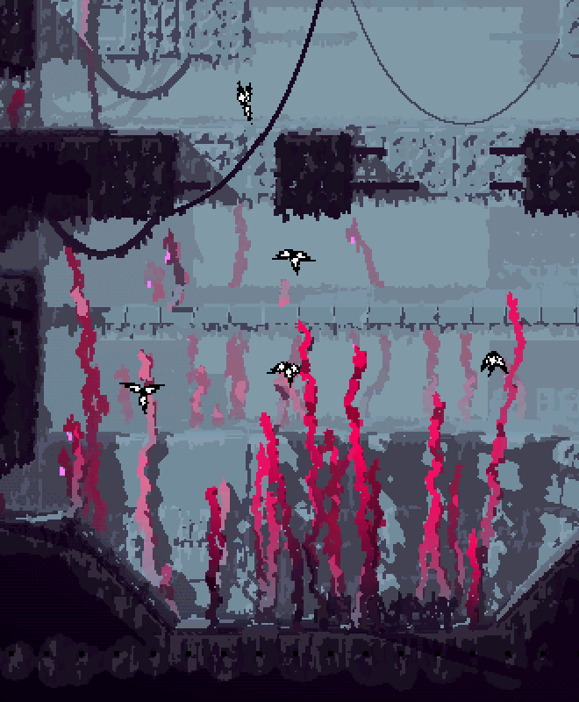
Everything, including the title, is subject to change, but the project is much more defined now than when this thread was started! Below is the original post from some time ago, if you want to follow the progress of the project from the start.
I post updates more or less every day, and am making slow but steady progress.
If you find the project interesting, please feel free to ask, suggest, comment or otherwise contribute.
Thanks for your time!
----------------------

