Glad I inspired you! It's a lot of fun to do path finding, as there's really nothing else that does as much for the feeling of AI units being autonomus and having their own minds. Ask me anything!

Update 3
Talking of path finding, I did a few lab tests today.

I created a floating island kind of structure, and had the croc try to path to it.

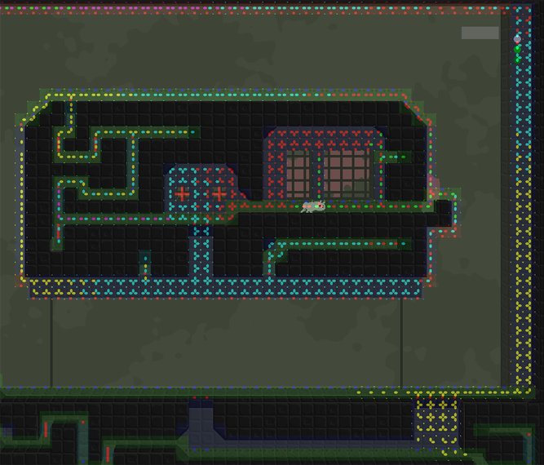

With the new dynamic abilities I've added I can change what a croc is able to do easily from its initiation code. A croc that's able to climb ceilings will, as expected, climb up the wall, then out above the island and drop down on it. A croc that's only able to climb walls will rush around desperately without ever finding a way, a behaviour I have to work with.

Actually this is going to be the next big step, I imagine. As a croc is able to drop down from somewhere it might easily get stuck in a hole. Also a croc might see a player across a gap, and the path finding will go on for ever and ever without realizing that there actually is no way across.

The task of making the croc aware of what's a "pit" where it will be stuck is almost impossible, as there's no way of saying "this is the level" and "this is a pit", all the code can find is two chunks of tiles from which you can pass from one to the other but not the other way around. You can of course say that the biggest chunk is "the level" while the rest is "dead ends" that should be avoided. This doesn't really apply to all situations though, look at the above picture for an example. The island structure might be smaller than the rest of the level, but it's more important, because more stuff is going on there. Here the majority of the level is a "pit" that you don't want to fall into.

The solution I imagine for this is that the crocs will live in holes. At start up the area that is accessable from the hole will be pre processed, and even more importantly, the areas from which you can't get back to the hole will be mapped out. The croc is only active in the area reachable from its hole.

This also allows the user of the level editor to place a croc, and decide what area of activity it'll have. For example you might want one that's confined to a pit at the bottom of the level and eats players that fall down.

More on that tomorrow!

