1 - Context
In Workana, matching is the heart that connects our entire ecosystem. Improving its quality and relevance allows us to enhance the experience for both clients and talents, increase marketplace efficiency, and boost the impact of every business unit.
Currently, the relevance ranking within Evalbids (the page displaying suggested freelancers who submitted proposals for the project) uses a very outdated logic and does not represent the freelancer's true relevance.
Based on that, we performed an ab test with a new order of relevance between 03/07/2025 and 21/07/2025, with 95% confidence to test the following hyphotesis:
Hnull: The proportion of accepted bids related to total projects of the evalbid group is lesser or equals than the proportion of accepted bids related to total projects of default group.
Halt: The proportion of accepted bids related to total projects of the evalbid group is greater than the proportion of accepted bids related to total projects of default group.
The metric used to evaluate the diferences in performance of both groups was proportion of accepted bids / total of projects. To understand and strenghtening our analysis, secondary metrics were chosen as below:
- number of messages exchanged in threads (engagement metric)
- average messages per day (engagement metric)
- EL1 rate (engagement metric)
- number of threads converted in accepted bids (matching quality metric)
- acceptance rate by gamification level (matching quality metric)
- time from project posting to accepted bids – (ux metric)
- time from project posting to accepted bids by gamification level (ux metric)
In the following sections, the main results, conclusions and following steps will be presented.
2 - Key Takeways
2.1 – Average of total messages exchanged between cliente and freelancer
Takeway: There is no relevant difference between the average messages exchanged between evalbidsneworder group and default group. This metric was inconclusive.

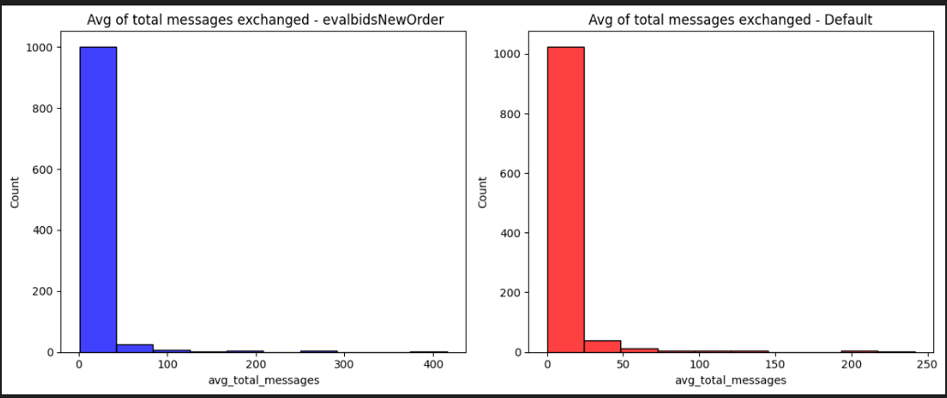

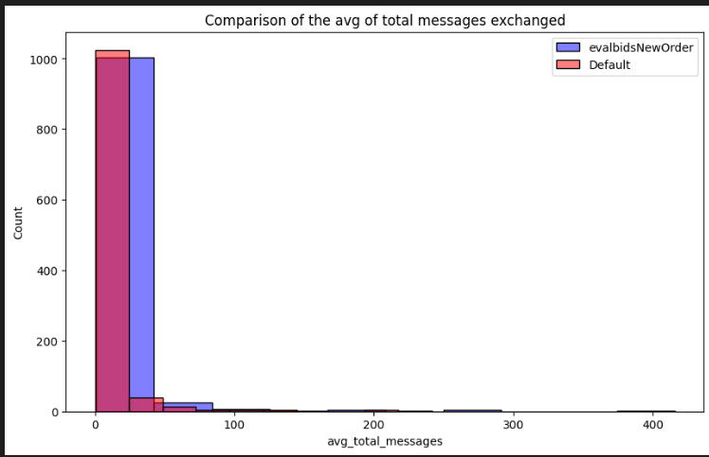

2.2 – Total messages exchanged in accepted bids
Takeway: There were more messages exchanged on average in bids accepeted of evalbidsneworder group than default group. This indicates that the interaction level between freelancer and cliente was higher in this group.

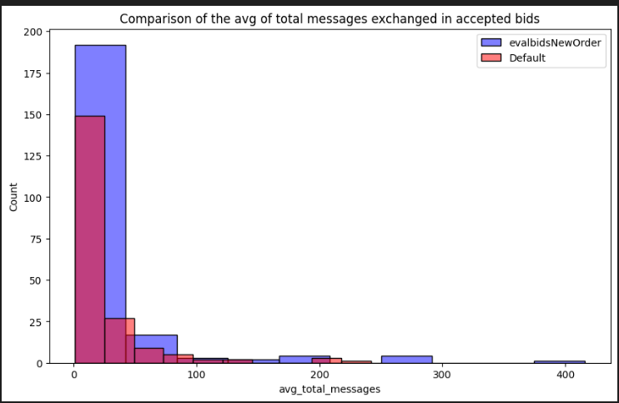
2.3 – Average of messages exchanged by day
Takeway: The evalbidsneworder had a performance more stable compared to default group. This can indicate that the new order of relevance was delivering a list with better matches to the clientes.

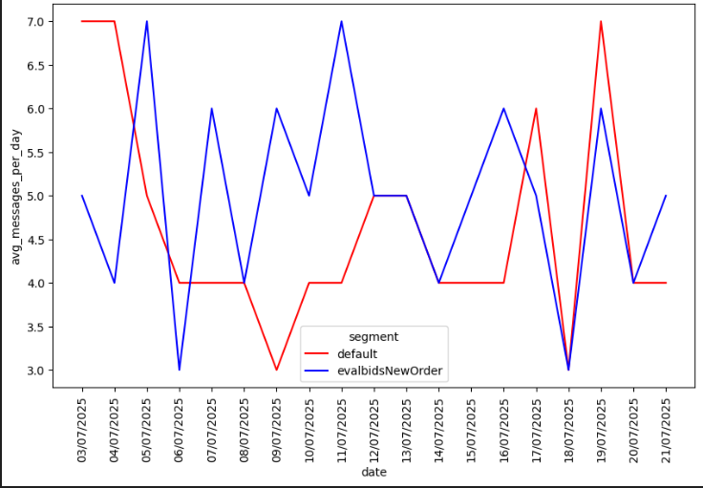

2.4 – Percentage of projects by EL1
Takeway: There is no relevant difference between groups. This metric was inconclusive.

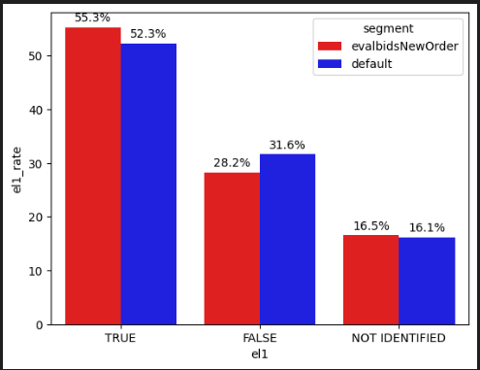
2.5 – Acceptance rate by gamification level
Takeway: The acceptance rate of evalbidsneworder group was higher for almost all gamification levels, principally levels with more experienced freelancers like hero and platinum. This result indicates an increase of matching quality from the new order in evalbids.
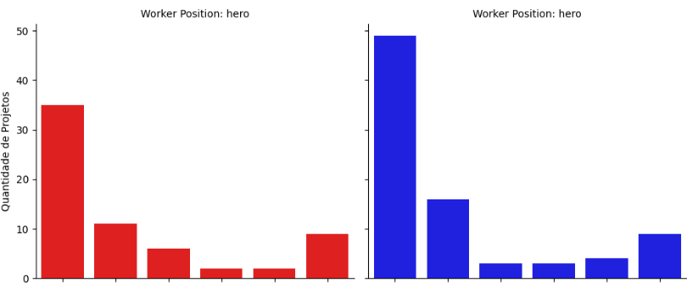
2.6 – Days between project posting and acceptance bid
Takeway: The number of days between project posting and acceptance bid was higher to the hero gamification level of evalbidsneworder. This result is another indicative of better matching quality with the new order application. Clients are finding more experienced freelancers and closing with them faster.
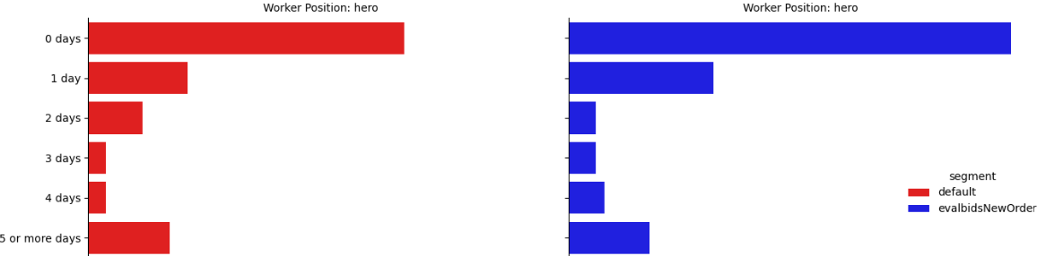

3 – Test Results
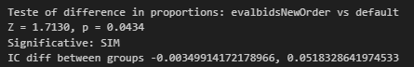
Besides the p-value nearly under 5%, if we look ate the condifdence interval, we can see that the difference between evalbidsneworder group and default group pass through the point zero. That indicates taht some results of the evalbidsneworder are statisticaly similar or worse compared to default group, and because of that, the difference has not statistically robust.

4 – Actions and Next Steps
Based on the collected evidences from the ab test applied. I suggest the following actions and next steps:
- The results are inconclusive based on the evidence collected from the test.
- To Run a second version of the test with more users in order to have more statistical power to conclude that evalbidsneworder group has a better performance than default group**.
- Focus on how to improve matching conditions for users with higher gamification levels like hero or platinum. Users from these levels had better performance in the test. Taking that in consideration, we have the opportunity to adjust the test to validade the hypothesis that weighting the evalbids with more experienced freelancers would increase the number of accepted bids in the platform.
- Use the support metrics ‘days between project posting and acceptance bid’, ‘acceptance rate by gamification level’ and ‘total messages exchanged in accepted bids’ as kpis to monitor the quality of usage in the platform.

** Considering 95% significante, 80% power, MDE ~2,5% (based on the difference between evalbidsneworder and default groups success rate). In case of success, this test could bring an incremental revenue of around 1,6k USD.

