# Detect vegetation burned areas in Ilia province(Greece), using the MODIS package in R

**Abstract**

In this project two MODIS images were downloaded and analyzed using R and mainly the packages MODIS and raster. The analysis regarded burned vegetation during the 2007 fires.

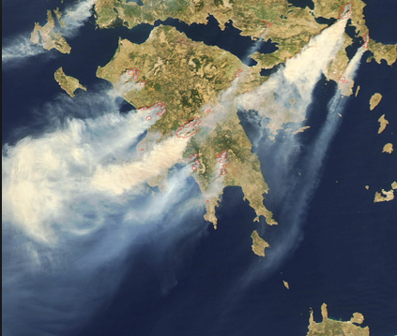**Introduction**

Between 23 and 27 of August 2007, the area of southern Peloponnese (Greece) and specifically the province of Ilia suffered from a huge fire, killing 67 people and burning more than 250,000 ha (!), including forest and agricultural areas as well as urban areas and infrastructures. In this project two MODIS multispectral images were used one before and one after the fire and their NDVI values were compared.

Figure : Ilia province at 25/08/2007

The date the first image was taken is 13/08/2007, which is 10 days before the beginning of the hazard and the date the second picture was taken is 14/09/2007, ten days after the end of the hazard. Both images have a spatial resolution of 250 meters.

**Objective**

Detect changes in NDVI between two MODIS images taken before and after the fire and estimate the total area of vegetation burned, as an area and as a percentage.

**Methodology**

* First, the data were downloaded using the MODIS package and the function runGdal() at the extent of Ilia province, which was downloaded using the getData() function of the Raster package after querying. With the use of runGdal() the images were also converted from hdf to geotiff, a form readable by R and saved to the workspace. Since we are only interesting on the NDVI, we are going to use only that layer and ignore any other information from the MODIS images.
* Second, the vegetation at the image prior to the fire had to be extracted. Only areas with high NDVI values were selected, representing the high vegetation of the area. The threshold was set to NDVI values bigger than 0.6
* Third, the NDVI at places with high vegetation were compared with the values after the fire for the same places. Thus, another rasterLayer was created, representing the difference in NDVI as a percentage
* Fourth, based on the previous raster areas were selected which their NDVI had decreased more than 60%. These are areas were before the fire had high vegetation (NDVI>0.6) and after the fire the NDVI has been decreased more than 60%. These are considered burned vegetation area
* Final, with the use of the custom functions burnedAreaHA() and burnedAreaPerCent() the burned area were evaluated in hectares and as a percentage of the original vegetation area.

**Results**

The total vegetation area burned was calculated to 1956.25 hectares or 5.39%

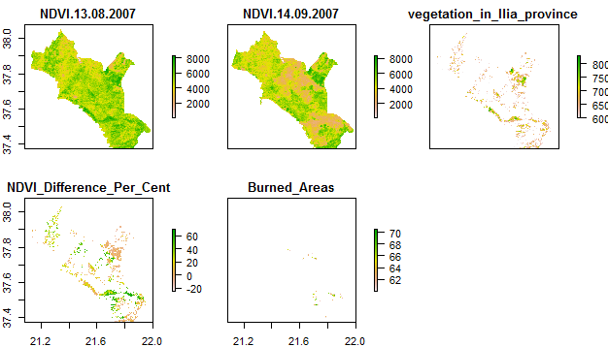

Figure : The RasterBrick object used and the layers produced in the project

**Conclusion**

During this project two MODIS images were downloaded and converted using the MODIS package and analyzed using a variety o functions, custom and not. At the end ,the burned area was calculated using a simplified methodology, as purpose of this project was to demonstrate the capabilities of R in geo-scripting and not an advanced methodology for burned areas detection. The MODIS package, if installed correctly, is really straightforward to use and handy to download and preprocess MODIS tiles.