**Technologies used:**

1. IIS server 8.5
2. Database: MYSQL
3. Backend: Perl CGI
4. Front End: HTML, JQuery, bootstrap, AJAX, JSON.

**Steps to run Project:**

1. Configured IIS to serve .pl scripts by adding handler mappings and MIME types for .pl file extension and the path for perl.exe.
2. Web service was added with hostname “[www.att-test.com](http://www.att-test.com/)” (included in screenshot below).
3. All the files and the directory structure should be copied into html directory for web server to access files.
4. Installed strawberry perl in windows and used the same to write .pl script.

Note: Can use .pl script for unix as well by changing from #!Strawberry\perl\bin\perl.exe

#!/usr/bin/perl

1. Created database in MYSQL in localhost with port:3306, username: root and password:lasya.
2. Queries used: create database dbAppointments

Create table dbAppointments.appointments(

Id INT NOT NULL AUTO_INCREMENT,

Appointment_date DATE NOT NULL,

Appointment_time TIME NOT NULL,

Description varchar(250) NOT NULL,

Primary key(id)

);

Note: Database creation can be automated using a simple perl script. To make it simple, I created the database using the above SQL commands.

7. Open browser and enter “<http://www.att-test.com/Main.html>” should

bring up the screenshots provided below.

**Screenshots for all usecases:**

1. **Main html page.**

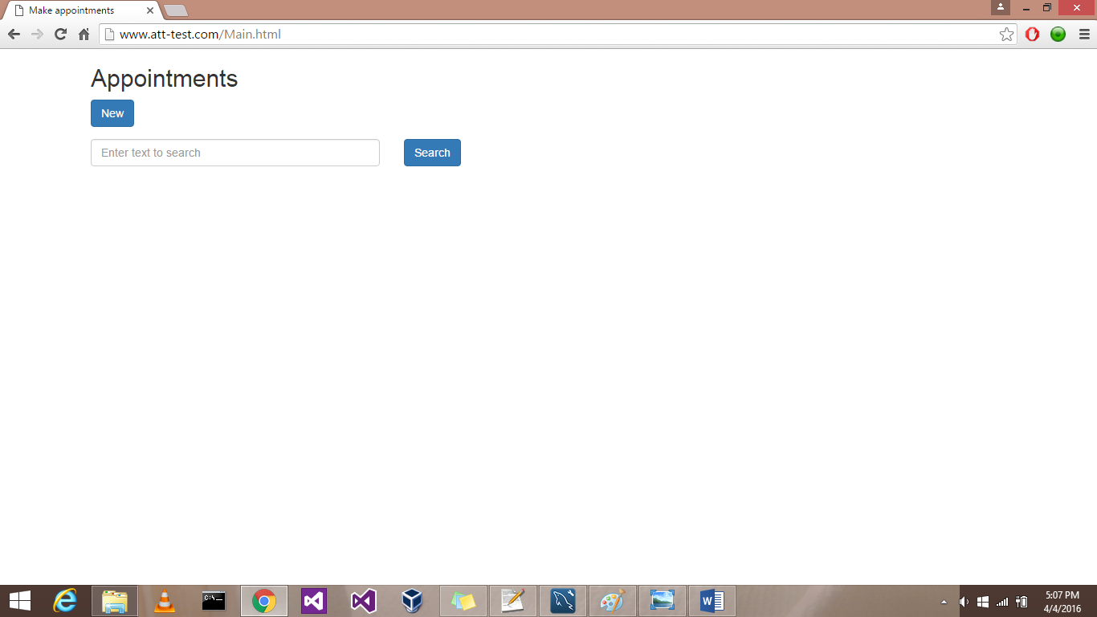

1. **when “New” button is pressed.**

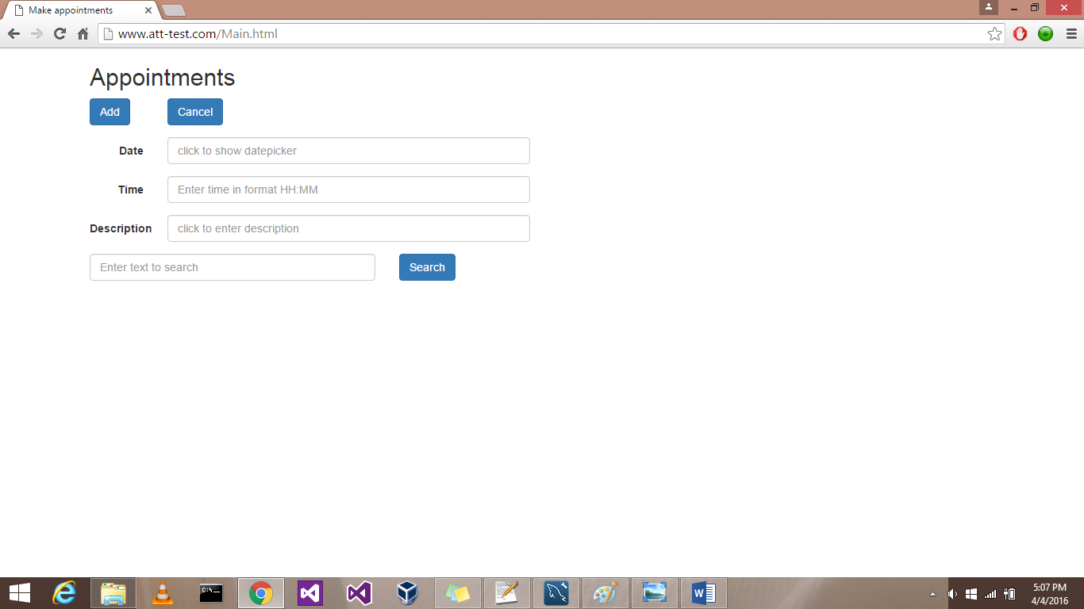

1. **Screenshot for datepicker.**

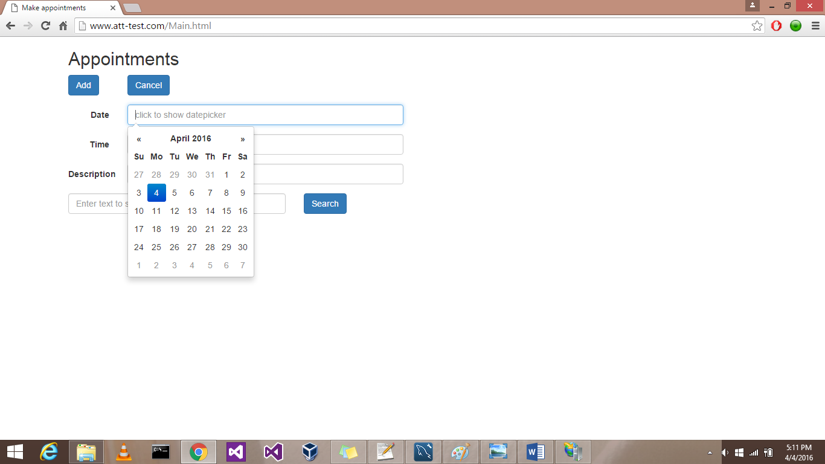

1. **Screenshot for default search**

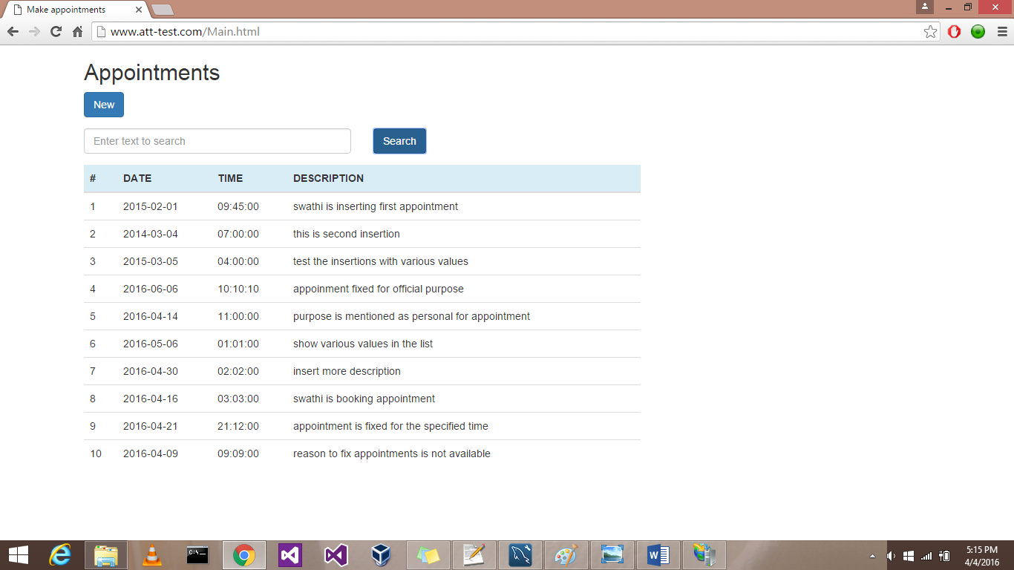

1. **Screenshot with filled form**

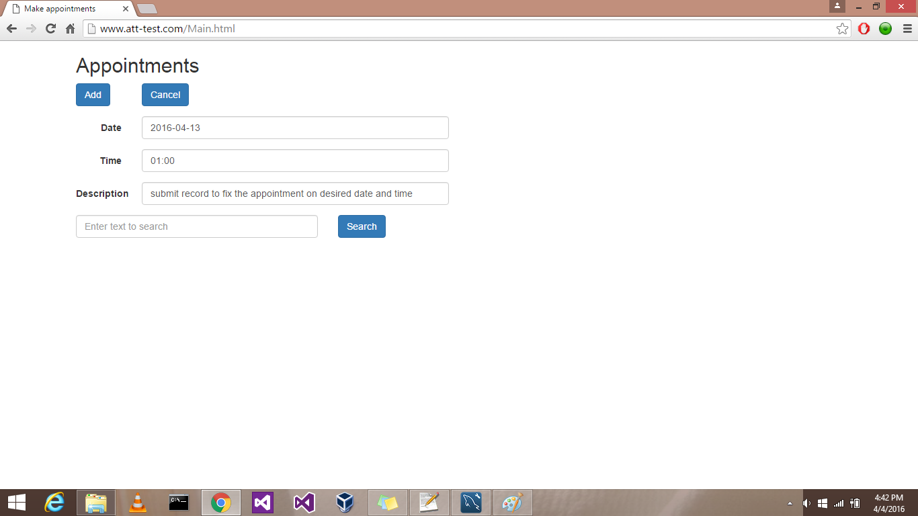

1. **Screenshot after appointment is inserted to database.**

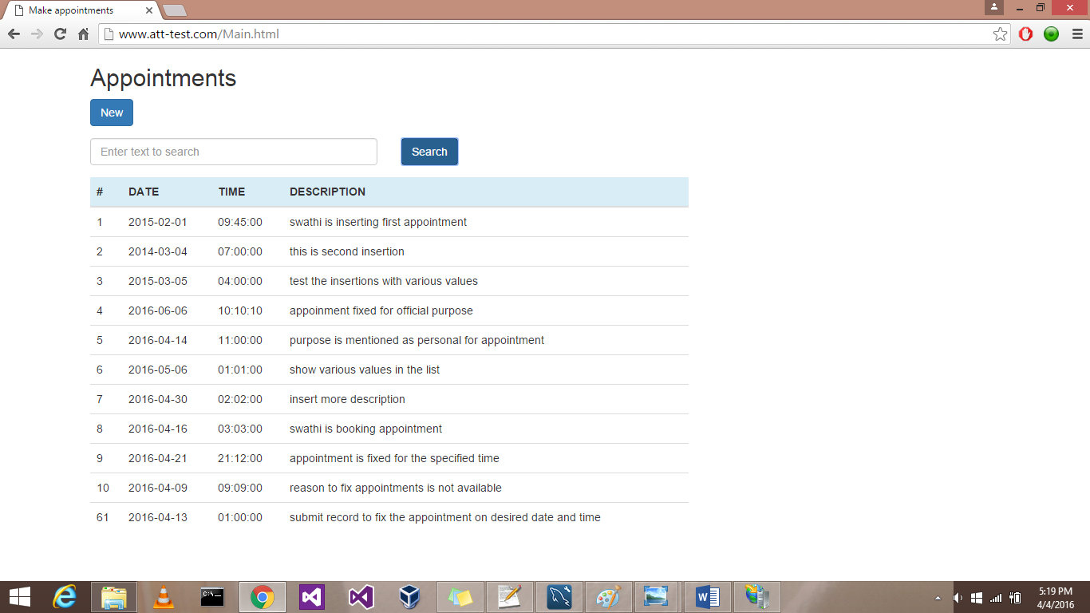

1. **Screenshot with search parameters**

