Externalizer

<https://docs.adobe.com/content/help/en/experience-manager-64/developing/platform/externalizer.html>

In AEM, the **Externalizer**is an OSGI service that allows you to programmatically transform a resource path (e.g. /path/to/my/page) into an external and absolute URL (for example, https://www.mycompany.com/path/to/my/page) by prefixing the path with a pre-configured DNS.

Configuring the Externalizer service

The **Externalizer**service allows you to centrally define multiple domains that can be used to programmatically prefix resource paths. Each domain is identified by a unique name that is used to programmatically reference the domain.

Steps:

1. Navigate to the configuration manager via **Tools,** then **Web Console,** or enter https://<host>:<port>/system/console/configMgr.

The direct link to the configuration is

https://<host>:<port>/system/console/configMgr/com.day.cq.commons.impl.ExternalizerImpl

1. Click **Day CQ Link Externalizer**to open the configuration dialog box.

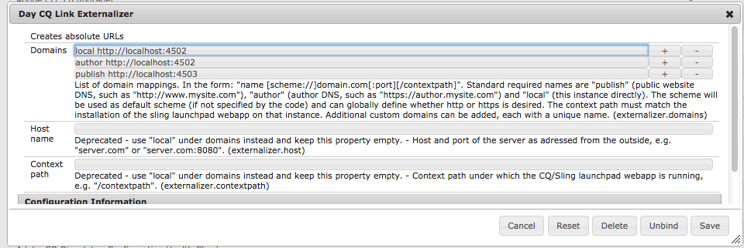

1. Define a domain mapping: a mapping consists of a unique name that can be used in the code to reference the domain, a space and the domain:

<unique-name> [scheme://]server[:port][/contextpath], where:

* **Scheme**is usually http or https, but can also be ftp etc.; use https to enforce https links if desired; it will be used if the client code does not override the scheme when asking for externalization of a URL.
* **Server**is the host name (can be a domain name or ip address).
* **Port**(optional) is the port number.
* **Contextpath**(optional) is only set if AEM is installed as a webapp under a different context path.

For example: production https://my.production.instance

The following mapping names are predefined and must always be set as AEM relies on them:

* **local**- the local instance
* **author**- the authoring system DNS
* **publish**- the public facing website DNS

1. Click **Save** to save your changes.

