Getting workflow resource path on which workflow runs.

String payloadPath = workItem.getWorkflowData().getPayload().toString();

Getting the process arguments that are added in process step

String[] params = processArguments.get("PROCESS_ARGS","string").

toString().split(",");

String attachmentsPath = params[0];

String saveToLocation = params[1];

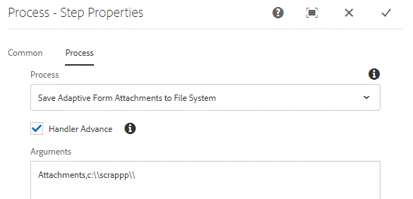

Here we have 2 arguments with comma separated.