PROJECT PROPOSAL
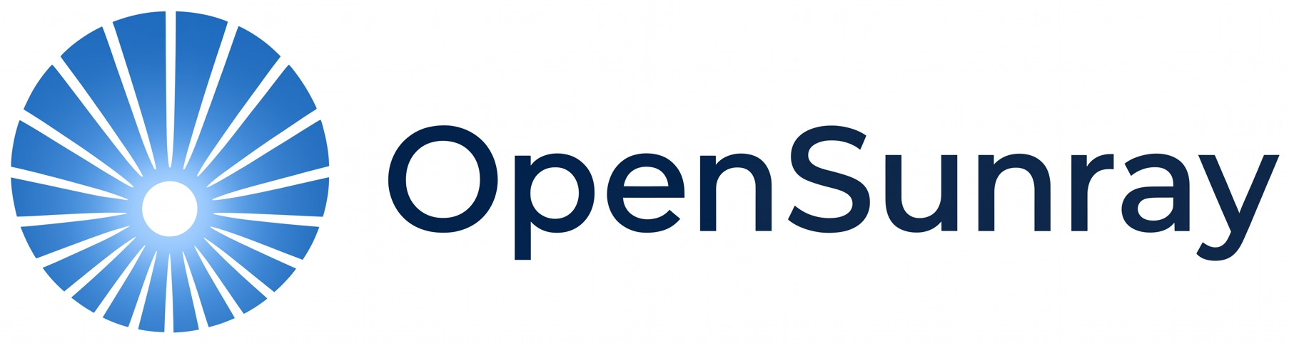
An AI-driven multimodal system for solar PV fault detection, localisation, severity analysis and rectification

Contents
1. Executive Summary
2. Problem Definition & Background
3. Proposed Solution — OpenSunray Insight
4. Market & Industry Analysis
5. Business Model
6. Implementation
7. Project Phases & Roadmap
8. Risks & Mitigations
9. Team
10. Supporting Materials

1. Executive Summary
OpenSunray Insight is an AI-driven multimodal system that detects, locates and rectifies solar panel faults quickly and accurately. It replaces the manual, fragmented inspection routines that utility-scale solar farms rely on today with a single pipeline that reads both electrical string data and thermal imagery, then automatically tells an operator what is wrong, where it is, how severe it is, and what to do about it.
The system has already been built and validated as a working prototype: four machine-learning components — fault detection, localisation, severity analysis, and rectification recommendation — have been trained, tested, and evaluated by independent domain experts, with detection accuracy exceeding 99% on both electrical and thermal data. The prototype has since been carried past the academic stage into a production-style deployment, with a rebranded, containerised API and a modern web dashboard.
This proposal sets out the problem OpenSunray Insight solves, how the solution works, who it serves, the business model behind it, and — most importantly — the phased roadmap that takes it from validated prototype to a pilot-ready, commercially viable product.

2. Problem Definition & Background

2.1 Problem Statement
Solar PV systems rely on manual, fragmented fault management, leading to delayed detection of issues such as hotspots, open circuits, short circuits, and shading. This results in energy losses, increased downtime, and higher maintenance costs due to the lack of an integrated, automated, data-driven solution.

2.2 Why It Matters
Global solar PV capacity has been expanding rapidly, driven by falling panel costs and supportive policy, but large-scale installations continue to underperform for reasons that have little to do with the panels themselves. Recent solar-asset inspection data shows that string-level electrical anomalies are the second-largest contributor to power loss across PV plants worldwide, behind only inverter issues, and account for roughly a quarter of total observed losses.
A representative site-level case study found that combined system- and module-level anomalies reduced annual energy production by 3.7%, equivalent to about USD 300,000 in lost revenue in a single year; string faults alone were responsible for the majority of that loss, at roughly USD 280,000. The same inspection data shows string-related faults increasing by close to a fifth in a single year, which points to a problem that is getting worse, not better, under current manual inspection regimes.

2.3 Research Background
Prior work in this space has consistently improved individual pieces of the fault-management puzzle: electrical-signal classifiers that detect anomalies with very high accuracy, deep-learning models that localise faults from thermal or electroluminescence imagery, regression models that estimate severity and power loss, and early explorations of automated maintenance recommendation. What remains largely unaddressed is the integration of these pieces: most published systems solve one stage of the pipeline in isolation, using either electrical data or imagery, but rarely both, and very few carry a detected, localised, and severity-scored fault through to an actionable rectification recommendation.
OpenSunray Insight is built directly to close that gap: a single system that combines both data modalities and covers the full pipeline from detection to recommended corrective action.

2.4 Project Scope
In-scope.
# | Capability
1 | Detects a defined set of fault types: open circuit, short circuit, shadowing, and hotspot.
2 | Locates the affected string or panel.
3 | Classifies fault severity and predicts the associated power loss.
4 | Recommends a rectification action to resolve the fault.
5 | Presents all of the above through a user-friendly web dashboard with visualisations.

Out of scope (for this phase).
# | Excluded for now
1 | Long-term degradation prediction for already-faulty panels.
2 | Electroluminescence (EL) imagery analysis.
3 | SCADA-based monitoring and control.
4 | Physical repair or modification of the PV installation itself.
5 | Return-on-investment or financial cost modelling.
6 | Extension to other renewable energy sources.

2.5 User Pain Points
- Manual inspection is slow, labour-intensive, and error-prone, so faults sit undetected while they continue to cost energy and money.
- Existing tools are fragmented: electrical monitoring and thermal imaging are typically analysed separately, so no single system gives a complete picture of a fault.
- Even where a fault is detected, operators are rarely told what to do about it — rectification is left entirely to human judgement.
- Black-box AI outputs are hard for field engineers to trust; without a transparent, explainable result, recommendations are likely to be ignored.

3. Proposed Solution — OpenSunray Insight

3.1 One-Line Pitch
A system that detects, locates, and rectifies solar panel faults quickly and accurately.

3.2 Solution Overview
OpenSunray Insight is built around four analytical components that together automate the full fault-management pipeline, from raw sensor and image data to a concrete maintenance recommendation:
Component | Approach | What it delivers
Fault Detection | Random Forest (electrical) + CNN / DenseNet201 (thermal) | Identifies open-circuit, short-circuit, shadowing, and hotspot anomalies as they occur.
Fault Localisation | CNN-BiLSTM hybrid (electrical) + DenseNet121 (thermal) | Pinpoints the exact string, module, or panel affected.
Fault Severity | XGBoost regression (electrical) + YOLOv11-OBB (thermal) | Quantifies expected power loss and classifies criticality for maintenance prioritisation.
Fault Rectification | Random Forest + reinforcement learning (Q-learning) | Recommends the optimal corrective action, adapting to environmental conditions.

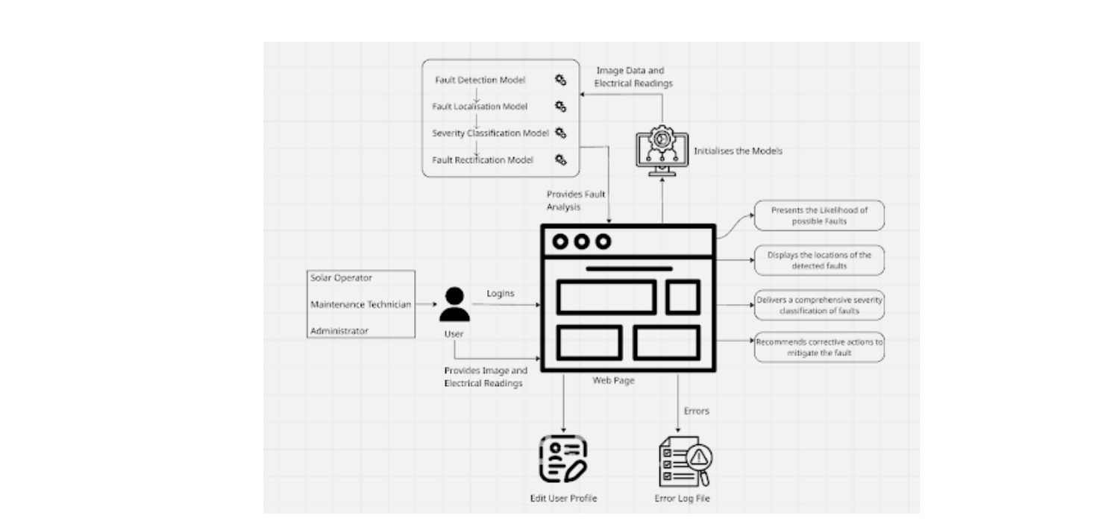
Figure 1 — System interaction overview: users, models, and the web dashboard.

3.3 System Architecture
The system exposes its four models through a Flask REST API, backed by a SQLite store for fault history, logs, and user accounts, with JWT-based authentication protecting all but the login endpoint. Users interact through a web dashboard — originally a Streamlit prototype and, following productisation, a Next.js dashboard — that lets a solar operator, maintenance technician, or administrator upload electrical readings or thermal images and receive fault analysis in return.

3.4 Purpose & Impact
The goal is to shift solar farm maintenance from a reactive, manual process to a proactive, data-driven one — catching faults earlier, cutting the time spent locating and diagnosing them, and giving operators a clear, prioritised, and actionable path to resolution. In practice that means less energy lost to undetected faults, less unplanned downtime, and lower maintenance cost per site.

3.5 Ethical & Social Impact
- Supports the transition to reliable renewable energy, directly reinforcing climate and clean-energy goals by keeping existing solar assets closer to their rated output.
- User data is limited to operational necessities — login credentials, uploaded readings/images, and prediction history — protected behind authenticated, role-aware access.
- Explainable-AI techniques are used alongside the detection models so that field engineers are shown why a fault was flagged, not just that it was — addressing the trust gap that blocks adoption of black-box recommendations.

3.6 What Makes It Different
Most existing tools solve one stage of fault management, using one data modality. OpenSunray Insight is deliberately end-to-end and multimodal: it fuses electrical and thermal evidence, and carries a fault all the way from first detection to a concrete rectification recommendation inside a single, explainable, web-based system.

4. Market & Industry Analysis

4.1 Target Audience & Market Segments
- Utility-scale solar farm operators
- Solar engineering & operations-and-maintenance (O&M) firms
- EPC (engineering, procurement, construction) contractors
- Asset owners and investors in solar infrastructure
- Insurance underwriters assessing solar-asset risk

4.2 Market Potential
Solar PV capacity continues to scale globally, and every gigawatt of new capacity brings more strings, more panels, and more inspection burden with it. Operators of large portfolios cannot realistically keep pace with that growth using manual inspection alone — the case-study losses cited in Section 2.2 recur, quietly, at scale, across the industry. That gap between installed capacity and available inspection capacity is the market OpenSunray Insight is built to serve, and it grows every year new capacity is added.

4.3 Competitive Differentiation
Solar operators today choose between manual visual inspection, SCADA-based alarm systems, and a small number of single-purpose detection tools that look at either electrical data or imagery, but not both, and rarely go further than “a fault happened.” OpenSunray Insight differentiates on three points: it is multimodal (electrical and thermal together), it is end-to-end (detection through to a recommended fix, not just a flag), and it is explainable (engineers see the reasoning behind a recommendation, not just a black-box output).

5. Business Model

5.1 Business Model Canvas
Block | Details
Key Partners | Engineering-solutions partners, solar farm operators, IoT hardware suppliers, cloud infrastructure providers
Key Activities | Model development & retraining, dashboard and API development, partner data collection, automated fault reporting
Key Resources | Trained AI models, proprietary PV fault dataset, the Flask + web dashboard platform, engineering partnerships
Value Propositions | >99% detection accuracy • precise string/panel localisation • automated severity prioritisation • automated rectification guidance • up to 80% faster fault diagnosis than manual inspection
Customer Relationships | Self-service dashboard, automated fault reports, an ongoing partner feedback loop
Channels | Web application, REST API, direct engineering partnerships
Customer Segments | Utility-scale solar operators • solar engineering & maintenance firms • EPC contractors • asset owners & investors • insurance underwriters
Cost Structure | Model development & cloud compute, data acquisition & labelling, sensor/hardware infrastructure, platform hosting & maintenance, engineering & research talent
Revenue Streams | SaaS subscriptions • B2B enterprise licensing • pay-per-report diagnostics • API access fees

5.2 Go-to-Market Strategy
The initial route to market runs through the engineering partners and solar farm operators who already contributed data and feedback during development: converting those relationships into pilot deployments, using the results to refine the product, and then expanding into B2B licensing with O&M firms and EPC contractors who need the same capability across larger portfolios.

5.3 Partnerships & Funding
The project currently sits within an academic partnership between the Informatics Institute of Technology and Robert Gordon University, Aberdeen. Moving forward, the plan is to deepen data-sharing agreements with partner farms (replacing synthetic training data with real operational data), and to explore university innovation funding and renewable-energy-focused grants or accelerators to support the pilot and scale-up phases described in Section 7.

6. Implementation

6.1 Technology Stack
Layer | Technology
Machine learning | Python, scikit-learn, TensorFlow / Keras, XGBoost
Backend API | Flask REST API, JWT authentication, SQLite
Frontend | Next.js (React) dashboard, deployed on Vercel
Deployment | Docker containers, deployed on Render, GitHub Actions CI/CD

6.2 Stakeholder Impact
- Operators & technicians: faster, clearer diagnosis and less unplanned downtime.
- Asset owners & investors: protected energy yield and revenue.
- Insurance underwriters: objective, data-backed severity assessments for risk pricing.
- Wider society: more reliable renewable generation supports climate and clean-energy goals.

6.3 User Journey
- The user logs in and, if needed, updates their profile.
- The user requests a fault analysis and uploads electrical readings (CSV) or thermal images (JPEG/PNG).
- The system loads the relevant models and processes the uploaded data.
- Each component model — detection, localisation, severity, rectification — produces its output.
- Results are displayed on the dashboard, with any errors logged for review.

7. Project Phases & Roadmap
OpenSunray Insight has already moved through a full research-to-prototype cycle and into a rebranded, production-style system — that is where the project stands today, as Phase 1. The remainder of this section sets out the concrete stages that take it from a validated system to an operating startup.

7.1 Phase 1 — Foundation: Research, Prototype & Productisation (Completed — Current Status)

Research & Prototype
Milestone | Outcome | Timeline
Topic selection & literature review | Established the multimodal integration gap this project addresses | Sep–Oct 2025
Project proposal & requirements (SRS) | Scope, stakeholder analysis, and functional/non-functional requirements defined | Oct–Nov 2025
System design | Architecture, component/class/sequence diagrams, and UI design completed | Nov 2025–Jan 2026
Prototype implementation | All four ML components built and integrated behind a working dashboard | Jan–Feb 2026
Testing & evaluation | Functional, integration, and performance testing, plus independent domain-expert evaluation | Feb–Mar 2026
Documentation | Full technical documentation completed | Mar–Apr 2026

Productisation
- Rebranded the academic prototype into OpenSunray Insight, with a consistent identity across the API, dashboard, and documentation.
- Migrated the dashboard from the original Streamlit prototype to a Next.js (React) frontend deployed on Vercel.
- Containerised the Flask API with Docker and deployed it on Render, with GitHub Actions CI/CD.
- Added JWT-based authentication with role-aware access for operators, technicians, and administrators.
- Integrated an optional AI assistant widget for natural-language questions about detected faults and results.

Validation Results
Component | Model | Key result
Fault Detection (electrical) | Random Forest | 99.9% accuracy
Fault Detection (thermal) | DenseNet201 | 99.3% accuracy
Fault Localisation (electrical) | CNN-BiLSTM hybrid | 85.0% accuracy
Fault Localisation (thermal) | DenseNet121 | 100% accuracy
Fault Severity (electrical) | XGBoost regressor | R² = 0.999, MAE = 0.002
Fault Severity (thermal) | YOLOv11-OBB | mAP@50 = 0.479
Fault Rectification | Random Forest + Q-learning | 84.0% accuracy

Independent domain-expert feedback
“If this can be scaled to handle real-time data and actively detect faults, it would be more convenient for engineers.” — M. Madushanka
“This is a commercially viable solution that reduces manual inspection costs.” — Nilantha Wijethilake
“It's a good application since solar energy is becoming widely adopted in households.” — Dr. Dinesh Arunatileka

7.2 Phase 2 — Startup Launch & Market Presence (Next)
With the system built and validated, the next stage is establishing OpenSunray Insight as a company that solar operators and partners can find, trust, and buy from.
- Produce marketing creatives and ads — demo videos, one-pagers, and social content — showcasing the detection-to-rectification pipeline to solar operators and O&M firms.
- Turn this proposal into a polished, investor- and partner-ready pitch deck, backed by the validation results above.
- Establish a company identity: register the OpenSunray Insight brand, launch a company LinkedIn page and supporting social presence, and stand up a simple marketing website.
- Begin direct outreach to prospective partners and early customers (engineering partners, solar farm operators) using the material above.
- Apply to university innovation funding, renewable-energy-focused grants, and startup accelerator programmes.

7.3 Phase 3 — Pilot & Data Validation (Following)
- Run pilot deployments with partner farms and engineering partners to replace synthetic training data with real operational data.
- Expand fault-type coverage and the current 32-string-per-analysis limit toward larger, real-world farm sizes.
- Surface SHAP-based explainability directly in the dashboard to strengthen operator trust in recommendations.
- Run structured usability testing with operators, technicians, and maintenance managers.

7.4 Phase 4 — Scale & Enterprise Readiness (Future)
- Build a real-time data pipeline connecting detection directly through to rectification recommendations, without manual upload.
- Add multi-user, multi-company login with enterprise-grade authentication.
- Extend to multi-spectral imaging for broader fault-type coverage.
- Ship a native/mobile companion app with push notifications for field technicians.
- Move to commercial rollout under the SaaS / B2B licensing model set out in Section 5.

8. Risks & Mitigations
Risk | Mitigation
Limited real-world fault data; heavy reliance on synthetic data | Combine public datasets, partner-collected data, and synthetic augmentation; prioritise real operational data as pilots (Phase 3) come online
Severe class imbalance in fault data | Class-weighting and other imbalance-aware training techniques to protect recall on rare, critical faults
Environmental variability (irradiance, temperature, shading) | Broaden training conditions and develop adaptive models that generalise across environments
Operator trust in automated recommendations | Explainable-AI outputs (e.g. SHAP) surfaced directly in the dashboard alongside every recommendation
Dependence on a small number of data-sharing partners | Maintain multiple partner relationships in parallel, having already experienced one partner withdrawal during Phase 1
Scaling beyond the current 32-string limit | Architectural changes planned for Phase 4 to support larger farm deployments

9. Team
Name | Role | Key contributions
Mohamed Razik Seyed Rumaiz | Team Leader / ML Engineer & Full Stack | Backend integration (inference, pipelines), REST API, database integration, dashboard, documentation
Tamadhi Liyanage | Scrum Master / ML Engineer | Literature review, primary liaison with domain experts, electrical fault-localisation model, thermal hotspot-localisation model, dashboard
R. M. Manuli Maneka Gokarella | ML Engineer | Hybrid rectification model, backend integration of trained models, rectification UI
Dion Rasmika | ML Engineer | System component design, electrical and thermal image models, dashboard visualisations, unit testing

Supervisor: Ms. Suvetha Suvendran

10. Supporting Materials
The following materials are available in support of this proposal:
- System architecture, component, class, and sequence diagrams.
- The full sprint-by-sprint delivery schedule from the research phase, available on request.
- Detailed model evaluation results (accuracy, precision, recall, F1, ROC-AUC/PR-AUC) for every component.
- The working OpenSunray Insight codebase, covering the ML pipeline, Flask API, and web dashboard.
- Recorded prototype demonstration and dashboard screenshots, available on request.

