**Thamaine Gangiah**

**PHASE 2: ER/EER MODEL AND RELATIONAL SCHEMA**

**1.ER/EER MODEL**

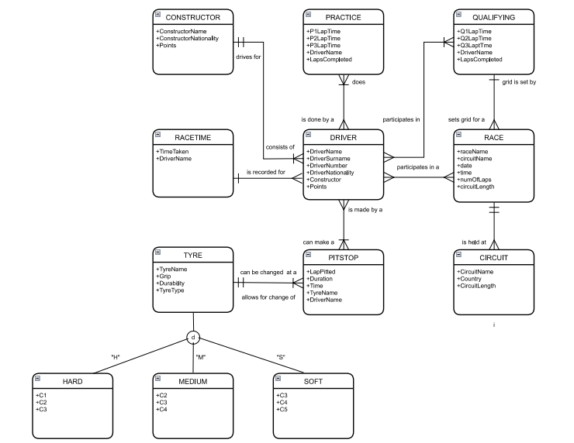

**2.RELATIONAL SCHEMA**

PRACTICE (P1LapTime, P2LapTime, P3LapTime, DriverName, LapsCompleted, PracticeID)

QUALIFYING (Q1LapTime, Q2LapTime, Q3LapTime, DriverName, LapsCompleted, QualifyingID)

RACE (raceName, circuitName, date, time, numOfLaps, circuitLength, RaceID, QualifyingID)

CONSTRUCTOR (ConstructorName, ConstructorNationality, Points, ConstructorID)

DRIVER (DriverName, DriverSurname, DriverNumber, DriverNationality, Team, Points, RaceID, QualifyingID, PitstopID, ConstructorID, RaceTimeID)

RACETIME (TimeTaken, DriverName, RaceTimeID)

CIRCUIT (CircuitName, Country, CircuitLength, CircuitID, RaceID)

PITSTOP (LapPitted, Duration, Time, PitstopID, TyreID)

TYRE (CompoundAvailable, Grip, Durability, TyreID)

HARD (HTyreID, C1, C2, C3)

MEDIUM (MTyreID, C2, C3, C4)

SOFT (STyreID, C3, C4, C5)