THE OPEN UNIVERSITY OF SRI LANKA
DEPARTMENT OF ELECTRICAL & COMPUTER ENGINEERING
BACHELOR OF SOFTWARE ENGINEERING

EEI6373 – Performance Modelling

Mini Project Deliverable

Name: P.V. Thamara
Student ID: S92061755
Registration No: 622512849

1. Identify a Complex System
The selected system is an Outpatient Department (OPD) healthcare delivery process. The system represents the flow of patients from arrival at the OPD through registration and doctor consultation until they leave the modeled process.
The high-level problem is to understand how patient demand and available service capacity affect waiting time, resource utilization, and the overall time a patient spends in the system. In particular, the project investigates whether registration desks or doctor consultation capacity creates greater delay, and how changing the number of doctors or the patient arrival rate changes system performance.

System Flow
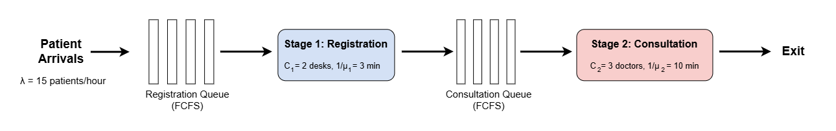
Why This is a Complex System
The OPD process has several steps. Patients first go to registration and then wait for a doctor. If there are too many patients, queues can form and waiting times can increase.
There are also multiple registration desks and doctors, so we need to consider how these resources are used.
Therefore, we can measure things such as:
- Patient waiting time
- Doctor and registration desk utilization
- Total time a patient spends in the system
- How the system performs when the number of patients increases
This makes the OPD process suitable for simulation and performance analysis.

Performance Model
Each service stage is represented as an M/M/c FIFO queue. Patient arrivals are modeled using exponentially distributed inter-arrival times, corresponding to a Poisson arrival process. Service times at registration and doctor consultation are modeled using exponential distributions. Patients are served on a First-In-First-Out (FIFO) basis.

Stage | Queue Model | Servers (c) | Mean Service Time | Queue Discipline
Registration | M/M/2 | 2 desks | 3 minutes | FIFO
Doctor consultation | M/M/3 | 3 doctors | 10 minutes | FIFO

The two registration desks result in an M/M/2 registration stage, while the three parallel doctors result in an M/M/3 consultation stage. These are baseline assumptions for the simulation and are later varied in the experiments.

Dataset
The project uses a simulated dataset generated by the queueing model rather than claiming to use confidential or real hospital records. The dataset contains 500 simulated patients in the base scenario. A fixed random seed is used so that the simulation results are reproducible.

Dataset Variables
For each simulated patient, the dataset records the main event times and waiting/service measurements required for performance analysis.
Variable | Meaning
Patient_ID | Unique identifier for each simulated patient
Arrival_Time | Time at which the patient arrives
Reg_Wait | Waiting time before registration starts
Registration_Start | Registration start time
Registration_End | Registration completion time
Reg_Service_Time | Time spent being registered
Cons_Wait | Waiting time before doctor consultation
Consultation_Start | Doctor consultation start time
Consultation_End | Doctor consultation completion time
Consultation_Service_Time | Time spent in consultation
Total_Waiting_Time | Registration waiting time plus doctor waiting time
Time_in_System | Time from patient arrival until consultation completion

Base Dataset Parameters
Parameter | Base Value | Description
Number of patients | 500 | Number of simulated patients
Mean inter-arrival time (1/λ) | 4.0 minutes | Average time between consecutive arrivals
Arrival rate (λ) | 15 patients/hour | 60 / 4.0
Registration desks | 2 | Parallel registration servers
Mean registration service time | 3.0 minutes | Average registration duration
Doctors | 3 | Parallel doctor servers
Mean consultation service time (μ) | 10.0 minutes | Average consultation duration
Queue discipline | FIFO | First-In-First-Out
Arrival distribution | Exponential inter-arrival times | Poisson arrival process
Service distribution | Exponential | At both service stages
Random seed | 42 | For reproducibility

2. Performance Objectives
The project focuses on measurable performance characteristics of the OPD process. The objectives are:
- Minimize patient waiting time: Measure and compare average registration waiting time, doctor waiting time, and total waiting time.
- Measure time in the system: Evaluate the average time from patient arrival until completion of the doctor consultation.
- Identify potential bottlenecks: Compare resource utilization and waiting contributions at registration and doctor consultation stages.
- Evaluate resource allocation: Study how changing the number of doctors affects patient waiting time and doctor utilization.
- Evaluate scalability under increased load: Study how increasing the patient arrival rate affects waiting time and overall system performance.
- Assess resource utilization: Measure the percentage of available server capacity used by registration desks and doctors.
Primary Performance Metrics
- Average registration waiting time (minutes)
- Average doctor waiting time (minutes)
- Average total waiting time (minutes)
- Average time in system (minutes)
- Registration desk utilization (%)
- Doctor utilization (%)

Git Repository
The project repository will contain the Word deliverable, simulation source code, generated dataset, and supporting result files.
Repo Link: thamara2X1/Outpatient-Department-OPD-Healthcare-Delivery-Process

