**E-Book-Library**

**Problem Statement**

Problems that are faced by most of users while using the current Library system is that the current libraray system doesn’t allow users acess the books over online

1. Due to the busy schedule in our daily lives even though we

wish to read book we are not able to do that as it is not available online.Every user should go up to ibrary to find out if the book is available or not.

2. Every time a user calls for a book you have to check the racks for the availability of the book. - Too much of physical work.

3. If some user reserves the book, he’s not sure if he definitely can get the book as the previous user may not return in time.

4. Either the user has to call or come to the library to reserve the book, but cannot reserve online over the internet.

5. Fines have to be calculated manually.

6. users have no facility to check their account.

**Scope of work**

The on-line Library Management System should manage different types of Books. which the management feels in the future could form a resource. A resource can be categorized to facilitate searching, sorting and managing the resources. This can be exemplified by dividing the books as general category. Users can borrow resources from the library. There will be a return date stipulated for the borrowed resource depending upon the individual to whom the resource has been lent to. If a stipulated return date has been specified and the resource is not returned within this stipulated due date, a fine may be imposed on the resource user. The basic fine amount should be updatable by the management if a need to do so arises in the future. The System should also allow users for a provision to rent one or more books , where by an individual can borrow the rented resource at once .

**System Overview**

The Library Management System is a web-based application which is able to manage different types of Books and any other resources which the management feels in the future could form a resource

Basically, there are three views for the convenience of the user. In the catalogue view the user can find all available books in library, in My Account view the user can know the details of books he borrowed and in Administrator view the admin have all the rights to add,delete,modify etc., Advanced search ,searches according to author ,book name. these are the main functions of the system.

Context Diagram summarizes all processing activity and also helps users to view highest level of system with system boundaries. The system overview can be shown in the form of context diagram.

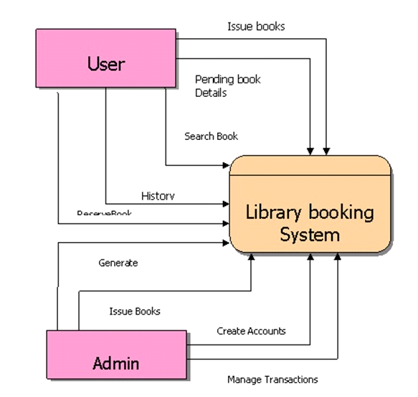

**Software Design**

The Library Management System is being developed for the users .important modules that are going to implement in the proposed system.

* Login facility for the users.
* view all the books present and choose among them
* Administrator has all the privileges to add, modify and delete the user data.
* users can rent the books.
* Searching facility depends upon i) Book name ii) Author.
* My account facility for the users so that he can view his account details.

**Architectural Design**

Name: Library First Page

Type: ASP page

Description:

First page contains the welcome message as well as the navigation buttons to direct the user to other pages. First page consists of catalogue view, My Account, Admin, Advanced Search. Left panel will have Categories of the books, and all the books available.

Name: user-account page

Description:

If the user wants to check their account details, it can be done with the help of MyAccount.When ever My Account button is clicked it asks the user login name and password, if the login name and password is valid the user is directed to My account page. Items Borrowed-Shows the current items holding by the user.

Issue History-Shows the history of issue details of the user.

Operations:

            Pre-condition: Connected to site

            Post-condition: presents another page

            Exceptions: None

Name: Administration Page

Description:

Administrator has all the rights of the complete system. To access the Administration Page the user has to enter login name and password if they are valid then the user can access Administration page.

Authors-Shows the authors list

Categories-Gives the information about all the categories of books in the database.

Final Issue-This page contains the list of the people who rented the books.

Transfer-It shows a page where the administrator can have the book list and list of different categories and he can transfer books from one category to other.

Pre-condition: Connected to site

            Post-condition: presents another page

            Exceptions: None

**Technoligies we Use:**

* Hml and Css.
* React and React Hooks.
* Material ui.
* Nodejs, Express js
* Mongo db.

**Roles:**

FrontEnd:Thamarai selvi.M

Backend: Praveen Kumar.B