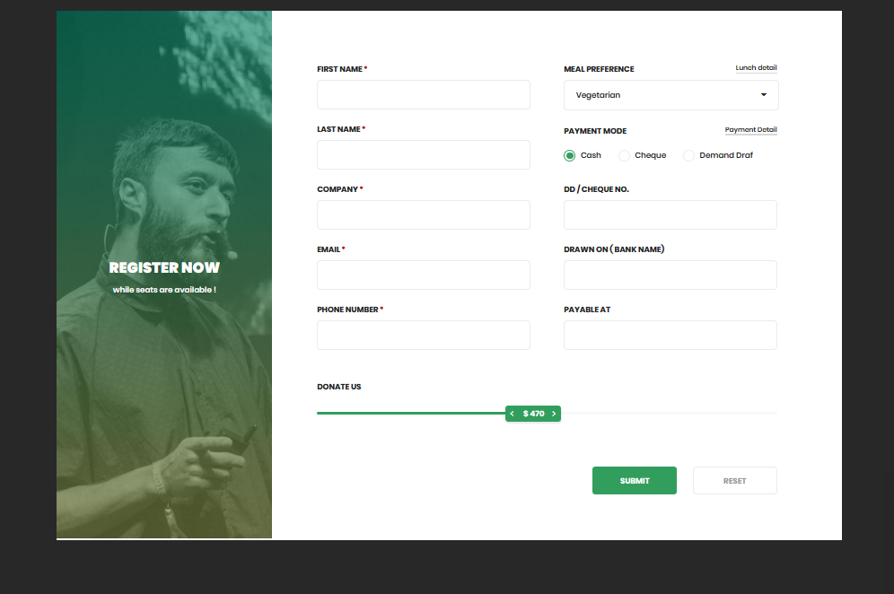Create a cfm file and design the page displayed like below image. ( should be a cfm file as we need to use this file in future for coldfusion CRUD )