Thamburu Tejasree

ID:LTVIP2026TMIDS70019
BOOKNEST:

WHERE STORIES NESTLE

INTRODUCTION

BOOK NEST is an app for book lovers, a charming community for those who love to read e-books.Readers can find favourite book. Also, authors can share their stories with the book nest community.
BookNest is a comprehensive full-stack web application developed using the PERN stack (PostgreSQL, Express.js, React.js, and Node.js). It functions as an online book shop where users can effortlessly browse, search, and purchase a wide array of books. Additionally, BookNest features a dynamic blogging platform that allows users to read and create posts on various literary topics, enhancing the community aspect of the platform.


PROJECT OVERVIiW
FEATURES:
User Authentication: Secure user registration and login using JWT.
Bookstore: Browse, search, and purchase books with ease.
Blog Section: Read and create blog posts about books, authors, and literary trends.
User Profiles: Personalized user dashboard displaying user information and activity.
Shopping Cart: Add books to the cart and manage purchases seamlessly.
Reviews and Ratings: Users can submit reviews and ratings for books.
Admin Dashboard: Manage books, posts, and user data efficiently

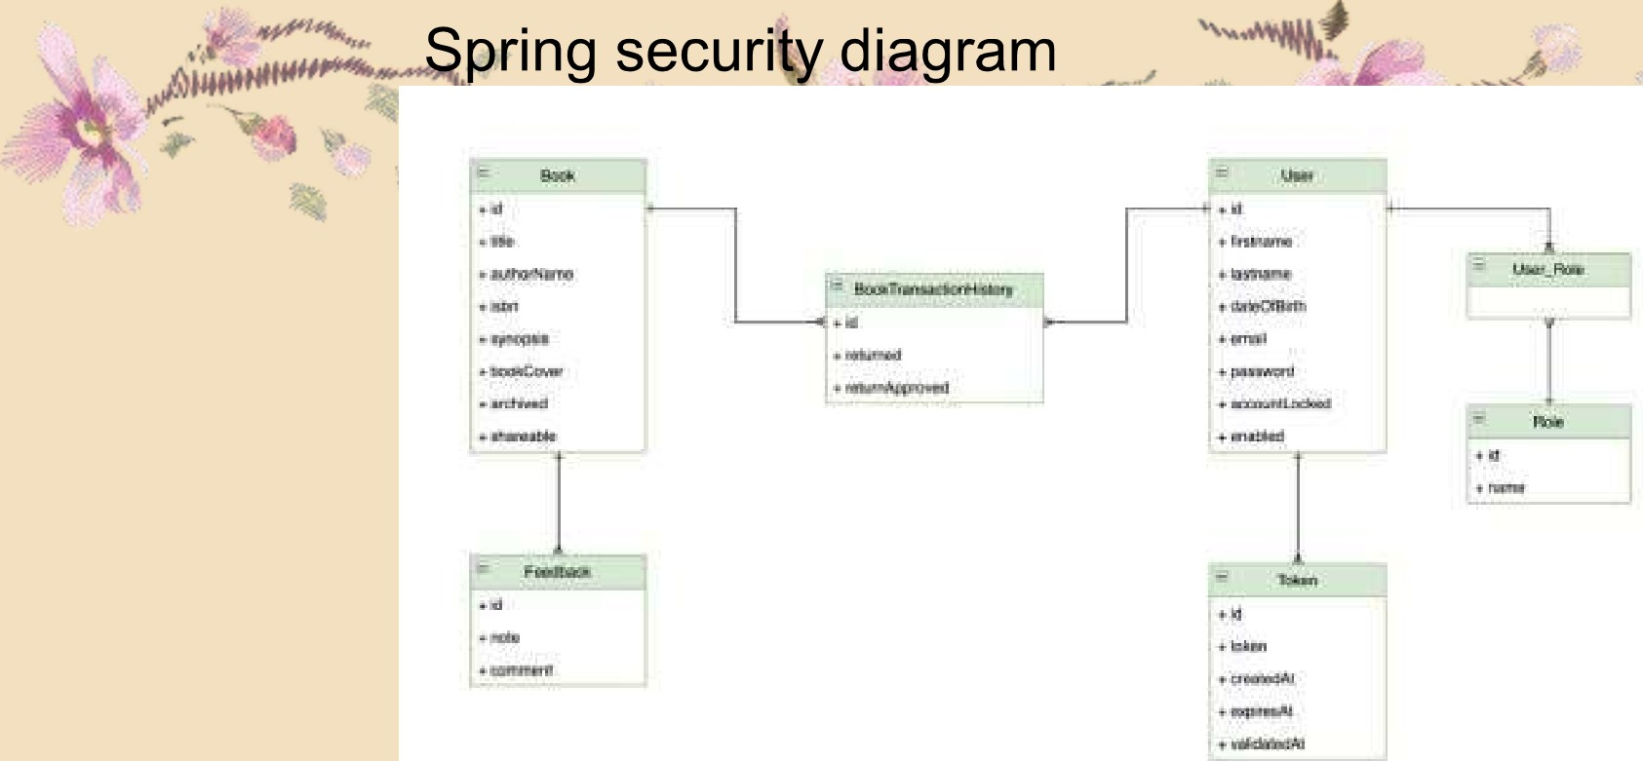
ARCHITECTURE
TECHNOLOGIES USED
Frontend:
React.js
React Router
Axios for API requests Tailwind for styling
Backend:
Node.js Class diagram
Express.js
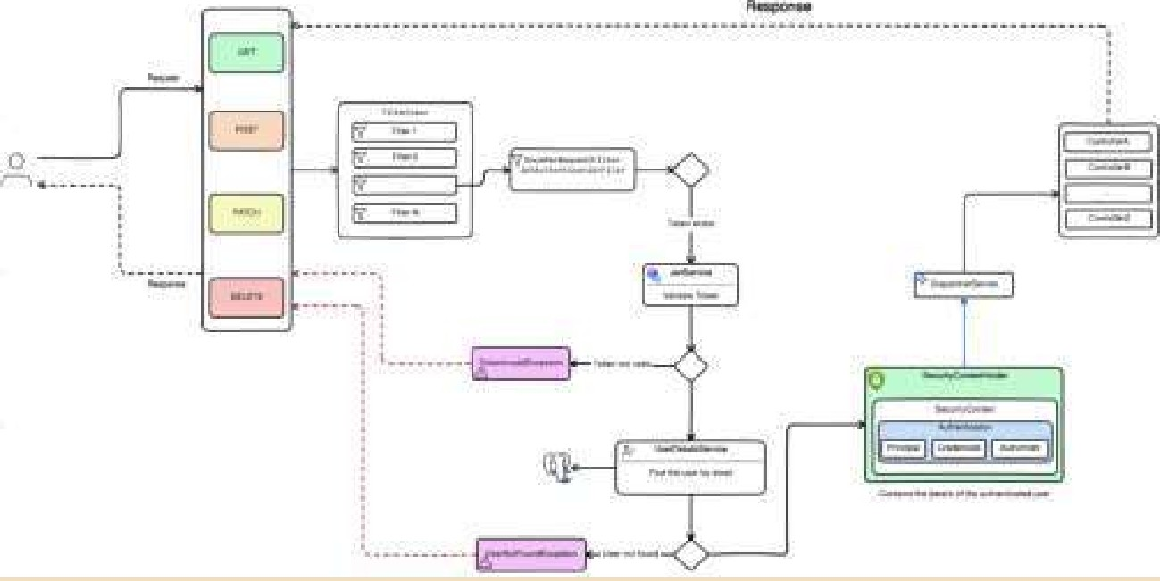
JWT for authentication Multer for file uploads
Database:
PostgreSQL
Environment Variables:
dotenv for managing sensitive data

INSTALLATION
Follow these steps to setup the BookNest appilication on your local machine:
1 .Clone the repositoryzgit clone htt s:// ithub.com/Manish312002/-BOOKNEST-Ultimate-Online-Bookstore-and-Litera
-Community.git cd -BOOKNEST-Ultimate-Online-Bookstore-and-Literary-Community.
2.1nstalI backend dependencies: cd server npm I
3.1nstalI frontend dependencies:cd ../client npm I
4. Set up environment variables: Create a .env file in the backend directory with the following content:
PG USER=your_username
PG
PG DATABASE=your_database
PG HOST=localhost
PG PORT=5432
5.Run the backend server:cd ../server nodemon server.js
6. Run frontend server:cd ../client npm run dev

FOLDER STRUCTURE RUNNING APPILICATION
1.CIient (React frontend): 1 .F rontend:
Typical React folder layout: open a terminal in the client directory
src/' components, pages, assets, App.js, index.js. Run npm install(first time) then
**npm start* * public/' index.html, favicon. 2.Backend:
package.json' for dependencies & scripts. open a terminal in the client directory
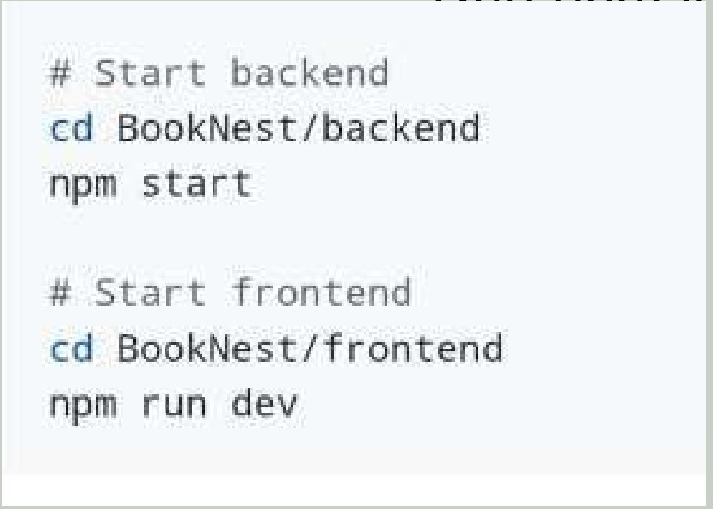
2. Server (Node.js backend): RI In nnm install(first time)then npm start(or
- Typical Node.js folder layout:if configured).
'routes/' API endpoint handlers.
'controllers/' —5 business logic.
models/' database schemas (Mongoose/Sequelize).
app.js' or 'server.js' main server file.

API DOCUMENTATION
User Authentication:
POST /register: Register a new user,POST /login: Log in an existing user , GET /profile: Get user profile information
Books:
GET /books: Get a list of books , POST /upload-book: Add a new book ,PATCH /book/update/:id: Update book details ,DELETE /book/delete/:id: Remove a book
Blog Posts:
GET /posts: Get all blog posts ,POST /dashboard/upload-post: Create a new blog post ,PATCH /post/update/:id: Update a blog post ,DELETE /post/delete/:id: Delete a blog post Cart Management:
GET /shop/cart: Get the user's shopping cart ,POST /shop/cart: Add an item to the cart ,DELETE /cart/delete/:id: Remove an item from the cart
Reviews:
GET (revltw$: Gef all reviews ,POST /review: Submit a review for a booe 

GET /dashboard/user: Get the user ,GET /dashboard/books: loaded books ,GET /dashboard/po*ifet user uploaded posts
Dashbo
POST /dashboard/logout: Log out user

AUTHENTICATION
Secure user registration and login using JWT.
Bookstore: Browse, search, and purchase books with ease.
Blog Section: Read and create blog posts about books, authors, and literary trends. User Profiles: Personalized user dashboard displaying user information and activity.
Shopping Cart: Add books to the cart and manage purchases seamlessly.
Reviews and Ratings: Users can submit reviews and ratings for books. Admin Dashboard: Manage books, posts, and user data efficiently

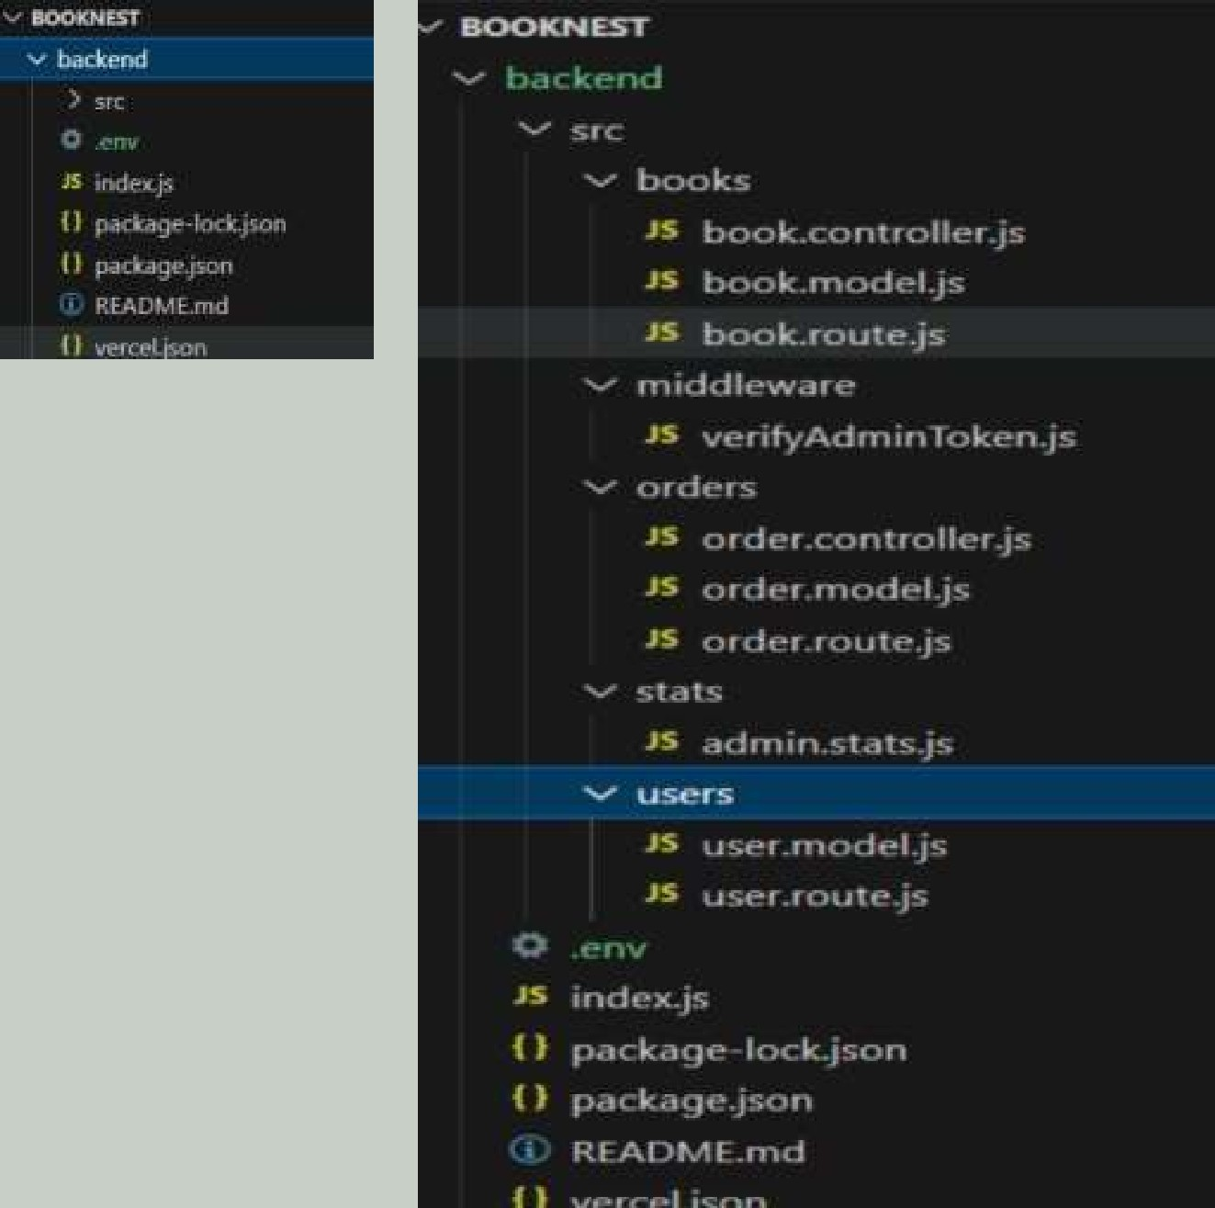
TESTING
- Frontend (React)
    - *Unit tests*: Jest + React Testing Library (test components, hooks).
    - *Integration tests*: Test API calls, interactions with Cypress/Playwright.
    - *Example*: Test book search, add-to-favorites flow.
- Backend (Node.js + DB)
  - *Unit tests*: Jest (test services, models, utils).
  - *Integration tests*: Supertest (test API endpoints). Test 'POST [books', 'GET /books/:id'.
- E2E Testing
  - Cypress: Test full flows (login, add book, checkout).
Tools Used
  - *Frontend*: Jest, React Testing Library, Cypress.
  - *Backend*: Jest, Supertest.
  - *DB*: Mock data or in-memory DB (e.g., Jest mocks for DB).
  - *CI/CD*: GitHub Actions for running tests on PRs.
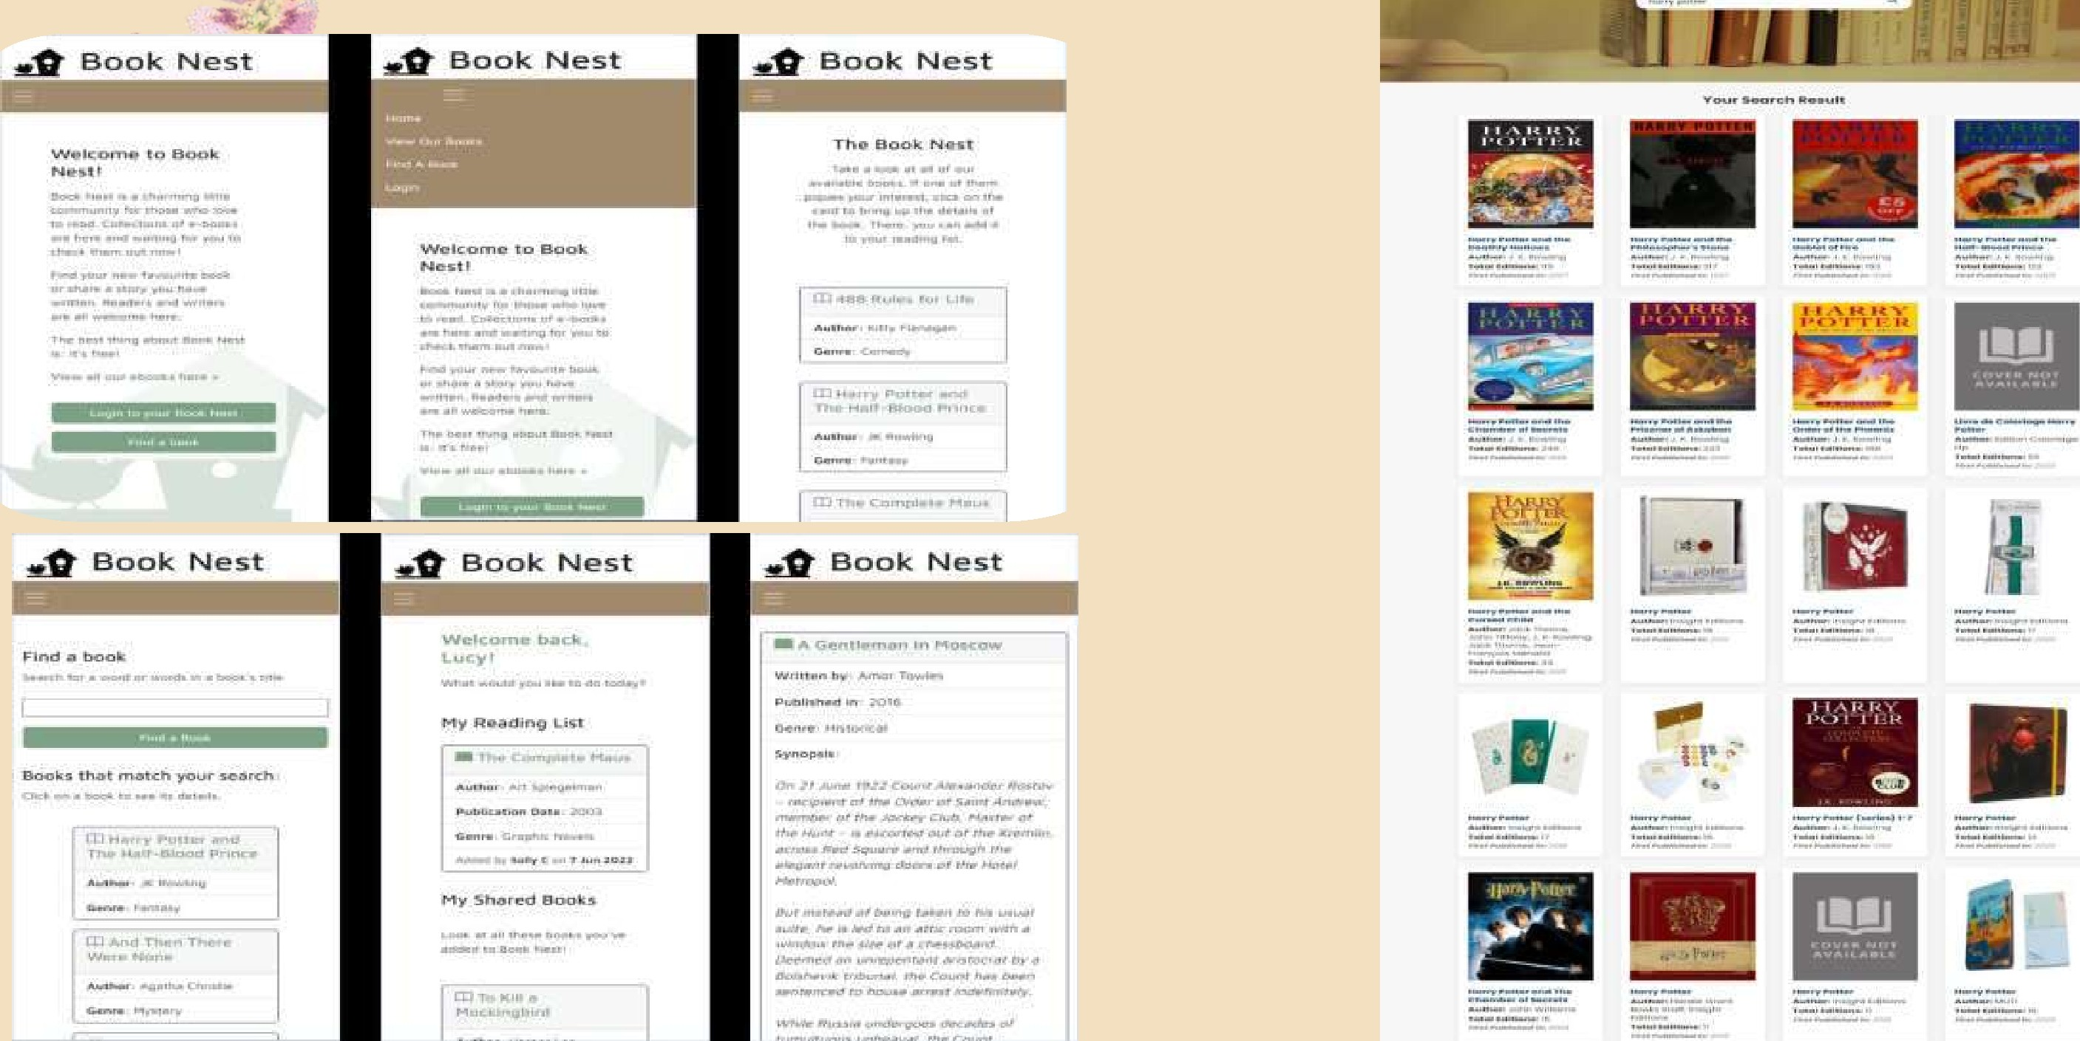
SCREENSHOTS AND DEMO 

FUTURE SCOPE 
User interface: margins on nav buttons to stop pushing out, more colour contrast
Manage when user tries to add a book already in their reading list (e.g. no "add to reading list button)

Manage when user tries to remove a book already in their reading list (e.g. no "remove from reading list" button)
Retain text in search so user sees their typed search
Link book record on reading list to its ebook
User checkout to read or reserve an ebook
Delete a book record
Edit a book record
Add images to a book record
Enhanced context-sensitive navigation
Notifications (e.g. when a new book in a favourite genre is shared)
Login with social media account 


CPNCIUSION
BookNest brbvideea robust platform for book lovers to explore literature and engage with a community of like-minded individuals. With user-friendly features and a modern tech stack, it's the perfect place to buy books and share literary insights. Enjoy your reading journey!

DEMONSTRATION
https://drive.google.com/file/d/1YxCG12jB3P65poJITCLed2GKDOH2a07r/vtew?usp=drive link

THANK YOU


