Setup/Create/View Employee’s e-Letter as Admin

How to update RTF Template? 2

How to upload e-Letter data? 4

How to generate e-Letter? 5

How to review e-Letter as Admin? 7

How to verify unprocessed data before processing? 8

How to change compensation retrieval as of date in the e-letter query? 9

# How to update RTF Template?

Step 1: Click ***Main Menu*** > ***Reporting Tools*** > ***BI Publisher > Report Definition***

Step 2: Update individual employee e-letter template by searching for report name **RWS_EE_LTR**

Update single e-letter template by searching for report name **RWS_EE_LTR3**

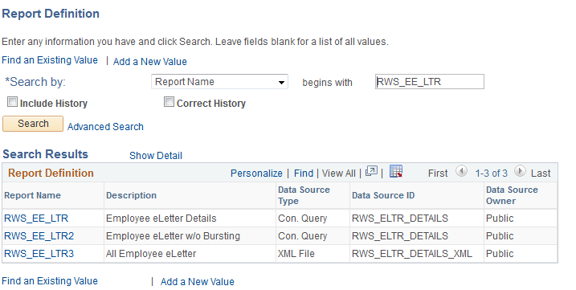

Step 3: Click on the specific report name and go to Template tab. Click on the Correct History button.

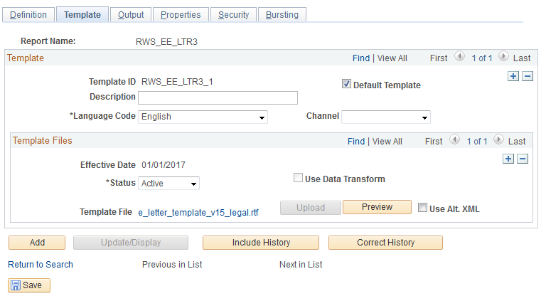

Step 4: Add a new row with a new effective date at Template Files section. Click on the Upload button to upload your new/modified template file

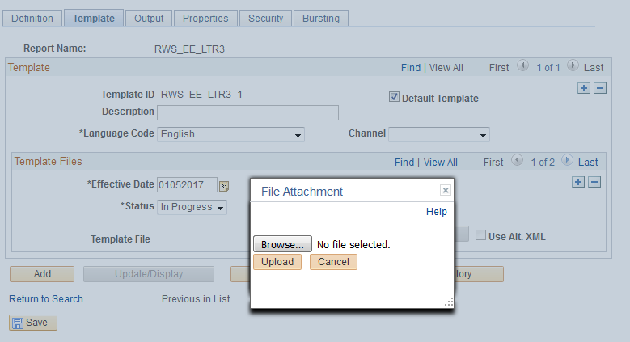

Step 5: Set the status to Active and click the Save button

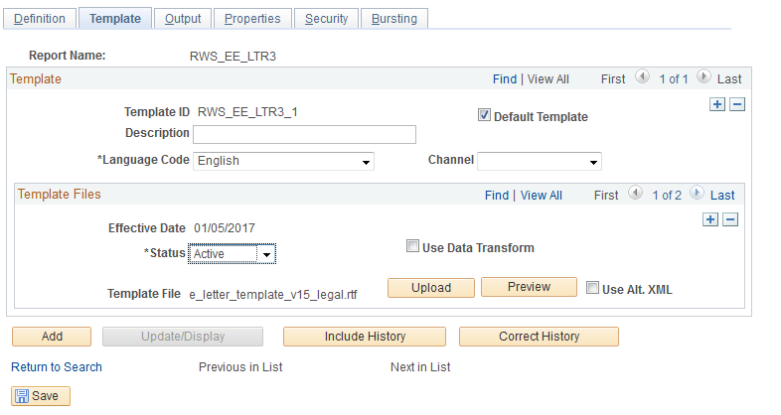

# How to upload e-Letter data?

Step 1: Click ***Main Menu*** > ***Compensation*** > ***Compensation Cycles > RWS eLetter Process > Year End Exercise Data Upload***

Step 2: Create new or reuse existing Run Control ID

Step 3: Click upload

**\*\*\* Only CSV file format is supported**

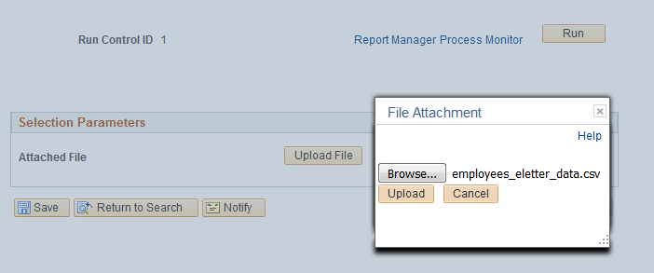

Step 4: Click the Run button and choose **RWS_YE_AE** process name. Click on OK to run

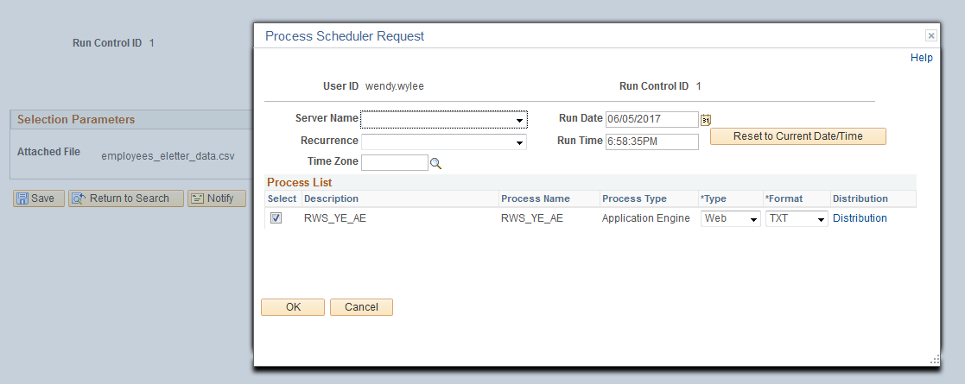

Step 5: Go to the process monitor to review the upload status. Wait until the process status is Success and distribution status is Posted

# How to generate e-Letter?

Step 1: Before generating any e-letters, please see the section on how to run a query to verify if there are any unprocessed data

Step 2: Once verified, Click ***Main Menu*** > ***Compensation*** > ***Compensation Cycles > RWS eLetter Process > Generate & Publish E-Letters***

Step 3: Create new or reuse existing Run Control ID

Step 4: Check Generate letters for all employees if you intend to generate for everyone OR

Select any of the criteria if you wish to generate only for a group of employees

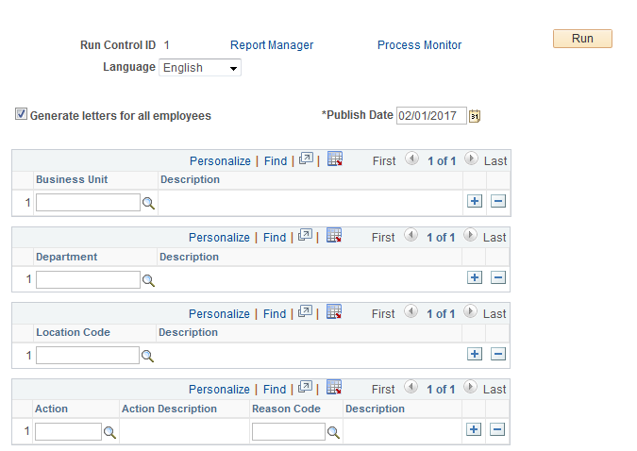

Step 5: Check Generate letters for all employees if you intend to generate for everyone OR select from the available criteria on the run control page

Step 6: Once the parameters are defined, click the Run button

Step 7: Ensure the process name **RWS_EE_LTR** is checked and click OK button

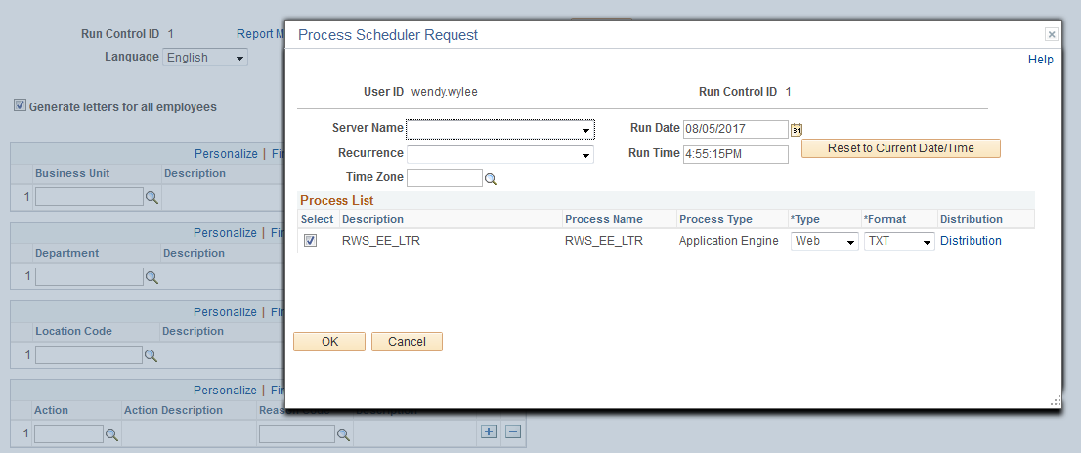

Step 8: Go to the process monitor to review the upload status. Wait until the process status is Success and distribution status is Posted

# How to review e-Letter as Admin?

Step 1: Click ***Main Menu*** > ***Compensation*** > ***Compensation Cycles > RWS eLetter Process > Review Employee E-Letters***

Step 2: Click on the Correct History if you need to update the ESS status

Step 3: Select an option from the Filter By drop down list then click on Select with Matching Criteria button. If Publish Date is selected, all e-letters published on a specific date will be returned. If Employee ID is selected, all e-letters belong to an employee is returned

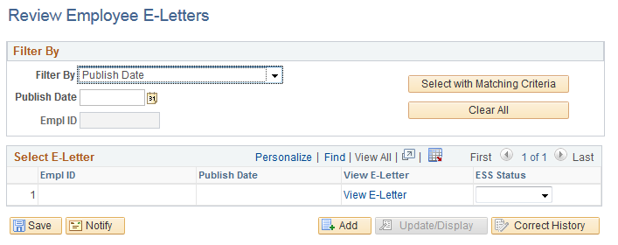

Step 4: Select an option from the ESS Status drop down list to control the visibility of the e-letter

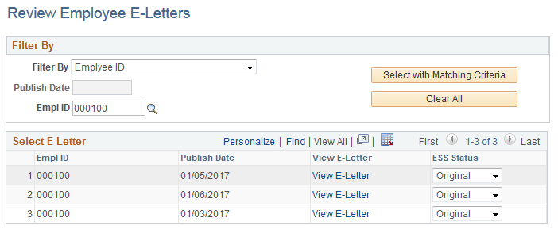

# How to verify unprocessed data before processing?

Step 1: Click ***Main Menu*** > ***Reporting Tools*** > ***Query > Query Manager or Query Viewer***

Step 2: Search for query name **RWS_YEE_DATA** and click Run to Excel link

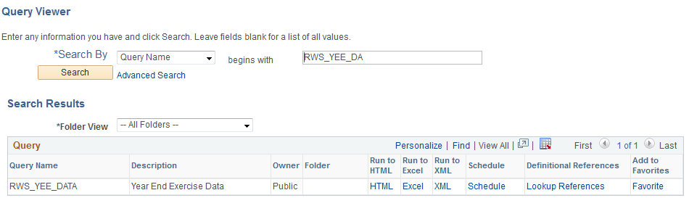

Step 3: Verify if the count is 0 to ensure all records from previous exercise are processed properly

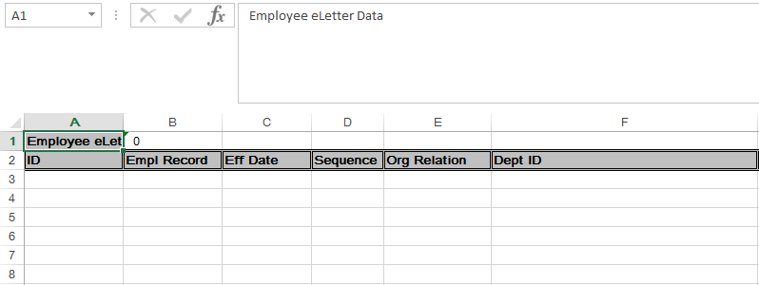

# How to change compensation retrieval as of date in the e-letter query?

Step 1: Click ***Main Menu*** > ***Reporting Tools*** > ***Query > Query Manager***

Step 2: Search for query name **RWS_ELTR_DATA** and click on the Edit link

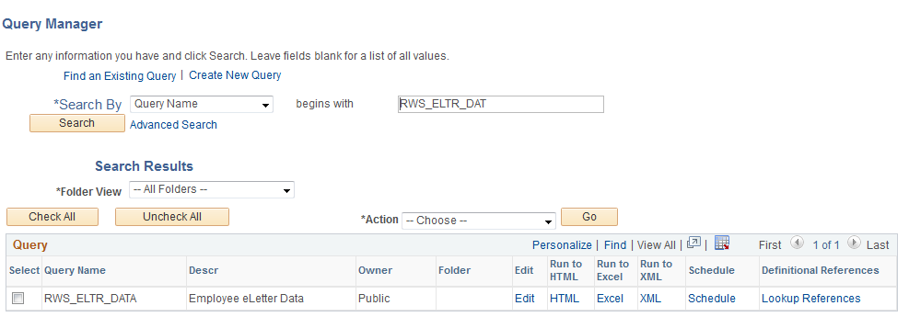

Step 3: Click on the Criteria tab and scroll down till you find as below. Look for [AND][I.EFFDT – Effective Date][Eff Date <=][<Date>(EffSeq = Last)]

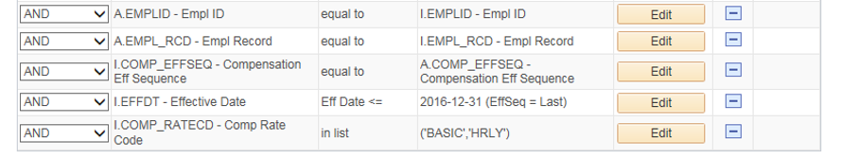

Step 4: Click on the Edit button and change the Date field in the Expression 2 box to retrieve compensation info as of a date



