**S M A R T P A R K I N G ( I O T )**

**NAME: THAMEEMUL AASHIF H**

**NM: AU721221106111**

**EMAIL:** 21ecb48@karpagamtech.ac.in

**PHASE:3**

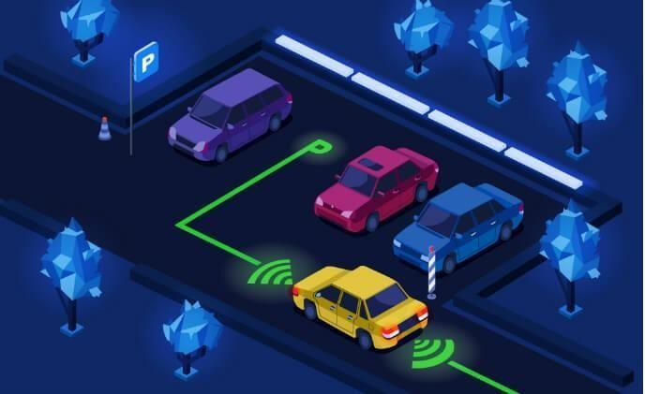

TABLE OF CONTENTS

Introduction 3

Development Part 1 4

Program Script 7

Conclusion 14

# INTRODUCTION:

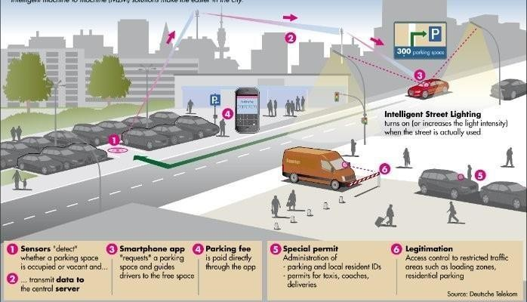

### Building the IoT sensor system with Raspberry Pi integration for parking space occupancy detection involves several steps.

In this overview, I'll guide you through the initial setup.

### Keep in mind that the specific hardware and software requirements may vary based on your project and sensor choices.

## DEVELOPMENT PART 1

#### Hardware and Components:

Ultrasonic Sensors:

You'll need ultrasonic sensors to detect parking space occupancy. These sensors measure distances using sound waves and are suitable for this application.

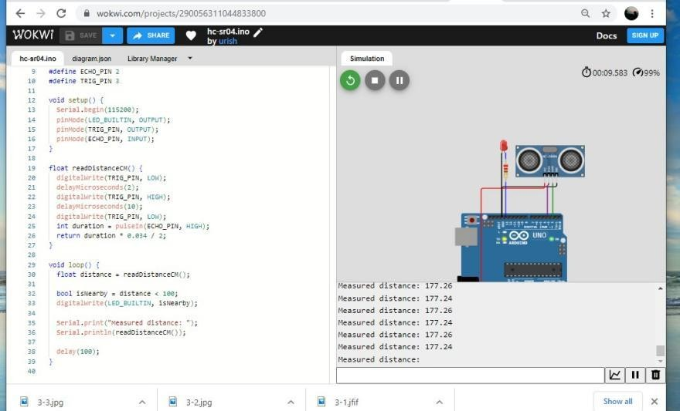

Raspberry Pi:

Use a Raspberry Pi (e.g., Raspberry Pi 3 or 4) as the central controller to collect sensor data and communicate with the IoT platform.

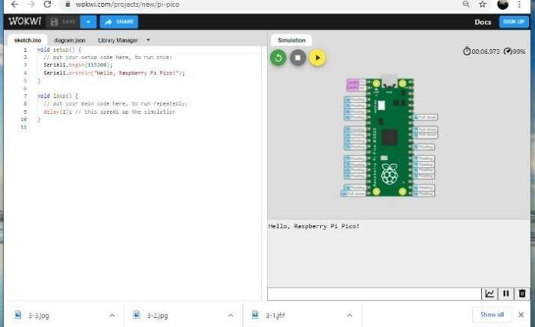

Breadboard and Jumper Wires:

These are essential for connecting the sensors and Raspberry Pi.

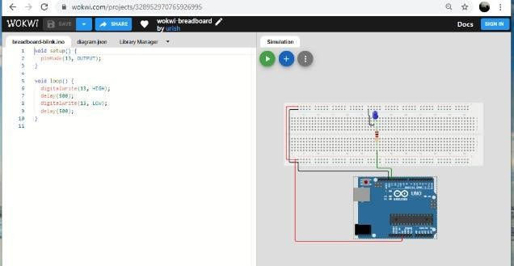

#### Software Setup:

Raspberry Pi OS:

Install the Raspberry Pi OS on your Raspberry Pi. Make sure it's up-to-date with the latest software updates.

Python: Pi.

Python is commonly used for IoT projects. Ensure Python is installed on your Raspberry

GPIO Library:

You may need to install GPIO libraries to interact with the Raspberry Pi's GPIO pins.

Popular options include RPi.GPIO and GPIO Zero.

### Programming:

ARDUINO SKETCH FOR THE ESP32 THAT READS THE DISTANCE DATA FROM THE ULTRASONIC SENSORS.

#include <Ultrasonic.h>

Ultrasonic sensor 1(GPIO_TRIGGER1, GPIO_ECHO1); Ultrasonic sensor2(GPIO_TRIGGER2, GPIO_ECH02);

/I Add more sensors if needed void setup () {

Serial. begin (115200);

}

void loop() {

long distance 1 = sensor1.read(); long distance2 = sensor2.read();

I Read distances from more sensors if needed

I Process distance data and manage parking spaces here delay(1000); // Delay for better readability

}

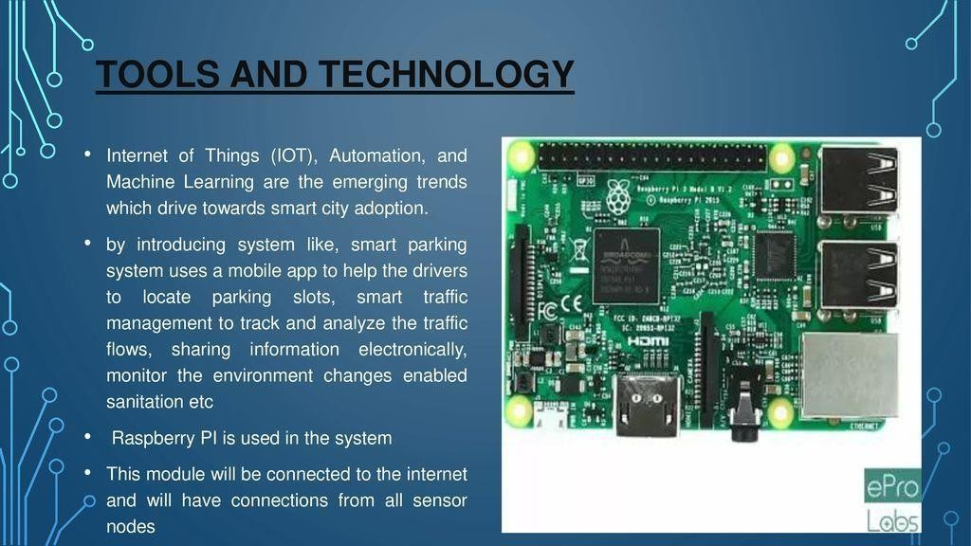

### Wiring and Connection:

Connect the ultrasonic sensors to the Raspberry Pi using jumper wires.

Typically, ultrasonic sensors have four pins: VCC (power), GND (ground), TRIG (trigger), and ECHO (echo).

Connect the VCC and GND pins of the sensors to the appropriate power and ground pins on the Raspberry Pi.

Connect the TRIG and ECHO pins of the sensors to GPIO pins on the Raspberry Pi.

Note down the GPIO pin numbers used for each sensor, as you'll need this information in your Python code.

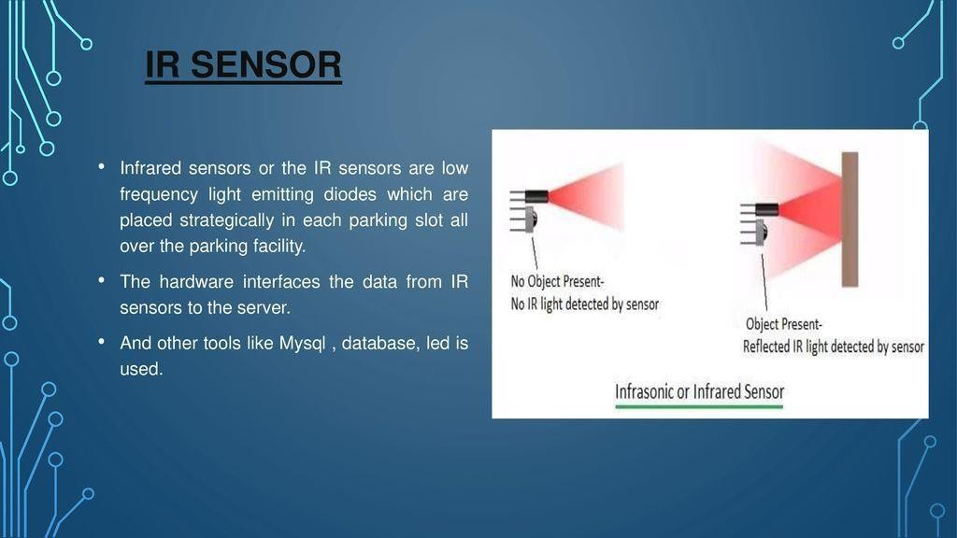

Python Script:

Write a Python script on raspberry pi to collect data from sensors and send it to the cloud or mobile app server.

import RPi.GPIO as io import time

import socket import sys

from _thread import * import threading import cv2

import imutils import numpy as np import pytesseract

from PIL import Image import time

def check(): global counter

ret, frame = cap.read()

frame = cv2.resize(frame, None, fx=0.5, fy=0.5, interpolation=cv2.INTER_AREA) print("Taking a photo")

img = frame

img = cv2.resize(img, (620,480))

gray = cv2.cvtColor(img, cv2.COLOR_BGR2GRAY) gray = cv2.bilateralFilter(gray, 11, 17, 17)

edged = cv2.Canny(gray, 30, 200)

cnts = cv2.findContours(edged.copy(), cv2.RETR_TREE, cv2.CHAIN_APPROX_SIMPLE) cnts = imutils.grab_contours(cnts)

cnts = sorted(cnts, key = cv2.contourArea, reverse = True)[:10] screenCnt = None

for c in cnts:

peri = cv2.arcLength(c, True)

approx = cv2.approxPolyDP(c, 0.018 * peri, True) if len(approx) == 4:

screenCnt = approx break

if screenCnt is None: detected = 0

print("No Contour detected") else:

detected = 1 if detected == 1:

cv2.drawContours(img, [screenCnt], -1, (0, 255, 0), 3) mask = np.zeros(gray.shape,np.uint8)

new_image = cv2.drawContours(mask,[screenCnt],0,255,-1,) new_image = cv2.bitwise_and(img,img,mask=mask)

(x, y) = np.where(mask == 255) (topx, topy) = (np.min(x), np.min(y))

(bottomx, bottomy) = (np.max(x), np.max(y)) Cropped = gray[topx:bottomx+1, topy:bottomy+1]

text = pytesseract.image_to_string(Cropped, config='--psm 11') print(text)

if(len(clients)>0 and len(clients[0].license_num)>0):

if (text == clients[0].license_num or clients[0].license_num in text): counter = 1

print("Detecteddddddddddddddddddddddddddd") write(clients[0].conn,"license_status:Received")

def start():

event = threading.Timer(interval, start).start() check()

def write(conn, msg): try:

conn.sendall((msg+'\n').encode('utf-8')) except:

print("Error-sending-msg") io.cleanup()

Sys.exit()

def read(conn): temp = '' while True:

try:

data = conn.recv(1024) data = data.decode("utf-8") if(temp!=data):

print('client:',data) if("license" in data):

a = data.split(":") clients[0].license_num = a[1] clients[0].entry_status = True print(clients[0].license_num)

temp = data

#start_new_thread(write,(conn, "license_status:Received",))

except:

continue

def init(sock): try:

while True: try:

print("waiting for connection")

conn, client_address = sock.accept() print('connection from',client_address) client = Client(conn) clients.append(client) start_new_thread(read,(conn,)) write(conn,'connected') write(conn,'vacant:4')

except:

sock.close()

finally:

conn.close() sock.close()

conn.close() sock.close()

class Client:

def init (self, conn): self.license_num = '' self.entry_status = False self.payment_status = True self.conn = conn

def setLicenseNum(num): self.license_num = num

def getLicenseNum(): return self.license_num

def setEntryStatus(status): self.entry_status = status

def getEntryStatus(): return self.entryStatus

def setPaymentStatus(status): self.payment_status = status

def getPaymentStatus(): return self.payment_status

vacant = 4

counter = 0

interval = 1

cap = cv2.VideoCapture(0) if not cap.isOpened():

raise IOError("Cannot open webcam")

servoPIN = 17 io.setmode(io.BCM) io.setup(servoPIN, io.OUT) clients = []

sock = socket.socket(socket.AF_INET, socket.SOCK_STREAM) print(socket.gethostname())

server_address = ('192.168.43.244',10000) print('starting up on %s port %s' % server_address) sock.bind(server_address)

sock.listen(10) start_new_thread(init,(sock,)) start()

p = io.PWM(servoPIN, 50)

#GPIO.cleanup()# GPIO 17 for PWM with 50Hz p.start(2.5) # Initialization

io.setwarnings(False) io.setmode(io.BCM)

io.setup(12,io.IN)

io.setup(20, io.OUT) io.setup(21, io.OUT)

io.setup(6,io.IN) io.setup(16, io.OUT) io.setup(26, io.OUT)

io.setup(22,io.IN) io.setup(1, io.OUT) io.setup(7, io.OUT)

io.setup(23,io.IN) io.setup(8, io.OUT) io.setup(11, io.OUT)

io.setup(18,io.IN) io.setup(4, io.IN)

#io.cleanup()

temp = list() temp.append(1) temp.append(1) temp.append(1) temp.append(1)

try:

while True:

t = vacant vacant = 0

#start_new_thread(write,(clients[0].conn,'vacant:'+str(vacant),)) if(io.input(12)==True):

temp[0]=0 io.output(20, True) io.output(21,False)

else:

temp[0]=1 io.output(20, False) io.output(21,True) #vacant -= 1

if(io.input(6)==True): temp[1]=0 io.output(16, True)

io.output(26,False)

else:

temp[1]=1 io.output(16, False) io.output(26,True) #vacant -= 1

if(io.input(23)==True): temp[2]=0 io.output(1, True) io.output(7,False)

else:

temp[2]=1 io.output(1, False) io.output(7,True) #vacant -=1

if(io.input(22)==True): temp[3]=0 io.output(8, True) io.output(11,False)

else:

temp[3]=1 io.output(8, False) io.output(11,True)

'''if(io.input(18)==True): if(counter == 1):

p.ChangeDutyCycle(6.5) time.sleep(5)

else:

p.ChangeDutyCycle(2.5) if(io.input(4)==True):

#start_new_thread(check(),) if(counter == 1):

p.ChangeDutyCycle(6.5) time.sleep(5)

else:

if(counter == 1): p.ChangeDutyCycle(2.5)'''

if(counter == 1): print("entered") p.ChangeDutyCycle(6.5) time.sleep(5)

counter = 0 else:

p.ChangeDutyCycle(2.5)

for i in temp: if(i==1):

vacant+=1 if(len(clients) > 0):

write(clients[0].conn,'vacant:'+str(vacant))

except:

print("Error") io.cleanup()

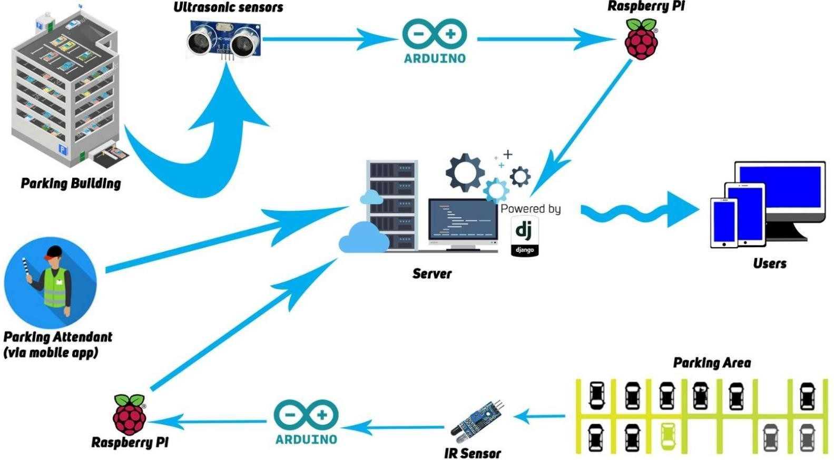

### Data Transmission:

#### Integrate a method for the Raspberry Pi to send this occupancy data to your IoT platform.

You can use MQTT, HTTP requests, or other communication protocols based on your chosen platform.

### Data Analysis and Integration:

On your IoT platform, set up a way to receive data from the Raspberry Pi.

### This platform should handle data storage, real-time analysis, and data visualization.

Continuous Testing and Refinement:

### Continuously test your system to ensure the sensors accurately detect parking space occupancy.

Refine your Python script and integration with the IoT platform as

### needed.

CONCLUSION:

#### This script configures a Raspberry Pi to trigger an ultrasonic sensor and send the distance data to an MQTT broker. You will need to adapt the GPIO pin numbers, MQTT settings, and sensor logic to match your specific hardware and cloud or mobile app server setup.

* This is a basic example to get you started. Depending on your specific use case, you may need to implement error handling, data filtering, and additional functionalities. Also, ensure that your cloud or mobile app server is set up to receive and process the MQTT data.