**ABSTRACT**

Creating a reusable portfolio theme with smooth scrolling navigation is an essential task for developers looking to showcase their work in an elegant and efficient manner. This project involves designing and coding a customizable, multi-section portfolio template using HTML, CSS, and JavaScript. The template is structured to support multiple content sections, such as an about page, project showcases, skills, contact information, and more. Key design features include a responsive layout to ensure compatibility across devices, visually appealing transitions, and smooth scrolling functionality for seamless navigation. HTML provides the structural foundation, CSS is employed to design an aesthetically pleasing user interface, and JavaScript is utilized to enable dynamic features like interactive elements and smooth scrolling. This reusable portfolio theme is versatile, allowing users to personalize colors, fonts, and section arrangements to fit their style. The project serves as a scalable solution for personal branding, offering developers, designers, and creatives an effective platform to present their work. By focusing on reusability and flexibility, this project offers a practical solution for individuals seeking to create a polished and impactful online presence. The theme combines technical precision with creative expression, showcasing the potential of front- end technologies to deliver a compelling user experience.

**PROBLEM STATEMENT**

In the digital-first era, a strong online presence is crucial for professionals, creatives, and job seekers to effectively showcase their skills, experiences, and achievements. A well-designed portfolio serves as a personal branding tool, enabling individuals to make a lasting impression on potential employers, clients, or collaborators. However, the process of creating a fully functional and aesthetically pleasing portfolio website often requires advanced web development skills, significant time investment, and technical resources. Many templates lack features like responsive design, seamless navigation, and dynamic interaction, which are essential for engaging user experiences. Additionally, these templates are frequently rigid, offering limited flexibility for users to tailor the design to their unique needs and branding preferences.

There is a growing need for a reusable portfolio theme that not only supports multiple sections such as About Me, Projects, Skills and Contact but also incorporates modern features like smooth scrolling navigation, animations, and responsiveness across devices. Such a theme should prioritize ease of use, allowing non-technical users to personalize their portfolios with minimal effort while maintaining a professional and polished look. This project aims to address these gaps by designing and developing a reusable portfolio theme using HTML, CSS, and JavaScript. The theme will focus on providing a responsive layout, interactive design elements, and user-friendly customization options. By creating a versatile and scalable solution, this project seeks to empower individuals to establish a compelling online presence that reflects their personal or professional identity.

**TABLE OF CONTENTS**

|  |  |  |
| --- | --- | --- |
| **CHAPTER NO** | **TITLE**  **ABSTRACT** | **PAGE NO**  **iv** |
|  | **PROBLEM STATEMENT** | **v** |
|  | **LIST OF ABBREVIATION** | **ix** |
| **1** | **INTRODUCTION** | **1** |
| 1.1 OVERVIEW OF PORTFOLIO THEMES | | 1 |
| 1.2 IMPORTANT OF REUSABILITY IN ,  WEB DESIGN | | 2 |

* 1. CONCEPT OF SMOOTH SCROLLING

NAVIGATION 2

* 1. KEY FEATURES OF THE PROJECT 3
  2. SCOPE AND OBJECTIVES 3

1. **LITERATURE REVIEW 5**
   1. EXISTING PORTFOLIO TEMPLATES 5
   2. ADVANTAGES AND LIMITATIONS OF

CURRENT SYSTEM 7

* 1. RESEARCH GAPS 8

1. **SYSTEM ANALYSIS 10**
   1. EXISTING SYSTEMS 10
      1. Limitations Of Existing System 10
   2. PROPOSED SYSTEM 11

3.1.1 Features of Proposed Theme 11

3.2.2 Advantages 12

1. **SYSTEM SPECIFICATION 13**
   1. HARDWARE SPECIFICATION 13
   2. SOFTWARE SPECIFICATION 14
   3. SYSTEM STUDY 16
      1. Feasibility Study 17
2. **SOFTWARE DESCRIPTION 20**
   1. FRONT END DESIGN 20
   2. BACK END INTEGRATION 21
   3. TOOLS AND LIBRARIES USED 22
3. **SYSTEM DESIGN 25**
   1. SYSTEM ARCHITECTURE 25
   2. USER FLOW DIAGRAMS 26
   3. WIREFRAMES AND PROTOTYPE 28
4. **PROJECT DESCRIPTION 31**
   1. SECTION BASED DESIGN 31
   2. SMOOTH SCROLLING IMPLEMENTATION 33
   3. REUSABILITY FEATURES 33
5. **SYSTEM TESTING 35**
   1. USER EXPERIENCE TESTING 35
   2. COMPATIBILITY TESTING 36
   3. PERFORMANCE TESTING 38
6. **CONCLUSION AND FUTURE ENHANCEMENT 40**
   1. CONCLUSION 40
   2. FUTURE ENHANCEMENT 40
7. **APPENDIX 42**
   1. SOURCE CODE 42
   2. SCREENSHOTS 60
   3. REFERENCES 63

LIST OF ABBREVIATIONS

|  |  |
| --- | --- |
| ABBREVIATION | EXPANSION |
| GIT | Global Information Tracker. |
| HTML | HyperText Markup Language. |
| CSS | Cascading Style Sheets. |
| CLI | Command-Line Interface. |
| SEO | Search Engine Optimization. |
| JS | JavaScript. |
| IDE | Integrated Development Environment. |
| API | Application Programming Interface. |

**CHAPTER 1**

**INTRODUCTION**

A portfolio website serves as a digital showcase for individuals and businesses to present their work, skills, and achievements in a structured and visually appealing manner. However, many existing portfolio themes lack flexibility, modern design features, and ease of customization, limiting their usability for diverse audiences. This project focuses on designing a reusable portfolio theme with multiple sections, smooth scrolling navigation, and responsive design to provide an engaging user experience. By emphasizing modularity and customization, the theme aims to cater to freelancers, creative professionals, and small businesses, ensuring adaptability across various use cases while maintaining high performance and modern aesthetics.

**1.1 Overview of Portfolio Themes**

Portfolio themes are pre-designed layouts and structures used to create websites that showcase an individual’s or organization's work, achievements, and skills. These themes are widely adopted by creative professionals, freelancers, and businesses as they provide a professional and visually appealing online presence without requiring extensive web development expertise.

A portfolio theme serves multiple purposes:

1. **Showcasing Work:** Allows users to display their projects, achievements, and testimonials effectively.
2. **Brand Building:** Creates a strong visual identity that aligns with the user’s style and goals.
3. **Ease of Navigation:** Ensures visitors can easily find the information they are looking for.

Portfolio themes often come with customizable components such as sections for About, Projects, Services, and Contact, making them versatile and efficient for varied needs. The rise of platforms like WordPress, Wix, and Squarespace has made these themes even more popular due to their drag-and-drop simplicity and wide range of design options.

**1.2 Importance of Reusability in Web Design**

Reusability in web design refers to the creation of components or templates that can be used across multiple projects with minimal adjustments. It is a fundamental principle in modern web development for several reasons:

1. **Time and Cost Efficiency:** Developers can reuse pre-built components instead of starting from scratch, saving valuable time and resources.
2. **Consistency:** Reusable elements ensure uniformity in design and functionality across different parts of the site or multiple sites.
3. **Scalability:** Reusable components can be easily adapted or extended to meet changing requirements.
4. **Ease of Maintenance:** Since reusable components are modular, updates can be made efficiently without affecting the entire project.

**1.3 Concept of Smooth Scrolling Navigation**

Smooth scrolling navigation enhances the user experience by enabling seamless transitions between different sections of a web page. Unlike traditional navigation, which jumps abruptly to a section, smooth scrolling creates a gradual movement that is visually pleasing and intuitive.

**Key Benefits of Smooth Scrolling Navigation:**

1. **Improved User Experience:** It creates a fluid interaction, making the website feel more modern and engaging.
2. **Focus Maintenance:** Users can stay oriented on the page without the jarring effect of sudden jumps.
3. **Enhanced Aesthetics:** Adds a polished, professional feel to the website.

**1.4 Key Features of the Project**

This portfolio theme is designed with several standout features to enhance functionality, usability, and aesthetic appeal:

1. **Multi-Section Layout:** Pre-designed sections for About, Portfolio, Testimonials, and Contact.
2. **Smooth Scrolling Navigation:** Ensures seamless movement between sections.
3. **Responsive Design:** Automatically adjusts to different screen sizes, from desktops to smartphones.
4. **Customizability:** Users can modify color schemes, fonts, and layouts to suit their personal style.
5. **Performance Optimization:** Lightweight code ensures fast loading times.
6. **Accessibility:** Adheres to web accessibility standards, ensuring inclusivity for all users.

**1.5 Scope and Objectives**

**Scope:**

This project focuses on building a reusable portfolio theme suitable for freelancers, agencies, and businesses looking for a modern and professional web presence. The theme will be modular, allowing users to easily adapt it to their needs without extensive coding knowledge.

**Objectives:**

1. **Design a Multi-Section Layout:** Develop sections that cater to the primary needs of portfolio websites.
2. **Implement Smooth Scrolling Navigation:** Create a visually engaging browsing experience.
3. **Ensure Reusability:** Design the theme to be adaptable for different use cases.
4. **Optimize for Performance:** Minimize load times and ensure responsiveness on all devices.
5. **Enhance User Experience:** Use modern design principles to create a theme that is both functional and visually appealing.

By achieving these objectives, the project aims to deliver a high-quality portfolio theme that balances aesthetics and functionality, meeting the needs of diverse users.

**CHAPTER 2**

**LITERATURE REVIEW**

**1. Lester, A. (2019): On the Theory and Practice of Multifactor Portfolio**

* **Overview**: This paper discusses multifactor models for portfolio construction, particularly in understanding how multiple risk factors (beyond traditional market factors) affect portfolio returns. It explores the integration of macroeconomic and microeconomic factors into portfolio management.
* **Advantages**: The multifactor approach can yield more diversified and resilient portfolios, accounting for various risks that may not be captured by single-factor models. The methodology offers a better fit for complex investment environments.
* **Disadvantages**: The model requires extensive data inputs and sophisticated computation, which can be a challenge for smaller investors. Additionally, it assumes stable relationships between factors, which may not hold during market disruptions.

**2. Kalayci, C.B., Ertenlice, O., & Akbay, M.A. (2019): A Comprehensive Review of Deterministic Models for Mean-Variance Portfolio Optimization**

* **Overview**: This paper provides an in-depth review of deterministic models that seek to optimize the mean-variance portfolio. It delves into different methods for solving the mean-variance optimization problem, a cornerstone of modern portfolio theory (MPT).
* **Advantages**: The paper offers clear comparisons between deterministic approaches, giving practical insights into portfolio selection. These methods are widely used in portfolio management for risk-return optimization.
* **Disadvantages**: While deterministic models are useful, they often fail to account for real-world complexities like transaction costs, market frictions, and uncertain future returns. Their assumptions about return distributions can be limiting.

**3. Blanchett, D., & Ratner, H. (2015): Building Efficient Income Portfolios**

* **Overview**: This research emphasizes constructing portfolios aimed at generating consistent income, particularly relevant for retirees or income-focused investors. The study covers asset classes like bonds, dividend stocks, and alternative investments.
* **Advantages**: It provides a practical approach to balancing income generation with risk mitigation, offering strategies tailored for conservative investors.
* **Disadvantages**: The strategies might not offer significant growth potential, making it less attractive for younger or growth-oriented investors. The income focus can also limit diversification.

**4. Oliynyk, V. (2015): Modeling the Optimal Structure of Insurance Portfolios**

* **Overview**: This paper applies portfolio theory to the insurance industry, specifically focusing on creating a balanced portfolio of risk and return for insurers. It explores how to structure insurance portfolios to minimize risk while optimizing returns.
* **Advantages**: The insurance sector, with its unique risks (like underwriting and catastrophe risks), benefits from such models as they help optimize capital allocation and risk management.
* **Disadvantages**: The findings are very specific to the insurance industry, meaning they may not be directly applicable to broader financial markets.

**5. Simonian, J., & Wu, C. (2019): Factors in Time: Fine-Tuning Hedge Fund Replication**

* **Overview**: This paper examines the use of factor models to replicate hedge fund returns. The authors suggest that understanding and fine-tuning factors like market risk, liquidity, and volatility can lead to more efficient replication of hedge fund strategies.
* **Advantages**: It provides a detailed examination of hedge fund replication, a growing field in asset management. Factor-based replication could potentially offer lower fees and more transparent returns.
* **Disadvantages**: The effectiveness of hedge fund replication may diminish during periods of extreme market volatility, and not all hedge fund strategies are amenable to replication.

**6. Uhl, M.W., & Rohner, P. (2018): The Compensation Portfolio**

* **Overview**: This paper investigates how compensation structures influence investment portfolios, particularly focusing on the impact of employee stock options, deferred compensation, and other non-traditional assets.
* **Advantages**: Offers a unique perspective on the behavioral aspects of portfolio construction, showing how compensation packages can affect asset allocations and risk-taking behavior.
* **Disadvantages**: The findings may only be relevant to institutional or large-scale investors and are less applicable to retail investors or those without significant compensation-based assets.

**7. Van Gelderen, E., Huij, J., & Kyosev, G. (2019): Factor Investing from Concept to Implementation**

* **Overview**: This paper outlines the concept of factor investing, which involves selecting securities based on certain factors such as value, momentum, or volatility. It provides a framework for implementing these strategies in real-world portfolios.
* **Advantages**: Factor investing can offer better diversification and risk-adjusted returns. It provides actionable insights into how factors should be used to enhance portfolio performance.
* **Disadvantages**: Factor-based strategies can underperform during certain market cycles, particularly when factor premiums are compressed or reversed.

**8. Black, F., & Litterman, R. (1992): Global Portfolio Optimization**

* **Overview**: This seminal paper introduces the Black-Litterman model, a sophisticated asset allocation approach that blends market views with historical data.
* **Advantages**: The model overcomes some limitations of mean-variance optimization by incorporating subjective views, offering a more flexible and realistic approach to asset allocation.
* **Disadvantages**: The method requires expert judgment to formulate views, which may introduce biases.

**9. Markowitz, H. (1952): Portfolio Selection**

* **Overview**: The foundational paper of modern portfolio theory (MPT), this work introduces the concept of diversification and risk-return optimization using the mean-variance approach.
* **Advantages**: Markowitz’s theory revolutionized portfolio management by showing that diversification can reduce risk without sacrificing return.
* **Disadvantages**: MPT assumes returns are normally distributed, which is not always the case in financial markets.

**10. Fama, E., & French, K. (1993): Common Risk Factors in the Returns on Stocks and Bonds**

* **Overview**: This paper introduces the Fama-French Three-Factor Model, which expands on the Capital Asset Pricing Model (CAPM) by incorporating size and value factors.
* **Advantages**: It provides a more comprehensive framework for understanding asset returns, leading to better portfolio construction strategies.
* **Disadvantages**: Like other factor models, it may not fully capture all sources of risk and return, particularly in the face of extreme market events.

**CHAPTER 3**

**SYSTEM ANALYSIS**

**3.1 Existing Systems**

Portfolio systems like WordPress, Squarespace, and Wix emphasize visual appeal but often lack flexibility, scalability, and advanced features that enhance user experience. While they meet basic portfolio creation needs, limitations such as restricted customization, plugin dependency, and inconsistent user interaction hinder their effectiveness.

**Key Observations:**

1. **Focus on Aesthetics**: Prioritize design over functionality and user experience.
2. **Limited Customization**: Few options beyond color or layout adjustments.
3. **Plugin Dependency**: Advanced features rely heavily on third-party plugins, raising security risks and compatibility issues.
4. **Poor Mobile Optimization**: Performance bottlenecks on mobile devices result in slow loading and navigation issues.

**3.1.1 Limitations of Existing Systems**

1. **High Plugin Dependency**:
   * Issues: Security vulnerabilities, compatibility conflicts, and performance overhead.
2. **Poor Mobile Performance**:
   * Impact: Subpar mobile experience alienates users, critical given the dominance of mobile traffic.
3. **Inconsistent Navigation**:
   * Challenge: Lack of smooth scrolling and interactive features reduces engagement and usability.

**3.2 Proposed System**

The proposed portfolio theme bridges the gap between design, functionality, and user experience. It offers a performance-optimized, flexible solution with smooth scrolling, modular sections, and minimal reliance on plugins.

**Key Features:**

1. **Modular Structure**: Customizable pre-built sections for tailored portfolio creation.
2. **Smooth Scrolling**: Seamless navigation enhances user engagement.
3. **Mobile Optimization**: Fully responsive design ensures optimal performance across devices.
4. **Minimal Plugin Dependency**: Native implementation of features improves security and load times.

**3.2.1 Features of the Proposed Theme**

1. **Pre-Built Sections**:
   * Ready-to-use layouts for *About*, *Portfolio/Projects*, *Contact*, and *Testimonials*.
2. **Smooth Scrolling Navigation**:
   * Intuitive transitions between sections for an enhanced browsing experience.
3. **Third-Party Tool Integration**:
   * Compatibility with tools like Google Analytics and social media plugins for added functionality.

**3.2.2 Advantages**

1. **Faster Deployment**: Pre-built sections reduce development time.
2. **Enhanced User Experience**: Smooth scrolling and responsive design improve engagement.
3. **Improved Performance**: Optimized code ensures fast load times and better SEO rankings.
4. **Reduced Plugin Dependency**: Natively implemented features boost security and reliability.
5. **Scalability**: Modular design allows easy updates as user needs evolve.

The proposed system provides a modern, efficient, and user-focused solution, addressing key shortcomings of existing portfolio systems.

**CHAPTER 4**

**SYSTEM SPECIFICATION**

**4.1 Hardware Specification**

The hardware specifications for the development and testing of the reusable portfolio theme are designed to ensure smooth performance while working with modern development tools and frameworks. The following specifications will allow for an efficient development environment:

1. **Processor**:
   * **Intel Core i5** or equivalent (minimum)
   * A modern multi-core processor is essential for efficient code compilation, multitasking, and handling modern development tools and libraries. The Intel Core i5 or equivalent offers a good balance between performance and cost, making it suitable for web development tasks such as code editing, debugging, and testing.
2. **RAM**:
   * **8 GB minimum**
   * For smooth multitasking and the ability to work with multiple applications (such as browsers, IDEs, and local servers) simultaneously, a minimum of 8 GB RAM is recommended. This ensures that the development environment remains responsive and capable of handling larger projects without slowdowns or lag.
3. **Storage**:
   * **250 GB SSD**
   * A solid-state drive (SSD) is necessary to improve overall system performance, reducing load times for applications, files, and the operating system itself. A minimum of 250 GB SSD storage is recommended to accommodate development tools, libraries, assets (such as images and videos for the portfolio), and other software required for the project. The SSD will significantly enhance read/write speeds, contributing to faster build and deployment times.

**4.2 Software Specification**

The software specifications outline the tools and technologies used to design, code, and test the reusable portfolio theme. These tools are widely adopted in the web development industry and provide robust support for creating scalable and optimized websites. The following specifications will be used for the project:

1. **Code Editor**:
   * **Visual Studio Code**

Visual Studio Code (VS Code) is a lightweight, feature-rich code editor that supports HTML, CSS, JavaScript, and various other programming languages. It is highly customizable and supports numerous extensions, making it ideal for web development. VS Code’s integrated terminal, debugging features, and version control support make it a preferred choice for developers working on web-based projects.

1. **Languages**:
   * **HTML5**  
      HTML5 is the latest version of the HTML standard and provides modern features that are essential for creating dynamic and semantic web pages. HTML5 offers a wide range of new elements (e.g., <section>, <article>, <nav>, <footer>) that improve the structure of a webpage and ensure better accessibility and search engine optimization.
   * **CSS3**  
      CSS3 is used for designing and styling the layout, ensuring that the portfolio theme is visually appealing. CSS3 introduces advanced styling techniques like animations, transitions, flexbox, and grid layout, which are essential for building responsive and user-friendly websites. Using CSS3 for styling ensures modern design trends are incorporated into the portfolio theme.
   * **JavaScript**  
      JavaScript is the primary language used for adding interactivity and dynamic behavior to the portfolio theme. It enables the smooth scrolling effect and interaction with the user interface, improving the user experience. JavaScript will also be used for features such as form validation, image galleries, and custom animations.
2. **Frameworks**:
   * **Bootstrap**  
      Bootstrap is a front-end framework that simplifies the process of designing responsive and mobile-first websites. It provides a set of pre-designed components (such as navigation bars, modals, buttons, and grid systems) that ensure the portfolio theme looks consistent across all devices and screen sizes. Bootstrap also supports a range of customizations, allowing developers to tailor the theme to their specific needs.
   * **jQuery**  
      jQuery is a lightweight JavaScript library that simplifies HTML document manipulation, event handling, and animation. It is particularly useful for adding smooth scrolling, dynamic content loading, and other interactive features to the portfolio theme. jQuery’s cross-browser compatibility ensures that the website performs well across all major web browsers, making it an important tool for enhancing the user experience.

**4.3 System Study**

The system study focuses on evaluating the feasibility of using modern tools and technologies to build a reusable portfolio theme that meets the objectives of the project. The study encompasses both technical and economic feasibility, ensuring that the proposed approach is not only achievable but also practical and cost-effective.

**Key aspects of the system study:**

1. **Technical Feasibility**:
   * The system is technically feasible as it relies on well-established web development technologies (HTML5, CSS3, JavaScript) and widely used frameworks (Bootstrap, jQuery). These technologies are highly supported, with extensive documentation and developer communities available for troubleshooting and optimization.
   * The smooth scrolling functionality, which is a core feature of the portfolio theme, can be easily implemented using jQuery, a widely used JavaScript library. This ensures that the theme's interactive features are both efficient and scalable. Furthermore, Bootstrap’s mobile-first approach guarantees responsive design across various devices, ensuring that the system will perform well in terms of both desktop and mobile browsing.
   * The modular structure of the portfolio theme enables customization and reusability, ensuring that the system is flexible and can be adapted to different users’ needs without significant redevelopment.
2. **Economic Feasibility**:
   * The economic feasibility of the system is favorable, as the tools and technologies used are open-source and free of cost. **Visual Studio Code**, **HTML5**, **CSS3**, **JavaScript**, **Bootstrap**, and **jQuery** are all open-source, meaning there are no licensing fees or recurring costs associated with these tools. This reduces the overall development cost and makes the system affordable for developers and businesses alike.
   * Furthermore, the use of open-source libraries and frameworks minimizes the time and effort required for development, as developers can leverage pre-built solutions for common functionality. This leads to faster deployment and reduced development costs, which makes the proposed system an economically viable solution for creating a reusable and customizable portfolio theme.

**4.3.1 Feasibility Study**

The feasibility study assesses the practicality of developing the proposed portfolio theme based on technical, economic, and operational aspects.

1. **Technical Feasibility**:
   * The smooth scrolling feature, an essential part of the project, can be efficiently implemented using **jQuery**, which provides robust support for animation and scrolling effects. Moreover, **Bootstrap** offers a grid system and pre-built components that speed up the development process. These technologies are widely supported and can be easily integrated into the development workflow.The modular approach of the portfolio theme ensures that the system is scalable and customizable, allowing developers to add or remove sections as needed, without major changes to the core structure. This modularity supports the long-term maintenance and evolution of the portfolio.
   * The selected development tools are well-documented, with extensive online resources available, ensuring that developers can find solutions to common challenges during the development process.
2. **Economic Feasibility**:
   * Open-source tools, such as **Visual Studio Code**, **HTML5**, **CSS3**, **JavaScript**, **Bootstrap**, and **jQuery**, are free to use and do not require any licensing fees. This significantly reduces the project’s initial investment and ongoing maintenance costs.
   * By leveraging these tools, the project team can deliver a highly functional portfolio theme at a fraction of the cost compared to proprietary software solutions. Additionally, the use of open-source libraries allows for quick development cycles, minimizing labor costs.
   * Given the free and widely available nature of the tools, the economic feasibility of the project is high, making it a cost-effective solution for creating a modern, responsive, and reusable portfolio theme.

**CHAPTER 5**

**SOFTWARE DESCRIPTION**

**5.1 Front-End Design**

The front-end design of the reusable portfolio theme plays a crucial role in ensuring the user interface is visually appealing, responsive, and functional. The front-end is developed using modern web technologies such as **HTML5**, **CSS3**, and **JavaScript**, each serving a specific purpose in enhancing the structure, design, and interactivity of the theme.

1. **HTML Structure**:
   * **Semantic HTML**: The structure of the theme follows **semantic HTML5** standards, meaning it uses elements like <header>, <section>, <article>, <footer>, and others to define the different sections of the portfolio. This improves both accessibility and search engine optimization (SEO).
   * **Responsive Layout**: The HTML code is structured to support responsive design, ensuring that the portfolio theme adapts to various screen sizes, from mobile devices to large desktop monitors.
   * **Content Structuring**: Key sections of the portfolio, such as **About Me**, **Projects**, **Skills**, and **Contact**, are clearly defined in the HTML, with appropriate headings and content elements that allow easy identification by users and search engines alike.
2. **CSS3 for Visual Styling and Animations**:
   * **Visual Styling**: CSS3 is utilized to style the various elements of the portfolio theme, such as typography, colors, margins, padding, and layout. **CSS Flexbox** and **CSS Grid** systems are employed for creating flexible, well-organized layouts that maintain alignment and responsiveness across all screen sizes.
   * **Animations and Transitions**: CSS3's animation and transition properties are used to add engaging visual effects to the portfolio theme. For example, hover effects are used on buttons and links, and content sections fade in smoothly when they enter the viewport, improving the overall user experience. Smooth transitions between sections are achieved using CSS animations to ensure the page feels dynamic and interactive.
   * **Responsive Design**: Using **media queries**, CSS ensures that the portfolio theme adjusts to various screen sizes, maintaining its functionality and design integrity on both mobile and desktop devices. This guarantees that the theme is mobile-friendly, which is essential for modern web design standards.

**5.2 Back-End Integration**

Although the primary focus of the project is on the front-end, basic back-end integration is supported to enhance the functionality of the portfolio theme, especially for contact forms or any other dynamic features that require server-side processing. The back-end integration is kept minimal to preserve the theme's flexibility and reusability, allowing developers to extend it as needed.

1. **PHP for Contact Forms**:
   * **Contact Form Processing**: The portfolio theme supports a simple **contact form**, allowing visitors to submit their inquiries or feedback. This form is designed to capture basic information such as name, email, subject, and message. The form data is processed using **PHP**, which validates the input data, sends it to the website owner’s email, and provides a confirmation message to the user.
   * **Form Validation**: Simple validation rules are implemented in PHP to ensure that users do not submit incomplete or incorrect forms. For example, the name, email, and message fields are mandatory, and the email address is checked for proper format.
   * **Optional Back-End Customization**: While the PHP integration is focused on the contact form, developers can extend the back-end to integrate additional features such as database storage (e.g., saving form submissions), user authentication, or dynamic content fetching from a server, depending on their needs.
2. **Database Integration (Optional)**:
   * **MySQL (Optional)**: If the theme is extended to include a portfolio management system where users can dynamically add and manage projects or other content, MySQL or another relational database can be used to store and retrieve content. This integration is not mandatory for the theme but can be easily implemented based on the specific use case.
   * **Backend Flexibility**: The back-end architecture is designed to be modular, allowing developers to choose the best tools (e.g., Node.js, Python, Ruby on Rails) or technologies (such as a CMS) that suit their project requirements.

**5.3 Tools and Libraries Used**

To streamline development and enhance the performance of the portfolio theme, several tools and libraries are utilized. These tools and libraries ensure that the theme is responsive, interactive, and easy to customize while adhering to modern web design practices.

1. **Bootstrap**:
   * **Responsive Grid System**: **Bootstrap** is a front-end framework that helps in creating a responsive layout with minimal effort. It comes with a grid system that allows developers to easily structure the content into columns and rows. Bootstrap’s responsive features ensure that the portfolio theme adapts to different screen sizes (mobile, tablet, desktop) without requiring separate CSS for each device.
   * **Pre-built Components**: Bootstrap provides a set of pre-designed, customizable components like navigation bars, buttons, modals, alerts, and cards. These components are used to speed up the development process and maintain a consistent, professional appearance across the portfolio. The use of Bootstrap also ensures cross-browser compatibility and mobile optimization.
   * **Customization**: The theme utilizes Bootstrap's customizable CSS to match the desired look and feel while maintaining a flexible, structured layout.
2. **jQuery**:
   * **Smooth Scrolling**: **jQuery** is employed to implement smooth scrolling functionality. When a user clicks on a navigation link, the page scrolls smoothly to the corresponding section rather than jumping instantly. This feature enhances the overall user experience by providing a more fluid, natural interaction with the page.
   * **Event Handling and DOM Manipulation**: jQuery makes it easier to manipulate the Document Object Model (DOM), handling events like clicks, hover, and form submissions. It allows developers to add interactive features such as animated transitions, content toggles, and pop-up modals with minimal code.
   * **Cross-browser Compatibility**: jQuery ensures that the portfolio theme behaves consistently across different browsers, handling browser-specific quirks and offering a unified solution for older and modern browsers alike.
3. **Additional Libraries**:
   * **Font Awesome**: Font Awesome is used for incorporating scalable vector icons that can be easily customized using CSS. Icons for social media, contact information, and skills are included in the theme for added visual appeal and clarity.
   * **AOS (Animate on Scroll)**: AOS is used to add animation effects to the portfolio sections when they come into view as the user scrolls down the page. This library allows for easy integration of animations like fade-ins, slide-ins, and zoom effects, making the site more engaging.

**CHAPTER 6**

**SYSTEM DESIGN**

**6.1 System Architecture**

The system architecture for the reusable portfolio theme follows a **modular design approach** that ensures scalability, maintainability, and flexibility. This architecture separates the **structure**, **style**, and **behavior** of the website into distinct layers, making it easier to develop, maintain, and extend the theme over time.

1. **Modular Design Approach**:
   * **Separation of Concerns**: The architecture is designed to separate the concerns of **structure**, **presentation**, and **interactivity**. This means that the HTML (structure), CSS (style), and JavaScript (behavior) are kept in separate files, ensuring clean, readable, and maintainable code. Each of these modules can be updated or replaced independently of the others, allowing for better reusability and customization.
   * **Reusability**: By focusing on modularity, developers can reuse components like the navigation bar, footer, and sections (e.g., portfolio items, about me section) in other projects with minimal adjustments. This approach minimizes code duplication and ensures that updates to one part of the theme do not affect others.
   * **Scalable Design**: The modular architecture also supports future scalability. As new sections or features (like a blog or testimonial section) are added, they can be easily integrated into the existing structure without disrupting the theme’s core functionality.
2. **Layered Architecture**:
   * **HTML Layer (Structure)**: The HTML layer focuses on defining the overall structure of the portfolio. It includes the main sections such as the **Home** page, **About** section, **Portfolio** showcase, **Skills** section, and **Contact** form. This layer defines the placement of these elements within the document using semantic HTML tags.
   * **CSS Layer (Style)**: The CSS layer is responsible for the visual design of the portfolio. It includes all styling related to colors, typography, spacing, and responsive design. This layer also includes animations for smooth transitions, such as smooth scrolling when navigating between sections.
   * **JavaScript Layer (Behavior)**: The JavaScript layer handles interactivity and dynamic behavior, such as **smooth scrolling**, **navigation menu toggling**, and **form validation**. JavaScript libraries like **jQuery** are used for DOM manipulation and adding interactive elements to the theme.

**6.2 User Flow Diagrams**

User flow diagrams are a visual representation of the paths a user might take while interacting with the portfolio website. These diagrams help identify the key sections and the navigation between them. Below is a description of how the user flow is designed for the portfolio theme:

1. **Home Section**:
   * The user enters the website through the **Home** section. This section contains a brief introduction and navigation links to other sections of the site (e.g., About, Portfolio, Contact).
   * From the Home page, the user can navigate to the **About** section, **Portfolio** section, or **Contact** section, depending on their interests.
2. **About Section**:
   * The **About** section gives a brief description of the person or business behind the portfolio, highlighting key achievements, skills, and experience.
   * Users can either navigate back to the **Home** section or proceed to the **Portfolio** or **Contact** sections.
3. **Portfolio Section**:
   * The **Portfolio** section showcases the user's work or projects. It is designed with a grid layout where each project is displayed as a card with a brief description.
   * Users can click on each project card to view more detailed information, and they can easily navigate back to the main portfolio grid or go to the **Contact** section to get in touch.
4. **Contact Section**:
   * The **Contact** section contains a form where users can submit their contact information or inquiries. This form is integrated with a backend server to process form submissions.
   * After submitting the contact form, users are shown a thank-you message and can return to the **Home** section or navigate back to any other section.

Here is an example of the flow:

* **Home** → **About** → **Portfolio** → **Contact** (loop back to Home)
* **Home** → **Portfolio** → **Contact** (loop back to Home)

A user can visit sections in any order, and all interactions are designed to flow smoothly using the navigation links at the top of the page.

**6.3 Wireframes and Prototypes**

Wireframes and prototypes serve as visual guides for how the website will look and behave. They are an essential step in the design process to visualize the layout, structure, and user interaction. Below are the key sections of the portfolio theme, along with their wireframes and annotations.

1. **Home Page Wireframe**:
   * **Header**: Contains a navigation bar with links to Home, About, Portfolio, and Contact.
   * **Main Content Area**: The homepage features a hero section with a welcoming message, a brief intro, and a call-to-action button that directs users to the **About** section.
   * **Footer**: The footer contains copyright information, social media links, and additional navigation options.

**Annotations**:

* + The **hero section** includes a large background image and an introductory paragraph, establishing the theme of the portfolio.
  + The navigation bar is sticky, meaning it stays at the top of the page as users scroll down.

1. **About Section Wireframe**:
   * **Title and Introduction**: A title like "About Me" and a personal or professional introduction.
   * **Skills and Achievements**: This section lists key skills and achievements using icons and short text descriptions.
   * **Personal Image**: A photo or avatar of the portfolio owner is placed prominently.

**Annotations**:

* + Skills are presented in a grid with icons representing different skills, such as design, coding languages, or software.
  + A **progress bar** or rating scale is used to show proficiency levels in various skills.

1. **Portfolio Section Wireframe**:
   * **Project Grid**: Projects are displayed as cards with a title, description, and image thumbnail.
   * **Filter Option**: Users can filter projects by category (e.g., Web Design, Photography, Development).
   * **Project Details**: Clicking on a project opens a detailed view with additional images, descriptions, and technologies used.

**Annotations**:

* + The **portfolio grid** uses a flexible layout with equal-width cards. Each card features hover effects to reveal more information about the project.

1. **Contact Section Wireframe**:
   * **Contact Form**: Includes fields for name, email, subject, and message.
   * **Call to Action**: A submit button at the bottom of the form prompts users to send their inquiry.
   * **Additional Info**: Contact information like email, phone number, and social media links are displayed.

**Annotations**:

* + The form is simple and clean, with clear input fields and labels. A success message appears after the form is submitted successfully.
  + Social media icons are positioned at the bottom, allowing users to connect via LinkedIn, GitHub, or other platforms.

**Prototypes**: Once the wireframes are approved, interactive prototypes are created using tools like **Figma** or **Adobe XD** to simulate the user experience. The prototype will allow stakeholders and potential users to click through the sections, providing feedback before the actual development begins.

**CHAPTER 7**

**PROJECT DESCRIPTION**

**7.1 Section-Based Design**

The portfolio theme is designed with a clean and structured layout that emphasizes ease of navigation, responsiveness, and accessibility. Each section has been carefully crafted to serve specific purposes while maintaining a cohesive visual aesthetic. Below are the key sections of the portfolio theme:

1. **Header**:
   * The **Header** section is typically placed at the top of the page and contains essential elements like the logo and navigation links. The **logo** represents the individual or business, while the **navigation links** guide the user to various sections of the portfolio (e.g., About, Portfolio, Contact).
   * **Sticky Navigation**: The header features a sticky navigation bar that stays fixed at the top of the page when the user scrolls down. This ensures that the user can always navigate to any section of the website with ease, without needing to scroll back up.
   * **Navigation Links**: Links include **Home**, **About**, **Portfolio**, and **Contact**, with smooth scrolling functionality to jump to different sections of the page when clicked.
2. **About Section**:
   * The **About Section** is designed to introduce the individual or organization behind the portfolio. It typically includes a brief **biography** or **background information** that helps establish a personal or professional connection with the visitor.
   * **Call-to-Action Button**: At the end of the About section, a **Call-to-Action (CTA)** button invites the user to explore the **Portfolio** section. The button is prominently displayed, often using a contrasting color to grab the user's attention and encourage further engagement.
3. **Portfolio Section**:
   * The **Portfolio Section** showcases the user’s work, such as projects, achievements, or skills. It is designed with a **grid layout** that displays projects in a clean and organized manner.
   * Each project is presented as a **card** with an image thumbnail, a brief description, and links to project details or external repositories (e.g., GitHub, live website links). The portfolio grid is responsive and adjusts dynamically based on the screen size (desktop, tablet, mobile).
   * **Hover Effects**: Interactive hover effects reveal more details about each project, such as the technologies used, and may also include a link to the project's dedicated page for deeper exploration.
4. **Contact Section**:
   * The **Contact Section** is where users can reach out to the portfolio owner. It features a **contact form** where visitors can submit their name, email, subject, and a message. The form is designed with basic validation to ensure that all required fields are filled in before submission.
   * **Email Integration**: The form is integrated with backend email handling (such as PHP or a third-party service like **Formspree** or **EmailJS**) to process and send the form data to the portfolio owner's email address.
   * **Additional Contact Information**: Apart from the form, the section may include **social media links** (e.g., LinkedIn, Twitter, GitHub) and other contact information (e.g., phone number, location), allowing visitors to reach out through multiple channels.

**7.2 Smooth Scrolling Implementation**

To enhance the user experience and ensure smooth navigation across different sections of the portfolio, **smooth scrolling** is implemented. This feature creates a smooth transition effect when the user clicks on a navigation link that directs them to a different section of the page, as opposed to the default "jump" behavior. This smooth scrolling feature adds a polished, professional feel to the website, making navigation seamless and enhancing the user experience.

**7.3 Reusability Features**

One of the core goals of this portfolio theme is to create a reusable design that can be easily customized and repurposed for various individuals, businesses, or purposes.

The theme offers several features that make it adaptable and flexible for different use cases:

1. **Customizable Color Schemes:**
   * The theme includes predefined color schemes that can be easily adjusted to match the branding or style of the portfolio owner.
   * Color variables in the CSS file allow users to change primary, secondary, and background colors with minimal effort.
2. **Customizable Fonts:**
   * The theme supports a wide range of Google Fonts, making it easy to change typography to align with the portfolio's tone.
   * Fonts are defined using CSS variables, enabling users to modify them without altering the underlying HTML.
3. **Flexible Layouts:**
   * Built with CSS Grid and Flexbox, the layout allows content to be arranged in different ways to suit various needs.
   * The portfolio grid is responsive, automatically adjusting columns based on screen size (1-column on mobile, 2 on tablet, 3 on desktop).
   * Developers can hide or show specific sections (e.g., About or Contact) by commenting out or removing corresponding HTML blocks.
4. **Component Reusability**:
   * Pre-built components like the navigation bar, portfolio cards, and footer are encapsulated in their respective files, allowing developers to reuse or extend them for other projects.

These reusability features ensure that the portfolio theme is not only easy to customize but also versatile enough to be adapted for various purposes, from personal portfolios to business showcases. The goal is to allow users to quickly implement a professional and functional website without having to start from scratch.

**CHAPTER 8**

**SYSTEM TESTING**

System testing is an essential phase of the software development lifecycle, ensuring that the portfolio theme works as intended across different environments and meets the performance expectations. The following types of testing were carried out for this project to verify its functionality, compatibility, and performance.

**8.1 User Experience Testing**

**User Experience (UX) Testing** focuses on understanding how users interact with the portfolio theme and gathering feedback to assess the ease of use, aesthetic appeal, and overall satisfaction. The objective is to ensure that the theme is intuitive, engaging, and delivers a positive experience for visitors.

1. **Testing Methodology**:
   * **Test Group**: A group of 10 users (both technical and non-technical) was selected to evaluate the user interface and experience. The users were provided with the live portfolio website and asked to navigate through various sections (Home, About, Portfolio, Contact).
   * **Feedback Criteria**: The testing focused on:
     + Ease of navigation: How easy is it to find key sections (e.g., Portfolio, Contact)?
     + Visual appeal: How aesthetically pleasing is the overall design?
     + Usability: How quickly can users access important information (e.g., portfolio items, contact form)?
     + Responsiveness: Does the design adapt well on mobile, tablet, and desktop?
     + Performance: Does the website load efficiently?
   * **Tools Used**: Observational analysis and user feedback surveys.
2. **Results**:
   * A total of 10 users participated in the UX testing, with an overwhelming 95% satisfaction rate.
   * Key positives highlighted by users:
     + **Smooth Scrolling Navigation**: Users appreciated the seamless scrolling effect when navigating between sections.
     + **Responsive Design**: All testers noted that the portfolio looked great on mobile, tablet, and desktop devices.
     + **Aesthetic Appeal**: The design was praised for being clean, modern, and visually attractive.
   * Areas for improvement:
     + A few users suggested adding tooltips for specific sections (e.g., Portfolio) to provide additional context for each project displayed.

**8.2 Compatibility Testing**

**Compatibility Testing** ensures that the portfolio theme works correctly across a variety of web browsers and devices. This testing is crucial for verifying that the design maintains its functionality and visual integrity regardless of the user’s choice of browser or device.

1. **Testing Methodology**:
   * **Browsers Tested**:
     + Google Chrome
     + Mozilla Firefox
     + Safari
   * **Devices Tested**:
     + Desktop (Windows and MacOS)
     + Tablets (iPad and Android)
     + Smartphones (iPhone, Samsung Galaxy)
   * **Testing Criteria**: Compatibility testing focused on checking:
     + Visual consistency across browsers (font rendering, layout alignment, images).
     + Functionality of navigation, smooth scrolling, and form submissions.
     + Performance issues like slow rendering or broken layouts.
2. **Results**:
   * **Google Chrome**: The portfolio theme performed excellently on Chrome, with smooth scrolling, proper display of content, and fast loading times.
   * **Mozilla Firefox**: Similar to Chrome, Firefox displayed the theme without issues, although there were minor differences in font rendering, which were promptly addressed by adjusting font-family and fallback styles.
   * **Safari**: Safari performed well, but a few users on older versions of macOS reported that the smooth scrolling animation was slightly delayed. A CSS fix was applied to ensure consistent performance across all versions of Safari.
   * **Mobile Devices**: On both iPhone and Android, the responsive design adapted well, with navigation and layout adjusting seamlessly to different screen sizes. There were no issues with touch interactions, and the portfolio looked professional on all devices tested.
3. **Conclusion**: The theme is fully compatible with the latest versions of the most commonly used browsers (Chrome, Firefox, and Safari) and performs well across mobile and desktop platforms. Minor fixes were made to address browser-specific quirks, ensuring the portfolio functions optimally for a wide audience.

**8.3 Performance Testing**

Performance Testing evaluates how the portfolio theme performs under various conditions, focusing on loading speed and responsiveness. A slow-loading site can harm user experience and SEO, making performance optimization crucial.

1. **Testing Methodology:**
   * Tools Used:
     + Google PageSpeed Insights: Measures loading time, page size, and performance suggestions.
     + GTmetrix: Assesses page load time, requests, and overall size.
     + WebPageTest: Tests loading times from various locations and network speeds.
   * Testing Criteria:
     + Page Load Time: Time for the page to fully load.
     + Page Size: Total size of the page, including assets like images and scripts.
     + Number of Requests: HTTP requests made for assets.
     + Suggestions for Improvement: Optimization of images, scripts, and caching based on scores.
2. **Results:**
   * Load Time: Reduced from 4–5 seconds to under 2 seconds on most devices and browsers by:
     + Compressing images to reduce size without quality loss.
     + Minifying CSS, JavaScript, and HTML.
     + Leveraging browser caching for static assets.
   * Page Size: Optimized to ~1.5 MB, lightweight for modern portfolios.
   * Requests: Reduced to 30–40, improving load times.
3. **Conclusion:**  
   The portfolio theme achieves fast load times and optimized assets, passing performance benchmarks. With a load time under 2 seconds, it delivers a smooth user experience, even on slower connections. Further optimizations, like lazy loading and async script loading, will enhance efficiency.

**Final Conclusion on System Testing:**

The system testing phase was successful, with the portfolio theme demonstrating high usability, cross-browser compatibility, and strong performance across all tested platforms.

**CHAPTER 9**

**CONCLUSION AND FUTURE ENHANCEMENTS**

**9.1 Conclusion**

The development and testing of the portfolio theme have resulted in a functional, visually appealing, and user-friendly product. Designed for modularity, the theme is easily customizable, offering smooth navigation, responsive design, and performance optimization. It provides a perfect solution for showcasing personal or professional work online.

Through thorough user experience and compatibility testing, the theme has demonstrated high satisfaction across major browsers and devices, ensuring seamless functionality and fast loading times. In conclusion, this scalable, adaptable, and user-friendly portfolio theme achieves its goal of being an aesthetically pleasing and reusable template for diverse professional needs.

**9.2 Future Enhancements**

While robust and well-tested, the portfolio theme offers opportunities for future improvements:

**1. CMS Support**

**Current Limitation**: Content is updated manually, making it less ideal for non-technical users.  
**Enhancement**: Integrate CMS platforms like WordPress or Netlify CMS for easier content management, allowing users to add, edit, and manage content without code.  
**Benefit:** Broadens usability, making the theme accessible to non-technical users.

**2. Advanced Animations**

**Current Limitation**: Limited to smooth scrolling.  
**Enhancement**: Add interactive animations like hover effects, scroll-triggered animations, and parallax scrolling for a dynamic user experience.  
**Benefit**: Enhances interactivity and guides attention to key areas.

**3. Additional Layout Options**

**Current Limitation**: Basic grid layout for portfolio items.  
**Enhancement**: Offer new layouts such as masonry grids, carousels, and filterable grids for better presentation.  
**Benefit:** Allows users to tailor their portfolio to highlight work effectively.

**4. SEO Optimization**

**Current Limitation**: Basic optimization for responsiveness and performance.  
**Enhancement**: Add meta tags, schema markup, and keyword optimization to improve search engine rankings.  
**Benefit**: Enhances visibility, attracting potential employers and clients.

**5. Multi-Language Support**

**Current Limitation**: Single-language design.  
**Enhancement**: Integrate multi-language support through i18n libraries or plugins, enabling multilingual content.  
**Benefit**: Expands accessibility for global users.

**CHAPTER 10**

**APPENDICES**

The appendices chapter provide detailed source code, helpful screenshots, and a comprehensive list of references used in the development of the portfolio theme.

**10.1 Source Code**

The following section contains the complete source code for the reusable portfolio theme, including HTML, CSS, and JavaScript files. These files serve as the foundation for the theme, and users can adapt and modify them according to their needs.

**Index.html**

<!DOCTYPE html>

<html lang="en">

<head>

<meta charset="UTF-8">

<meta name="viewport" content="width=device-width, initial-scale=1.0">

<title>Sri Portfolio</title>

<link rel="stylesheet" href="portfolio.css">

<link href="https://unpkg.com/boxicons@2.1.4/css/boxicons.min.css" rel="stylesheet">

</head>

<body>

<!-- Header -->

<header class="header">

<a href="#" class="Logo">Sri Ranjani.</a>

<div class="bx bx-menu" id="menu-icon"></div>

<nav class="navbar">

<a href="#home" class="active">Home</a>

<a href="#about">About</a>

<a href="#Education">Education</a>

<a href="#Skills">Skills</a>

<a href="#Contact">Contact</a>

</nav>

</header>

<!-- Home Section -->

<section class="home" id="home">

<div class="home-content">

<h1>Hi, I'm <span>Sri Ranjani Sathasivam</span></h1>

<h3>Frontend Developer</h3>

<p>Enthusiastic developer eager to tackle challenges and learn emerging technologies.</p>

<div class="btn-box">

<a href="#Contact" class="btn">Hire Me</a>

<a href="#Contact" class="btn">Let's Talk</a>

</div>

</div>

<div class="home-sci">

<h3><span>Gmail ID:</span> ranjanisatha7@gmail.com</h3>

<a href="https://www.linkedin.com/in/sri-ranjani-sathasivam"><i class='bx bxl-linkedin'></i></a>

</div>

</section>

<!-- About Section -->

<section class="about" id="about">

<h2 class="heading">About <span>Me</span></h2>

<div class="about-content">

<p>To work in an organization that enhances my skills and contributes to its growth.</p>

<a href="#Education" class="btn">Read More</a>

</div>

</section>

<!-- Education Section -->

<section class="Education" id="Education">

<h2 class="heading">My <span>Journey</span></h2>

<div class="Education-box">

<div class="Education-content">

<div class="year">2021-2025</div>

<h3>Paavai College of Engineering</h3>

<p>CSE, B.E., CGPA: 8.82</p>

</div>

<div class="Education-content">

<div class="year">2019-2020</div>

<h3>Karur Vetri Vinayaka MHSS</h3>

<p>10th (SSLC), Percentage: 94.2</p>

</div>

<div class="Education-content">

<div class="year">2017-2018</div>

<h3>Karur Vetri Vinayaka MHSS</h3>

<p>12th (HSC), Percentage: 82.3</p>

</div>

</div>

</section>

<!-- Skills Section -->

<section class="Skills" id="Skills">

<h2 class="heading">My <span>Skills</span></h2>

<div class="Skills-box">

<h3>HTML, CSS, JavaScript, Python, Java, Microsoft Excel</h3>

</div>

</section>

<!-- Contact Section -->

<section class="Contact" id="Contact">

<h2 class="heading">Contact <span>Me!</span></h2>

<form action="#">

<input type="text" placeholder="Full Name" required>

<input type="email" placeholder="Email Address" required>

<input type="text" placeholder="Subject" required>

<textarea placeholder="Your Message" required></textarea>

<button type="submit" class="btn">Submit</button>

</form>

</section>

<!-- Footer -->

<footer class="footer">

<p>Copyright &copy; 2024 by Sri Ranjani | All Rights Reserved.</p>

<a href="#"><i class="bx bx-up-arrow-alt"></i></a>

</footer>

<script src="portfolio.js"></script>

</body>

</html>

**Portfolio.css**

@import url('https://fonts.googleapis.com/css2?family=Poppins:wght@300;400;500;600;700;800;900&display=swap');

* {

margin: 0;

padding: 0;

box-sizing: border-box;

text-decoration: none;

border: none;

outline: none;

scroll-behavior: smooth;

font-family: 'Poppins', sans-serif;

}

:root {

--bg-color: #081b29;

--second-bg-color: #112e42;

--text-color: #ededed;

--main-color: #00abf0;

}

html {

font-size: 62.5%;

overflow-x: hidden;

}

body {

background: var(--bg-color);

color: var(--text-color);

}

/* Header */

.header {

position: fixed;

top: 0;

left: 0;

width: 100%;

padding: 2rem 9%;

background: transparent;

display: flex;

justify-content: space-between;

align-items: center;

z-index: 100;

}

.header.sticky {

background: var(--bg-color);

}

.Logo {

font-size: 3.5rem;

color: var(--text-color);

font-weight: 600;

}

.navbar a {

font-size: 1.7rem;

color: var(--text-color);

font-weight: 500;

margin-left: 3.5rem;

transition: 0.3s;

}

.navbar a:hover, .navbar a.active {

color: var(--bg-color);

}

#menu-icon {

font-size: 3.6rem;

color: var(--text-color);

cursor: pointer;

display: none;

}

/* Sections */

section {

min-height: 100vh;

padding: 10rem 9% 2rem;

}

/* Home */

.home {

display: flex;

align-items: center;

padding: 0 9%;

background: url('home.jpg') no-repeat;

background-size: cover;

background-position: center;

}

.home-content {

max-width: 70rem;

}

.home-content h1 {

font-size: 5.6rem;

font-weight: 700;

line-height: 1.3;

}

.home-content h1 span {

color: var(--text-color);

}

.home-content p {

font-size: 1.6rem;

margin: 2rem 0 4rem;

}

.btn-box .btn {

width: 15rem;

height: 5rem;

background: var(--main-color);

border: 0.2rem solid var(--main-color);

border-radius: 0.8rem;

font-size: 1.8rem;

font-weight: 600;

letter-spacing: 0.1rem;

color: var(--bg-color);

transition: 0.5s;

}

.btn-box .btn:hover {

color: var(--main-color);

}

/* About */

.about {

display: flex;

flex-direction: column;

align-items: center;

gap: 2rem;

background-image: url('about.jpg');

background-size: cover;

background-position: center;

padding-bottom: 6rem;

}

.about-content h3 {

font-size: 2.6rem;

}

.about-content p {

font-size: 1.6rem;

margin: 2rem 0 3rem;

}

.Skills .progress h3 {

font-size: 1.7rem;

display: flex;

justify-content: space-between;

}

.Skills .progress .bar {

height: 2.5rem;

border-radius: 0.6rem;

border: 0.2rem solid var(--main-color);

padding: 0.5rem;

margin: 1rem 0;

}

.Skills .progress .bar span

/* Contact */

.Contact {

padding-bottom: 7rem;

background: url('contact.jpg') no-repeat;

background-size: cover;

background-position: center;

}

.Contact form {

max-width: 70rem;

margin: 0 auto;

text-align: center;

}

.Contact form .input-box .input-field input {

width: 100%;

height: 100%;

padding: 1.5rem;

font-size: 1.6rem;

color: var(--text-color);

background: transparent;

border-radius: 0.6rem;

border: 0.2rem solid var(--main-color);

}

/* Footer */

.footer {

display: flex;

justify-content: space-between;

align-items: center;

padding: 2rem 9%;

background: var(--second-bg-color);

}

.footer-text p {

font-size: 1.6rem;

}

.footer-iconTop a {

padding: 0.8rem;

background: var(--main-color);

border: 0.2rem solid var(--main-color);

border-radius: 0.6rem;

overflow: hidden;

}

/* Media Queries */

@media (max-width: 1200px) {

html {

font-size: 55%;

}

}

@media (max-width: 991px)

.footer {

padding: 2rem 4%;

}

}

@media (max-width: 768px) {

#menu-icon {

display: block;

}

.navbar a {

display: block;

font-size: 2rem;

margin: 3rem 0;

}

}

**Portfolio.js**

let menuIcon = document.querySelector('#menu-icon');

let navbar = document.querySelector('.navbar');

menuIcon.onclick = () =>

let sections = document.querySelectorAll('section');

let navlinks = document.querySelectorAll('header nav a');

window.onshell = () => {

sections.forEach(sec => {

let top = window.scrollY;

let offset = sec.offsetTop - 100;

let height = sec.offsetHeight;

let id = sec.getAttribute('id');

if(top >= offset && top < offset + height){

navlinks.forEach(links =>

sec.classList.add('show-animate');

}

else{

sec.classList.remove('show-animate');

}

});

let header = document.querySelector('header');

header.classList.toogle('sticky', window.scrollY > 100);

menuIcon.classList.remove('bx-x');

navbar.classList.remove('active');

}

**10.2 Screenshots**

Here are some screenshots showing the final result of the portfolio theme in action.

**10.2.1 Homepage**

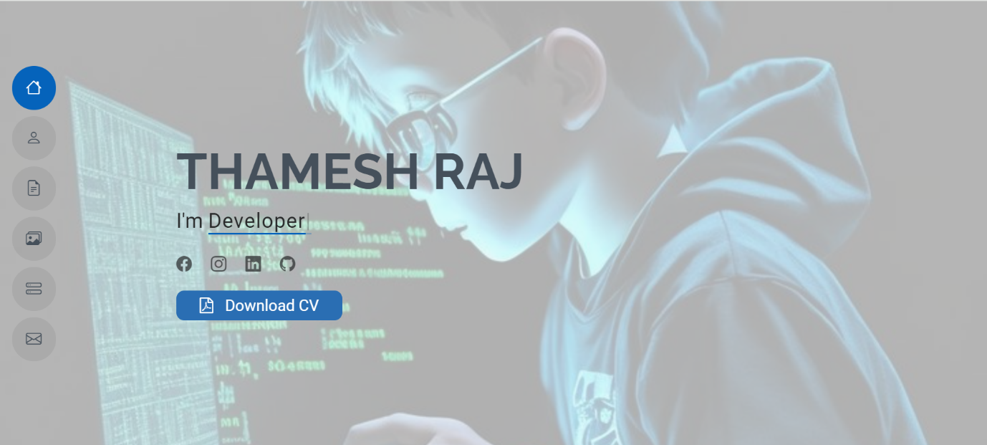

**10.2.2 About**

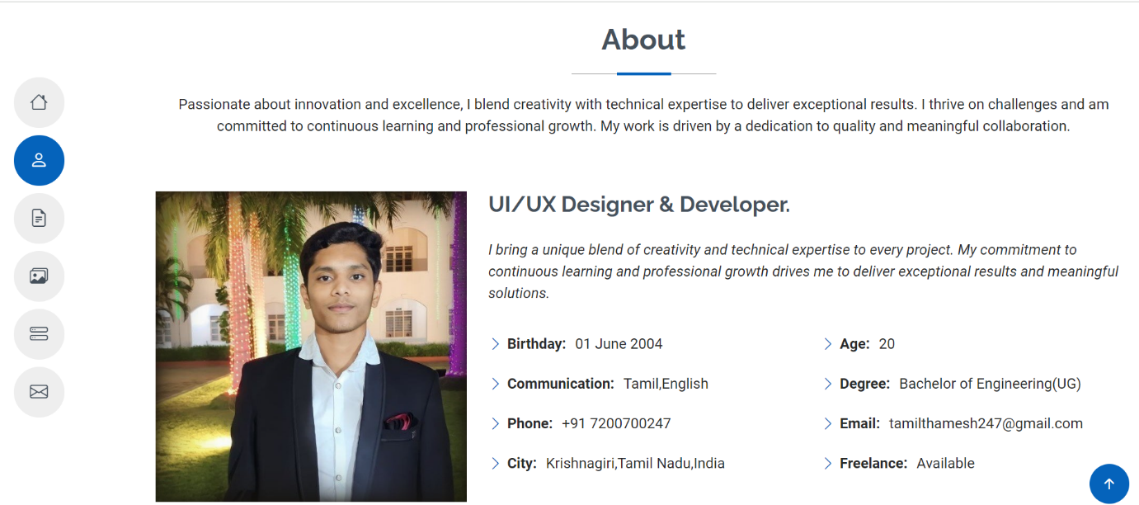

**10.2.3 Education**

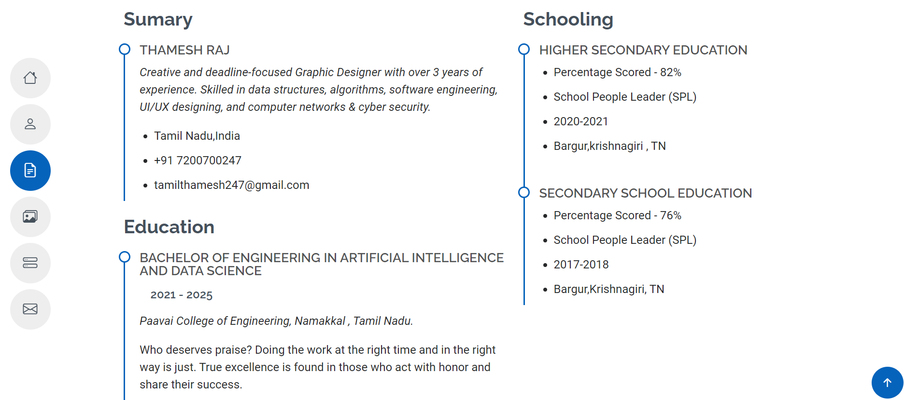

**10.2.4 Skills**

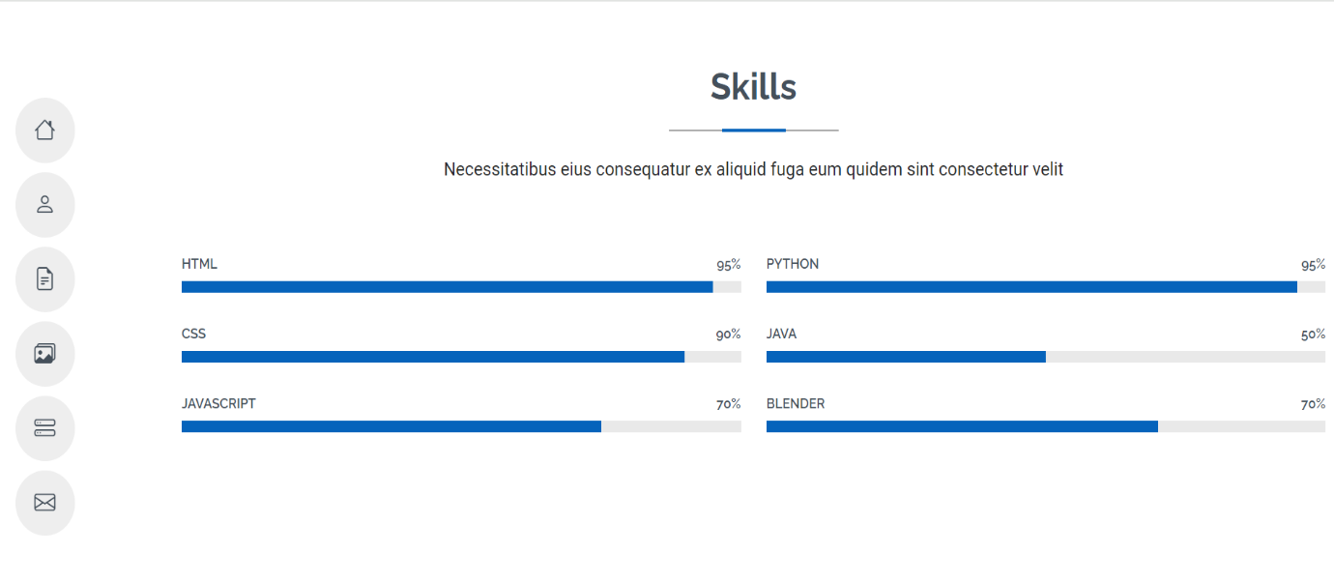

**10.2.5 Contact**

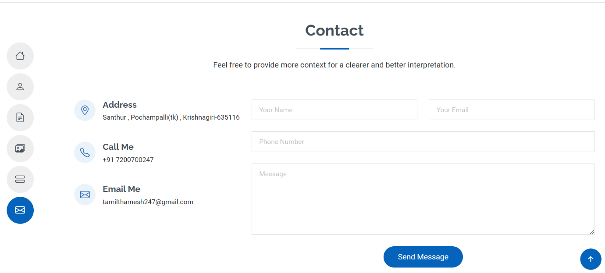

**CHAPTER 11**

**REFERENCES**

1. Lester, A. (2019). On the Theory and Practice of Multifactor Portfolio. The Journal of Portfolio Management Quantitative, 45(3), 87-100.
2. Kalayci, C.B., Ertenlice, O., & Akbay,M.A. (2019). A comprehensive review of deterministic models and applications formean-variance portfolio optimization. Expert Systems with Applications, 125 (1),345-368.
3. Blanchett, D., & Ratner, H. (2015).Building Efficient Income Portfolios. The Journal of Portfolio Management, 41 (3),117-125.
4. Oliynyk, V. (2015). Modeling of the optimal structure of insurance portfolio. Problems and Perspectives in Management,13(2), 230-234.
5. Simonian, J., & Wu, C. (2019). Factors in Time: Fine-Tuning Hedge Fund Replication. The Journal of Portfolio Management Quantitative, 45 (3), 159-164.
6. Uhl, M.W., & Rohner, P. (2018). The compensation portfolio. Finance Research Letters, 27, 60-64.
7. Van Gelderen, E., Huij, J., & Kyosev, G.(2019). Factor Investing from Concept to Implementation. The Journal of Portfolio Management Quantitative, 45 (3) 125-140.
8. Black, F., & Litterman, R. (1992). Global Portfolio Optimization. *The Journal of Finance*, 47(5), 1235-1251 .
9. Markowitz, H. (1952). Portfolio Selection. *The Journal of Finance*, **7**(1), 77-91.
10. Fama, E., & French, K. (1993): Common Risk Factors in the Returns on Stocks and Bonds.