2. pottery

Pottery is one of the oldest handicrafts in Sri Lanka. The primarily utilitarian character of Sri Lankan pottery has been continuing to exist since the very beginning of Aryan Sinhalese civilization of Sri Lanka. The simplicity of ornamentation and charm of the elegance of pottery have held fast in the island for more than a couple of millenniums and a half in Sri Lanka.

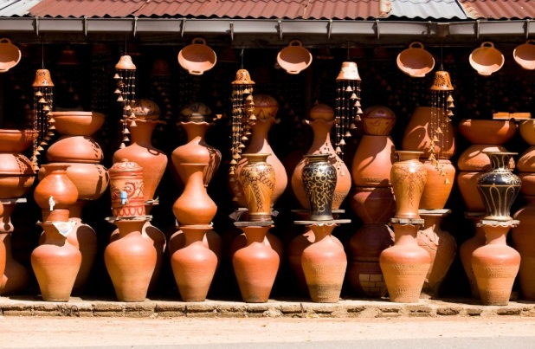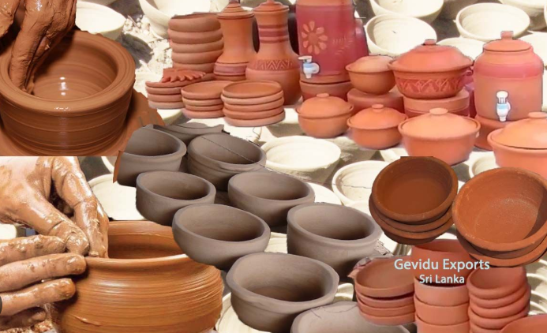Low fired cooking pots, cooking pans, jugs, bowls, goblets, tiles, vases, are the most widely used kitchen utensils of Sri Lanka. In addition to the kitchen pots and pans, intricately designed products such as terracotta figures and carved vases too are popular in Sri Lanka. Ornaments such as figurines and delightful animals with distinctly Sinhalese characteristics are also produced at the pottery workshops in the countryside.

Mainly clay is available in the areas of Dediyawela,Boralesgamuwa and Meetiyagoda. Most of the traditional pottery villages are found near these clay deposits areas. But one of the most famous area for clay pottery is Molagoda in kegalle District.

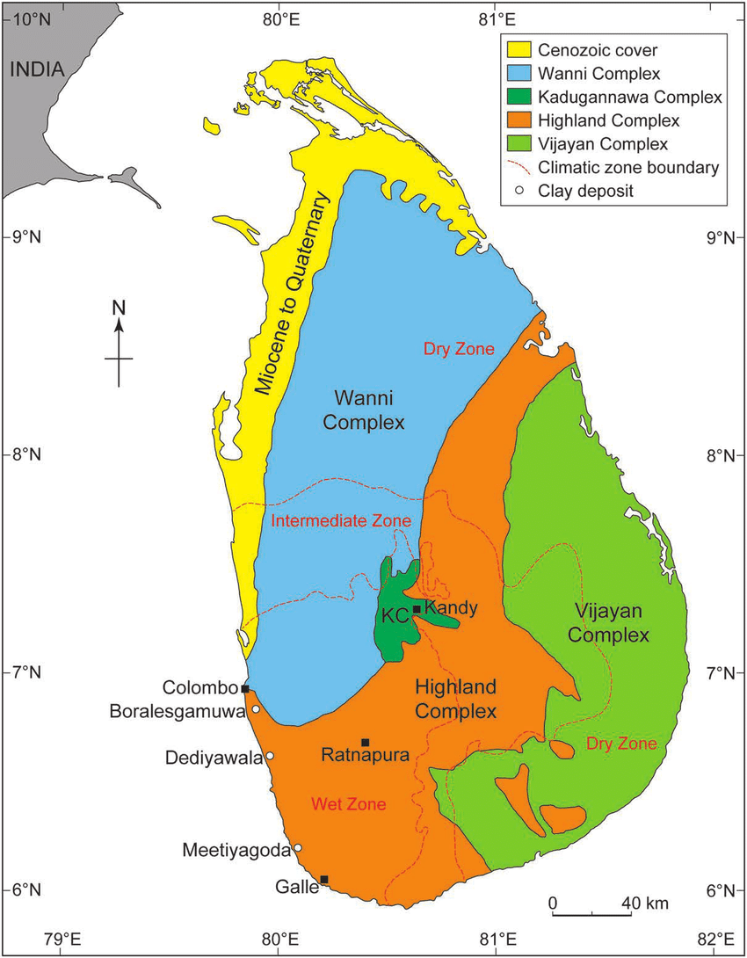

In Sri Lanka's pottery industry, the tool used to make pottery is called SAKAPORUWA. The pottery made from it is hardened in a brick kiln.(youtube link)

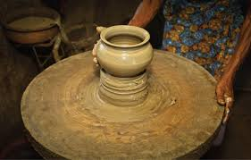

The major quantity of the products is plain utensils devoid of decoration. With the demand for decorated pottery being on the rise, dying the wet clay in patterns and glazing are now introduced.

