
DEPARTMENT OF INFORMATION TECHNOLOGY
24ITT32 - PROGRAMMING IN JAVA
INDIVIDUAL PROJECT ON
ACADEMIC MANAGEMENT SYSTEM
PROJECT REPORT
Submitted by
THAMILKUMARAN VG
25ITR155
JAVA ASSIGNMENT
AIM:
Development of Kongu Engineering College (R2024) Student Academic & Continuous Evaluation System using Java JDBC.
OBJECTIVE:
Design and develop a database-driven Java application using JDBC to manage student records, perform incremental marks entry (Continuous Internal Assessments and End Semester Examinations), enforce attendance eligibility rules, and generate formal academic performance reports according to Kongu Engineering College (Autonomous) - Regulation 2024. System Requirements & Specifications.
FLOW CHART:
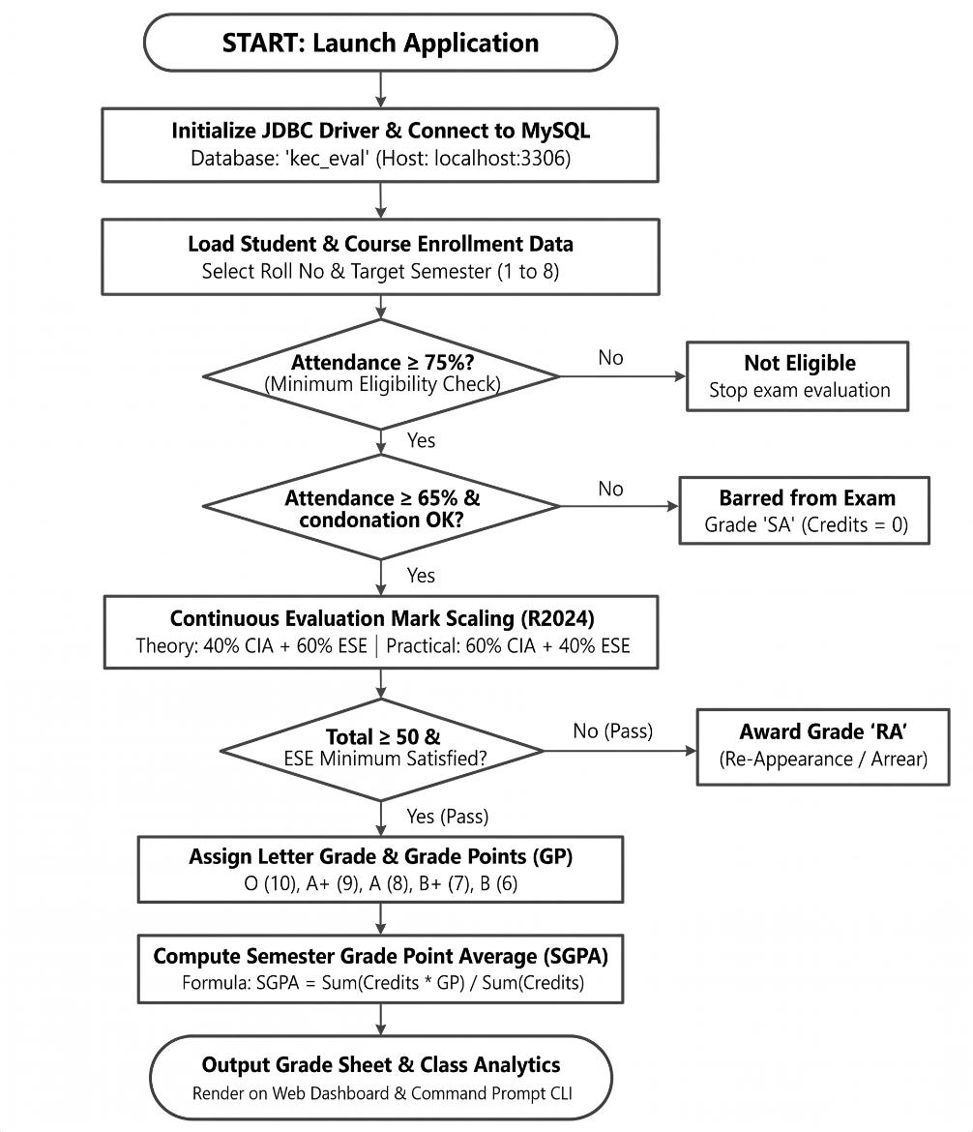
PROCEDURE:
- Load the MySQL Connector/J driver to enable communication between the Java application and the MySQL database.
- Establish a connection to the kec_eval database running on the local MySQL server using DriverManager.getConnection().
- Store and retrieve student details, including roll number, name, department, and semester, along with course information such as course code, title, credits, and course type.
- Enroll students in semester courses, record the number of classes held and attended, and calculate the attendance percentage.
- Verify examination eligibility based on attendance percentage. Students with 75% or above are eligible, those with 65%–74% require medical condonation verification, and those below 65% are marked as Shortage of Attendance (SA).
- Record CIA-1, CIA-2, and assignment marks, and calculate the scaled internal assessment marks according to the specified theory and practical course weightages.
- Record end-semester examination marks out of 100, verify the minimum passing requirements, and scale the marks according to the applicable theory and practical .
- Calculate the total marks by combining scaled CIA and ESE marks. Assign letter grades and grade points according to the specified grading scale, marking students as RA if they fail the examination or score below the required passing mark.
- Generate student grade sheets, attendance shortage reports, and department-wise pass percentage reports. Display the results through the interactive web dashboard and the command prompt console.
DATABASE SCHEMA:
1.STUDENTS TABLE:
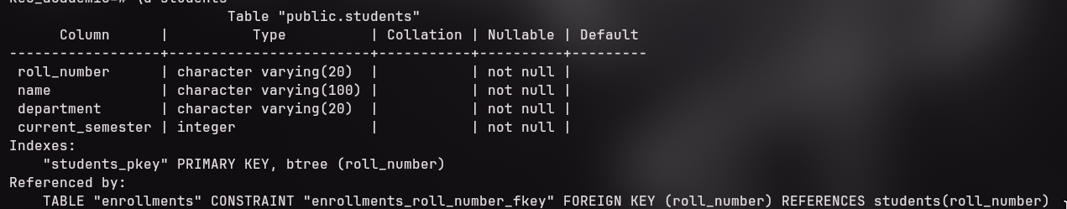
2. COURSES TABLE:
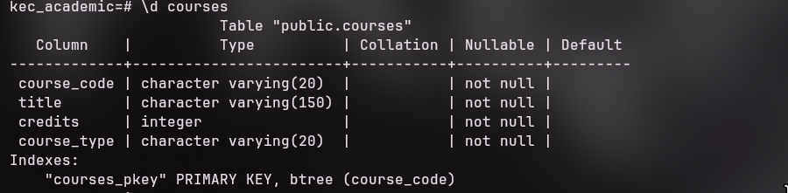
3. ENROLLMENTS TABLE:
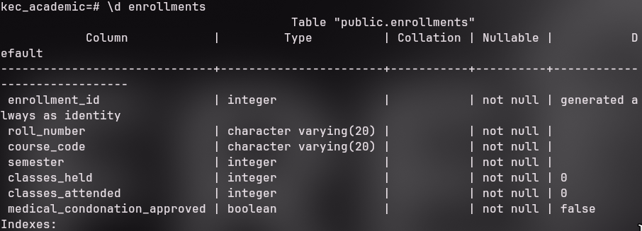
4. ASSESSMENT MARKS TABLE:
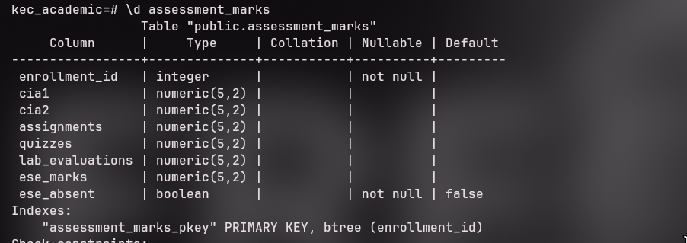
SOURCE CODE:
MAINAPP.JAVA:
import java.util.*;
import java.text.SimpleDateFormat;
/**
* KEC (Autonomous) - Regulation 2024
* Student Academic & Continuous Evaluation System
* Short documentation version of MainApp.java
*/
public class MainApp {
private static final AcademicDAO dao = new AcademicDAO();
private static final Scanner sc = new Scanner(System.in);
public static void main(String[] args) {
if (!DBConnection.testConnection()) {
System.out.println("Database connection failed. Check DBConnection.java.");
return;
}
System.out.println("KEC STUDENT EVALUATION SYSTEM - R2024");
boolean running = true;
while (running) {
System.out.println("\\n1.Student 2.Course 3.Enrollment/Attendance");
System.out.println("4.Enter Marks 5.Mark Sheet 6.Defaulters");
System.out.println("7.Department Summary 0.Exit");
System.out.print("Choice: ");
switch (sc.nextLine().trim()) {
case "1": registerStudent(); break;
case "2": addCourse(); break;
case "3": enrollStudent(); break;
case "4": enterMarks(); break;
case "5":
System.out.print("Roll number: ");
String roll = sc.nextLine().trim();
System.out.print("Semester: ");
printStudentMarkSheet(roll, Integer.parseInt(sc.nextLine().trim()));
break;
case "6":
System.out.print("Semester: ");
printAttendanceDefaulters(Integer.parseInt(sc.nextLine().trim()));
break;
case "7":
System.out.print("Semester: ");
printDepartmentSummary(Integer.parseInt(sc.nextLine().trim()));
break;
case "0": running = false; break;
default: System.out.println("Invalid choice.");
}
}
System.out.println("System closed.");
}
private static void enterMarks() {
System.out.print("Roll number: "); String roll = sc.nextLine().trim();
System.out.print("Course code: "); String course = sc.nextLine().trim();
System.out.print("Semester: "); int sem = Integer.parseInt(sc.nextLine().trim());
int id = dao.getEnrollmentId(roll, course, sem);
if (id <= 0) { System.out.println("Enrollment not found."); return; }
System.out.println("1.CIA marks 2.Assignment marks 3.ESE marks");
String phase = sc.nextLine().trim();
if (phase.equals("1")) {
System.out.print("CIA-1: "); double c1 = Double.parseDouble(sc.nextLine().trim());
System.out.print("CIA-2: "); double c2 = Double.parseDouble(sc.nextLine().trim());
System.out.println(dao.recordPhase1Marks(id, c1, c2) ? "Saved." : "Failed.");
} else if (phase.equals("2")) {
System.out.print("Assignment: "); double a = Double.parseDouble(sc.nextLine().trim());
System.out.println(dao.recordPhase2Marks(id, a) ? "Saved." : "Failed.");
} else if (phase.equals("3")) {
System.out.print("Absent in ESE? (y/n): "); boolean absent =
sc.nextLine().trim().equalsIgnoreCase("y");
Double marks = null;
if (!absent) {
System.out.print("ESE marks: "); marks = Double.parseDouble(sc.nextLine().trim());
}
System.out.println(dao.recordPhase3Marks(id, marks, absent) ? "Saved." : "Failed.");
} else System.out.println("Invalid phase.");
}
DB CONNECTION.JAVA:
import java.sql.Connection;
import java.sql.DriverManager;
import java.sql.SQLException;

/**
* DBConnection - Database Connection Management for KEC Evaluation System
* Kongu Engineering College (Autonomous) - Regulation 2024
*/
public class DBConnection {
private static final String DEFAULT_HOST = "localhost";
private static final String DEFAULT_PORT = "3306";
private static final String DEFAULT_DB = "kec_eval";
private static final String DEFAULT_USER = "root";
private static final String DEFAULT_PASS = "0000";

public static String getUrl() {
String host = System.getenv("DB_HOST") != null ? System.getenv("DB_HOST") : DEFAULT_HOST;
String port = System.getenv("DB_PORT") != null ? System.getenv("DB_PORT") : DEFAULT_PORT;
String db = System.getenv("DB_NAME") != null ? System.getenv("DB_NAME") : DEFAULT_DB;
return "jdbc:mysql://" + host + ":" + port + "/" + db +
"?useSSL=false&allowPublicKeyRetrieval=true&serverTimezone=UTC";
}

public static String getUser() {
return System.getenv("DB_USER") != null ? System.getenv("DB_USER") : DEFAULT_USER;
}

public static String getPassword() {
return System.getenv("DB_PASSWORD") != null ? System.getenv("DB_PASSWORD") :
DEFAULT_PASS;
}

static {
try {
Class.forName("com.mysql.cj.jdbc.Driver");
} catch (ClassNotFoundException e) {
System.err.println("[ERROR] MySQL JDBC Driver not found in classpath: " + e.getMessage());
}
}

/**
* Obtains a new database connection
*/
public static Connection getConnection() throws SQLException {
return DriverManager.getConnection(getUrl(), getUser(), getPassword());
}

/**
* Tests the database connectivity
*/
public static boolean testConnection() {
try (Connection conn = getConnection()) {
return conn != null && !conn.isClosed();
}
OUTPUT SCREENSHOTS:
MAIN MENU:
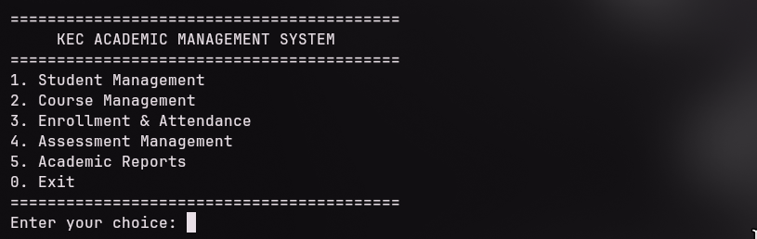
STUDENT & COURSE MANAGEMENT:
1.STUDENT REGISTRATION:
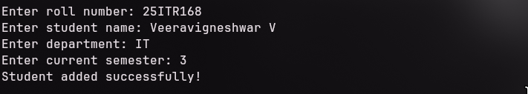
2. COURSE CATALOG:
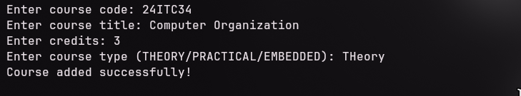
3. COURSE ENROLLMENT & ATTENDANCE TRACKING:
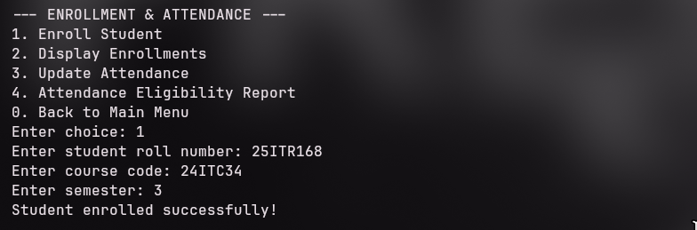
INCREMENTAL MARKS ENTRY:
1.PHASE 1 (MID-SEMESTER):
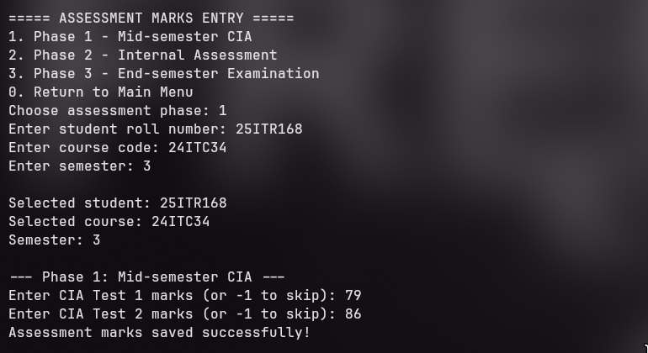
2.PHASE 2 (END OF SEMESTER - CIA):
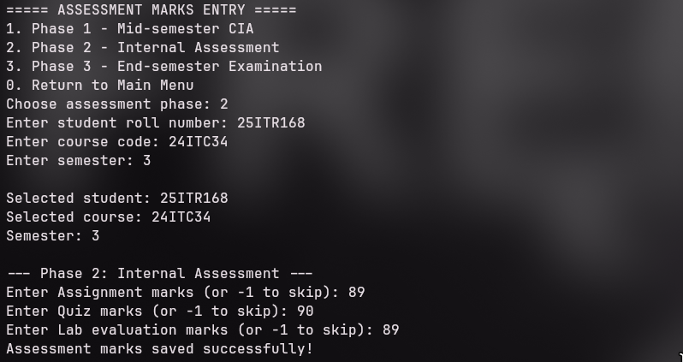
3. PHASE 3 (POST SEMESTER):
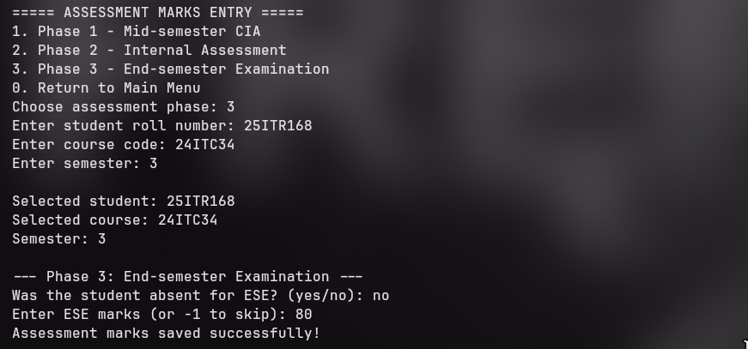
ATTENDANCE & GRADING RULES:
1.ATTENDANCE FILTER:
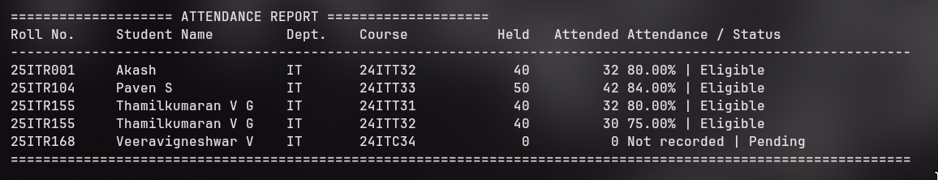
STUDENT SEMESTER MARK SHEET:
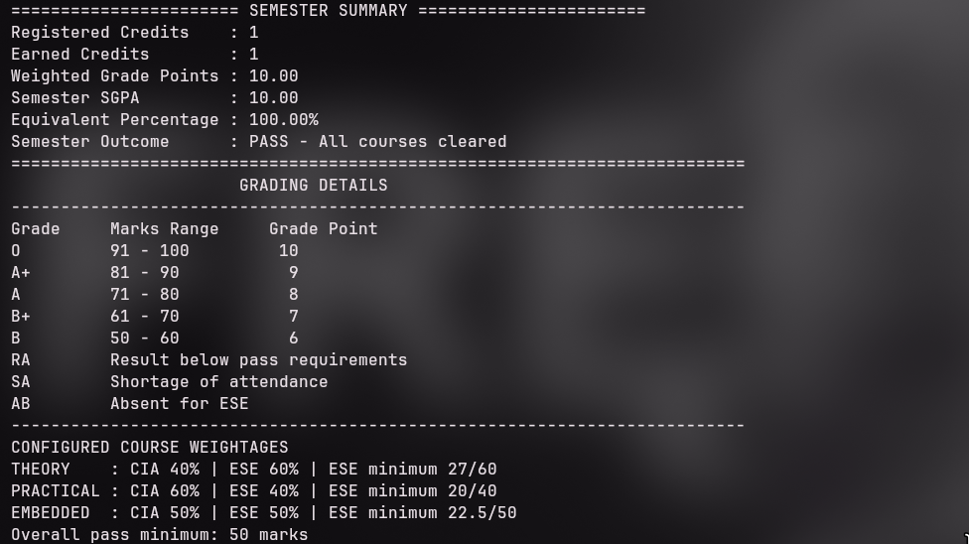
DEPARTMENT WISE CLASS PERFORMANCE & RESULT SUMMARY:
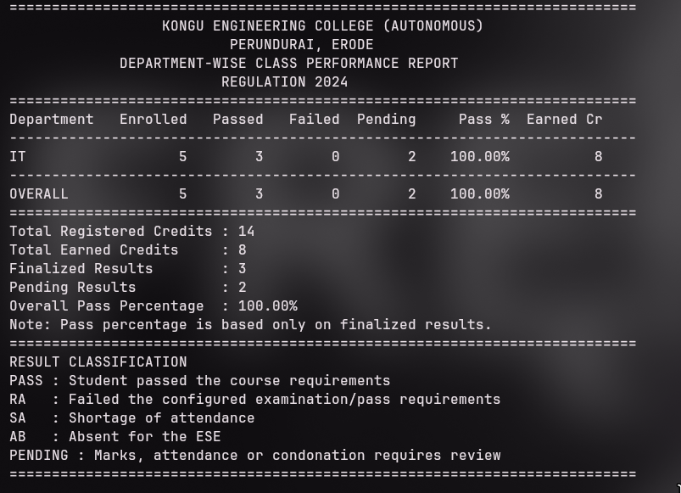
DATABASE:
STUDENTS DATABASE:
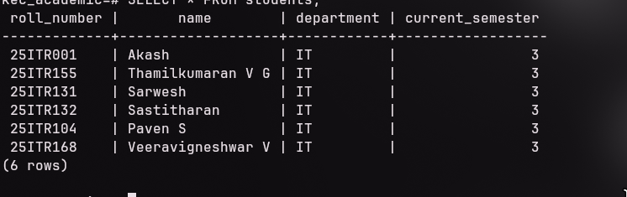
COURSES DATABASE:
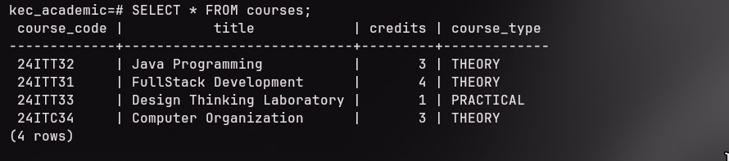
ENROLLMENTS DATABASE:
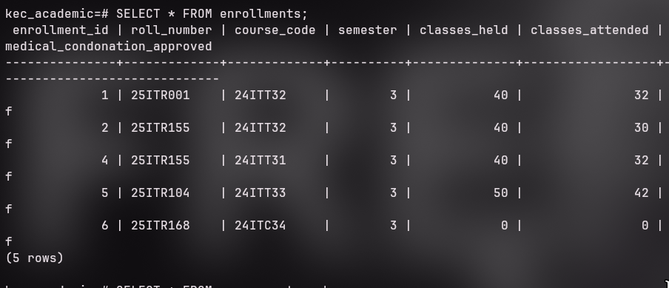
ASSESSMENT MARKS DATABASE:
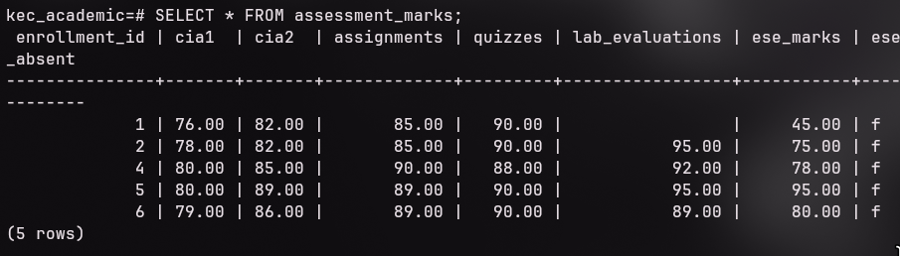
RESULT:
Thus, the Student Academic and Continuous Evaluation System for Kongu Engineering College (Autonomous) Regulation 2024 was successfully designed, developed, and tested using Java (JDBC) and MySQL. The system accurately automates the calculation of Continuous Internal Assessments (CIA), End Semester Examinations (ESE), Letter Grades, Attendance Eligibility, and Semester Grade Point Average (SGPA).
REFERENCES:
- Oracle, Java SE Documentation – JDBC Overview and Architecture. https://docs.oracle.com/javase/8/docs/technotes/guides/jdbc/ .
- Oracle, Java SE API – HttpServer. https://docs.oracle.com/en/java/javase/17/docs/api/jdk.httpserver/com/sun/net/httpserver/HttpServer.html .
- Oracle, MySQL 8.0 Reference Manual. https://dev.mysql.com/doc/refman/8.0/en/ .
- Oracle, MySQL Connector/J Developer Guide. https://dev.mysql.com/doc/connectorj/8.0/en/ .
- University Grants Commission, Guidelines for Choice Based Credit System (CBCS). https://www.ugc.gov.in/pdfnews/8023719_Guidelines-for-CBCS.pdf .
- Chart.js, Chart.js Documentation. https://www.chartjs.org/docs/latest/ .
- Tailwind CSS, Tailwind CSS Documentation. https://tailwindcss.com/docs .
- GeeksforGeeks, Establishing JDBC Connection in Java. https://www.geeksforgeeks.org/establishing-jdbc-connection-in-java/ .
- YouTube, Java JDBC with MySQL Tutorial Videos. https://www.youtube.com/results?search_query=Java+JDBC+MySQL+tutorial .
- Anthropic, Claude AI Assistant (used for project ideas and guidance). https://claude.ai/ .
GITHUB:
LINK: https://github.com/thamilkumaranvg-org/Java-assignment

