SMART WATER MANAGEMENT

***PROTOTYPE OF MQTT IMPLEMENTATION:***

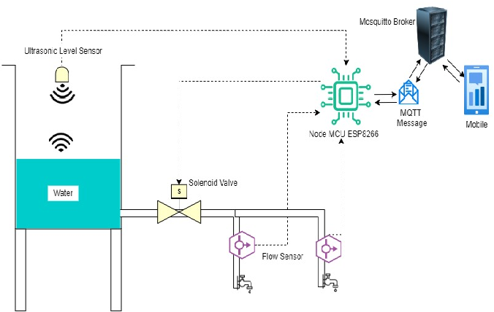

SOURCE CODE FOR MQTT :

// Code to measure water level in a water tank

// Board: ESP8266 NodeMCU

// 15 May 2021

// Pablo Cruz Lemini

// portfedh@gmail.com

// Mills Function

const unsigned long event_interval = 300000; // 5 minute interval, 300 second

//const unsigned long event_interval = 2000; // 2 second interval. For testing

unsigned long previous_time = 0;

// MQTT Library

#include "EspMQTTClient.h"

#define WIFI_SSID "<Wifi_Username_here>" // WiFi Username

#define WIFI_PASS "<Wifi_Password_here>" // Wifi Password

#define BROKER_IP "<MQTT_ip_here>" // IP adress of MQTT broker

#define BROKER_USERNAME "<broker_username_here>" // Broker username

#define BROKER_PASSWORD "<broker_password_here>" // Broker password

#define CLIENT_NAME "<device_name_here>" // MQTT client name to identify the device

#define BROKER_PORT <mqtt_port_here> // MQTT Port. No "" needed

#define lastwill_topic "<lastwill_topic_here>" // MQTT topic to report lastwill and testament.

#define lastwill_text "<lastwill_message_here>" // MQTT memssage to report lastwill and testament.

String client_name = CLIENT_NAME; // MQTT Topic to report initial value

String startup_topic = "<startup_topic_here>"; // MQTT Topic to report startup

String water_level_topic = "<reporting_values_topic_here>"; // MQTT topic to report values

// Function to connect to MQTT

EspMQTTClient client(

WIFI_SSID,

WIFI_PASS,

BROKER_IP,

BROKER_USERNAME,

BROKER_PASSWORD,

CLIENT_NAME,

BROKER_PORT

);

// Water Sensor pins

#define TRIG 14 //GPIO Number 14, D5

#define ECHO 12 //GPIO Number 12, D6

void setup() {

Serial.begin(115200); // Serial monitoring

// Enable debugging messages sent to serial output

client.enableDebuggingMessages();

// Enable the web updater.

client.enableHTTPWebUpdater();

// MQTT Last Will & Testament

client.enableLastWillMessage( lastwill_topic , lastwill_text);

// Water level sensor Pin Setup

pinMode(TRIG, OUTPUT); // Initializing Trigger Output

pinMode(ECHO, INPUT_PULLUP); // Initializing Echo Input

}

// MQTT Innitial Connection

void onConnectionEstablished() {

client.publish(startup_topic, String(client_name + " is now online."));

}

void loop() {

// MQTT Loop: Must be called once per loop.

client.loop();

// Mills Loop

unsigned long current_time = millis();

// Mills if Statement

if(current_time - previous_time >= event_interval) {

// Set the trigger pin to low for 2uS

digitalWrite(TRIG, LOW);

delayMicroseconds(2);

// Send a 20uS high to trigger ranging

digitalWrite(TRIG, HIGH);

delayMicroseconds(20);

// Send pin low again

digitalWrite(TRIG, LOW);

// Read pulse times

int distance = pulseIn(ECHO, HIGH,26000);

//Convert the pulse duration to distance

distance= distance/58;

//Print Result in serial monitor

Serial.print("Distance ");

Serial.print(distance);

Serial.println("cm");

// MQTT Client Publisher

client.publish(water_level_topic, String(distance));

// Mills Update timing for next time

previous_time = current_time;

}

}

The graph shows 15 days period of water consumption:

