Register api  
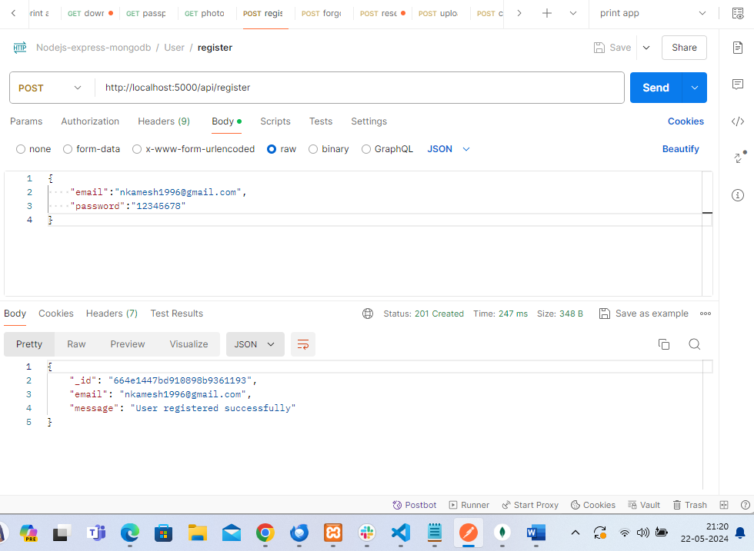  
  
forgot api  
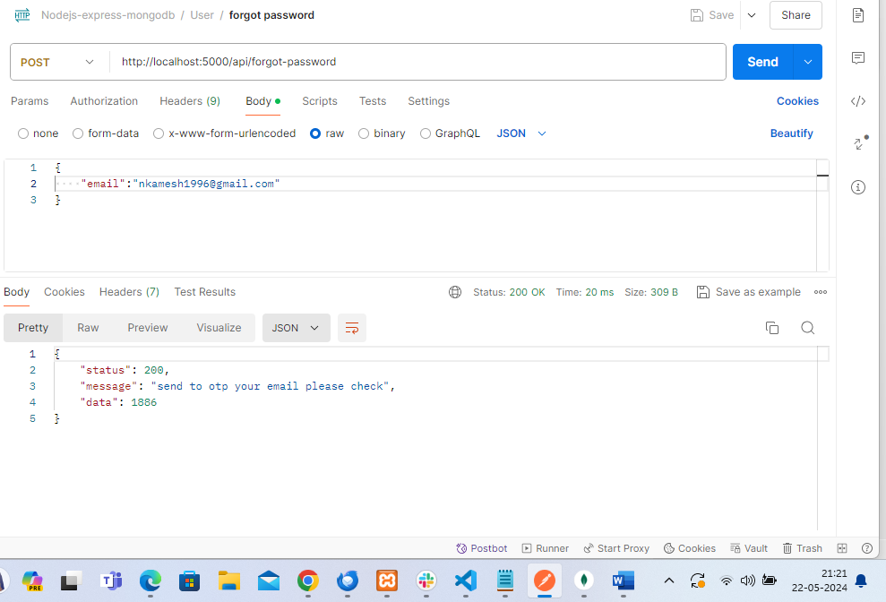  
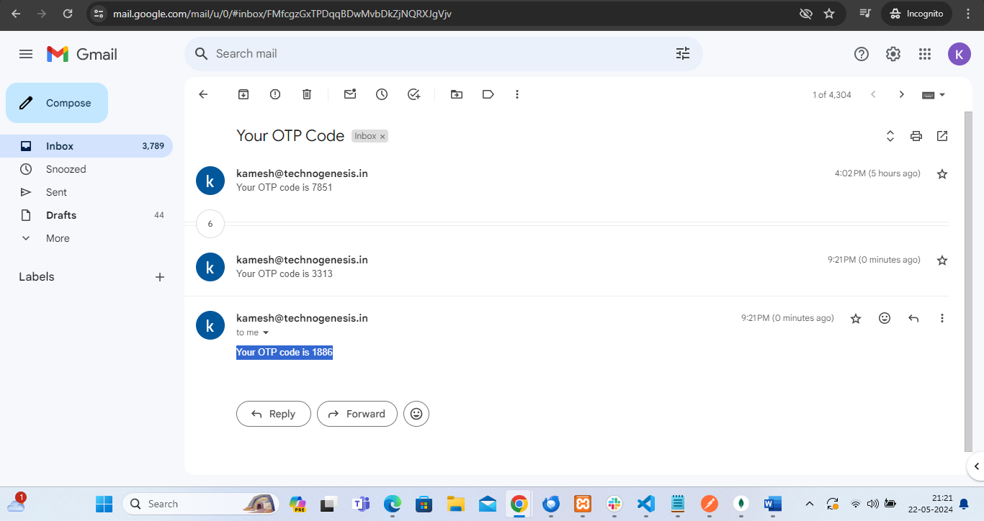  
reset api – otp verify and password updated  
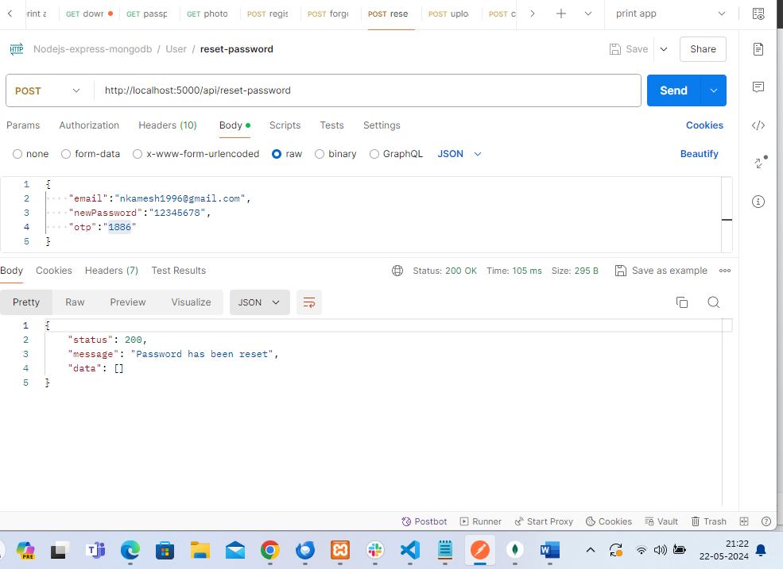  
Crud with image upload cloudinary  
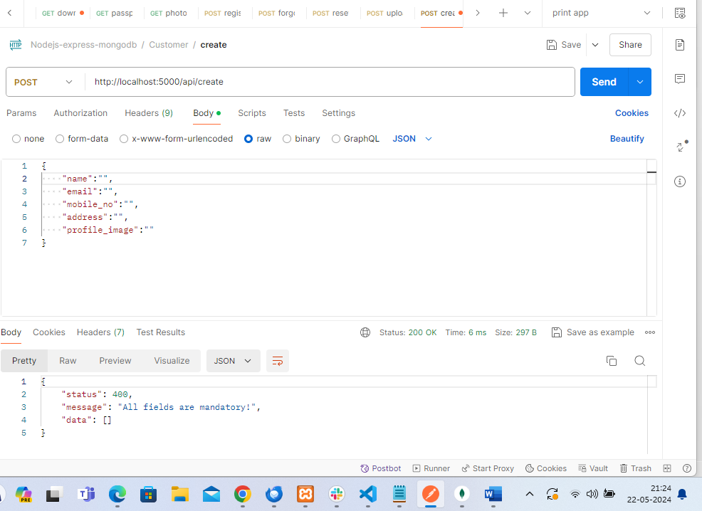  
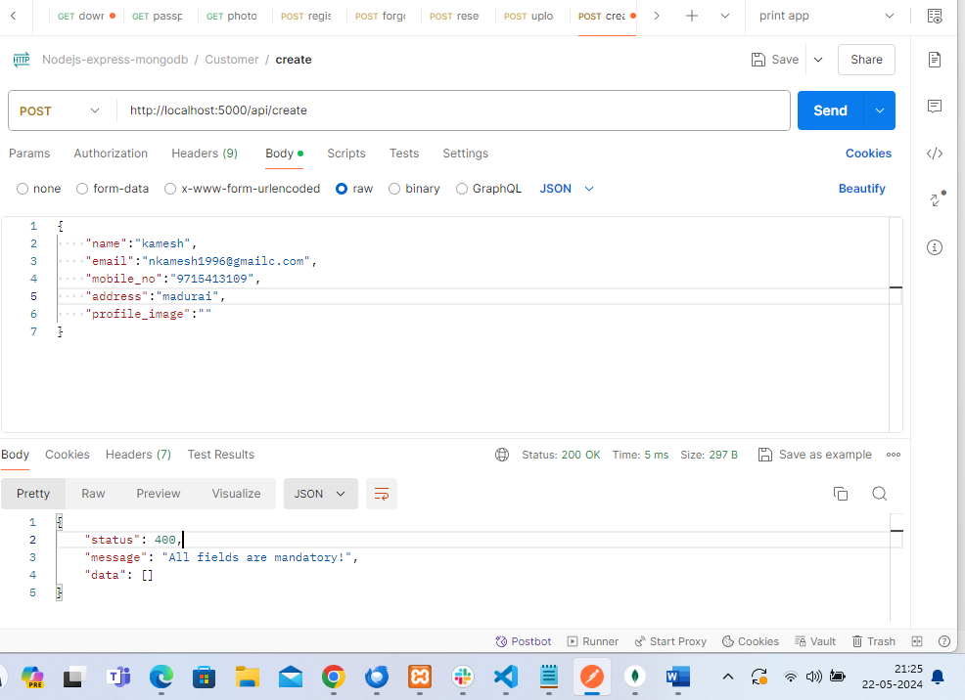  
I have upload image cloudinary - aws credential using  
image upload  
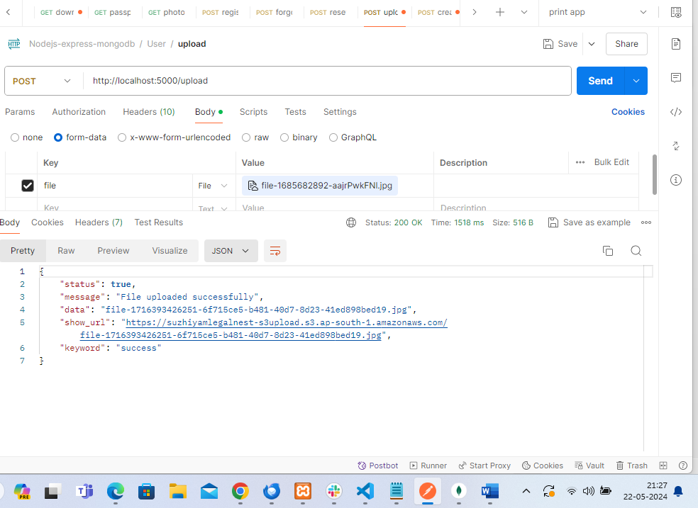  
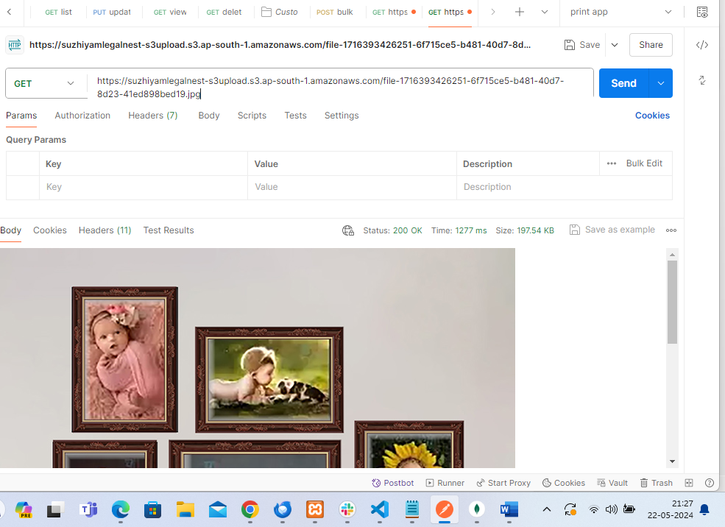

Response - {

    "status": true,

    "message": "File uploaded successfully",

    "data": "file-1716393426251-6f715ce5-b481-40d7-8d23-41ed898bed19.jpg",

    "show_url": "https://suzhiyamlegalnest-s3upload.s3.ap-south-1.amazonaws.com/file-1716393426251-6f715ce5-b481-40d7-8d23-41ed898bed19.jpg",

    "keyword": "success"

}  
now I use this data key - file-1716393426251-6f715ce5-b481-40d7-8d23-41ed898bed19.jpg  
  
go to customer create api profile_image key add this above upload response data key using  
like – screenshot  
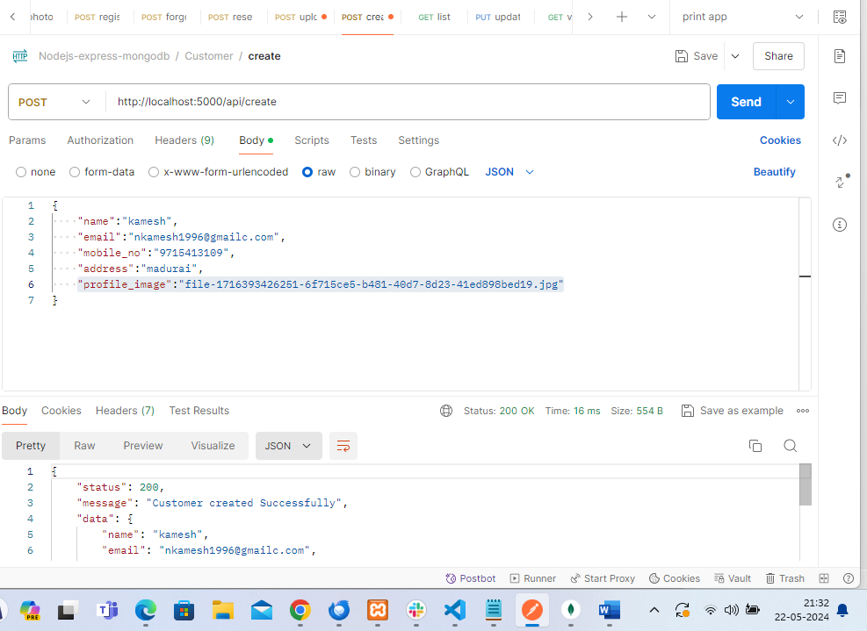  
  
Update the customer details  
now I upload the pdf file  
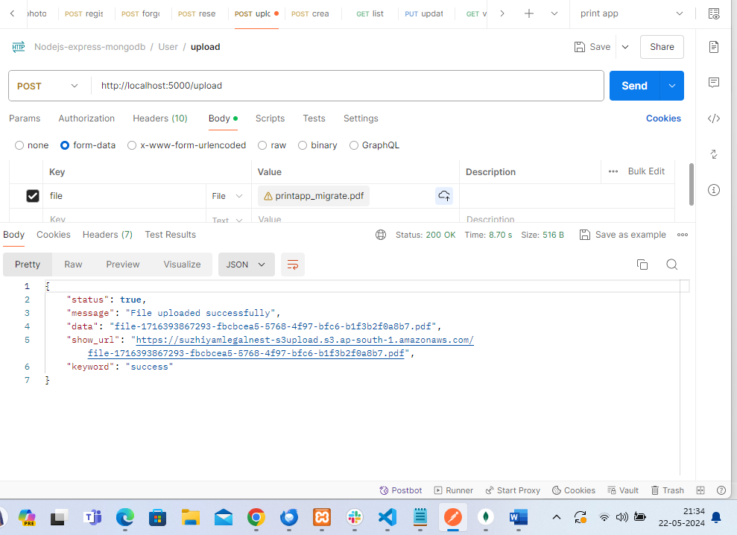  
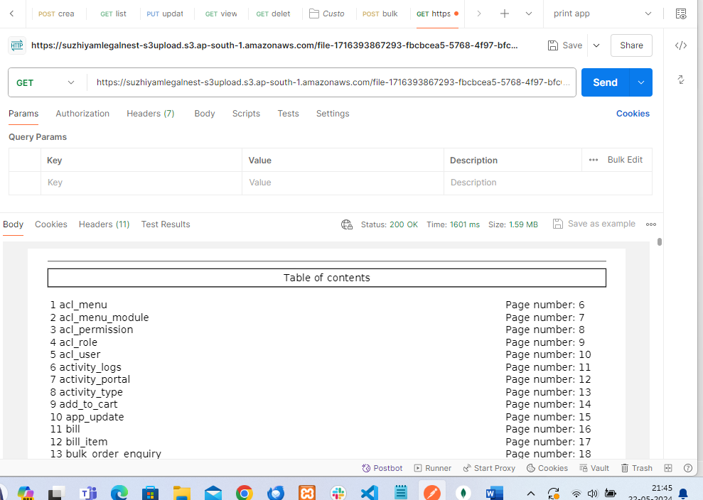  
some flow use this path only in update api  
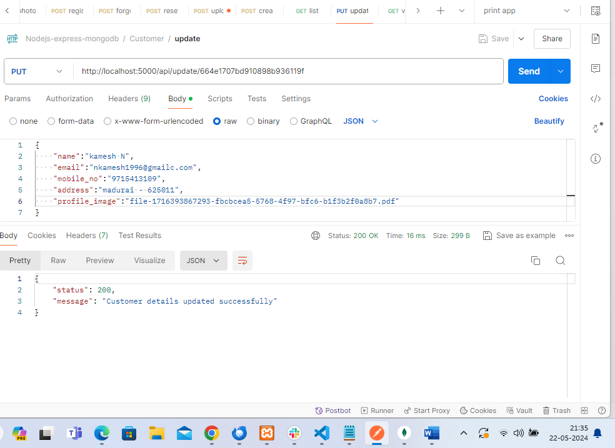  
list api  
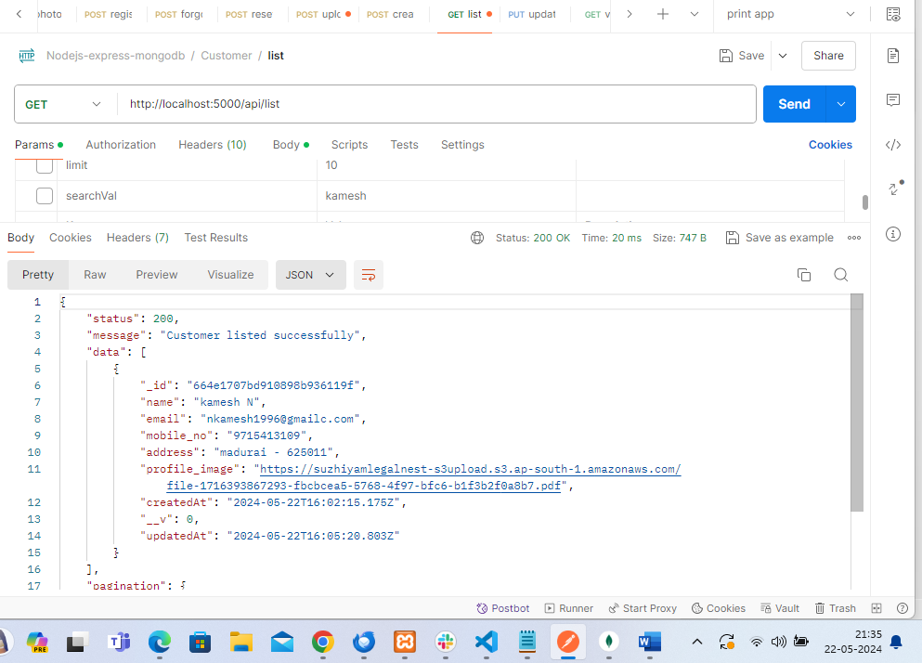  
I have two list  
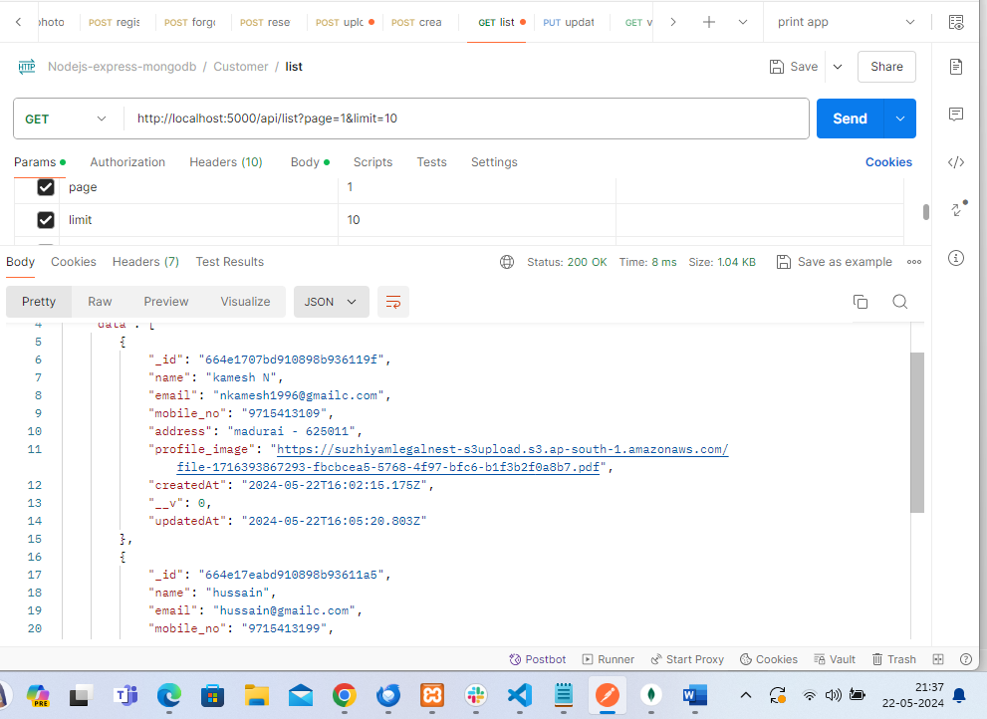  
now I search the email so searched data only showing  
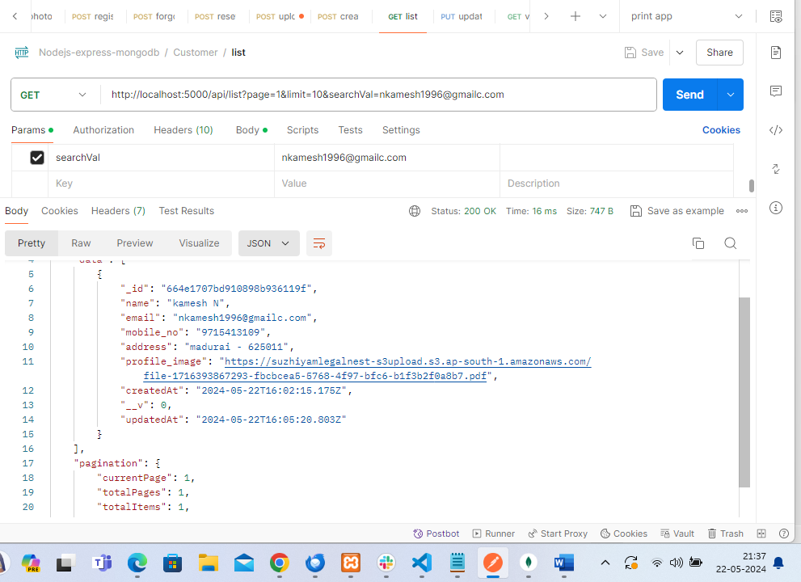  
customer view api  
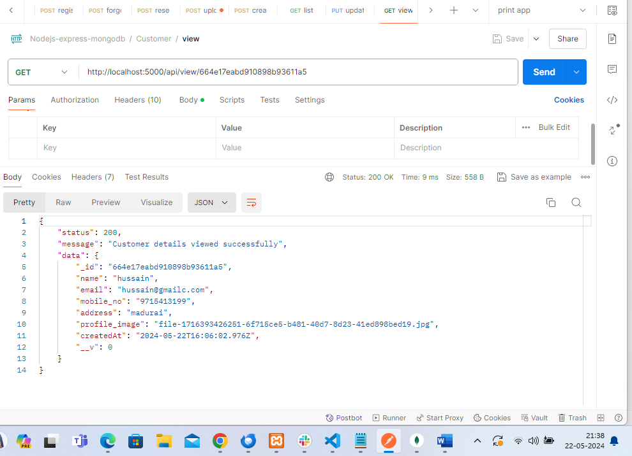  
customer delete api  
hussain customer deleted  
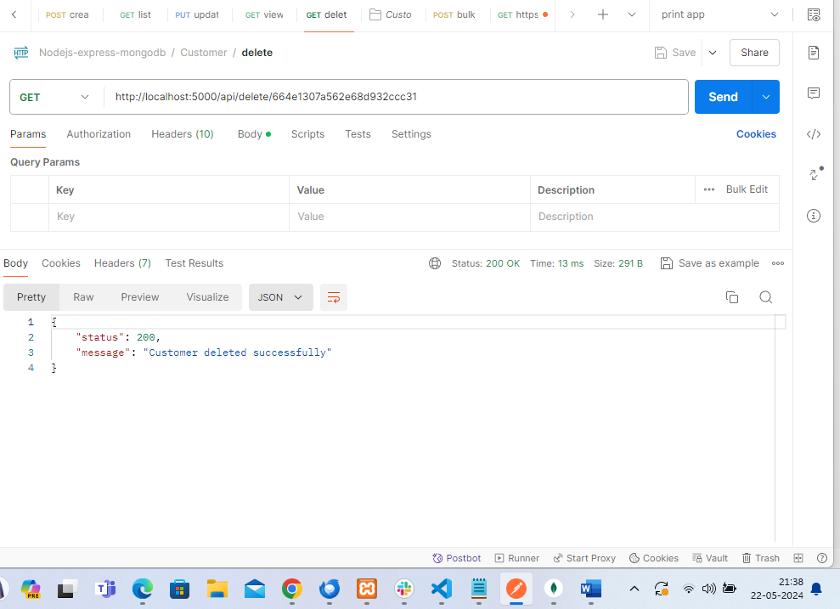  
now listed one data  
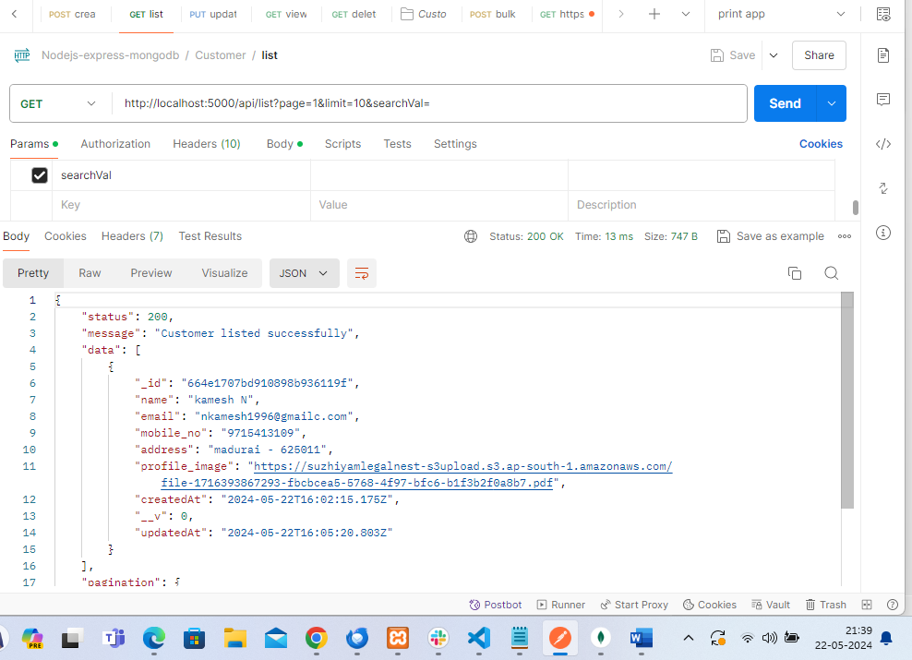  
  
Bulk Email  
I have statically using three emails using in bulk email  
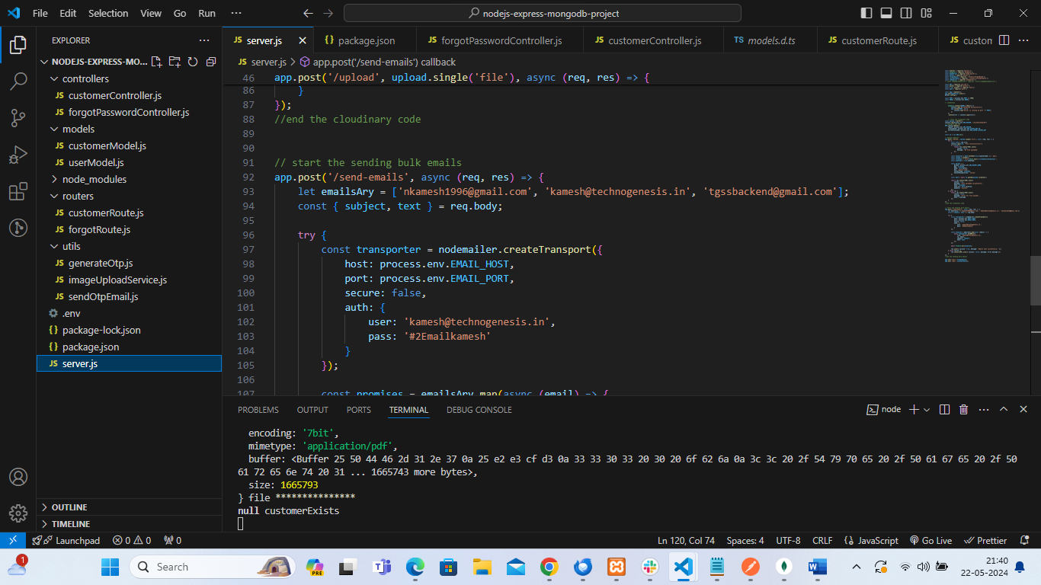  
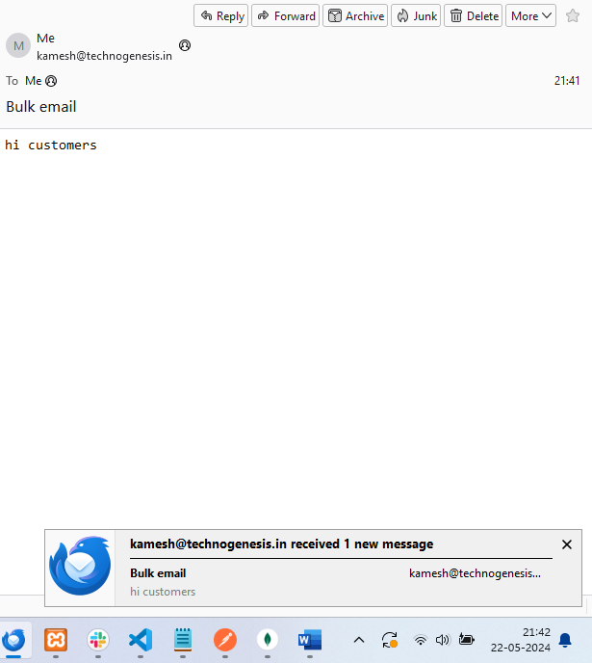  
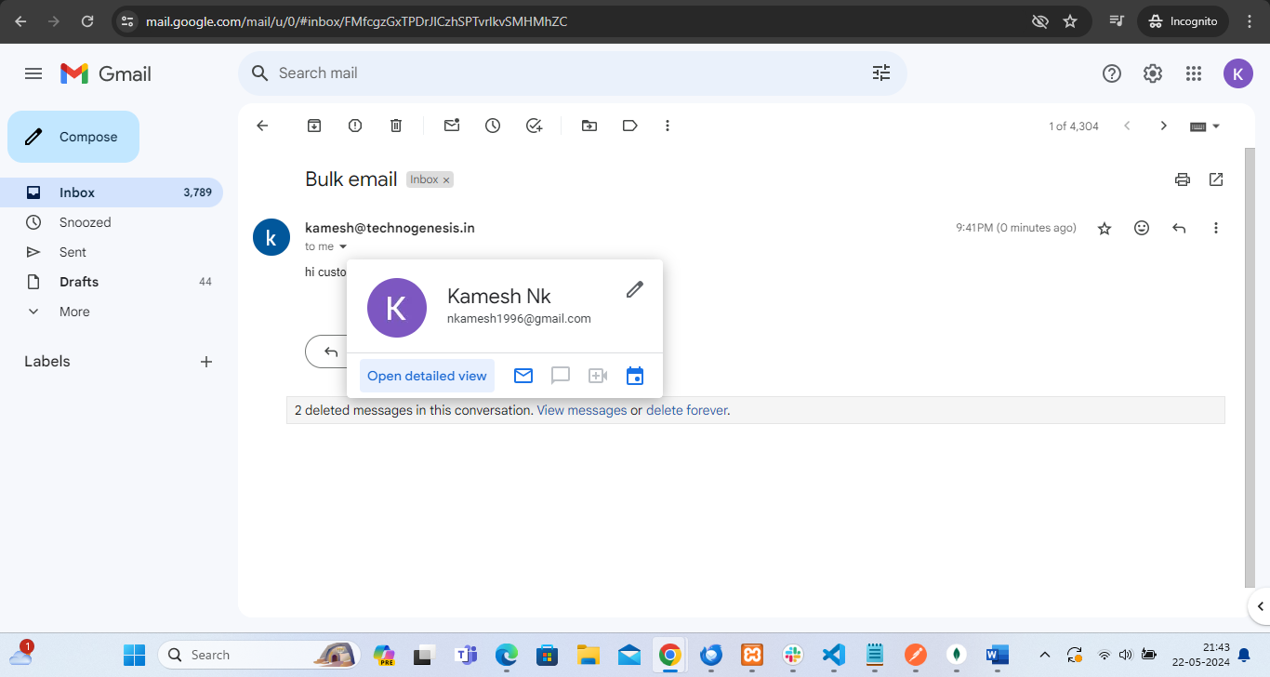  
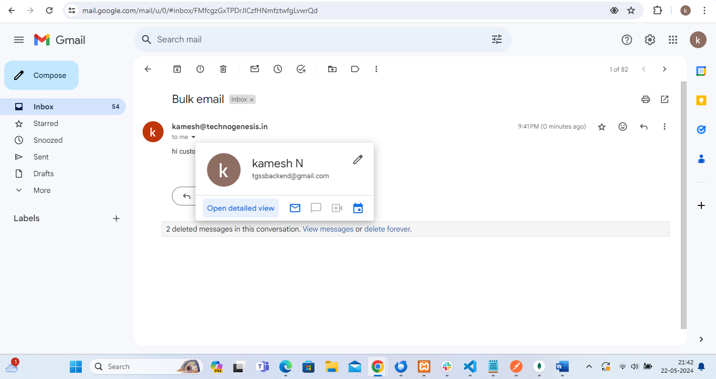

Mongodb  
