05 Monitoring prediction services:

$cd 05-monitoring

$conda create -m mlops5 python=3.8

$conda activate mlops5

$pip install -r requirements.txt

#download all files nyc-taxi files.

$python prepare.py

$docker compose up –build

Sending data to prediction service:

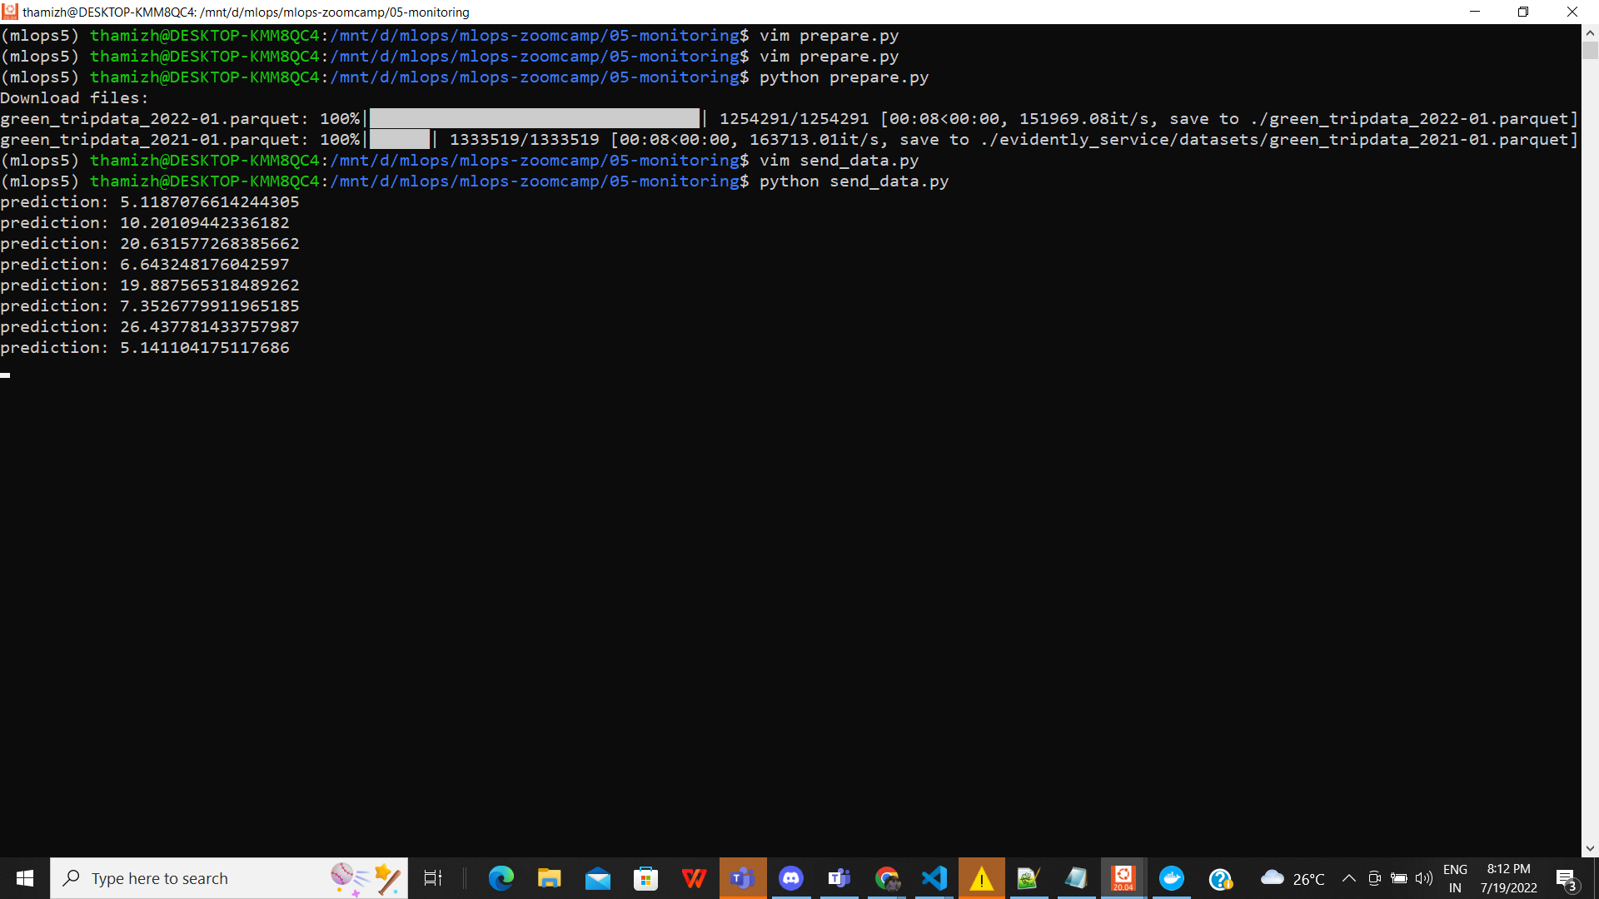

Prefect Monitoring:

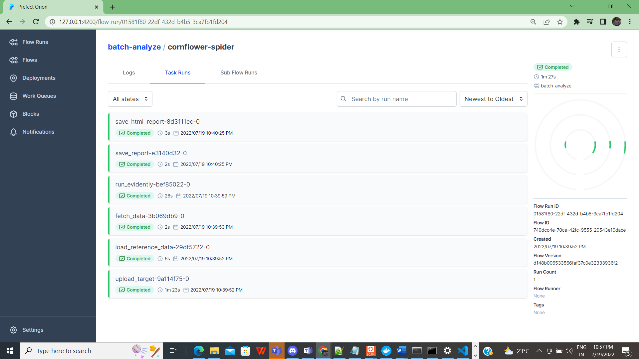

Evidently Dashboard:

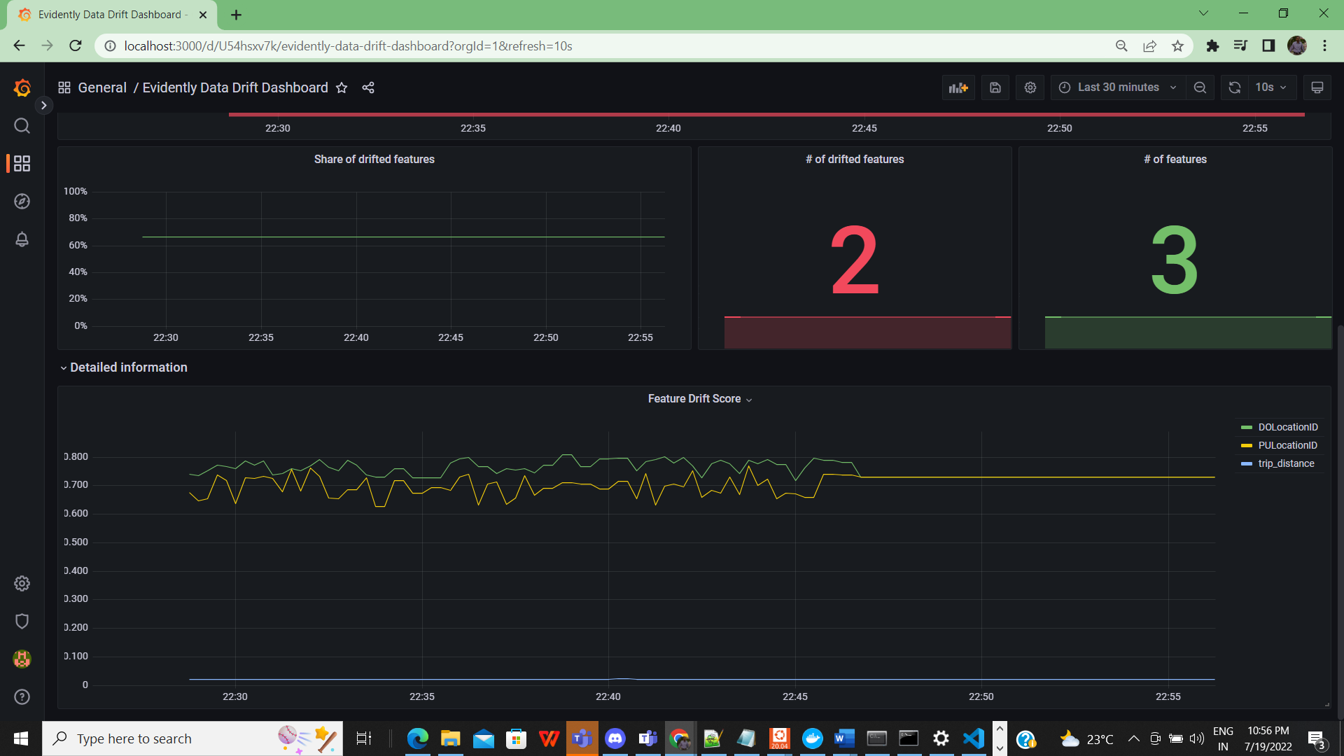

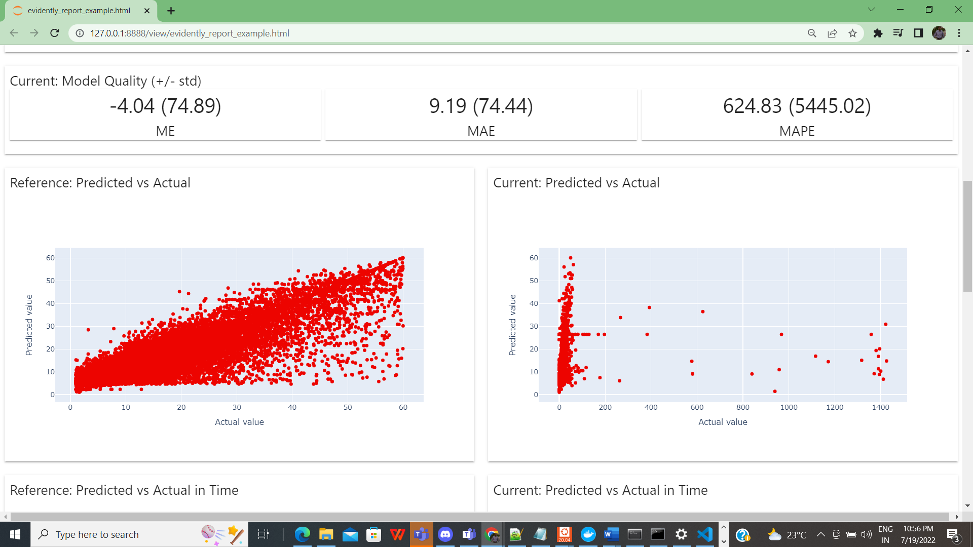

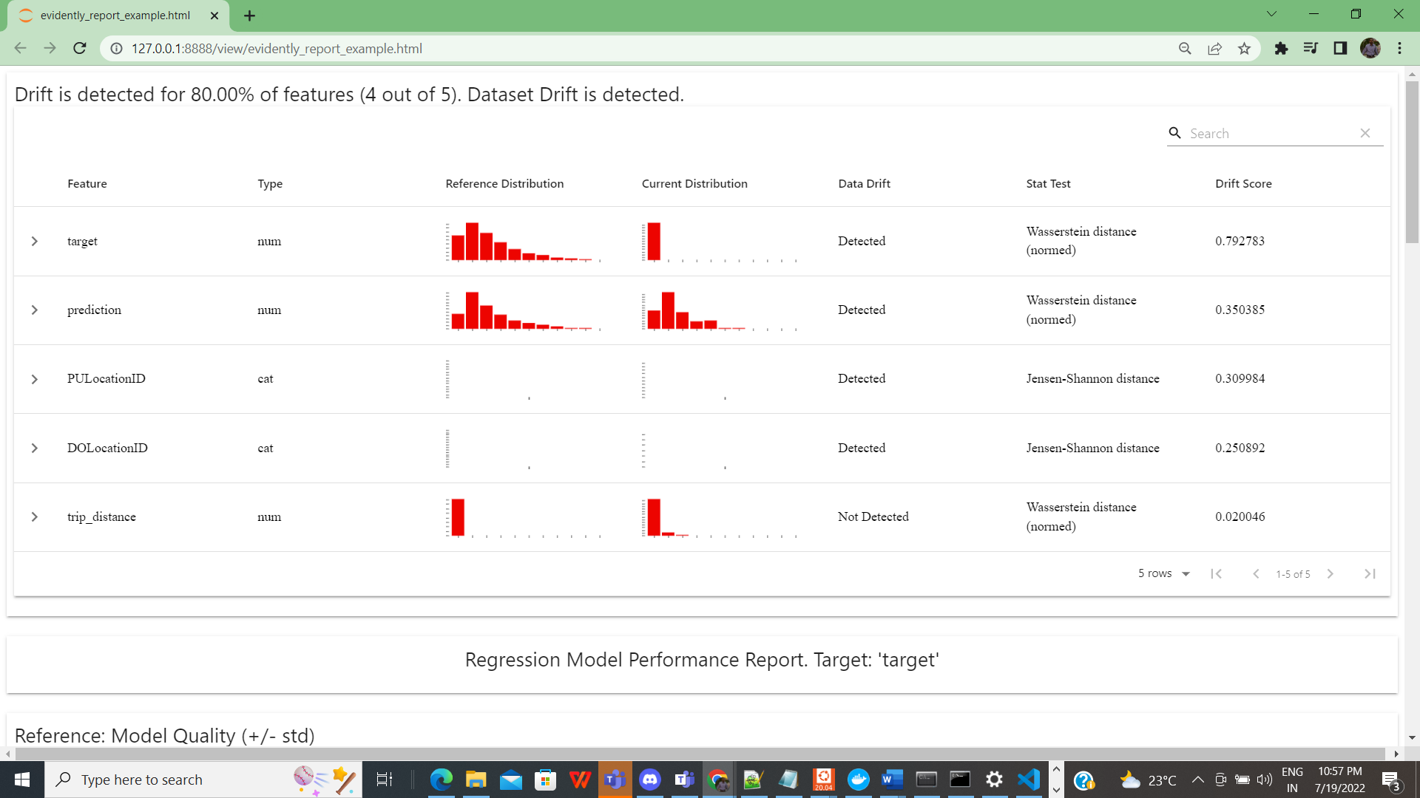

Prometheus Monitoring:

