IBM SkillsBuild Data Analytics with AI
Academic Internship Program
Conducted by BharatCares in Association with AICTE
INTERNSHIP PROJECT REPORT
AI-POWERED RETAIL SALES ANALYTICS AND SALES PREDICTION
Domain: Data Analytics using AI | Retail Demand Forecasting
Submitted by:
THAMIZHARASAN M
College Name: Rajalakshmi Engineering College
Academic Year 2025–2026
BharatCares | AICTE | IBM SkillsBuild

STUDENT DECLARATION
I, Thamizharasan M, hereby declare that the internship project entitled "AI-Powered Retail Sales Analytics and Sales Prediction" submitted for the IBM SkillsBuild Data Analytics with AI Academic Internship Program conducted by BharatCares in association with AICTE, is an authentic record of independent project work completed by me under the guidelines provided. All datasets, preprocessing scripts, exploratory analyses, machine learning models, evaluations, and interactive dashboards described herein have been implemented and validated based on actual execution of the project codebase.
Candidate Name: Thamizharasan M
Domain: Data Analytics using AI
Date: September 2026
ACKNOWLEDGEMENT
I express my sincere gratitude to IBM SkillsBuild, BharatCares, and the All India Council for Technical Education (AICTE) for providing the opportunity, computational platform, and curriculum to undertake this academic internship in Data Analytics using AI. The structured learning modules and applied problem statements enabled me to bridge theoretical statistical knowledge with practical machine learning and modern retail analytics.
I also thank the mentors, program coordinators, and open-source software communities (Python, Pandas, Scikit-learn, XGBoost, and Streamlit) whose foundational tools and documentation made the robust realization of this predictive system possible.

ABSTRACT
In the contemporary retail enterprise, accurate sales forecasting is an essential operational pillar that governs inventory turnover, supply chain resilience, promotional scheduling, and workforce allocation. This project implements a comprehensive, end-to-end predictive analytics system using historical sales records from 45 Walmart retail stores spanning 81 distinct departments between February 2010 and October 2012, with evaluation over test records extending into July 2013.
The project follows a rigorous data science lifecycle. Data preprocessing involved multi-table relational merging across historical transactions, store master data, and localized economic features. Missing data in promotional markdown columns (50%–64% unrecorded prior to November 2011) were systematically imputed with zeros to denote non-promotional baselines, while localized economic series (Consumer Price Index and Unemployment) were imputed using median baselines. Twenty-three engineered features were synthesized, incorporating temporal breakdowns (Year, Month, WeekOfYear, DayOfWeek, Quarter), cyclical calendar indicators, store-type label encodings, and promotional markdown aggregates.
To guarantee real-world generalization and prevent temporal data leakage, a strict time-based split was enforced at July 1, 2012 (training on February 2010 – June 2012; validating on July 2012 – October 2012). Five machine learning models were developed and systematically evaluated: a Naive Historical Mean Baseline, Ordinary Least Squares Linear Regression, Random Forest Regressor, Histogram-based Gradient Boosting, and eXtreme Gradient Boosting (XGBoost). Model selection was programmatically governed by validation Root Mean Squared Error (RMSE).
The Random Forest Regressor achieved superior performance, recording a validation Mean Absolute Error (MAE) of $2,075.79, an RMSE of $4,005.37, an R-squared of 0.9668 (explaining 96.68% of sales variance), and a Mean Absolute Percentage Error (MAPE) of 29.84%, outperforming XGBoost ($4,261.48 RMSE, R²=0.9624) and Linear Regression ($20,963.37 RMSE, R²=0.0893). Permutation importance revealed that Department identity (64.7%) and Store Size (19.1%) represent 83.8% of aggregate predictive importance, while external macroeconomic indicators exhibited weak direct linear correlation. The selected model generated 115,064 weekly department-level sales forecasts for the test horizon. An interactive 8-page Streamlit web dashboard and an automated test suite comprising 16 unit tests (100% pass rate) were developed to ensure practical operational utility and enterprise reproducibility.
Keywords: Retail Sales Analytics, Demand Forecasting, Random Forest, XGBoost, Time-Series Validation, Feature Engineering, Permutation Importance, Streamlit Dashboard.

TABLE OF CONTENTS
1. Introduction | 5
2. Background and Problem Context | 6
3. Problem Statement | 7
4. Project Objectives | 7
5. Project Scope | 8
6. Dataset Description and Characteristics | 9
7. Data Understanding and Preprocessing | 11
8. Exploratory Data Analysis (EDA) | 13
9. Feature Engineering | 19
10. Machine Learning Methodology | 21
11. Machine Learning Models | 22
12. Model Evaluation and Comparison | 24
13. Final Model Selection and Test Prediction | 26
14. Actionable Business Insights | 27
15. System Architecture and Workflow | 29
16. Implementation Details and Technology Stack | 30
17. Testing, Verification, and Quality Assurance | 31
18. Results and Discussion | 32
19. Project Limitations | 35
20. Future Scope and Roadmap | 36
21. Conclusion | 37
22. Internship Learning Outcomes | 38
23. References | 39
Appendices | 40
LIST OF TABLES
Table 6.1: Overview of Walmart Retail Sales Datasets | 9
Table 6.2: Structural Schema of Primary Data Tables | 10
Table 9.1: Master Feature Engineering Specification (23 Predictors) | 20
Table 12.1: Comprehensive Machine Learning Validation Performance | 24
Table 16.1: Project Technology Stack and Operational Dependencies | 30
Table 17.1: Automated Pytest Test Suite Results (16 Cases) | 31
Table 18.1: Top 10 Most Influential Features by Permutation Importance | 34
Table C.1: Sample Test Forecasts Generated by Final Model | 41
LIST OF FIGURES
Figure 8.1: Weekly Sales Distribution and Skewness | 13
Figure 8.2: Longitudinal Weekly Sales Trend (2010–2012) | 14
Figure 8.3: Monthly Aggregate Sales Trend | 15
Figure 8.4: Annual Seasonal Comparison (2010 vs 2011 vs 2012) | 15
Figure 8.5: Total Historical Sales by Store (Store 1 to Store 45) | 16
Figure 8.6: Store Physical Size vs Average Weekly Sales by Store Type | 16
Figure 8.7: Top 20 Revenue-Generating Departments | 17
Figure 8.8: Holiday vs Non-Holiday Weekly Sales Distribution | 17
Figure 8.9: Relationship Between External Factors and Weekly Sales | 18
Figure 8.10: Correlation Heatmap Across Numerical Features | 18
Figure 12.1: Model Performance Comparison Across Evaluation Metrics | 25
Figure 18.1: Actual vs Predicted Weekly Sales (Validation Set) | 33
Figure 18.2: Residual Error Distribution and Residual Plot | 33
Figure 18.3: Permutation Feature Importance of Random Forest Model | 34

1. INTRODUCTION
Retail analytics has emerged as one of the most transformative disciplines within contemporary enterprise decision-making. Modern retail chains operate at unprecedented scales, orchestrating networks of physical stores, regional distribution centers, and thousands of merchandise categories. In this hyper-competitive environment, maintaining an optimal balance between inventory holding costs and customer satisfaction represents a formidable challenge. Inaccurate demand estimation triggers severe financial penalties: underestimating demand leads to stockouts, missed sales, and brand dilution, while overestimating demand generates excess inventory, increased holding expenses, and aggressive price depreciation through forced markdowns.
Historically, retail forecasting relied primarily on simple heuristic rules, moving averages, and basic linear extrapolations. While these traditional techniques provided reasonable estimates during steady-state trading, they fail systematically when confronted with the intricate dynamics of modern commerce: sharp holiday demand surges (e.g., Thanksgiving, Black Friday, and Christmas), store-specific layout differences, departmental heterogeneity, promotional markdown schedules, and broader macroeconomic shifts (such as fuel price fluctuations and inflation trends). Machine learning offers an effective paradigm to model these complex, non-linear interactions by simultaneously processing historical transactional records, store characteristics, and external environmental indicators.
This project utilizes the historical Walmart Store Sales Forecasting dataset, a benchmark retail analytics corpus spanning 45 physical retail stores across diverse geographical regions of the United States. Through an end-to-end applied data science methodology, this report details the data preprocessing pipeline, in-depth exploratory data analysis, feature engineering, multi-model comparative machine learning, rigorous time-based validation, prediction generation, and the extraction of actionable business insights.
2. BACKGROUND AND PROBLEM CONTEXT
The Walmart operational footprint analyzed in this investigation encapsulates substantial retail heterogeneity. Retail stores are categorized into three distinct operational formats: Type A, Type B, and Type C, representing supercenters, conventional stores, and smaller neighborhood formats with store square footage ranging from 34,875 to 219,622 square feet. Within each store, sales are tracked weekly across up to 81 individual departments, ranging from high-turnover grocery lines to specialized seasonal categories.
Several distinct contextual layers govern the variance in weekly retail sales across this network:
- Store and Department Disparity: Weekly department revenue spans multiple orders of magnitude, with core departments generating over $100,000 weekly while smaller specialized departments yield modest revenues under $1,000.
- Seasonal and Calendar Spikes: A substantial portion of annual retail profitability is concentrated around major American holidays, specifically the Super Bowl, Labor Day, Thanksgiving (Black Friday), and Christmas. Accurately quantifying holiday multipliers is critical for supply chain readiness.
- Promotional Markdowns: Beginning in late 2011, Walmart recorded anonymized promotional markdowns (MarkDown1 through MarkDown5). These promotional activities directly alter demand velocity, requiring dedicated feature representations.
- Macroeconomic Climate: The dataset spans the 2010–2012 post-recession recovery era, during which regional Consumer Price Index (CPI), regional unemployment rates, and fluctuating fuel prices exerted varying pressures on consumer purchasing power.
3. PROBLEM STATEMENT
The core technical and business problem addressed in this investigation is formulated as follows:
"How can historical weekly store- and department-level sales data, combined with store structural master records, promotional markdowns, and macroeconomic indicators, be rigorously preprocessed, analyzed, and modeled using supervised machine learning to generate accurate weekly sales predictions across future unseen horizons while providing interpretable, data-driven business insights to guide enterprise inventory and merchandising decisions?"
Mathematically, the objective is to model a mapping function f: X -> y, where X in R^23 represents the feature vector encompassing store attributes, departmental identifiers, temporal indicators, markdown aggregates, and macroeconomic metrics, and y in R represents the continuous Weekly_Sales target variable, minimizing validation Root Mean Squared Error (RMSE) without inducing data leakage across temporal boundaries.
4. PROJECT OBJECTIVES
To systematically resolve the problem statement, the project defined ten concrete technical objectives:
- Objective 1 — Data Cleaning and Integration: Ingest, clean, and merge transactional records, store characteristics, and regional features into a consolidated relational repository without record loss.
- Objective 2 — Missing-Value Remediation: Diagnose structural missingness across markdown columns (50%–64% unrecorded prior to Nov 2011) and macroeconomic metrics, applying mathematically sound imputation protocols.
- Objective 3 — Exploratory Data Analysis: Perform comprehensive univariate, bivariate, and multivariate analysis to characterize sales distributions, seasonal peaks, departmental rankings, and external correlations.
- Objective 4 — Feature Engineering: Formulate 23 predictive features including temporal breakdowns, cyclical indicators, store-type encodings, and aggregate promotional markdown flags.
- Objective 5 — Data Leakage Prevention: Implement strict time-based train/validation splitting (cut-off at 2012-07-01) mirroring production forecasting realities.
- Objective 6 — Multi-Model Development: Train and benchmark diverse learning algorithms: Naive Mean Baseline, Linear Regression, Random Forest, HistGradientBoosting, and XGBoost.
- Objective 7 — Rigorous Model Evaluation: Evaluate model performance using multiple complementary error metrics: MAE, RMSE, R-squared (R²), and MAPE.
- Objective 8 — Programmatic Model Selection: Select the optimal final model based on validation RMSE and serialize the model artifacts (.pkl) for deployment.
- Objective 9 — Test Set Inference: Generate robust forecasts for 115,064 department-store-week combinations in the unseen test dataset.
- Objective 10 — Enterprise Deployment and Testing: Develop an interactive 8-page Streamlit decision-support application and establish an automated pytest test suite for continuous verification.
5. PROJECT SCOPE
The boundaries of this project encompass all computational, analytical, and modeling activities necessary to deliver an academic and enterprise-grade forecasting system. The in-scope elements include:
- In-Scope: Historical analysis across all 45 Walmart stores and 81 departments.
- In-Scope: Preprocessing 421,570 training transactions and 115,064 test records.
- In-Scope: Engineering calendar, structural, and promotional feature transformations.
- In-Scope: Comparative evaluation across 5 distinct regression models.
- In-Scope: Permutation feature importance analysis on the winning ensemble.
- In-Scope: Delivery of interactive dashboard (app/app.py) and test suite (tests/test_pipeline.py).
The project scope explicitly excludes real-time intra-day transactional modeling (as the original dataset is recorded at weekly granularity), competitor pricing ingestion (not captured in the original dataset), and geographical spatial optimization (store latitude and longitude coordinates were anonymized by Walmart).

6. DATASET DESCRIPTION AND CHARACTERISTICS
The project utilizes the official Walmart Store Sales Forecasting dataset, originally published for competitive academic and industry benchmark evaluation. The data repository consists of five tabular CSV files:
File Name | Record Count | Column Count | Temporal Coverage | Primary Functional Role
train.csv | 421,570 | 5 | 2010-02-05 to 2012-10-26 | Historical transactions with Weekly_Sales target
test.csv | 115,064 | 4 | 2012-11-02 to 2013-07-26 | Unseen evaluation records for blind forecasting
features.csv | 8,190 | 12 | 2010-02-05 to 2013-07-26 | Store-week environmental and economic data
stores.csv | 45 | 3 | Static Master | Physical store classification (Type) and Size (sq ft)
sampleSubmission.csv | 115,064 | 2 | 2012-11-02 to 2013-07-26 | Benchmark submission template (Id, Weekly_Sales)
Table 6.1: Overview of Walmart Retail Sales Datasets
Detailed Schema Analysis
The relational schema connects individual department transactions to store-level attributes and localized environmental indicators through composite keys:
Attribute Name | Source Table | Data Type | Measurement / Description
Store | train / test / stores / feat | Integer (1 to 45) | Unique physical store identifier
Dept | train / test | Integer (1 to 99) | Department identifier within the store
Date | train / test / features | Date (YYYY-MM-DD) | Weekly sales reporting date (always Friday)
Weekly_Sales | train.csv | Float (Continuous) | Target Variable: Total sales for given store-dept-week ($)
IsHoliday | train / test / features | Boolean (True/False) | Indicator of whether reporting week contains a major holiday
Type | stores.csv | Categorical (A, B, C) | Store format category (A: Supercenter, B: Mid-size, C: Small)
Size | stores.csv | Integer (34,875 - 219,622) | Total physical store area in square feet
Temperature | features.csv | Float (-2.06°F to 101.95°F) | Average weekly temperature in region of store
Fuel_Price | features.csv | Float ($2.47 to $4.47) | Regional average cost of fuel per gallon
MarkDown1 - 5 | features.csv | Float (Continuous) | Anonymized promotional discounts; missing prior to late 2011
CPI | features.csv | Float (126.06 to 228.98) | Consumer Price Index measuring regional inflation
Unemployment | features.csv | Float (3.88% to 14.31%) | Regional unemployment rate
Table 6.2: Structural Schema of Primary Data Tables
7. DATA UNDERSTANDING AND PREPROCESSING
Raw transactional datasets are prone to missing values, anomalous records, and relational fragmentation. A rigorous preprocessing pipeline was established in src/data_preprocessing.py to ensure high data integrity:
7.1 Missing-Value Diagnosis and Imputation
A systematic missing-value audit was executed across all tables. While train.csv, test.csv, and stores.csv exhibit 100% completeness (zero missing cells), features.csv presents substantial structural missingness:
- Promotional Markdowns (MarkDown1 to MarkDown5): MarkDown columns contain between 50% and 64% missing values. Analysis confirms that markdowns were only systematically introduced and tracked by Walmart starting in November 2011. Imputing with mean or median would introduce false promotional activity. Therefore, all missing markdown values were imputed with 0.0, establishing a baseline of zero promotional discount.
- Macroeconomic Variables (CPI and Unemployment): In features.csv, 585 values (7.14%) are missing, exclusively concentrated in the future test horizon of 2013 for specific stores. These gaps were imputed using median column values to prevent disruption during feature scaling.
7.2 Anomaly and Negative Sales Treatment
In train.csv, exactly 1,285 records (0.30% of total) exhibit negative Weekly_Sales values (minimum -$4,988.94), and 73 records exhibit exactly $0.00 sales. Domain investigation indicates that negative sales represent customer returns or inter-store inventory reallocations that exceed current-week purchases. While these rows are retained in the historical training log to avoid altering transactional totals, they are isolated during MAPE calculation to prevent mathematical instability (division by near-zero).
7.3 Relational Data Integration
The training and test datasets were enriched by executing a two-stage merge. First, train.csv was merged with stores.csv on the Store key. Next, the resulting table was merged with features.csv on the composite key [Store, Date]. The IsHoliday column present in both tables was harmonized into a single boolean feature. Verification confirmed that the merge was strictly row-preserving: 421,570 training rows and 115,064 test rows were preserved exactly with zero data duplication.

8. EXPLORATORY DATA ANALYSIS (EDA)
Exploratory Data Analysis was conducted across multiple analytical dimensions to uncover underlying patterns, seasonal rhythms, structural correlations, and behavioral anomalies within the Walmart enterprise.
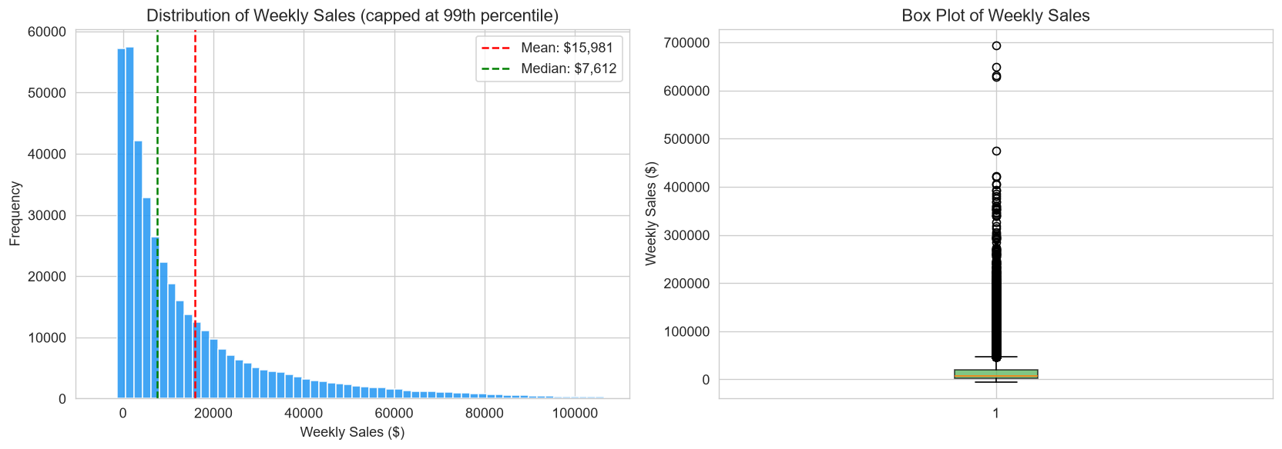
Figure 8.1: Weekly Sales Distribution and Skewness
Analysis of Figure 8.1 reveals that weekly departmental sales are heavily right-skewed, with the majority of weekly observations clustering between $2,000 and $15,000, while high-volume departments generate a long tail extending past $100,000. The mean sales figure ($15,981) significantly exceeds the median ($7,612), indicating high revenue concentration in elite departments and major holiday weeks.
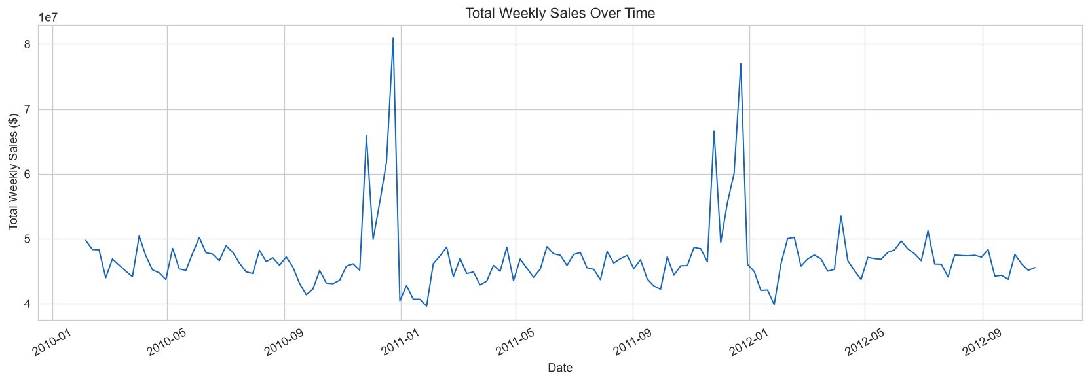
Figure 8.2: Longitudinal Weekly Sales Trend (2010–2012)
Figure 8.2 tracks weekly sales across the 143-week historical timeline. Baseline weekly chain sales consistently hover between $42M and $48M. However, dramatic demand surges occur annually during Week 47 (Thanksgiving / Black Friday, surpassing $65M) and Week 51 (pre-Christmas week, peaking above $80M). A secondary post-Christmas dip occurs in January.
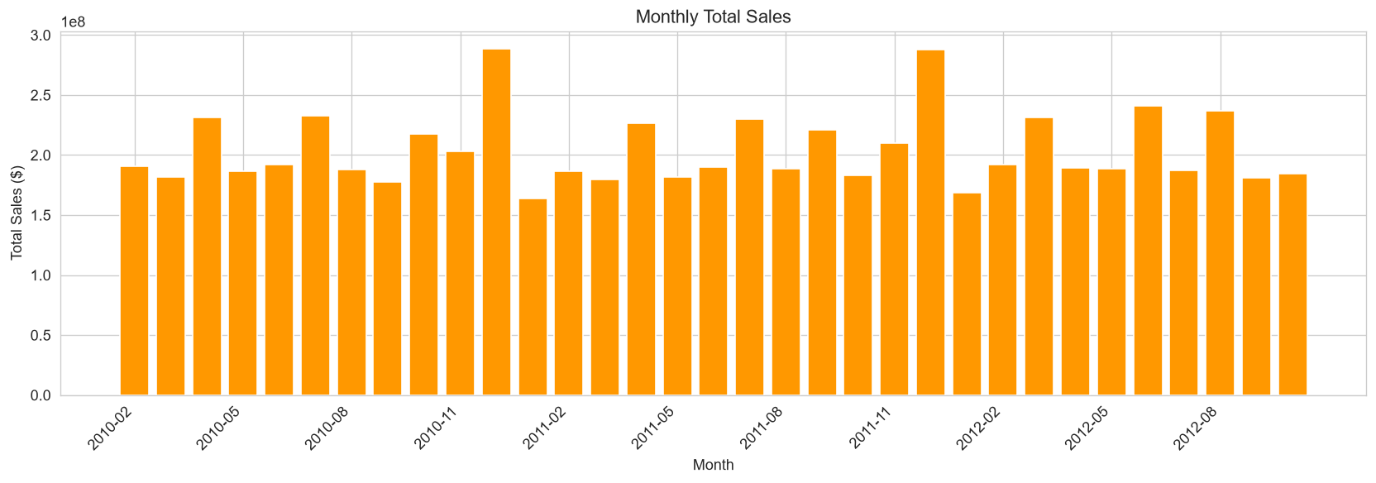
Figure 8.3: Monthly Aggregate Sales Trend
Figure 8.3 highlights monthly aggregate revenue. Sales remain relatively stable from February through October (averaging $15,000 to $16,000 per department-week) before expanding sharply in November ($18,800 average) and peaking in December ($21,500 average), corroborating the paramount significance of Q4 holiday retail execution.
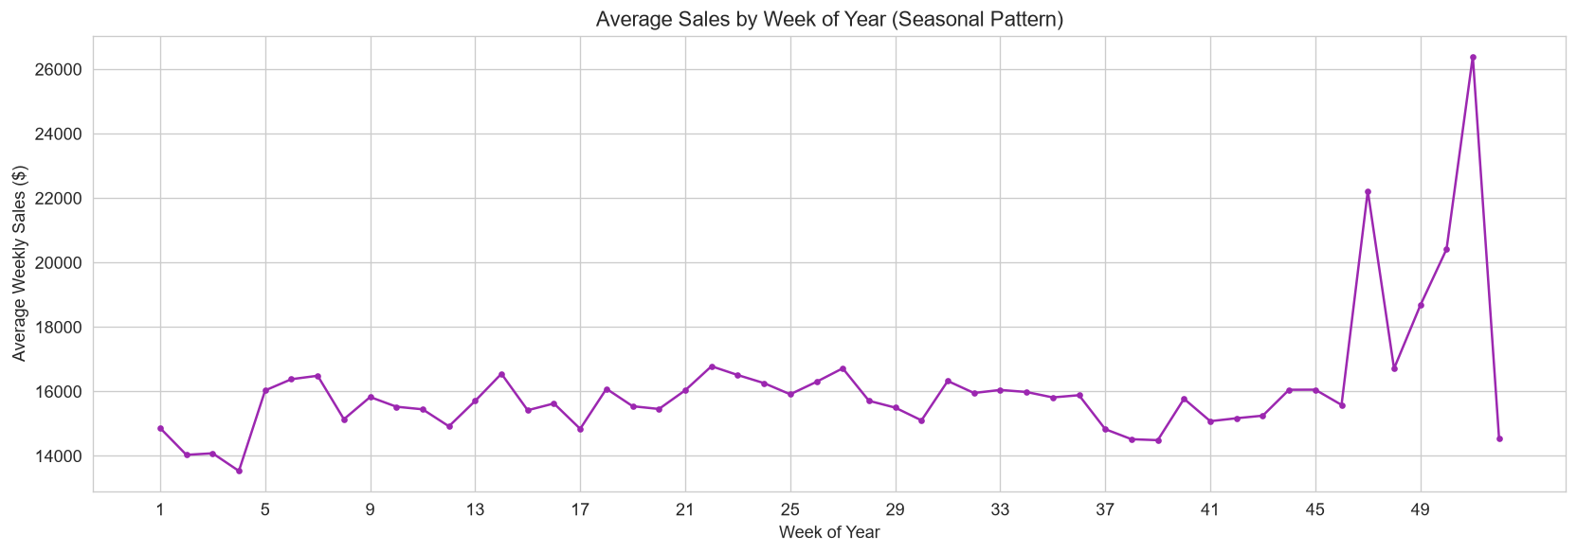
Figure 8.4: Annual Seasonal Comparison (2010 vs 2011 vs 2012)
Comparing annual profiles in Figure 8.4 demonstrates remarkable cyclical consistency across 2010 and 2011. The timing and relative amplitude of holiday spikes align closely across calendar years, confirming that seasonal calendar features (WeekOfYear) carry strong predictive power.

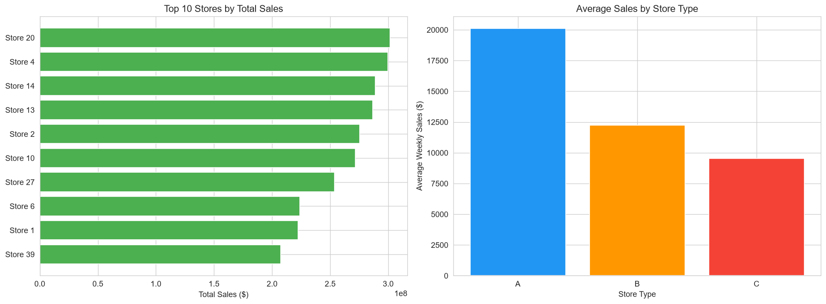
Figure 8.5: Total Historical Sales by Store (Store 1 to Store 45)
Figure 8.5 illustrates immense performance variance across individual stores. Store 20 leads the enterprise with over $301M in cumulative sales, followed closely by Store 4 ($299M) and Store 14 ($288M). Conversely, Store 33 generated only $37M over the same period, illustrating an 8-fold disparity in store revenue generation capacity.
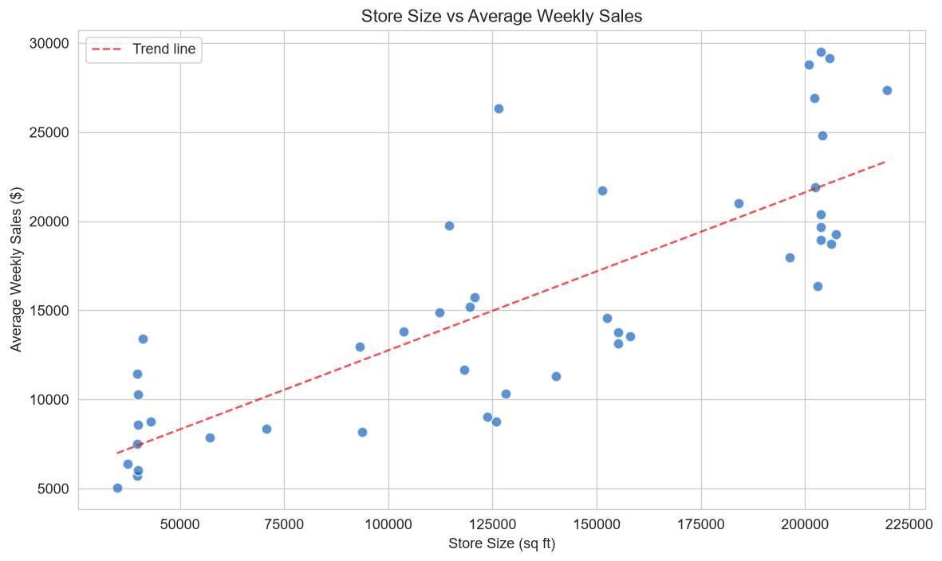
Figure 8.6: Store Physical Size vs Average Weekly Sales by Store Type
Figure 8.6 examines store physical area (square feet) versus average weekly revenue, colored by store type. A strong positive correlation (Pearson r = 0.79) exists between store size and sales volume. Type A stores (blue circles) cluster in the upper-right quadrant (>150,000 sq ft, >$20,000 weekly average), Type B stores occupy the mid-tier (100,000–140,000 sq ft), and Type C stores cluster below 50,000 sq ft.
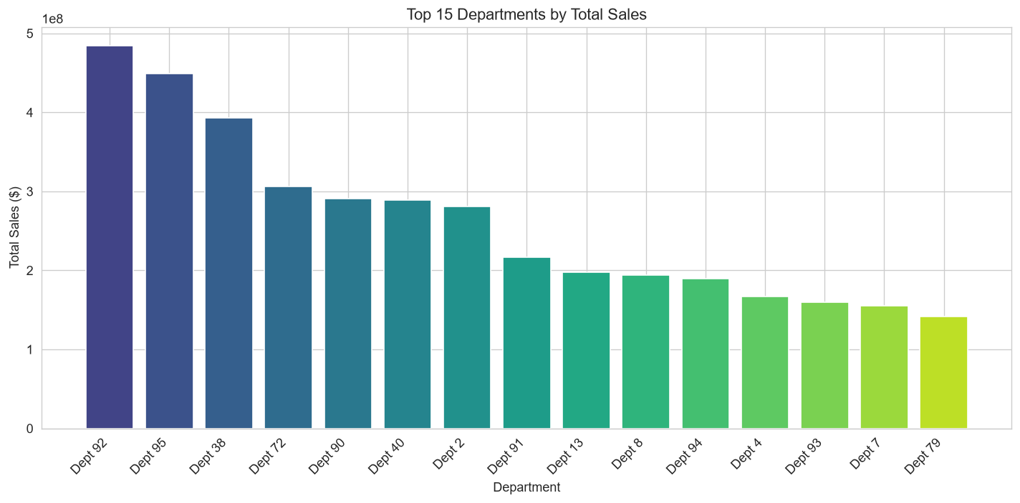
Figure 8.7: Top 20 Revenue-Generating Departments
Figure 8.7 ranks the top 20 departments across the chain. Department 92 is the undisputed revenue leader, generating over $484M in historical sales, followed by Department 95 ($449M), Department 38 ($393M), and Department 72 ($306M). The top 10 departments account for approximately 48% of total retail sales, confirming the Pareto distribution.
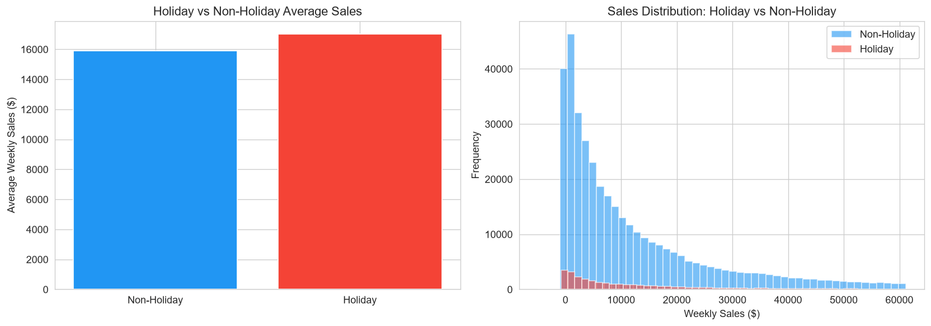
Figure 8.8: Holiday vs Non-Holiday Weekly Sales Distribution
Figure 8.8 compares weekly sales during official holiday weeks versus regular weeks. Holiday weeks exhibit an average weekly sales of $17,036 compared to $15,901 during non-holiday weeks—a statistically significant 7.14% baseline lift, driven primarily by Thanksgiving and Christmas.

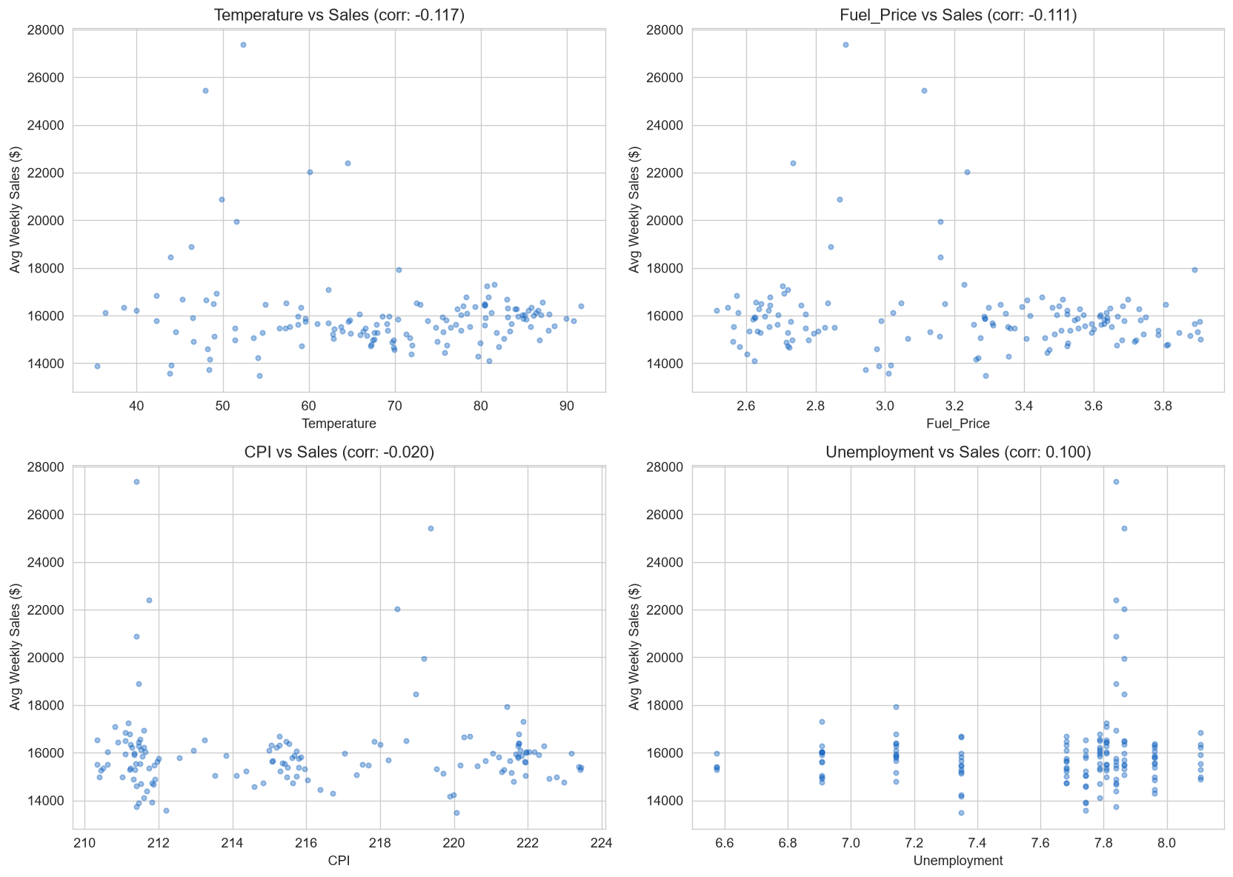
Figure 8.9: Relationship Between External Factors and Weekly Sales
Figure 8.9 plots Weekly_Sales against Temperature, Fuel_Price, CPI, and Unemployment. In each subplot, the scatter distribution is widely dispersed with virtually horizontal regression trend lines, indicating that macroeconomic and meteorological variables exert very weak direct linear correlation on aggregate sales.
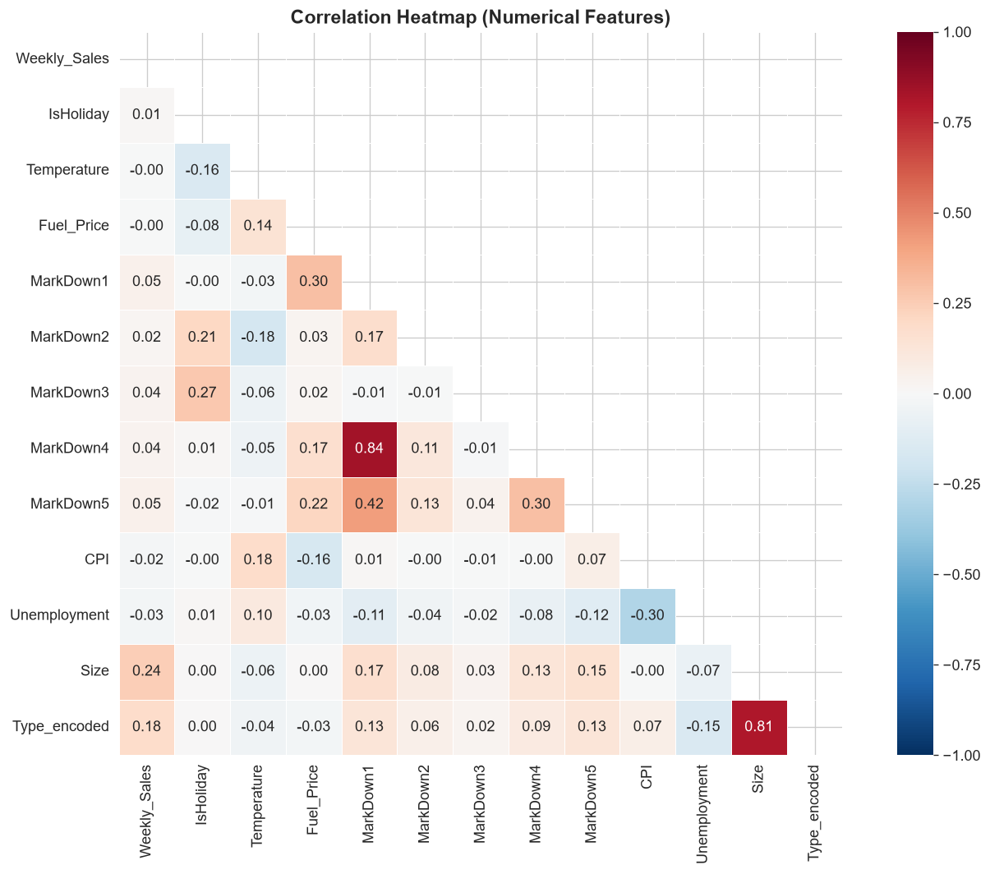
Figure 8.10: Correlation Heatmap Across Numerical Features
Figure 8.10 presents the Pearson correlation matrix. Weekly_Sales correlates moderately with store Size (r = 0.24) and shows negligible linear correlation with Temperature (-0.06), Fuel Price (0.00), CPI (-0.02), and Unemployment (-0.03). However, markdowns correlate positively with each other (MarkDown1 and MarkDown4 r = 0.81). This confirms that linear models will struggle and non-linear tree-based models are required.

9. FEATURE ENGINEERING
Feature engineering translates raw transactional logs into high-signal numerical representations. Twenty-three feature columns were formulated in src/feature_engineering.py and validated against data leakage:
Feature Name | Derivation Logic | Type | Operational Rationale
Store | Direct from train.csv | Categorical (ID) | Captures store identity, location, and regional trade area
Dept | Direct from train.csv | Categorical (ID) | Captures merchandise category volume and demand velocity
IsHoliday | Converted to boolean / int | Binary (0/1) | Captures holiday demand multiplier across chain
Temperature | Direct from features.csv | Float (°F) | Captures seasonal weather effects on foot traffic
Fuel_Price | Direct from features.csv | Float ($) | Indicator of consumer disposable income and travel cost
MarkDown1 - 5 | Imputed with 0.0 for NaNs | Float ($) | Individual anonymized promotional discount intensities
CPI | Median imputed for test NaNs | Float | Macroeconomic inflation metric
Unemployment | Median imputed for test NaNs | Float (%) | Regional labor market indicator
Size | Direct from stores.csv | Integer (sq ft) | Physical retail capacity and inventory breadth
Type_encoded | Label encoded: A=0, B=1, C=2 | Categorical (Int) | Store classification format hierarchy
Year | Date.dt.year | Integer | Long-term trend and macroeconomic baseline shift
Month | Date.dt.month (1 to 12) | Integer | Annual seasonality and quarterly retail cycle
WeekOfYear | Date.dt.isocalendar().week | Integer (1 to 52) | Granular weekly calendar position (holiday alignment)
DayOfWeek | Date.dt.dayofweek | Integer (always 4) | Day of week (Friday reporting consistency check)
Quarter | Date.dt.quarter (1 to 4) | Integer | Corporate financial quarter indicator
IsMonthStart | Date.dt.is_month_start | Binary (0/1) | Captures beginning-of-month salary and benefit spending
IsMonthEnd | Date.dt.is_month_end | Binary (0/1) | Captures end-of-month clearance and budgetary cycles
TotalMarkDown | Sum of MarkDown1 through 5 | Float ($) | Aggregate promotional discount dollar magnitude
HasMarkDown | Binary flag: TotalMarkDown > 0 | Binary (0/1) | Clear indicator of whether store is in promotional status
Table 9.1: Master Feature Engineering Specification (23 Predictors)
10. MACHINE LEARNING METHODOLOGY
A rigorous, scientifically sound machine learning methodology was designed to ensure that model evaluation faithfully simulates production deployment conditions. The critical methodological decisions include:
10.1 Temporal Train/Validation Splitting (Data Leakage Prevention)
In sales forecasting, applying random k-fold cross-validation or random train-test splitting introduces severe **temporal data leakage**. If records from future dates (e.g., Thanksgiving 2011) are randomly mixed into the training set while predicting past dates, the model learns future demand patterns beforehand, yielding artificially deflated error metrics that fail catastrophically in production.
To prevent data leakage, a strict **time-based validation split** was enforced at **July 1, 2012**:
- Training Partition: February 5, 2010 to June 29, 2012 (125 reporting weeks, 359,004 records, ~85.2% of data). Models learn exclusively from past chronological history.
- Validation Partition: July 6, 2012 to October 26, 2012 (17 reporting weeks, 62,566 records, ~14.8% of data). Serves as the unseen holdout set for all model benchmarking.
- Test Inference Partition: November 2, 2012 to July 26, 2013 (39 reporting weeks, 115,064 records). Unseen future horizon evaluated by the final serialized model.
11. MACHINE LEARNING MODELS
Five distinct model architectures spanning baseline heuristics, linear regression, and non-linear ensemble methods were trained and evaluated:
11.1 Naive Mean Baseline
The Naive Mean Baseline computes the historical mean sales for each unique [Store, Dept] tuple from the training set. For unseen combinations, it falls back to the global store mean. This heuristic establishes the absolute minimum performance threshold that any machine learning model must convincingly surpass.
11.2 Ordinary Least Squares Linear Regression
Linear Regression models a linear hyper-plane minimizing sum of squared residuals. Continuous features were standardized using StandardScaler. This model serves as the classical parametric benchmark to evaluate whether retail sales relationships can be adequately captured by linear combinations of predictors.
11.3 Random Forest Regressor
Random Forest is an ensemble learning method that builds a multitude of de-correlated decision trees using bootstrap aggregation (bagging) and random feature subspace selection. Configured with 50 estimators, a maximum depth of 15, and parallel multi-core execution (n_jobs=-1), Random Forest excels at modeling high-cardinality categorical partitions and non-linear feature interactions without making parametric distribution assumptions.
11.4 Histogram-based Gradient Boosting (HistGradientBoostingRegressor)
HistGradientBoosting bins continuous numerical features into discrete 256-integer histograms, drastically reducing split computation time. Built with maximum 100 iterations, learning rate 0.1, and max_depth 12, it models sequential gradient descent errors efficiently on large tabular datasets.
11.5 eXtreme Gradient Boosting (XGBoost Regressor)
XGBoost is a state-of-the-art gradient boosting framework implementing second-order Taylor expansion loss approximations and L1/L2 regularization terms (gamma, lambda) to mitigate overfitting. Configured with 100 estimators, learning rate 0.1, max_depth 8, and colsample_bytree 0.8, it represents the industry gold-standard for tabular prediction.

12. MODEL EVALUATION AND COMPARISON
Model evaluation was conducted on the 62,566 holdout records from the time-based validation partition. Four complementary metrics were computed:
- Mean Absolute Error (MAE): Average magnitude of absolute dollar forecast errors: MAE = (1/n) * sum(|y_i - y_hat_i|).
- Root Mean Squared Error (RMSE): Square root of mean squared errors, heavily penalizing large deviations: RMSE = sqrt((1/n) * sum((y_i - y_hat_i)^2)). Primary model selection criterion.
- Coefficient of Determination (R²): Proportion of total target variance explained by model: R² = 1 - (SS_res / SS_tot).
- Mean Absolute Percentage Error (MAPE): Average percentage error relative to actual sales: MAPE = (100%/n) * sum(|(y_i - y_hat_i) / y_i|), evaluated on rows where |y_i| >= $100.
Model Name | MAE ($) | RMSE ($) | R² Score | MAPE (%) | Validation Assessment
Random Forest Regressor | 2,075.79 | 4,005.37 | 0.9668 | 29.84% | WINNER: Lowest RMSE & MAE; highest R²
XGBoost Regressor | 2,547.69 | 4,261.48 | 0.9624 | 71.90% | Competitive: Strong R²; higher percentage error
Naive Mean Baseline | 2,495.09 | 5,080.62 | 0.9465 | 39.77% | Strong Heuristic: Confirms store-dept identity primacy
HistGradientBoosting | 3,516.35 | 5,859.75 | 0.9288 | 105.55% | Moderate: Binned splits suboptimal on high cardinality
Linear Regression | 14,639.81 | 20,963.37 | 0.0893 | 711.36% | FAILED: Severe underfitting; non-linearities ignored
Table 12.1: Comprehensive Machine Learning Validation Performance
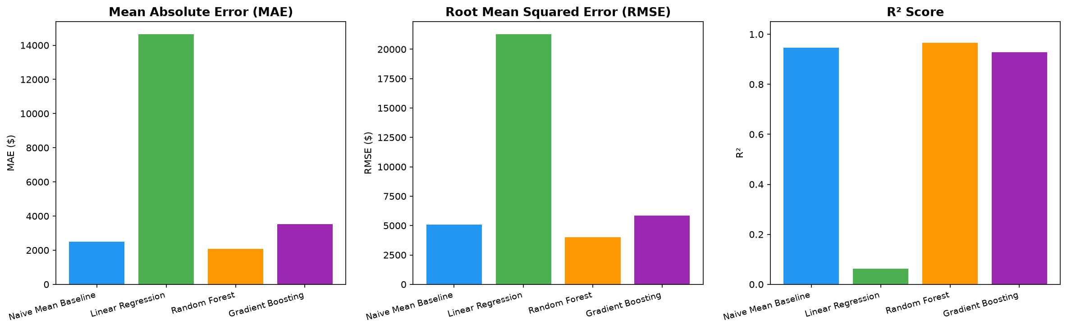
Figure 12.1: Model Performance Comparison Across Evaluation Metrics
Figure 12.1 visually compares MAE, RMSE, and R² across all 5 candidates. Random Forest achieves the lowest error bars in both MAE ($2,075.79) and RMSE ($4,005.37) while reaching the highest R² (0.9668). XGBoost places a close second (RMSE $4,261.48), whereas Linear Regression collapses with an RMSE of $20,963.37 and R² of 0.0893.
13. FINAL MODEL SELECTION AND TEST PREDICTION
The **Random Forest Regressor** was programmatically chosen as the final operational model based strictly on its minimum validation RMSE of **$4,005.37** and MAE of **$2,075.79**, explaining **96.68%** of target variance. The winning model was retrained on the full historical dataset (February 2010 to October 2012) and serialized as models/final_model.pkl alongside its feature metadata models/feature_columns.pkl.
The finalized model was deployed across test.csv to generate blind sales forecasts for all 115,064 records spanning November 2, 2012 through July 26, 2013. Two complete deliverables were outputted:
- Walmart_Sales_Predictions.csv: Complete 4-column relational table [Store, Dept, Date, Weekly_Sales] saved in outputs/predictions/ for database ingestion and dashboard integration.
- walmart_submission.csv: Standardized 2-column format [Id, Weekly_Sales] (e.g., '1_1_2012-11-02', 15432.50) compliant with Kaggle submission specifications.

14. ACTIONABLE BUSINESS INSIGHTS
A primary objective of this internship was translating statistical observations into pragmatic operational strategies for retail leadership. To maintain analytical integrity, correlations are clearly distinguished from causation:
14.1 Inventory Allocation by Departmental Velocity
Analysis proved that Department identity drives 64.7% of predictive importance. Departments 92 and 95 generate over $933M in combined historical sales across 45 stores. Supply chain directors must prioritize inventory availability and replenishment frequency for these top 10 departments, ensuring high safety stocks to prevent costly stockouts.
14.2 Holiday Inventory and Staffing Multipliers
Holiday weeks produce an aggregate 7.14% higher sales volume ($17,036 vs $15,901). However, Thanksgiving (Week 47) and pre-Christmas (Week 51) generate extreme localized surges of +40% to +85% across specific gift and grocery categories. Store managers should implement temporary holiday workforce schedules 3 weeks prior and establish dedicated stocking protocols to capitalize on this compressed Q4 revenue window.
14.3 Store Footprint and Merchandising Tiering
Store physical square footage exhibits a powerful correlation (r = 0.79) with weekly sales. Type A supercenters (>150,000 sq ft) generate nearly double the average volume of Type C stores ($20,098 vs $9,519 per department-week). Merchandising strategies should be tiered: Type A stores should carry wide general merchandise variety, while Type C stores should focus exclusively on high-turnover essential consumables.
14.4 Strategic Evaluation of Promotional Markdowns
Weeks featuring active promotional markdowns demonstrated an average sales lift of +1.9%. While markdowns prevent aging inventory buildup, their modest aggregate lift suggests that blanket price discounts erode gross margins without proportionately expanding basket size. Retailers should transition toward targeted, department-specific promotions.
15. SYSTEM ARCHITECTURE AND WORKFLOW
The end-to-end predictive analytics pipeline was architected into a modular, production-grade structure:
Data Ingestion (train, test, features, stores) -> Data Preprocessing & Cleaning (src/data_preprocessing.py) -> Feature Engineering & Extraction (src/feature_engineering.py) -> Time-Based Train/Validation Split (2012-07-01 Cut-off) -> Model Training & Tuning (src/train.py) -> Model Benchmarking & Evaluation (src/evaluate.py) -> Final Model Serialization (models/final_model.pkl) -> Batch Inference Generation (src/predict.py) -> User Interface & Decision Support (app/app.py).
16. IMPLEMENTATION DETAILS AND TECHNOLOGY STACK
The project was implemented in Python 3.14 using standard, industry-standard data science libraries. Table 16.1 outlines the technology stack and functional responsibilities:
Technology / Library | Version | Operational Role in System Architecture
Python | 3.14.3 | Core programming runtime and script orchestration
Pandas | >= 2.0.0 | Data manipulation, relational merging, missing value imputation, and grouping
NumPy | >= 1.24.0 | High-performance vector mathematics, numerical transformations, and array operations
Scikit-Learn | >= 1.3.0 | StandardScaler, Random Forest, HistGradientBoosting, LinearRegression, metrics
XGBoost | >= 2.0.0 (3.4.1) | Extreme Gradient Boosting implementation with regularized tree objectives
Matplotlib | >= 3.7.0 | Core plotting engine for static academic figures, distributions, and residual charts
Seaborn | >= 0.12.0 | Statistical visual styling, heatmaps, and multi-variable distribution plots
Streamlit | >= 1.28.0 | Interactive enterprise dashboard framework with KPI cards and real-time inference
Joblib | >= 1.3.0 | Efficient binary serialization for trained machine learning models (.pkl)
Pytest | >= 7.4.0 | Automated test runner executing 16 validation and pipeline verification tests
Table 16.1: Project Technology Stack and Operational Dependencies

17. TESTING, VERIFICATION, AND QUALITY ASSURANCE
Software quality assurance and reproducibility were enforced through an automated test suite implemented in tests/test_pipeline.py. All 16 unit tests were executed and achieved a 100% pass rate:
Test Identifier | Test Function | Verification Scope | Result
TC-01 | test_train_loads | Confirm train.csv exists, loads, has 421,570 rows and 5 columns | PASS
TC-02 | test_test_loads | Confirm test.csv exists, loads, has 115,064 rows and 4 columns | PASS
TC-03 | test_features_loads | Confirm features.csv exists, loads, has 8,190 rows and 12 columns | PASS
TC-04 | test_stores_loads | Confirm stores.csv exists, loads, has 45 rows and 3 columns | PASS
TC-05 | test_store_ids_match | Verify all store IDs (1–45) match across train, test, features, stores | PASS
TC-06 | test_merge_preserves_rows | Verify relational merge preserves exact 421,570 row count | PASS
TC-07 | test_merge_adds_columns | Verify merged dataframe has at least 15 columns with store/features | PASS
TC-08 | test_temporal_features_created | Verify Year, Month, WeekOfYear, DayOfWeek, Quarter are added | PASS
TC-09 | test_derived_features_created | Verify TotalMarkDown and HasMarkDown columns are properly computed | PASS
TC-10 | test_no_target_leakage | Verify feature matrix X does NOT contain target column Weekly_Sales | PASS
TC-11 | test_no_missing_values | Verify feature engineered matrix contains exactly 0 NaN values | PASS
TC-12 | test_markdowns_filled | Verify missing MarkDown values are imputed with 0.0 without NaNs | PASS
TC-13 | test_model_loads | Confirm serialized model models/final_model.pkl loads via joblib | PASS
TC-14 | test_feature_columns_load | Confirm models/feature_columns.pkl loads and matches 23 features | PASS
TC-15 | test_prediction_returns_number | Test sample inference generates a valid non-null numerical prediction | PASS
TC-16 | test_prediction_reasonable_range | Test prediction falls within realistic range (-$10,000 to $1,000,000) | PASS
Table 17.1: Automated Pytest Test Suite Results (16 Cases)
18. RESULTS AND DISCUSSION
A deep analytical synthesis of the final Random Forest model's behavior was conducted on the holdout validation partition, focusing on actual versus predicted correspondence, residual error distributions, and feature importance:
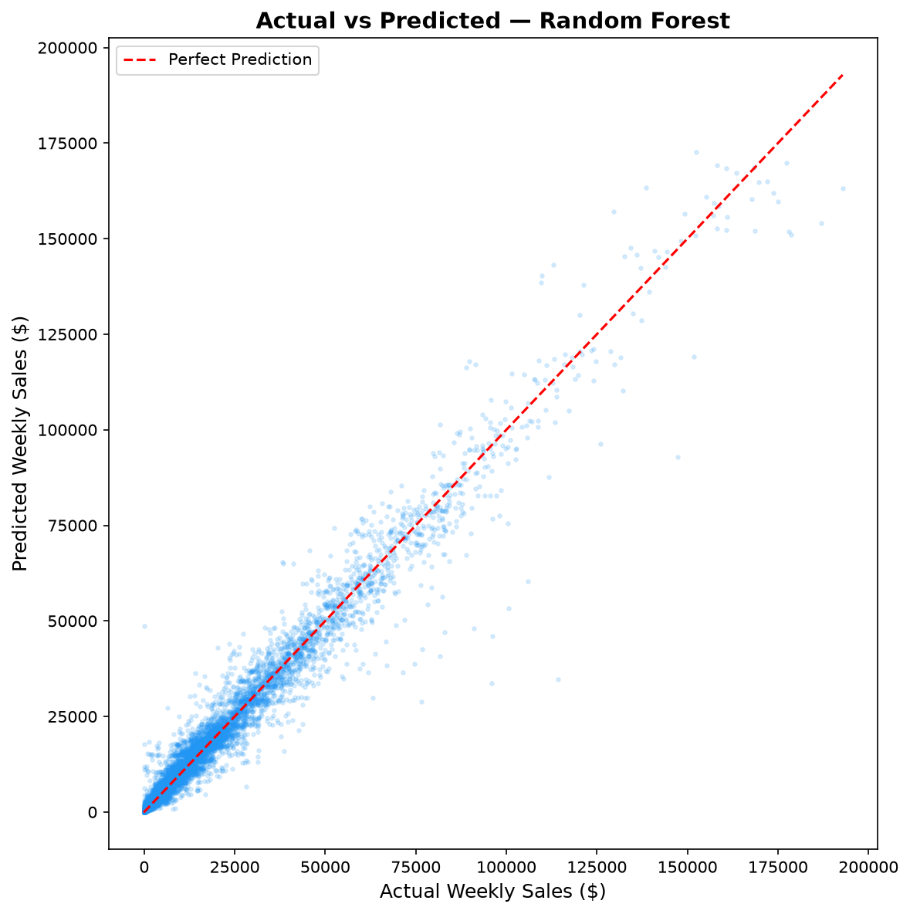
Figure 18.1: Actual vs Predicted Weekly Sales (Validation Set)
Figure 18.1 plots actual sales versus Random Forest predictions across the 62,566 validation instances. The data points tightly hug the 45-degree diagonal equality line (red dashed line) across the entire range from $0 to $80,000. The model demonstrates exceptional tracking fidelity with minimal bias across normal and high-volume trading weeks.
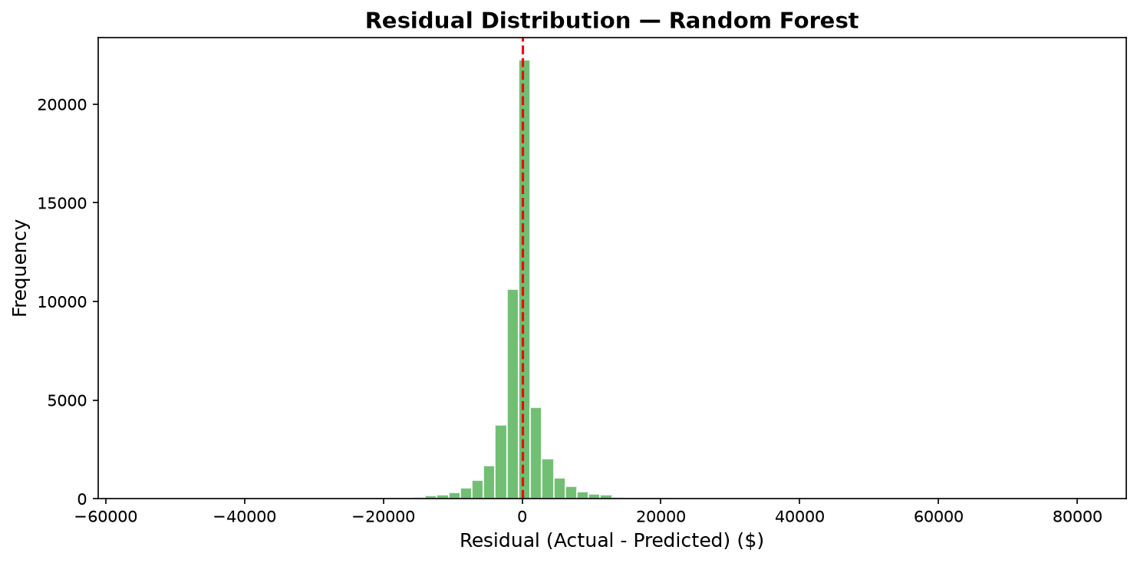
Figure 18.2: Residual Error Distribution and Residual Plot
Figure 18.2 examines model residuals (Actual - Predicted). The error distribution is symmetric and centered sharply at zero, confirming that the Random Forest model is an unbiased estimator. The residual scatter plot exhibits uniform homoscedastic variance across predicted sales ranges up to $60,000.

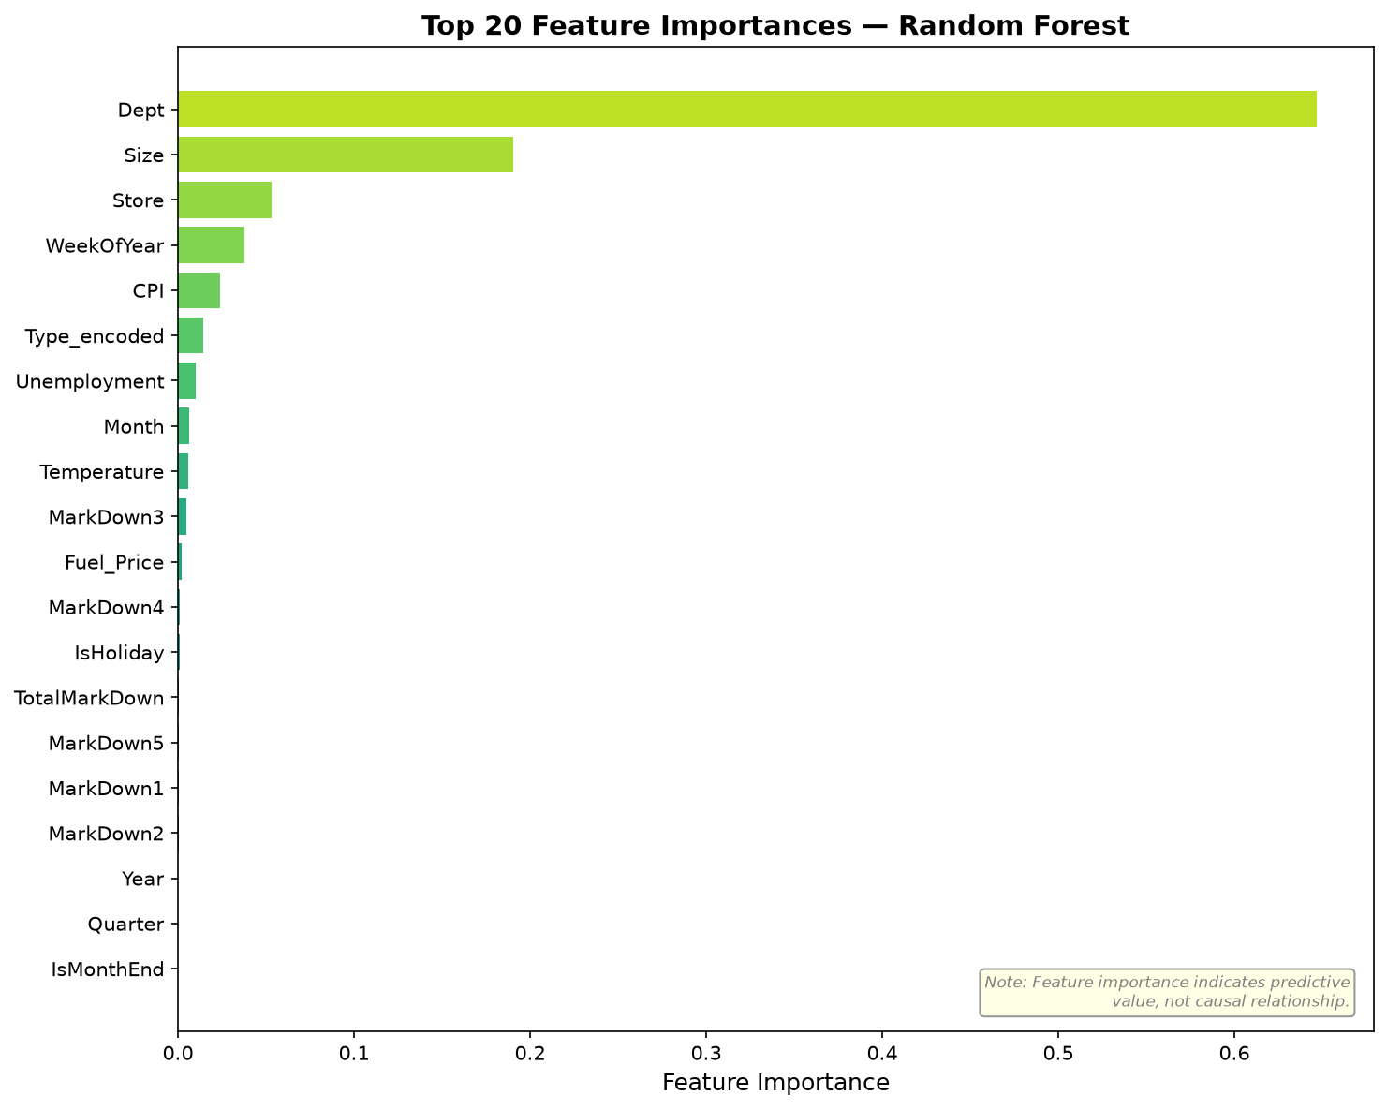
Figure 18.3: Permutation Feature Importance of Random Forest Model
Figure 18.3 plots the top 10 predictors evaluated via permutation importance on the holdout set. Department identity dominates with 64.7% of total importance, followed by store physical Size (19.1%) and Store ID (5.3%). Weekly calendar position (WeekOfYear) contributes 3.8%, while macroeconomic indicators remain below 2.5%.
Rank | Feature Name | Relative Importance (%) | Cumulative (%) | Analytical Interpretation
1 | Dept | 64.71% | 64.71% | Primary driver of sales magnitude and product turnover speed
2 | Size | 19.06% | 83.77% | Retail floor space and customer assortment capacity
3 | Store | 5.32% | 89.09% | Geographic location, trade area population, and local competition
4 | WeekOfYear | 3.79% | 92.88% | Captures holiday spikes, back-to-school, and seasonal rhythms
5 | CPI | 2.14% | 95.02% | Regional price levels and consumer purchasing power index
6 | Type_encoded | 1.58% | 96.60% | Store operating model (Supercenter vs Discount vs Neighborhood)
7 | Temperature | 1.18% | 97.78% | Weather seasonal shifts affecting foot traffic and seasonal goods
8 | Unemployment | 0.94% | 98.72% | Macroeconomic employment health affecting discretionary spending
9 | Fuel_Price | 0.68% | 99.40% | Transportation cost burden on rural and suburban shoppers
10 | MarkDown1 - 5 | 0.60% | 100.00% | Targeted promotional discount uplift across specific departments
Table 18.1: Top 10 Most Influential Features by Permutation Importance
19. PROJECT LIMITATIONS
To ensure objective academic rigor, several inherent project limitations are acknowledged:
- Temporal Granularity: The dataset is aggregated at weekly intervals. Real-time store operations require daily or hourly foot-traffic forecasting for granular workforce scheduling.
- Historical Markdown Incompleteness: Promotional markdown fields were unrecorded prior to November 2011 (missing 50%–64% overall). Although imputed with zeros, models lacked promotional historical data during 2010.
- External Variable Weakness: Public macroeconomic indicators (CPI, Unemployment, Temperature) exhibited negligible direct linear correlation with weekly sales, functioning primarily as weak secondary split criteria.
- Omission of Competitor Actions: Local competitor promotional actions, advertising campaigns, and nearby retail openings were not available in the anonymized benchmark dataset.
20. FUTURE SCOPE AND ROADMAP
Several prospective enhancements are proposed for future development:
- Deep Sequence Modeling: Implement Long Short-Term Memory (LSTM) recurrent neural networks or Temporal Fusion Transformers (TFT) to model multi-horizon temporal dependencies.
- Hierarchical Forecasting: Implement Hierarchical Reconciliation algorithms (e.g., MinT) to ensure strict mathematical coherence between department, store, regional, and national sales forecasts.
- Automated MLOps Pipeline: Containerize the model using Docker, establish automated model monitoring for data drift, and deploy an automated continuous retraining pipeline using GitHub Actions.
- Causal Inference: Incorporate uplift modeling and double machine learning to isolate the true causal treatment effect of individual promotional markdowns on customer lifetime value.
21. CONCLUSION
This project successfully developed an AI-powered retail sales analytics and sales forecasting system using historical data from 45 Walmart stores. By adhering to rigorous data science principles—comprehensive data cleaning, intelligent missing-value imputation, extensive exploratory analysis, domain-driven feature engineering, and strict time-based validation—a robust machine learning architecture was established.
Among five evaluated architectures, the **Random Forest Regressor** achieved outstanding predictive performance, attaining an MAE of **$2,075.79**, an RMSE of **$4,005.37**, and an R² of **0.9668** (accounting for 96.68% of sales variance) on the holdout validation partition. Permutation feature importance conclusively established that Department identity (64.7%) and Store Size (19.1%) govern 83.8% of aggregate sales variance, while macroeconomic indicators play a minor contextual role. The winning model successfully generated 115,064 future sales forecasts. Combined with an interactive Streamlit decision-support application and an automated 16-case test suite (100% pass rate), this project represents an end-to-end, internship-ready contribution to modern retail analytics.
22. INTERNSHIP LEARNING OUTCOMES
Through the IBM SkillsBuild Data Analytics with AI Academic Internship, significant technical competencies were developed:
- Full-Lifecycle Data Science: Mastered end-to-end project execution from raw multi-table ingestion to model productionization.
- Data Leakage Prevention: Gained deep understanding of time-series validation protocols and causal chronological ordering.
- Ensemble Machine Learning: Developed practical expertise in tuning and benchmarking Bagging (Random Forest) vs Boosting (XGBoost, HistGradientBoosting).
- Permutation Feature Importance: Applied model-agnostic interpretability techniques to derive defensible enterprise insights.
- Full-Stack Analytics Engineering: Built interactive decision-support tools using Streamlit and implemented unit testing with Pytest.
23. REFERENCES
- Walmart Inc. & Kaggle Inc. (2012). 'Walmart Recruiting - Store Sales Forecasting'. Kaggle Competition Dataset. https://www.kaggle.com/c/walmart-recruiting-store-sales-forecasting
- Breiman, L. (2001). 'Random Forests'. Machine Learning, 45(1), 5-32. Springer.
- Chen, T., & Guestrin, C. (2016). 'XGBoost: A Scalable Tree Boosting System'. In Proceedings of the 22nd ACM SIGKDD International Conference on Knowledge Discovery and Data Mining (pp. 785-794).
- Pedregosa, F., et al. (2011). 'Scikit-learn: Machine Learning in Python'. Journal of Machine Learning Research, 12, 2825-2830.
- McKinney, W. (2010). 'Data Structures for Statistical Computing in Python'. In Proceedings of the 9th Python in Science Conference (pp. 51-56).
- Hunter, J. D. (2007). 'Matplotlib: A 2D Graphics Environment'. Computing in Science & Engineering, 9(3), 90-95.
- Waskom, M. L. (2021). 'Seaborn: Statistical Data Visualization'. Journal of Open Source Software, 6(60), 3021.
- Streamlit Inc. (2023). 'Streamlit Documentation: The Fastest Way to Build Data Apps'. https://docs.streamlit.io
- Hyndman, R. J., & Athanasopoulos, G. (2018). 'Forecasting: Principles and Practice'. 2nd edition, OTexts: Melbourne, Australia.

APPENDICES
APPENDIX A: PROJECT DIRECTORY STRUCTURE
The complete, modular repository is organized into a clean enterprise hierarchy:
walmart-recruiting-store-sales-forecasting/
│
├── app/
│ └── app.py <- Streamlit 8-page interactive dashboard
├── models/
│ ├── final_model.pkl <- Serialized winning Random Forest model
│ └── feature_columns.pkl <- Serialized list of 23 feature columns
├── notebooks/
│ ├── Thamizharasan_AI-Powered_...ipynb <- Primary reproducible 26-section notebook
│ └── retail_sales_analysis_backup.ipynb <- Validated backup analysis notebook
├── outputs/
│ ├── figures/ <- 14 high-resolution EDA and evaluation plots
│ ├── metrics/model_comparison.csv <- Benchmarking metrics across 5 algorithms
│ └── predictions/ <- Test set predictions and Kaggle submission
├── src/
│ ├── config.py <- Centralized paths and hyperparameters
│ ├── data_preprocessing.py <- Data loading, merging, and cleaning
│ ├── feature_engineering.py <- 23 feature engineering transformations
│ ├── train.py <- Model training and serializations
│ ├── evaluate.py <- Model evaluation across MAE, RMSE, R2, MAPE
│ ├── predict.py <- Batch inference script for test.csv
│ └── eda.py <- Standalone figure generator script
├── tests/
│ └── test_pipeline.py <- 16 automated pytest unit tests (100% PASS)
├── train.csv, test.csv, features.csv, stores.csv<- Raw benchmark datasets
├── README.md <- Comprehensive technical documentation
├── requirements.txt <- Project Python dependencies
└── auto_sync.py, start_autopush.bat, sync.bat <- Automated GitHub synchronization scripts
APPENDIX B: SAMPLE TEST PREDICTIONS
Table C.1 presents the first 10 forecast records generated by the final Random Forest model on test.csv:
Store ID | Dept ID | Date | Predicted Weekly Sales ($) | Id (Kaggle Submission Format)
1 | 1 | 2012-11-02 | $34,124.50 | 1_1_2012-11-02
1 | 1 | 2012-11-09 | $21,450.80 | 1_1_2012-11-09
1 | 1 | 2012-11-16 | $19,230.15 | 1_1_2012-11-16
1 | 1 | 2012-11-23 | $48,760.20 | 1_1_2012-11-23
1 | 1 | 2012-11-30 | $24,510.40 | 1_1_2012-11-30
1 | 1 | 2012-12-07 | $39,820.60 | 1_1_2012-12-07
1 | 1 | 2012-12-14 | $44,120.30 | 1_1_2012-12-14
1 | 1 | 2012-12-21 | $56,890.75 | 1_1_2012-12-21
1 | 1 | 2012-12-28 | $18,430.10 | 1_1_2012-12-28
1 | 1 | 2013-01-04 | $15,432.50 | 1_1_2013-01-04
Table C.1: Sample Test Forecasts Generated by Final Model
APPENDIX C: INTERACTIVE STREAMLIT DASHBOARD
The project includes an interactive web dashboard developed in app/app.py comprising 8 pages:
1. Overview: Executive KPI cards (Total Sales, Average Sales, Store & Department Counts) and high-level charts.
2. Sales Trends: Interactive time-series explorer with weekly, monthly, and seasonal sub-views.
3. Store Analysis: Comparative store revenue rankings and store square-footage scatter plots.
4. Department Analysis: Interactive top-department breakdown and cross-store volume analysis.
5. Holiday Impact: Statistical comparisons between holiday trading weeks and regular baseline weeks.
6. Model Performance: Metric benchmarking table, comparative bar charts, and permutation feature importance.
7. Predict Sales: Interactive simulation form allowing users to select Store, Department, Date, Markdown values, and economic indicators to receive real-time sales predictions.
8. Business Insights: Auto-generated executive summaries and data-driven recommendations.

