PROGRAM
import numpy as np
import matplotlib.pyplot as plt
from sklearn.linear_model import LinearRegression
from sklearn.preprocessing import PolynomialFeatures
from sklearn.metrics import mean_squared_error, r2_score

# 1. Generate synthetic dataset
np.random.seed(42)
X = np.random.rand(100, 1) * 10 # Features from 0 to 10
y = 2.5 * X**2 + 1.5 * X + 5 + np.random.randn(100, 1) * 8 # Quadratic relationship with noise

# 2. Linear Regression
lin_reg = LinearRegression()
lin_reg.fit(X, y)
y_pred_linear = lin_reg.predict(X)

# 3. Polynomial (Non-linear) Regression
degree = 2
poly_features = PolynomialFeatures(degree=degree)
X_poly = poly_features.fit_transform(X)
poly_reg = LinearRegression()
poly_reg.fit(X_poly, y)
y_pred_poly = poly_reg.predict(X_poly)

# 4. Metrics
print("Linear Regression:")
print(f" MSE: {mean_squared_error(y, y_pred_linear):.2f}")
print(f" R² : {r2_score(y, y_pred_linear):.4f}")

print("\nPolynomial Regression (degree = 2):")
print(f" MSE: {mean_squared_error(y, y_pred_poly):.2f}")
print(f" R² : {r2_score(y, y_pred_poly):.4f}")

# 5. Plot results
plt.figure(figsize=(10, 5))

# Scatter plot of data
plt.scatter(X, y, color="blue", label="Data Points", alpha=0.6)

# Sort X for smooth curve plotting
X_range = np.linspace(0, 10, 200).reshape(-1, 1)

# Linear prediction line
plt.plot(X_range, lin_reg.predict(X_range), color="red", label="Linear Regression")

# Polynomial prediction curve
X_range_poly = poly_features.transform(X_range)
plt.plot(X_range, poly_reg.predict(X_range_poly), color="green", label=f"Polynomial Regression (deg={degree})")

plt.xlabel("X")
plt.ylabel("y")
plt.title("Linear vs Polynomial Regression")
plt.legend()
plt.show()

OUTPUT
Linear Regression:
MSE: 442.24
R² : 0.9278
Polynomial Regression (degree = 2):
MSE: 49.74
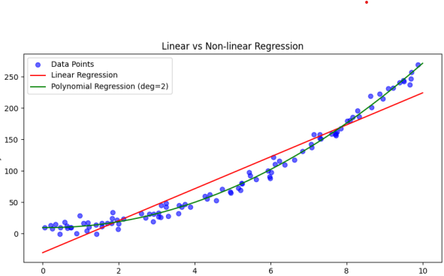
R² : 0.9919

