OUTPUT:
Opening Guymager application
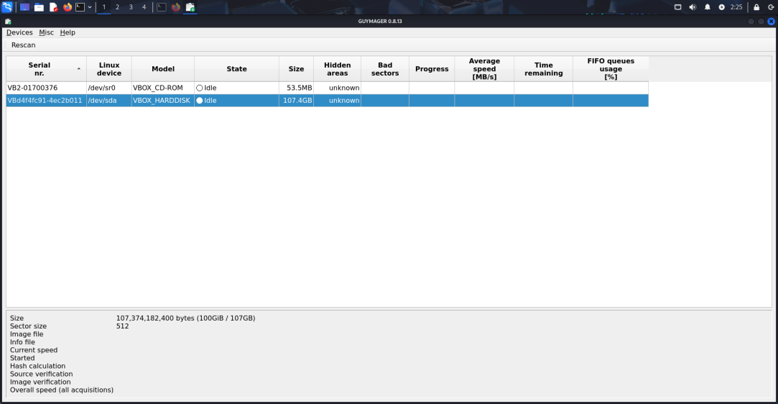
Selecting the storage device that is used to acquire image
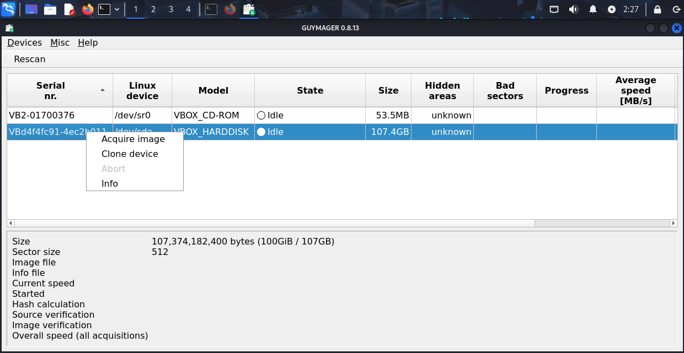

Give the directory, file name, encryption method and click start

