MongoDB

Connecting to mongodb

* Open MongoDB Compass  
  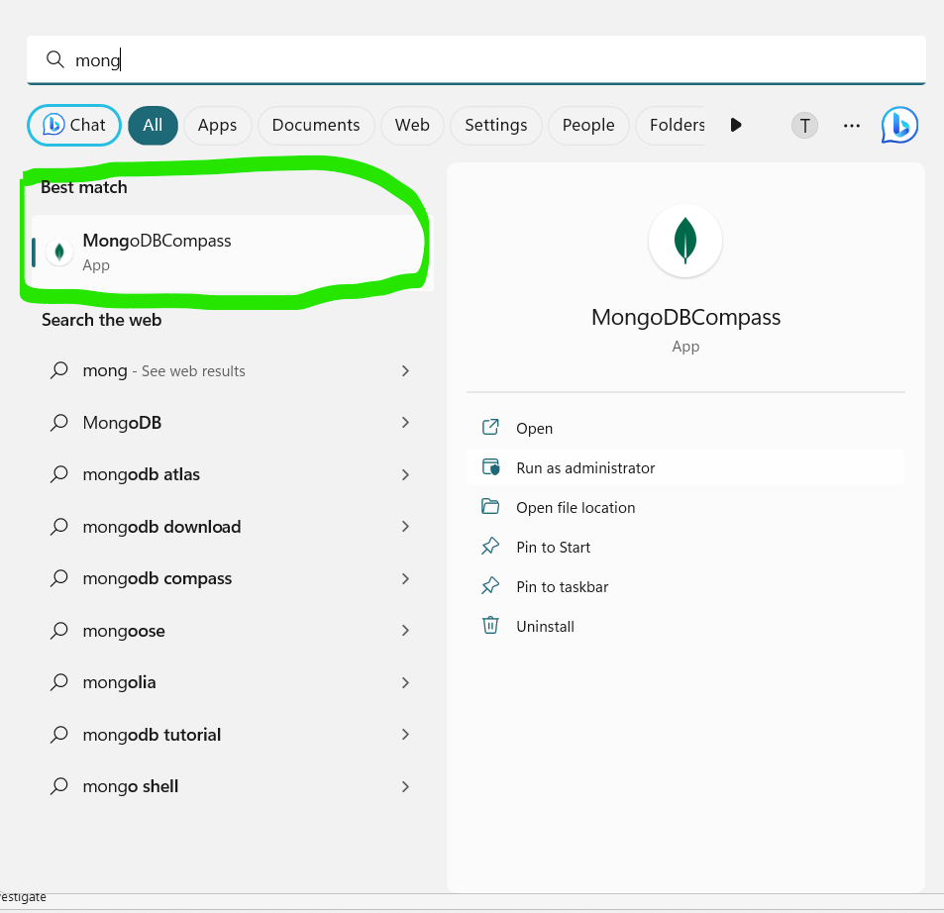
* Copy the connection string

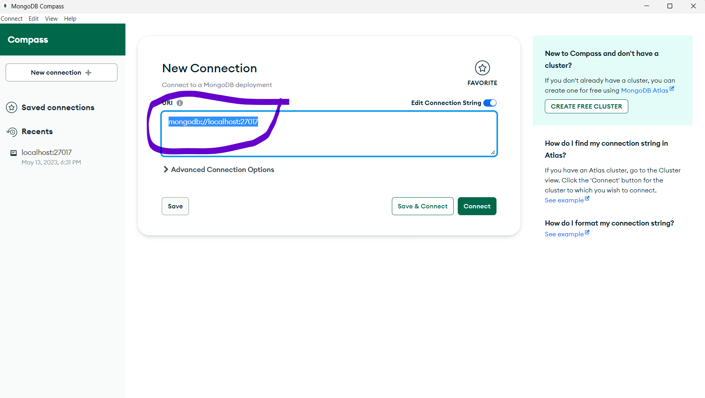

* Connect to the database so that the server gets started

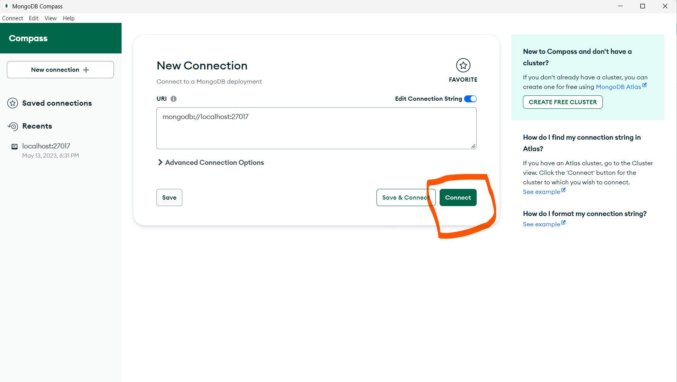

* Now download the mongo shell [https://www.mongodb.com/try/download/shell](mongodb_connect.docx)
* After downloading mongsh , it will be in directory   
  C:\Users\<Username> \Downloads\mongosh-1.8.2-win32-x64.zip\mongosh-1.8.2-win32-x64\bin  
    
  create a shortcut for it in desktop  
    
  then open the mongosh

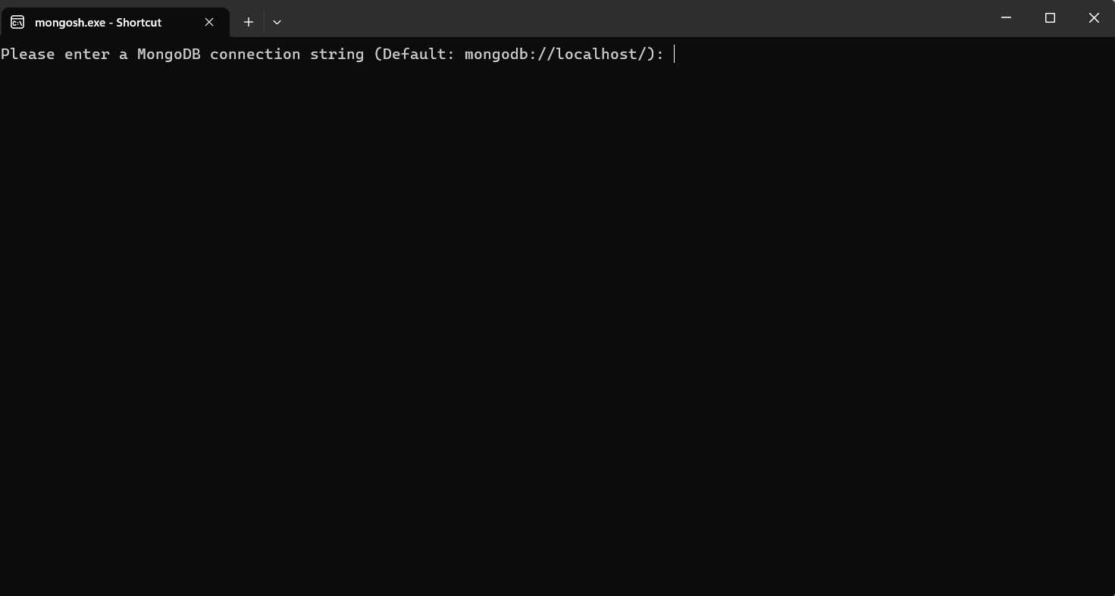

* Then paste the previously copied string from MongoDB Atlas  
  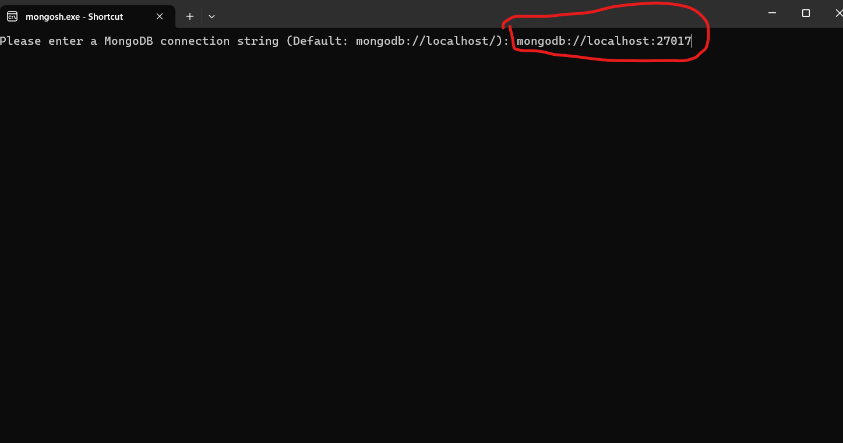
* Then press the enter button and if there is no problem in connecting to database , it will be like this  
  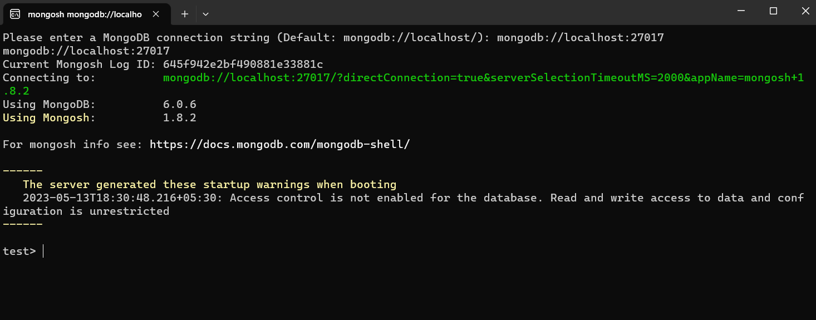

Now you can start working with mongodb using shell 😊

Download the resources from the links below:  
  
MongoDB Atlas : <https://www.mongodb.com/try/download/community>  
MongoDB Shell : [https://www.mongodb.com/try/download/shell](file:///C:\Users\Thamizharasi\Desktop\Learn%20MongoDB\mongodb_connect.docx)