LangGraph-Driven Conversational Autonomous Agent for Exploratory Data Analysis
Tharunkumar VK*, Himacharan T*,Niranjan P*, Ramkumar T **
*Department of Software and Systems Engineering
**Department of Computer Applications
School of Computer Science Engineering and Information Syetms
Vellore Institute of Technology, Vellore, India – 632 014
**Corresponding Author : ramkumar.thirunavukarasu@vit.ac.in

ABSTRACT
Exploratory Data Analysis (EDA) plays a vital role in any data science workflow because it helps uncover trends, detect inconsistencies, and understand relationships within datasets. However, performing EDA usually demands technical expertise, which can make it difficult for people without programming experience to participate effectively. In this work, we present an enhanced conversational framework that transforms tabular data into an interactive EDA assistant. The system has been developed using Streamlit, LangGraph, and Gemini AI [11], allowing users to perform tasks such as data profiling, cleaning, visualization, and dataset merging simply by typing plain-language instructions. To evaluate its capability, the framework was tested with the well-known Titanic dataset [13]. The results illustrate how the agent simplifies essential EDA processes, including handling missing data, detecting outliers, combining datasets, and generating visual summaries. Overall, the study aims to make exploratory data analysis more approachable by providing a scalable, no-code platform that can be adapted for various application domains.
KEYWORDS
Exploratory Data Analysis, Conversational Agents, Tabular Data, Chatbot Generation, Data Preprocessing, Visualization

Introduction
1.1 Background and Nature of the Proposed Work
Exploratory Data Analysis (EDA) is an important part of the data science process. It helps in finding patterns, spotting mistakes, and understanding how different factors in a dataset are related. When EDA is done without looking at these relationships, the accuracy of the machine learning model can be affected. For example, unseen bias in patient data might lead to wrong medical predictions, and unnoticed errors in financial data could cause poor forecasts. Data experts can usually fix these issues using coding and visualization tools. However, this becomes difficult for people who do not know programming. This work aims to make EDA easier for everyone. It builds on the framework created by Gomez-Vazquez et al. (2024) and develops it into an automatic agent made especially for EDA. This agent allows users to work with data by typing simple English commands instead of writing code. It can also join multiple datasets into one, fill missing values, adjust data ranges, and balance uneven data. The system can create more than twelve different types of charts to show the results clearly. To test its use, the agent was applied to the Titanic dataset [13], which is a popular dataset in data science. It can easily answer questions like “show survival rate for each passenger class” or “plot the age distribution of passengers.” This makes EDA faster and more understandable, even for people who are not experts in data science.
1.2 Recent Developments
The emergence towards natural language processing for data tasks has received attention recently, with tools aiming to make complex queries feel effortless. To show where the proposed work fits in, this paper reviewed several recent tools that try to make data analysis easier. Insights from these tools were incorporated into the development of the proposed system, while also adding new features that were previously not focused. The proposed research began with ideas from the paper by Gomez-Vazquez (2024) and his team. Their tool automatically creates a chatbot from a data table. Its main strength is that it's a no-code tool and understands user’s queries using using both pre-set patterns and a smart AI backup. However, the framework is designed for general questions and wasn't specifically designed for the deep digging that data exploration requires. For example, it couldn't merge different files together or do the heavy-duty data cleaning needed for messy, real-world scenarios. This limitation presented an opportunity to build our autonomous and Lang graph-based EDA agent, making it a tool specially designed for data exploration.
Auto-Prep, a data cleaning tool introduced by Bilal et al. (2022) identifies issues in data and suggests appropriate remedies. Wijesinghe (2025) introduced a pre-processing pipeline namely Dyno-Prep, which advances the work carried out by Bilal et al. in line with the desirable properties of the data. The biggest advantage of these tools is that they automate the most time-consuming part of data pre-processing. However, they are mainly used to prepare a dataset for an expert, not to help a beginner to explore it. The proposed work integrates the powerful data-cleaning abilities into the chat itself. This lets a user clean up data, handle weird values, and prepare the data for analysis just by asking questions in plain English language. Xie et al. (2024) introduced a waitGPT, an LLM based system for monitoring and steering data analysis. It creates visualization of given data by understanding the inherent relationship and helps the user community to interpret the underlying code involved. While the proposed conversational EDA agent caters to the requirement of users who don't want to see the code at all. Instead of showing how the code works, the autonomous EDA agent does the work in the background and facilitates more on conversational aspect about the data.
Recently, agentic systems aimed to automate the entire workflow from raw data to visualization. The Data-to-Dashboard framework, proposed by Zhang and Elhamod (2025) demonstrates a multi-agent LLM system to handle the full pipeline. Their approach includes agents for detecting the business domain, extracting key concepts, generating multi-perspective analysis, and performing iterative self-reflection to refine insights. A key strength is its attempt to simulate analyst reasoning and incorporate domain knowledge without relying on predefined questions or rigid templates. While powerful for generating comprehensive dashboards, this approach differs from our goal to build a purely conversational interface designed to hide and simplify the underlying processes entirely for non-technical users.
PlotGen, introduced by Goswami et al. (2025), is a multi-agent framework specifically designed for precise scientific data visualization. It uses a Query Planning Agent to break down requests, a Code Generation Agent to create plots, and uniquely employs three feedback agents (Numeric, Lexical, and Visual) that leverage multimodal LLMs. These feedback agents iteratively review the generated plots for data accuracy, correct labeling, and visual alignment with user specifications, enabling self-correction. While this multimodal agent significantly improves plot accuracy through this sophisticated feedback loop, its focus is specifically on automating visualization correctness, whereas our proposed agent aims for a broader conversational exploration capability encompassing automated data preparation and analysis alongside visualization.
Hong, M. H., & Crisan, A. (2023) showed that for data exploration, people need more than just a single chat window; they like to have multiple "threads" to explore different ideas at once. The InsightLens, LLM powered data analysis tool introduced by Weng, Luoxuan, et al. (2025) helps users to keep track of all the discoveries made during the chats. The strength of these tools is that they make the analysis process, more intuitive one. However, they focus more on organizing the conversation and less on the data tools. This research builds up on their interface designs but focuses on making the autonomous EDA agent more powerful with respect to all aspects of data analysis. The proposed system equips the agent with the complete toolkit for data cleaning, preparation, and file merging, creating a solution which is easy to adopt.
1.3 Organization of the Paper
The structure of the manuscript has been organized as follows; Section 2 presents the detailed technical architecture of the proposed conversational EDA agent. Section 3 outlines the implementation details. Section 4 compares the proposed agent with the work proposed by Gomez-Vazquez (2024), where Section 5 concludes with future directions.

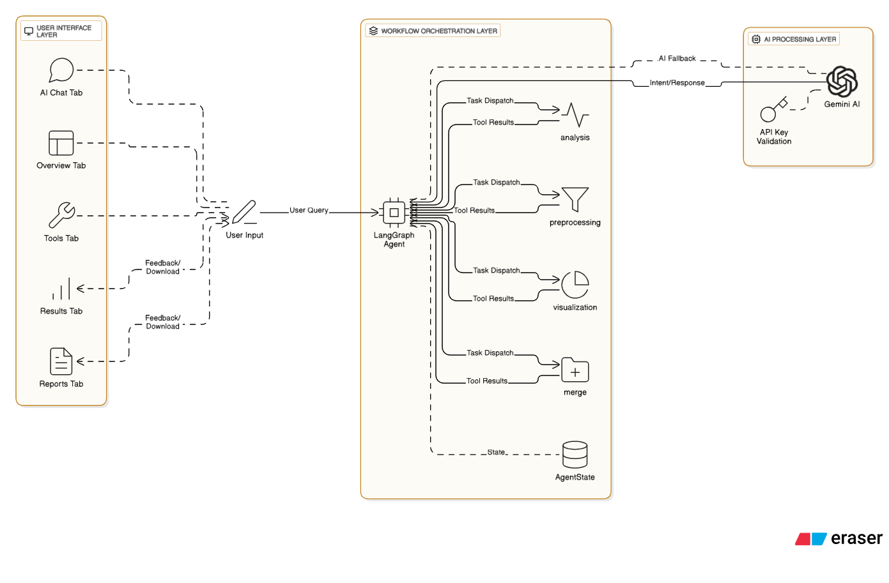
Detailed technical architecture

Figure 1: Workflow Orchestration of the proposed conversational Agent
The design of the Autonomous EDA Agent is based on the conversational model created by Gomez-Vazquez et al. (2024). The system is organized into multiple layers. First, user commands are received through the interface layer, then passed to a main control unit that manages the workflow. This control unit assigns each task to the right module and collects the results before sending them back to the user. The agent is built as a no-code tool that helps users explore data easily, combining a structured process with the freedom of using plain language.
2.1 System Overview and Components
The conversational EDA agent is built with three main layers: the User Interface Layer (Streamlit), the Workflow Layer (LangGraph), and the AI Layer (Gemini AI). The User Interface Layer includes a clear, tab-based dashboard with five main sections — Overview, Tools, AI Chat, Results, and Reports. These sections allow users to upload files, use tools, and view visual outputs easily. The Workflow Layer uses LangGraph to manage different stages of the process and carry out tasks automatically. The AI Layer uses Gemini AI to understand user intent and handle queries that are too complex for standard rules. Together, these layers make the system modular, scalable, and able to work with tabular data smoothly, even with very little user effort. The key components include

- File Management Module: Manages file uploads (CSV, Excel) and metadata (e.g., shape, dtypes, missing counts) stored in session state, supporting multiple files for merging operations.
- Tool Suite: Comprises four primary tools—analyze_data_tool, preprocess_data_tool, create_visualization_tool, and merge_files_tool—each encapsulated as LangGraph-compatible functions with extensive parameter sets.
- State Management: Utilizes a custom AgentState class to track messages, current tasks, file contexts, and results, ensuring continuity across interactions.
- Error Handling Framework: Implements try-except blocks across all modules to manage exceptions (e.g., API failures, file loading errors) with user feedback via Streamlit’s success/error boxes.

2.2 Data Flow and Processing Pipeline

The data flow starts when a file is uploaded through the load_file_buffer function. This function can handle different file formats and encodings. After a file is loaded, its details are captured using the FileMetadata data class. All uploaded files are stored in st.session_state.files, and the most recent file is tracked using last_idx.
The LangGraph workflow then manages how each task is carried out:

- Intent Detection: When a user types a command in the AI Chat tab, the agent_node processes it. Gemini AI is used to understand what the user wants and match the request to the correct tool. For instance, a command like “analyze file 0” activates the analyze_data_tool, while “merge files 0 and 1” runs the merge_files_tool.
- Tool Execution: The tool_node runs the selected tool using details taken from the query or the user interface. The results are stored in st.session_state.preprocessed_files or plot_cache for easy access.
- Output Generation: The processed data and generated plots are shown in the Results tab. From there, users can download the results as a CSV or PNG file, or generate a detailed report in the Reports tab.

The proposed EDA pipeline supports multi-file merging through the merge_dataframes function, which offers standard pandas merges (inner, outer, left, right, cross) and advanced fuzzy matching using recordlinkage and fuzzywuzzy, with configurable thresholds (e.g., 80% similarity). Preprocessing is handled by enhanced_preprocessing, supporting 26 parameters across missing value imputation (mean, median, mode, KNN, iterative), outlier handling (IQR, Z-score, Isolation Forest), scaling (MinMax, Standard, Robust), encoding (OneHot, Label, Ordinal, etc.), dimensionality reduction (PCA, t-SNE, SVD, LDA), feature selection (VarianceThreshold, SelectKBest, importance), imbalance correction (SMOTE, undersampling), and feature engineering (polynomial, binning). Visualization is facilitated by create_smart_visualizations and create_custom_plot, offering over 30 plot types (e.g., scatter3d, heatmap, treemap) using Plotly and Seaborn, with adaptive sampling for large datasets.

2.3 Error Handling

The EDA Agent includes strong error-handling measures at every step of its workflow. When loading files, the system automatically tries different encodings, and if all fail, it replaces unreadable parts instead of stopping. For Gemini API calls, it checks for valid keys and tests the model before running. Within LangGraph, each tool runs inside try-except blocks to catch possible errors such as invalid plot types or merge conflicts. If an issue occurs, the system shows a clear and useful error message to the user. The agent also keeps track of memory usage and gives a warning when a dataset is larger than 100 MB, switching to chunked processing to prevent system overload.

2.4 Scalability and Performance Considerations
The architecture of the EDA Agent is designed to handle scalability using several important methods. Its main functions rely on session state persistence, which helps the system manage multiple file uploads and run several tasks at the same time. On Windows systems, input and output operations are made faster using an asynchronous event loop policy.
To keep the system stable and efficient, a few safety measures are also built in. For example, fuzzy merge operations are limited to datasets with less than one million row combinations to avoid memory overload. Likewise, visualization tools work on a sample of up to 5,000 rows when creating custom plots. This keeps the interface quick and responsive, even when handling large datasets.

2.5 Integration with Visualization

The proposed EDA Agent architecture supports extensive visualization, and generates up to 12 intelligent plots (e.g., correlation heatmaps, scatter plots) based on data characteristics, and create_custom_plot enabling user-specified plots (e.g., 3D scatter, choropleth). Plots are cached and rendered interactively in the UI, enhancing accessibility for non-technical users.

implementation details
To show how the Autonomous EDA Agent works in practice, this section outlines the agent’s workflow demonstration with a real-world example using the well-known Titanic dataset [13] . Two versions were employed: the standard Kaggle dataset and the "Titanic3" [14] dataset from OpenML. The second file is similar but contains extra columns like 'boat' and 'home.dest,' which makes it suiatable for showing how the proposed system can merge related but different files. The following steps, illustrated with screenshots of the Streamlit interface, outlines how the autonomous EDA agent was built to handle the entire EDA workflow.

3.1 File upload and Preview

The process begins from the "Overview" tab, as shown in Figure 2. The "File Manager" in the sidebar was used to upload the input files. The proposed system was built to smoothly handle different file types (like CSV and Excel) and formats. Once uploaded, the agent immediately provides a summary of each file, including the number of rows and columns, the types of data in each column (e.g., text, numbers), and a count of any missing values. This summary gives a quick and essential first look at the data's quality. This system also has a "Quick Analysis" button to give each file a quality score and an "Auto Visualize" button that instantly creates up to 12 useful charts, such as a histogram of passenger ages.
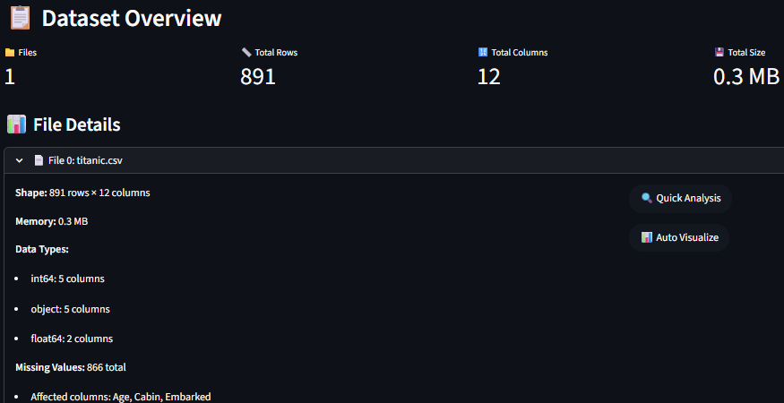
Figure 2 Snapshot of FILE MANAGER module

3.2 Custom Pre-processing

Next, the process shifts to the "Tools" tab to clean and prepare the data for analysis (Figure 2). Here, a simple form was designed that gives the user to have full control over the preprocessing steps. For the Titanic [13] example, the selected options are allowed to handle missing values by filling in the average age for passengers with missing Age data and the most common port for those with a missing Embarked value. Outliers are managed to acknowledge unusually high or low numbers, to prevent them from skewing the analysis. After clicking "Process Data," the agent applied these cleaning steps and saved a new, processed version of the dataset to use.
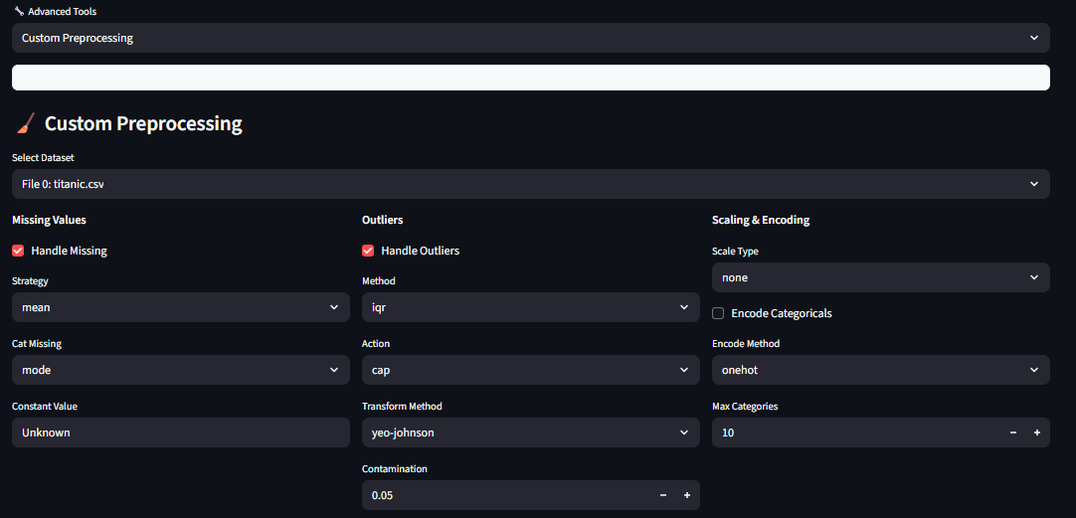
Figure 3 Snapshot of Custom Pre-Processing
3.3 Plot Generation

A key part of exploring data is creating charts and graphs, which are made simple in the "Plot Generator" section (Figure 4). The system provides over 30 different chart types for users to choose from. For instance, an interactive scatter plot was selected to see the relationship between passenger Age and the Fare they paid, using color to show who survived. For users who aren't sure what to plot, the Autonomous EDA agent has also an "Auto" mode that intelligently suggests and creates charts based on the data's characteristics.

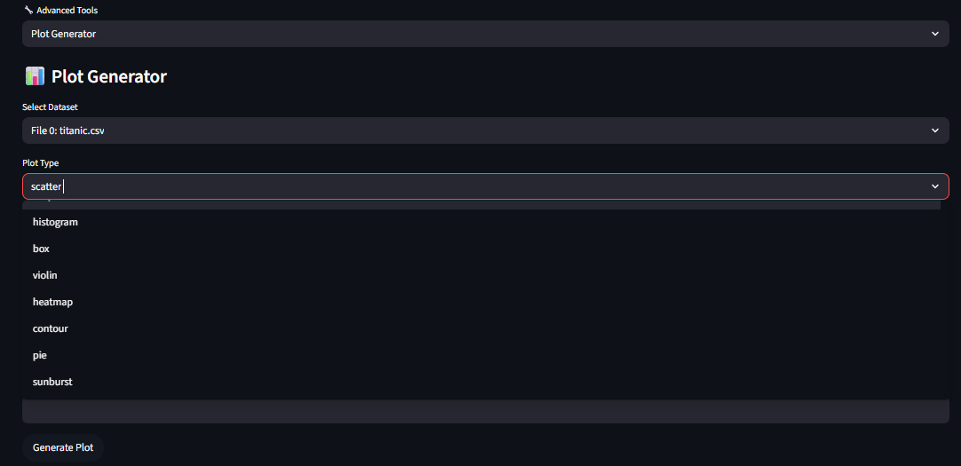

Figure 4 Plot Generator

3.4 Data Merging

One of the most useful features of the system is its ability to merge multiple datasets, as shown in Figure 5. In this example, the first Titanic [13] file is combined with the second “Titanic3” [14] file. The system’s interface is designed to be simple and easy to use. Users can select the files they want to merge, choose the merge type, and pick the matching columns such as Name or Ticket. The system also includes a “Fuzzy Matching” option, which is helpful when the data is not perfectly clean. For instance, it can still match two passengers even if their names are slightly different by comparing how similar the text values are. This feature helps users merge related records from both files, adding extra details from Titanic3 [14], such as the lifeboat used by each passenger.
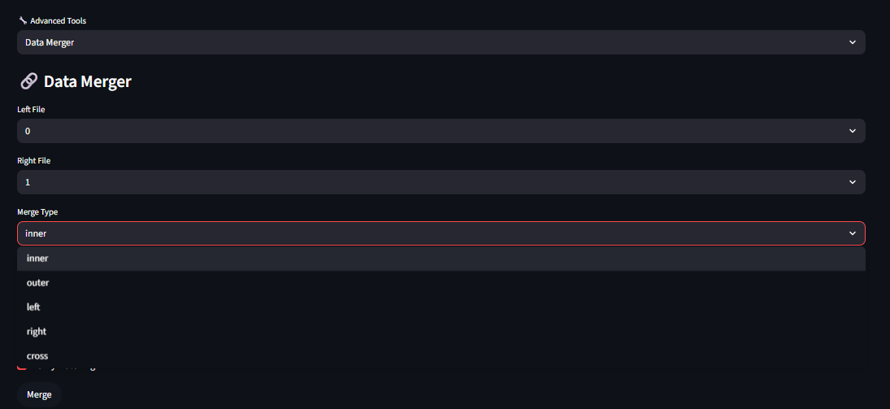
Figure 5 Data Merger

3.5 Ai Chat and Execution

Finally, this section outlines the demonstration of the agent's AI-driven capabilities in the "AI Chat" tab (Figure 6). Instead of using the manual merger tool, users can simply type a request in plain English: "merge file 0 and file 1 by suitable means (choose embarked column to merge)." The proposed system, using LangGraph to manage the workflow, understood the command and automatically used the correct merging tool with fuzzy logic enabled. The agent then confirmed the successful merge and logged the results, showing how a complex task can be completed through simple conversation. Moreover, the Autonomous EDA agent uses Gemini AI to understand these kinds of requests and as a smart backup for any questions that the pre-defined tools cannot answer.
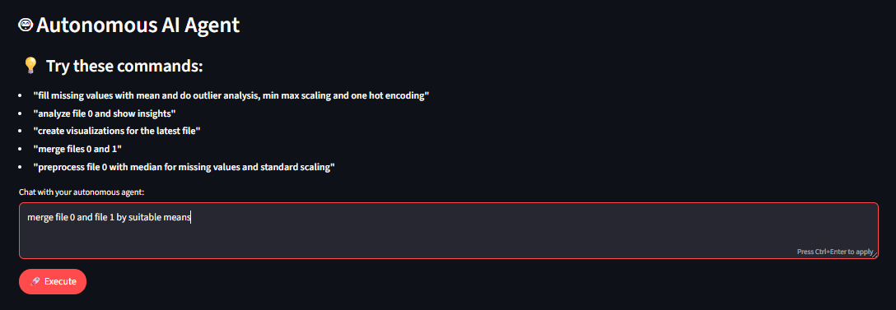
Figure 6 Snapshot of Conversational Agent bot

3.6 Results

This section describes the results which are obtained from the Conversational EDA Agent. The Titanic [13] dataset and Titanic3 [14] dataset are merged (Figure 7) on the basis of the most common attribute. Moving further, the agent did an extensie pre-processing on the dataset to make it fit for training the model (Figure 8) and it also displayed the confusion matrix (Figure 9), showing the correlation between key features of the dataset as per the user’s request. Moreover, the agent maintains a log of all the actions it performed on the dataset (Figure 10).

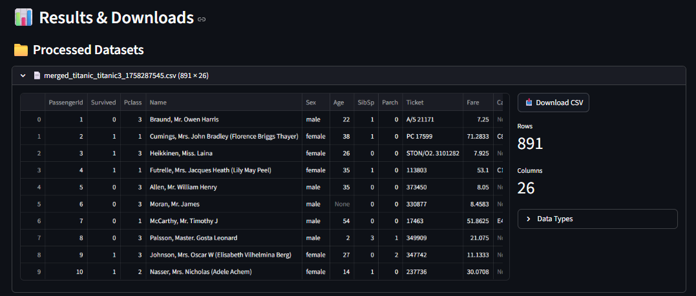
Figure 7 Snap shot of Merged Dataset

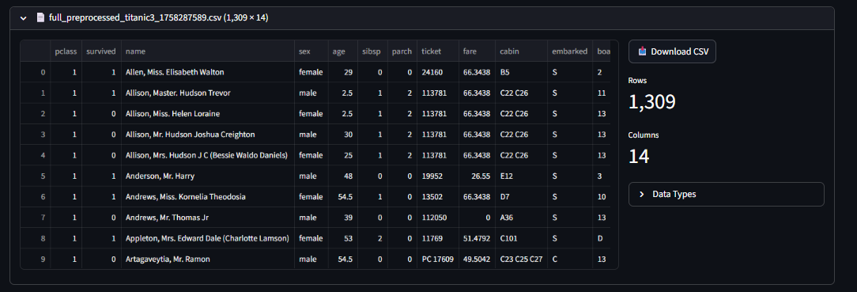
Figure 8 Snap shot of Fully pre-processed Dataset

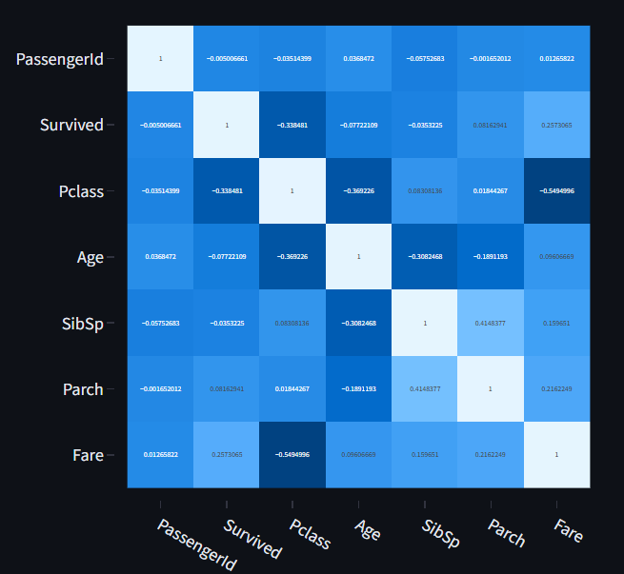
Figure 9 snap shot of confusion matrix
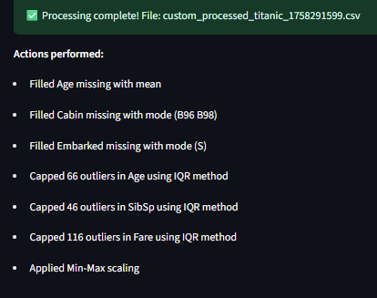
Figure 10 snap shot demonstrating actions performed during pre-processing

Figure 11 and Figure 12 demonstrate the pre-processing effect of the EDA Agent on the dataset.

Before Pre-processing
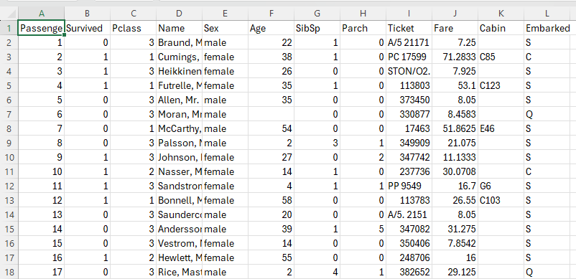
Figure 11 Snapshot of raw dataset before pre-processing

After Pre-processing
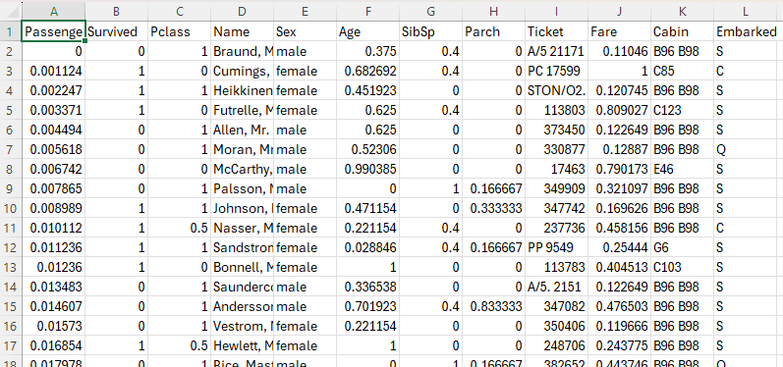
Figure 12 Snapshot of pre-processed dataset

Comparison with existing work
This proposed project builds directly on the foundational framework for automated chatbot generation introduced by Gomez-Vazquez et al. (2024). Their work demonstrates how to create conversational agents from tabular data, achieving high accuracy in understanding user intent, while reducing the need of manual setuo. The strengths of their system lie in its ability to automatically understand a dataset's structure and generate conversation patterns from it. However, their framework was designed for general-purpose tasks and was not specifically equipped for detailed tasks involved in Exploratory Data Analysis (EDA). It lacked features such as merging multiple datasets or performing advanced data preprocessing, which are both important for real-world analytical work (see Table 1).
Table 1: Comparison of Architectural Features and Capabilities
Aspect/Feature | Data Bot by Gomez-Vazquez | Proposed Conversational EDA Agent
Architecture | Intent matching with LLM fallback for unrecognized queries | Hybrid LangGraph state machine with agent and tool nodes.
Data Handling | Schema inference from tabular data (CSV/XLSX) | Multi-file upload and management with metadata tracking (shape, dtypes, missing counts)
Supported Features | Predefined features for SQL-like queries (e.g., comparisons, frequencies) and chart generation | Novel features for profiling, comprehensive preprocessing, extensive visualization and multi-file merging.
Visualization Capabilities | Generates basic charts via GUI | Expanded to over 30 plots using Plotly/Seaborn; smart auto-generation with sampling;
Merging/Preprocessing | No explicit multi-file merging or advanced preprocessing. | Multi-file merging with fuzzy matching (fuzzywuzzy/recordlinkage, 80% threshold default);
Novelty | Automatic generation from schemas, reducing annotations gaps in preprocessing depth | Autonomous multi-file merging, comprehensive preprocessing, and visualization diversity
The Autonomous EDA Agent adds several major improvements over the earlier framework. First, it includes support for merging multiple files, which allows users to combine different datasets for a more complete analysis — a feature that was missing in the previous system. It also introduces an advanced “fuzzy matching” function that can link records which are similar but not the same. Second, the agent offers a wider range of data preprocessing tools. Unlike the earlier version, which had only basic cleaning options, this system provides a full set of advanced features. These include various methods for filling missing values (imputation), detecting and handling outliers, scaling data, preparing features for machine learning, and fixing imbalanced datasets. In addition, the system greatly improves visualization capabilities. Instead of using only simple, static charts, it now includes a library of more than 30 customizable plot types, allowing users to explore their data in a richer and more interactive way. Lastly, the agent is designed to handle scalability more effectively. While the original framework was limited by standard data processing libraries, this system introduces safeguards and performance enhancements that make it more stable for larger datasets.
Conclusion and Future Work
This paper aimed to make Exploratory Data Analysis (EDA) easier and more accessible to all types of users. The work builds on the conversational framework developed by Gomez-Vazquez et al. (2024) and extends it into a specialized agent designed to handle the complex steps involved in data exploration. The main contribution of this study is the addition of three major features that were missing in the earlier framework: multi-file merging, a complete set of data preprocessing tools, and a large collection of advanced visualizations. When used together, these features help simplify the entire EDA process. Through a conversational interface, the Autonomous EDA Agent allows even non-technical users to perform data analysis without writing code. For future development, the system can be improved in several ways. Upcoming work may include adding domain-specific knowledge to make the agent more context-aware, creating methods to automatically detect data bias during EDA, and improving speed and scalability using distributed computing. Overall, this research highlights how conversational AI can make data analysis more efficient, user-friendly, and inclusive.
.

References

- Gomez-Vazquez, Marcos, Jordi Cabot, and Robert Clarisó. "Automatic generation of conversational interfaces for tabular data analysis." Proceedings of the 6th ACM Conference on Conversational User Interfaces. 2024.

- Bilal, Mehwish, et al. "Auto-prep: efficient and automated data preprocessing pipeline." IEEE Access 10 (2022): 107764-107784.

- Wijesinghe, D. T. "Dyno-Prep: An Efficient and Automated Data Preprocessing Pipeline for Enhanced Machine Learning Performance."

- Xie, Liwenhan, et al. "Waitgpt: Monitoring and steering conversational llm agent in data analysis with on-the-fly code visualization." Proceedings of the 37th Annual ACM Symposium on User Interface Software and Technology. 2024.

- Hong, Matt-Heun, and Anamaria Crisan. "Data has Entered the Chat: How Data Workers Conduct Exploratory Visual Analytic Conversations with GenAI Agents." ACM Transactions on Interactive Intelligent Systems (2025).

- Hong, M. H., & Crisan, A. (2023). Conversational ai threads for visualizing multidimensional datasets. arXiv preprint arXiv:2311.05590.

- Weng, Luoxuan, et al. "InsightLens: Augmenting LLM-Powered Data Analysis with Interactive Insight Management and Navigation." IEEE Transactions on Visualization and Computer Graphics (2025).

- Zhang, Ran, and Mohannad Elhamod. "Data-to-Dashboard: Multi-Agent LLM Framework for Insightful Visualization in Enterprise Analytics." arXiv preprint arXiv:2505.23695 (2025).

- Goswami, Kanika, et al. "Plotgen: Multi-agent llm-based scientific data visualization via multimodal feedback." arXiv preprint arXiv:2502.00988 (2025).

- Mavroudis, Vasilios. "LangChain." The Alan Turing Institute (2024).

- Gemini Team, et al. "Gemini: A Family of Multimodal AI Models." arXiv preprint arXiv:2312.11805 (2023).

- Google. "Google Generative AI SDK for Python." GitHub (2024)

- Kaggle, "Titanic - Machine Learning from Disaster," 2012. [Online]. Available: https://www.kaggle.com/c/titanic. [Accessed: Oct. 31, 2025].

- F. E. Harrell Jr., "Titanic3," Version 1, OpenML, 2017. [Online]. Available: https://www.openml.org/d/40945. [Accessed: Oct. 31, 2025].

We suggest that you text box to insert a graphic (which is ideally a 300 dpi TIFF or EPS file, with all fonts embedded) because, in an MSW document, this method is somewhat more stable than directly inserting a picture.
To have non-visible rules on your rame, use the MSWord “Format” pull-down menu, select Text Box > Colors and Lines to choose No Fill and No Line.

