SIMATS ENGINEERING (SAVEETHA SCHOOL OF ENGINEERING)
Department of Artificial Intelligence and Data Science
ASSESSMENT TOOL 2 – SCENARIO BASED

Course Code: | DSA03 | Course Title: | Natural Language Processing
CO Assessed: | CO2 – Manipulation | Assessment: | Assessment Tool 2 – SCENARIO BASED
Weightage: | 35% of CIA
CO5 Statement: | Design inflectional, derivational, finite-state parsing, stemming algorithms and for analyse morphological methods. (BL-3)
Student Name: | T. Kiran Kumar | Reg. No.: | 192472321
Section / Batch: | CSE-AI(2024) | Date:

Code of Conduct
I T. Kiran Kumar (192472321) (Name / Reg No) certify that this submission is my original work and that I have adhered to the guidelines specified for this assessment. I understand that any violation of academic integrity rules will result in disciplinary action.
Signature of the Student: T. Kiran Kumar

Instructions
- Read all questions carefully before attempting the answers.
- Answer all five questions. Each question carries equal marks.
- Show all intermediate steps, calculations, probability computations, tagging decisions, and justifications wherever applicable.
- Duration: 30 minutes.

Section / Topic | Focus | Q Nos
English Word Classes, Tagsets for English, Stochastic Part of Speech Tagging, HMM | Morphological parsing of disagree, agreement, and agreeable; identification of prefixes, suffixes, base forms, and semantic effects of derivation. | Q1

Annexure A – SCENARIO BASED
A company is developing an NLP-based grammar checker for educational applications. The system is trained using a manually POS-tagged corpus. Your task is to recreate the Hidden Markov Model (HMM) without using any built-in NLP or HMM libraries.
From the given corpus,
- determine the Emission Probability
- determine the Transition Probability
- implement the Viterbi Algorithm
- predict the POS tags for the new input sentence.
Use only Python dictionaries, loops, and basic programming constructs.

Training Corpus
Sentence | POS Tags
The/DT boy/NN eats/VBZ rice/NN | DT NN VBZ NN
The/DT girl/NN drinks/VBZ milk/NN | DT NN VBZ NN
A/DT cat/NN drinks/VBZ milk/NN | DT NN VBZ NN
The/DT dog/NN chases/VBZ cat/NN | DT NN VBZ NN
A/DT teacher/NN teaches/VBZ students/NNS | DT NN VBZ NNS
Students/NNS study/VBP English/NN | NNS VBP NN
Birds/NNS fly/VBP high/RB | NNS VBP RB
Children/NNS play/VBP games/NNS | NNS VBP NNS

New Input Sentence
The cat drinks milk

Tasks
- Separate each sentence into words and POS tags.
- Compute the Emission Probability of every word.
- Compute the Transition Probability between POS tags.
- Recreate the Hidden Markov Model using Python dictionaries.
- Implement the Viterbi Algorithm without using any built-in HMM/NLP libraries.
- Predict the POS tag sequence for “The cat drinks milk”

Code:

sentences = [
[("The", "DT"), ("boy", "NN"), ("eats", "VBZ"), ("rice", "NN")],
[("The", "DT"), ("girl", "NN"), ("drinks", "VBZ"), ("milk", "NN")],
[("A", "DT"), ("cat", "NN"), ("drinks", "VBZ"), ("milk", "NN")],
[("The", "DT"), ("dog", "NN"), ("chases", "VBZ"), ("cat", "NN")],
[("A", "DT"), ("teacher", "NN"), ("teaches", "VBZ"), ("students", "NNS")],
[("Students", "NNS"), ("study", "VBP"), ("English", "NN")],
[("Birds", "NNS"), ("fly", "VBP"), ("high", "RB")],
[("Children", "NNS"), ("play", "VBP"), ("games", "NNS")]
]
print("==============================================")
print("WORDS AND POS TAGS")
print("==============================================")

for sentence in sentences:

words = []
tags = []

for word, tag in sentence:
words.append(word)
tags.append(tag)

print("Words :", words)
print("Tags :", tags)
print()

tags = []

for sentence in sentences:
for word, tag in sentence:

if tag not in tags:
tags.append(tag)

print("POS Tags:")
print(tags)
print()
tag_count = {}

for tag in tags:
tag_count[tag] = 0

for sentence in sentences:

for word, tag in sentence:
tag_count[tag] = tag_count[tag] + 1
print("==============================================")
print("TAG COUNTS")
print("==============================================")

for tag in tag_count:
print(tag, ":", tag_count[tag])

print()
emission_count = {}
for tag in tags:
emission_count[tag] = {}
for sentence in sentences:
for word, tag in sentence:
if word not in emission_count[tag]:
emission_count[tag][word] = 1
else:
emission_count[tag][word] = emission_count[tag][word] + 1
emission_probability = {}

for tag in tags:

emission_probability[tag] = {}

for word in emission_count[tag]:

count = emission_count[tag][word]

probability = count / tag_count[tag]

emission_probability[tag][word] = probability

print("==============================================")
print("EMISSION PROBABILITIES")
print("==============================================")

for tag in emission_probability:

print("\nTag:", tag)

for word in emission_probability[tag]:

print(
"P(" + word + "|" + tag + ") =",
emission_probability[tag][word]
)

print()
transition_count = {}

for tag in tags:
transition_count[tag] = {}

for sentence in sentences:

for i in range(len(sentence) - 1):

current_tag = sentence[i][1]
next_tag = sentence[i + 1][1]

if next_tag not in transition_count[current_tag]:

transition_count[current_tag][next_tag] = 1

else:

transition_count[current_tag][next_tag] = \
transition_count[current_tag][next_tag] + 1
transition_probability = {}

for tag in tags:

transition_probability[tag] = {}

for next_tag in transition_count[tag]:

count = transition_count[tag][next_tag]

probability = count / tag_count[tag]

transition_probability[tag][next_tag] = probability

print("==============================================")
print("TRANSITION PROBABILITIES")
print("==============================================")

for tag in transition_probability:

print("\nFrom Tag:", tag)

for next_tag in transition_probability[tag]:

print(
"P(" + next_tag + "|" + tag + ") =",
transition_probability[tag][next_tag]
)

print()
print("==============================================")
print("HMM")
print("==============================================")

print("Emission Model:")
print(emission_probability)

print("\nTransition Model:")
print(transition_probability)

print()
def viterbi(words):

# Viterbi probability table
viterbi_table = []

# Backpointer table
backpointer = []
first_word = words[0]
first_probabilities = {}
first_backpointer = {}

for tag in tags:

if first_word in emission_probability[tag]:

# Since there is no previous tag,
# we use the emission probability.

first_probabilities[tag] = \
emission_probability[tag][first_word]

else:

first_probabilities[tag] = 0

first_backpointer[tag] = None

viterbi_table.append(first_probabilities)
backpointer.append(first_backpointer)
for i in range(1, len(words)):

word = words[i]

current_probabilities = {}
current_backpointer = {}

for current_tag in tags:

# Get emission probability

if word in emission_probability[current_tag]:

emission = emission_probability[current_tag][word]

else:
emission = 0

best_probability = 0
best_previous_tag = None

# Find best previous tag

for previous_tag in tags:

previous_probability = \
viterbi_table[i - 1][previous_tag]
if current_tag in transition_probability[previous_tag]:

transition = \
transition_probability[previous_tag][current_tag]

else:

transition = 0
probability = \
previous_probability * transition * emission
if probability > best_probability:

best_probability = probability
best_previous_tag = previous_tag
current_probabilities[current_tag] = best_probability

current_backpointer[current_tag] = best_previous_tag

viterbi_table.append(current_probabilities)
backpointer.append(current_backpointer)
last_column = viterbi_table[-1]

best_final_tag = None
best_final_probability = 0

for tag in tags:

if last_column[tag] > best_final_probability:

best_final_probability = last_column[tag]
best_final_tag = tag
best_tags = []

current_tag = best_final_tag

for i in range(len(words) - 1, -1, -1):

best_tags.append(current_tag)

current_tag = backpointer[i][current_tag]
best_tags.reverse()

return best_tags, viterbi_table

new_sentence = ["The", "cat", "drinks", "milk"]
result, table = viterbi(new_sentence)
print("==============================================")
print("VITERBI TABLE")
print("==============================================")

for i in range(len(new_sentence)):

print("\nWord:", new_sentence[i])

for tag in tags:

print(tag, ":", table[i][tag])

print()
print("==============================================")
print("FINAL POS TAGGING")
print("==============================================")

for i in range(len(new_sentence)):

print(new_sentence[i], "->", result[i])

print()
print("Predicted POS Tag Sequence:")
print(result)

Output:
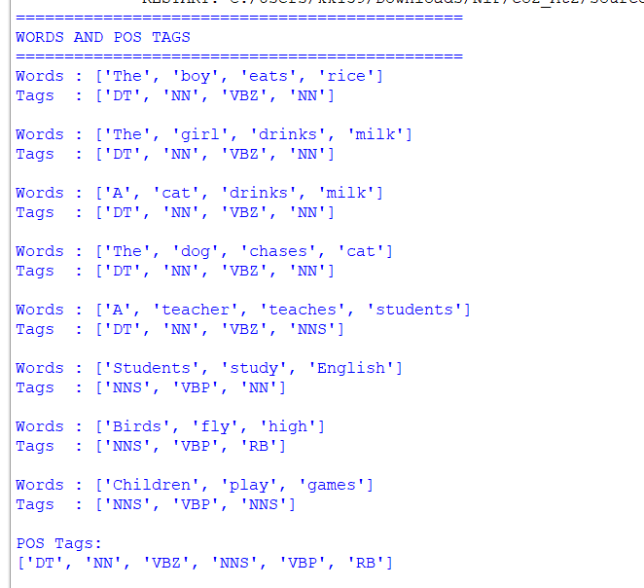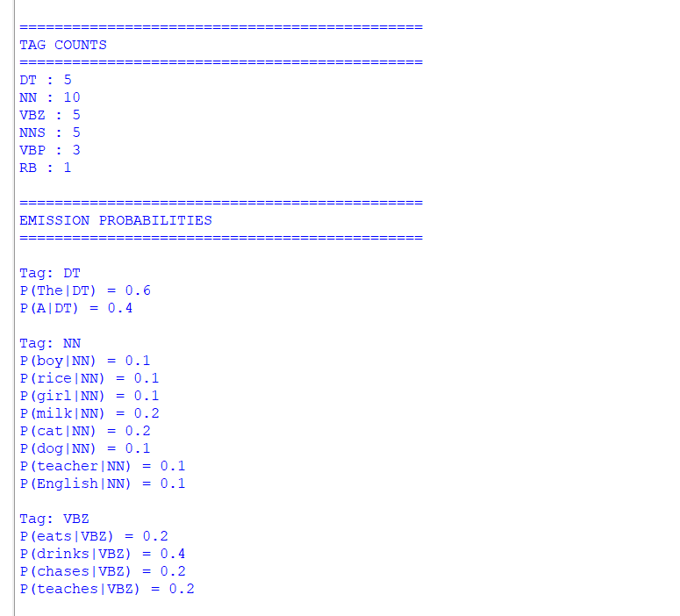

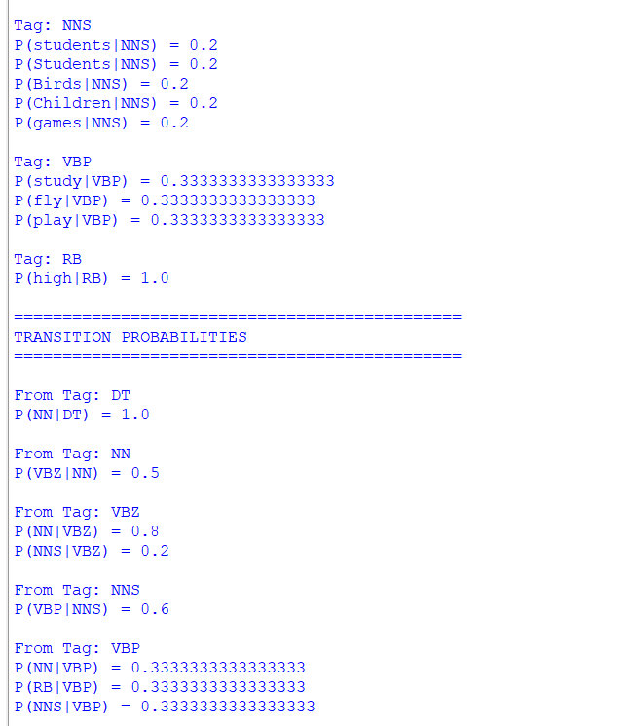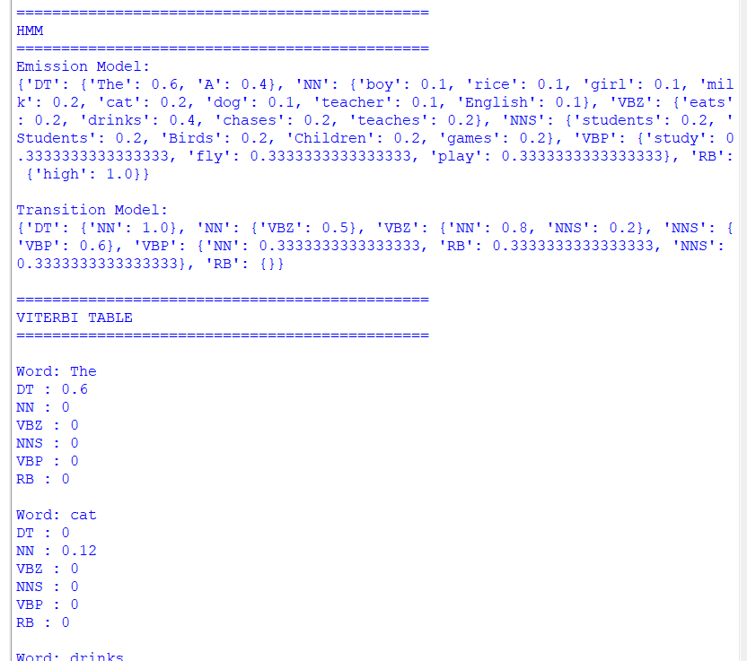

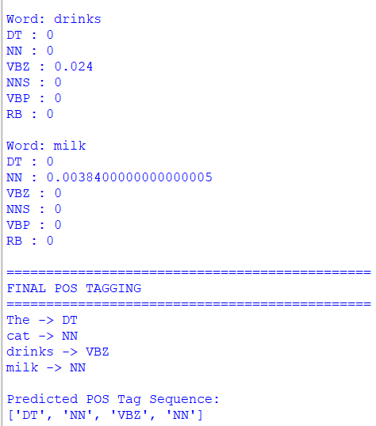
Rubrics for Calculation

Criteria | Weightage (%) | Level 4 (Exemplary) | Level 3 (Proficient) | Level 2 (Developing) | Level 1 (Beginning)
Understanding of Scenario | 20% | Demonstrates clear and complete understanding of the scenario and context | Shows good understanding with minor gaps | Partial understanding; misses key aspects | Misinterprets or fails to understand the scenario
Identification of Key Issues | 20% | Accurately identifies all relevant issues and factors involved | Identifies most key issues with minor omissions | Identifies limited issues; some irrelevant points | Unable to identify key issues
Application of Concepts | 25% | Applies appropriate concepts effectively to address the scenario | Applies concepts with minor errors | Limited or partially correct application | Unable to apply relevant concepts
Decision Making | 20% | Makes well-reasoned, logical decisions with strong rationale | Makes reasonable decisions with some justification | Makes weak decisions with limited justification | No clear decisions made or rationale provided
Clarity of Response | 15% | Response is clear, structured, and logically presented | Generally clear with minor issues | Somewhat unclear or poorly structured | Disorganized and difficult to understand

Q. No. / Criteria Level | Understanding of Scenario | Identification of Key Issues | Application of Concepts | Decision Making | Clarity of Response | Sub. Total | Total %
1
2
3
4
5

Faculty In-charge | Course Coordinator | Program Director
Dr. KUMARAGURUBARAN T
Signature: _______________ | Signature: _______________ | Signature: _______________
Date: ___________________ | Date: ___________________ | Date: ___________________

