AI-Driven Citizen Support and Complaint Management Using Natural Language Processing
A CAPSTONE PROJECT REPORT
Submitted in the partial fulfillment for the award of the degree of
DSA0306-Natural Language Processing

to the award of the degree of
BACHELOR OF TECHNOLOGY
IN
Computer Science Engineering in Artificial Intelligence

Submitted by
T. Kiran Kumar (192472321)
Y. Sai Kumar (192425218)
Leela Sravan Kumar (192425272)
A Mohith Krishna (192425199)
K Varshan (192325089)

Under the Supervision of
Dr. Kumaragurubaran T

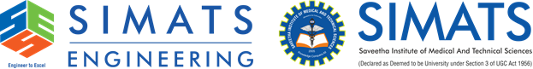

SIMATS ENGINEERING
Saveetha Institute of Medical and Technical Sciences
Chennai-602105

August-2026

