SIMATS ENGINEERING (SAVEETHA SCHOOL OF ENGINEERING)
Department of Artificial Intelligence and Data Science
ASSESSMENT TOOL 3 – DESIGN TASK

Course Code: | DSA03 | Course Title: | Natural Language Processing
CO Assessed: | CO3 – Precision | Assessment: | Assessment Tool 3 – Design Task
Weightage: | 40% of CIA
CO5 Statement: | Apply N-gram models, smoothing techniques, part-of-speech tagging systems and to evaluate effective syntactic analysis. (BL-3)
Student Name: | T. Kiran Kumar | Reg. No.: | 192472321
Section / Batch: | CSA_Ai(2024) | Date:

Code of Conduct
I T. Kiran Kumar (192472321) (Name / Reg No) certify that this submission is my original work and that I have adhered to the guidelines specified for this assessment. I understand that any violation of academic integrity rules will result in disciplinary action.
Signature of the Student: T.Kiran Kumar

Instructions
- Implement the assigned NLP Design Task using Python with appropriate algorithms and a suitable dataset/application.
- Execute the program and demonstrate the output using relevant sample inputs and test cases.
- Analyze and explain the results, including the algorithm, implementation steps, and performance of the developed application.
- Duration: 30 minutes.

Section / Topic | Focus |  | Experiment Questions
N-gram Based Next-Word Prediction for Smart Text Input |  | Corpus preprocessing and tokenization  Unigram, bigram and trigram counting  Probability calculation  Next-word prediction | Q1
Smoothing and Backoff Model for Speech/Text Prediction |  | N-gram frequency calculation  Unsmoothed probability estimation  Backoff mechanism | Q2
Entropy-Based Evaluation of an English Language Model |  | Training and testing corpus creation  Unigram/bigram/trigram construction  Probability estimation | Q3
Part-of-Speech Tagging System for Text Analysis |  | Text preprocessing and tokenization  English/Penn Treebank tagset representation  Rule-based POS tagging | Q4

Annexure A – Design Task

Task 1 – N-gram Based Text Prediction
Design and implement a Python-based N-gram language model that predicts the next word in a given sentence using an English text corpus. The system should preprocess the corpus, perform sentence segmentation and tokenization, and construct unigram, bigram, and trigram models by calculating word-frequency counts and maximum-likelihood probabilities.
For an incomplete sentence such as:
"Artificial intelligence is"
the system should identify and display the top-5 most probable next words.
The program should allow the user to select N = 1, 2, or 3, display the corresponding N-gram frequency counts and probabilities, and demonstrate the behavior of the model when an unseen N-gram is encountered. Finally, test the model using multiple incomplete sentences, calculate the prediction accuracy, and discuss the limitations of using an unsmoothed N-gram model for real-world language prediction.

Task 2 – Backoff and Interpolation for Language Prediction
Design and implement a Python-based enhanced language prediction system that addresses the zero-probability problem of an unsmoothed N-gram model. The system should construct unigram, bigram, and trigram models from an English corpus and accept an incomplete sentence such as:
"Machine learning can"
When the required trigram is unavailable, the system should use a backoff strategy by first checking the trigram model, then the bigram model, and finally the unigram model. Extend the system using Deleted Interpolation to combine unigram, bigram, and trigram probabilities using predefined interpolation weights.
The system should generate the top-5 next-word predictions using:
- Unsmoothed N-gram model
- Backoff model
- Deleted Interpolation model
Compare the three approaches in terms of zero probabilities, prediction coverage, and prediction accuracy, and explain why backoff and interpolation are useful for sparse language data.

Task 3 – Entropy-Based Evaluation of Language Models
Design and implement a Python program for measuring the uncertainty of N-gram language models using entropy. Given separate training and testing corpora, construct unigram, bigram, and trigram language models and calculate the probabilities assigned to words in the test sentences. For each test sentence, calculate its entropy and classify the sentence as having relatively high or low predictive uncertainty.
For example, compare sentences such as:
"The cat sits on the mat."
and
"The quantum processor redesigned the..."
The system should evaluate how predictable the next word is based on the trained language model.
The program should also compare entropy values obtained using:
- Unigram model
- Bigram model
- Trigram model
- Smoothed model
Finally, interpret the results and explain how entropy can be used to measure prediction uncertainty and evaluate the reliability of a language model.

Task 4 – Comparative POS Tagging System
Design and implement a Python-based POS tagging system that assigns grammatical tags to words in English sentences.
The system should implement three approaches:
1. Rule-Based POS Tagging
Use a combination of lexical dictionaries, word patterns, and grammatical rules to assign POS tags.
2. Stochastic POS Tagging
Construct a statistical POS tagger using:
- Word/tag frequencies
- Tag transition probabilities
- Probabilities obtained from a training corpus
3. Transformation-Based Tagging
Initially assign tags using a simple tagging strategy and subsequently apply transformation rules to correct likely tagging errors.
For example:
"I book a ticket."
and
"I read a book."
The system should demonstrate how the same word can receive different POS tags depending on its context. Use an appropriate English corpus such as the Brown Corpus or another publicly available tagged corpus. The program should accept user-entered sentences, display the POS tags produced by all three approaches, and compare their results using suitable evaluation measures such as tagging accuracy. Finally, analyze the differences among the three approaches and explain the advantages and limitations of rule-based, stochastic, and transformation-based POS tagging.

Q1 — N-gram Based Next-Word Prediction

Code:
import re
from collections import Counter, defaultdict
corpus = """
Artificial intelligence is changing the world.
Artificial intelligence helps people solve complex problems.
Machine learning is a part of artificial intelligence.
Machine learning can analyze large amounts of data.
Natural language processing helps computers understand language.
Natural language processing is used in many applications.
Deep learning is a powerful technique in artificial intelligence.
Deep learning can solve difficult problems.
Students learn artificial intelligence and machine learning.
Students use natural language processing for text analysis.
Language models predict the next word in a sentence.
Language models are useful for speech and text prediction.
The computer learns patterns from the training data.
The model predicts words using previous words.
Machine learning models learn from data.
Artificial intelligence and machine learning are important technologies.
"""

def preprocess(text):
sentences = re.split(r'[.!?]+', text.lower())

processed_sentences = []

for sentence in sentences:
words = re.findall(r'\b[a-z]+\b', sentence)

if words:
words = ["<s>"] + words + ["</s>"]
processed_sentences.append(words)

return processed_sentences

sentences = preprocess(corpus)

unigram = Counter()
bigram = Counter()
trigram = Counter()

for sentence in sentences:

# Unigram
for word in sentence:
unigram[word] += 1

# Bigram
for i in range(len(sentence) - 1):
pair = (sentence[i], sentence[i + 1])
bigram[pair] += 1

# Trigram
for i in range(len(sentence) - 2):
triple = (
sentence[i],
sentence[i + 1],
sentence[i + 2]
)
trigram[triple] += 1

def unigram_probability(word):
total = sum(unigram.values())

if unigram[word] == 0:
return 0

return unigram[word] / total

def bigram_probability(w1, w2):
denominator = unigram[w1]

if denominator == 0:
return 0

return bigram[(w1, w2)] / denominator

def trigram_probability(w1, w2, w3):
denominator = bigram[(w1, w2)]

if denominator == 0:
return 0

return trigram[(w1, w2, w3)] / denominator

def display_counts(n):

print("\n------------------------------")
print(f"{n}-GRAM FREQUENCY COUNTS")
print("------------------------------")

if n == 1:

for word, count in unigram.items():
print(word, ":", count)

elif n == 2:

for words, count in bigram.items():
print(words, ":", count)

elif n == 3:

for words, count in trigram.items():
print(words, ":", count)
def display_probabilities(n):

print("\n------------------------------")
print(f"{n}-GRAM PROBABILITIES")
print("------------------------------")

if n == 1:

for word in unigram:
print(
word,
"=>",
round(unigram_probability(word), 4)
)

elif n == 2:

for (w1, w2) in bigram:
print(
(w1, w2),
"=>",
round(bigram_probability(w1, w2), 4)
)

elif n == 3:

for (w1, w2, w3) in trigram:
print(
(w1, w2, w3),
"=>",
round(
trigram_probability(w1, w2, w3),
4
)
)
def predict_next_word(sentence, n=3):

words = re.findall(r'\b[a-z]+\b', sentence.lower())

if not words:
return []

predictions = []
if n == 1:

for word, count in unigram.most_common():

if word not in ["<s>", "</s>"]:
predictions.append(
(word, unigram_probability(word))
)

elif n == 2:

last_word = words[-1]

for (w1, w2), count in bigram.items():

if w1 == last_word and w2 not in ["<s>", "</s>"]:

probability = bigram_probability(w1, w2)

predictions.append(
(w2, probability)
)

elif n == 3:

if len(words) < 2:
return []

w1 = words[-2]
w2 = words[-1]

for (a, b, c), count in trigram.items():

if a == w1 and b == w2:

if c not in ["<s>", "</s>"]:

probability = trigram_probability(
a, b, c
)

predictions.append(
(c, probability)
)

predictions.sort(
key=lambda x: x[1],
reverse=True
)

return predictions[:5]

def calculate_accuracy(test_cases, n):

correct = 0

for sentence, actual_word in test_cases:

predictions = predict_next_word(sentence, n)

predicted_words = [
word for word, probability in predictions
]

if actual_word.lower() in predicted_words:
correct += 1

if len(test_cases) == 0:
return 0

return (correct / len(test_cases)) * 100
while True:

print("\n======================================")
print(" N-GRAM LANGUAGE MODEL")
print("======================================")

print("1. Display Unigram")
print("2. Display Bigram")
print("3. Display Trigram")
print("4. Predict Next Word")
print("5. Test Prediction Accuracy")
print("6. Exit")

choice = input("\nEnter your choice: ")
if choice == "1":

display_counts(1)
display_probabilities(1)

elif choice == "2":

display_counts(2)
display_probabilities(2)
elif choice == "3":

display_counts(3)
display_probabilities(3)
elif choice == "4":

sentence = input(
"\nEnter incomplete sentence: "
)

print("\nSelect N-gram:")
print("1. Unigram")
print("2. Bigram")
print("3. Trigram")

n = int(input("Enter N: "))

predictions = predict_next_word(
sentence,
n
)

print("\nTop-5 Predictions:")

if not predictions:

print(
"No prediction available "
"for this sentence."
)

else:

for word, probability in predictions:

print(
word,
"=> Probability:",
round(probability, 4)
)
elif choice == "5":

print("\nEnter number of test cases:")

number = int(input())

test_cases = []

for i in range(number):

print(
f"\nTest case {i + 1}"
)

sentence = input(
"Incomplete sentence: "
)

actual_word = input(
"Actual next word: "
)

test_cases.append(
(sentence, actual_word)
)

n = int(
input(
"\nEnter N (1/2/3): "
)
)

accuracy = calculate_accuracy(
test_cases,
n
)
print(
"\nPrediction Accuracy:",
round(accuracy, 2),
"%"
)
elif choice == "6":
print("Program terminated.")
break
else:
print("Invalid choice.")
Output:
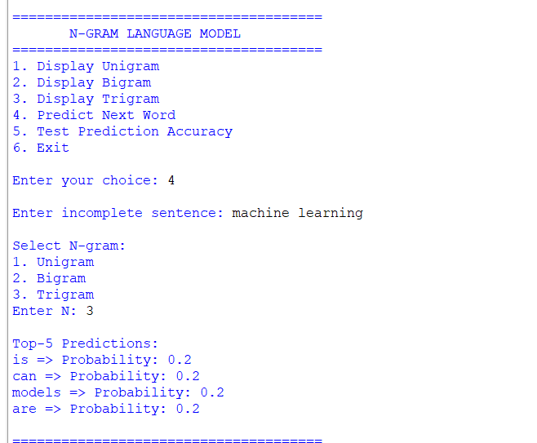

Q2 — Backoff + Deleted Interpolation
Code:
import re
from collections import Counter
corpus = """
Machine learning is a part of artificial intelligence.
Machine learning can analyze data.
Machine learning models learn patterns.
Artificial intelligence is changing the world.
Artificial intelligence helps people.
Natural language processing is a branch of artificial intelligence.
Natural language processing helps computers understand language.
Deep learning is a part of machine learning.
Deep learning models learn from data.
The computer learns patterns from data.
The model predicts the next word.
Language models predict words.
Students learn machine learning.
Students study artificial intelligence.
"""

def preprocess(text):

sentences = re.split(r'[.!?]+', text.lower())
result = []
for sentence in sentences:
words = re.findall(
r'\b[a-z]+\b',
sentence
)

if words:

words = [
"<s>"
] + words + [
"</s>"
]

result.append(words)

return result

sentences = preprocess(corpus)
unigram = Counter()
bigram = Counter()
trigram = Counter()
for sentence in sentences:

for word in sentence:
unigram[word] += 1

for i in range(len(sentence) - 1):

bigram[
(sentence[i], sentence[i + 1])
] += 1

for i in range(len(sentence) - 2):

trigram[
(
sentence[i],
sentence[i + 1],
sentence[i + 2]
)
] += 1

def P1(word):

total = sum(unigram.values())

return unigram[word] / total
def P2(w1, w2):

if unigram[w1] == 0:
return 0
return bigram[
(w1, w2)
] / unigram[w1]

def P3(w1, w2, w3):

if bigram[(w1, w2)] == 0:
return 0

return trigram[
(w1, w2, w3)
] / bigram[(w1, w2)]

def unsmoothed(sentence):

words = re.findall(
r'\b[a-z]+\b',
sentence.lower()
)

if len(words) < 2:
return []

w1 = words[-2]
w2 = words[-1]

result = []

for word in unigram:

if word in ["<s>", "</s>"]:
continue

probability = P3(
w1,
w2,
word
)

if probability > 0:

result.append(
(word, probability)
)

result.sort(
key=lambda x: x[1],
reverse=True
)

return result[:5]

def backoff(sentence):

words = re.findall(
r'\b[a-z]+\b',
sentence.lower()
)

if not words:
return []

w2 = words[-1]

if len(words) >= 2:
w1 = words[-2]
else:
w1 = None

result = []

for word in unigram:

if word in ["<s>", "</s>"]:
continue

probability = 0

# TRIGRAM
if w1 is not None:

probability = P3(
w1,
w2,
word
)

# BIGRAM
if probability == 0:

probability = P2(
w2,
word
)

# UNIGRAM
if probability == 0:

probability = P1(word)

result.append(
(word, probability)
)

result.sort(
key=lambda x: x[1],
reverse=True
)

return result[:5]
def interpolation(sentence):

words = re.findall(
r'\b[a-z]+\b',
sentence.lower()
)

if not words:
return []

w2 = words[-1]

if len(words) >= 2:
w1 = words[-2]
else:
w1 = None
lambda1 = 0.2
lambda2 = 0.3
lambda3 = 0.5

result = []

for word in unigram:

if word in ["<s>", "</s>"]:
continue

p1 = P1(word)

p2 = P2(
w2,
word
)

p3 = 0

if w1 is not None:

p3 = P3(
w1,
w2,
word
)

probability = (
lambda1 * p1
+
lambda2 * p2
+
lambda3 * p3
)

result.append(
(word, probability)
)

result.sort(
key=lambda x: x[1],
reverse=True
)

return result[:5]
def display(title, predictions):

print("\n------------------------------")
print(title)
print("------------------------------")

if not predictions:

print("No prediction available.")

else:

for word, probability in predictions:

print(
f"{word:15} "
f"{probability:.4f}"
)

while True:

print("\n======================================")
print(" BACKOFF & INTERPOLATION MODEL")
print("======================================")

print("1. Unsmoothed N-gram")
print("2. Backoff Model")
print("3. Deleted Interpolation")
print("4. Compare All")
print("5. Exit")

choice = input(
"\nEnter your choice: "
)

if choice == "1":

sentence = input(
"Enter incomplete sentence: "
)

display(
"UNSMOOTHED MODEL",
unsmoothed(sentence)
)

elif choice == "2":

sentence = input(
"Enter incomplete sentence: "
)

display(
"BACKOFF MODEL",
backoff(sentence)
)

elif choice == "3":

sentence = input(
"Enter incomplete sentence: "
)

display(
"DELETED INTERPOLATION",
interpolation(sentence)
)

elif choice == "4":

sentence = input(
"Enter incomplete sentence: "
)

display(
"UNSMOOTHED",
unsmoothed(sentence)
)

display(
"BACKOFF",
backoff(sentence)
)

display(
"INTERPOLATION",
interpolation(sentence)
)

elif choice == "5":

print("Program terminated.")
break

else:

print("Invalid choice.")
Output:
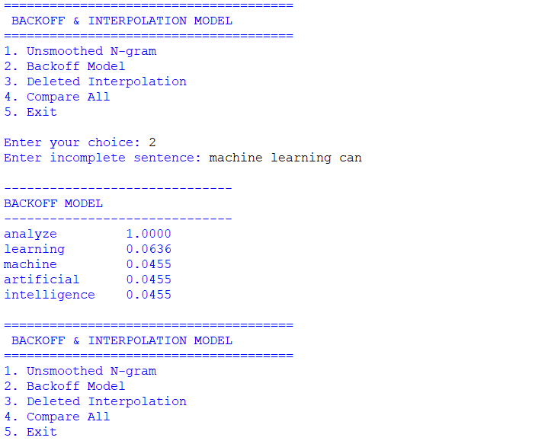

Q3 — Entropy-Based Evaluation
Code:
import re
import math
from collections import Counter
training_text = """
The cat sits on the mat.
The cat eats food.
The dog sits on the mat.
The dog eats food.
The student reads a book.
The student learns language.
Machine learning is useful.
Machine learning learns from data.
Artificial intelligence is useful.
Natural language processing analyzes text.
The computer processes data.
Language models predict words.
"""
testing_text = """
The cat sits on the mat.
The dog eats food.
The quantum processor redesigned the system.
Machine learning predicts words.
"""
def preprocess(text):

sentences = re.split(
r'[.!?]+',
text.lower()
)

result = []

for sentence in sentences:

words = re.findall(
r'\b[a-z]+\b',
sentence
)

if words:

result.append(
["<s>"] +
words +
["</s>"]
)

return result

train = preprocess(
training_text
)

test = preprocess(
testing_text
)

# =========================================================
# BUILD MODELS
# =========================================================

unigram = Counter()
bigram = Counter()
trigram = Counter()

for sentence in train:

for word in sentence:
unigram[word] += 1

for i in range(len(sentence) - 1):

bigram[
(
sentence[i],
sentence[i + 1]
)
] += 1

for i in range(len(sentence) - 2):

trigram[
(
sentence[i],
sentence[i + 1],
sentence[i + 2]
)
] += 1
def p_unigram(word):

total = sum(unigram.values())

return unigram[word] / total

def p_bigram(w1, w2):

if unigram[w1] == 0:
return 0

return (
bigram[(w1, w2)]
/
unigram[w1]
)

def p_trigram(w1, w2, w3):

if bigram[(w1, w2)] == 0:
return 0

return (
trigram[(w1, w2, w3)]
/
bigram[(w1, w2)]
)

vocabulary = set(unigram.keys())

V = len(vocabulary)

def smoothed_bigram(w1, w2):

return (
bigram[(w1, w2)] + 1
) / (
unigram[w1] + V
)

def entropy_unigram(sentence):

probabilities = []

for word in sentence:

if word in ["<s>", "</s>"]:
continue

probability = p_unigram(word)

if probability > 0:
probabilities.append(
probability
)

if not probabilities:
return float("inf")

entropy = 0

for p in probabilities:

entropy += -math.log2(p)

return entropy / len(
probabilities
)

def entropy_bigram(sentence):

probabilities = []

for i in range(1, len(sentence)):

word = sentence[i]
previous = sentence[i - 1]

probability = p_bigram(
previous,
word
)

if probability > 0:

probabilities.append(
probability
)

else:

return float("inf")

if not probabilities:
return float("inf")

entropy = 0

for p in probabilities:

entropy += -math.log2(p)

return entropy / len(
probabilities
)

def entropy_trigram(sentence):

probabilities = []

for i in range(2, len(sentence)):

w1 = sentence[i - 2]
w2 = sentence[i - 1]
w3 = sentence[i]

probability = p_trigram(
w1,
w2,
w3
)

if probability > 0:

probabilities.append(
probability
)

else:

return float("inf")

if not probabilities:
return float("inf")

entropy = 0

for p in probabilities:

entropy += -math.log2(p)

return entropy / len(
probabilities
)

def entropy_smoothed(sentence):

probabilities = []

for i in range(1, len(sentence)):

previous = sentence[i - 1]
word = sentence[i]

probability = smoothed_bigram(
previous,
word
)

probabilities.append(
probability
)

entropy = 0

for p in probabilities:

entropy += -math.log2(p)

return entropy / len(
probabilities
)

def classify(entropy):

if entropy == float("inf"):
return "HIGH UNCERTAINTY"

if entropy > 4:
return "HIGH UNCERTAINTY"

return "LOW UNCERTAINTY"

def show_result(sentence):

print("\n====================================")
print(
"Sentence:",
" ".join(sentence)
)
print("====================================")

e1 = entropy_unigram(sentence)
e2 = entropy_bigram(sentence)
e3 = entropy_trigram(sentence)
es = entropy_smoothed(sentence)

print(
"Unigram Entropy :",
e1
)

print(
"Bigram Entropy :",
e2
)

print(
"Trigram Entropy :",
e3
)

print(
"Smoothed Entropy:",
es
)

print("\nClassification:")

print(
"Unigram :",
classify(e1)
)

print(
"Bigram :",
classify(e2)
)

print(
"Trigram :",
classify(e3)
)

print(
"Smoothed:",
classify(es)
)
while True:

print("\n======================================")
print(" ENTROPY BASED LANGUAGE MODEL")
print("======================================")

print("1. Evaluate test corpus")
print("2. Enter your own sentence")
print("3. Exit")

choice = input(
"\nEnter your choice: "
)

if choice == "1":

for sentence in test:

show_result(sentence)

elif choice == "2":

sentence = input(
"\nEnter sentence: "
)

processed = preprocess(
sentence
)

if processed:

show_result(
processed[0]
)

elif choice == "3":

print("Program terminated.")
break

else:

print("Invalid choice.")
Output:
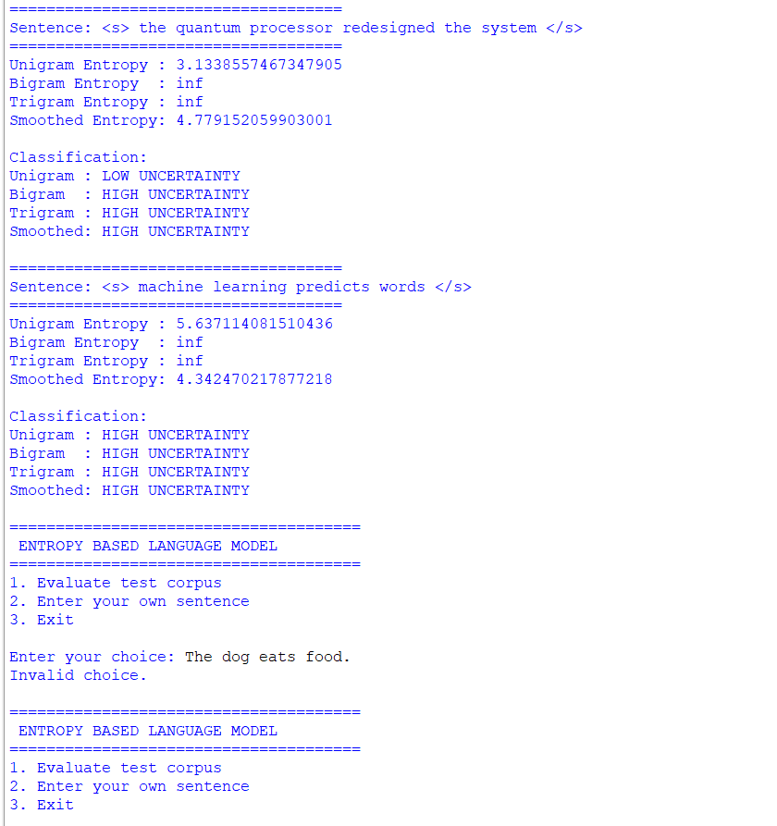

Q4 — Comparative POS Tagging
Code:
import re
from collections import Counter, defaultdict
training_data = [
("I", "PRP"),
("read", "VBP"),
("a", "DT"),
("book", "NN"),

("I", "PRP"),
("book", "VB"),
("a", "DT"),
("ticket", "NN"),

("The", "DT"),
("cat", "NN"),
("sits", "VBZ"),
("on", "IN"),
("the", "DT"),
("mat", "NN"),

("The", "DT"),
("dog", "NN"),
("eats", "VBZ"),
("food", "NN"),

("She", "PRP"),
("reads", "VBZ"),
("a", "DT"),
("book", "NN"),

("He", "PRP"),
("plays", "VBZ"),
("football", "NN"),

("Machine", "NN"),
("learning", "NN"),
("is", "VBZ"),
("useful", "JJ"),

("Artificial", "JJ"),
("intelligence", "NN"),
("is", "VBZ"),
("powerful", "JJ"),
]

# =========================================================
# STOCHASTIC MODEL
# =========================================================

word_tag_count = defaultdict(Counter)
tag_transition = defaultdict(Counter)
tag_count = Counter()

previous_tag = "<START>"

for word, tag in training_data:

word_tag_count[
word.lower()
][tag] += 1

tag_transition[
previous_tag
][tag] += 1

tag_count[tag] += 1

previous_tag = tag
def rule_based_tag(word):

w = word.lower()

# Dictionary
dictionary = {

"i": "PRP",
"you": "PRP",
"he": "PRP",
"she": "PRP",
"we": "PRP",
"they": "PRP",

"a": "DT",
"an": "DT",
"the": "DT",

"on": "IN",
"in": "IN",
"at": "IN",
"with": "IN",

"is": "VBZ",
"am": "VBP",
"are": "VBP",

"read": "VBP",
"reads": "VBZ",

"book": "NN",
"ticket": "NN",
"cat": "NN",
"dog": "NN",
"food": "NN",
"mat": "NN",

"useful": "JJ",
"powerful": "JJ"
}

if w in dictionary:

return dictionary[w]

# Pattern rules

if w.endswith("ing"):
return "VBG"

if w.endswith("ed"):
return "VBD"

if w.endswith("ly"):
return "RB"

if w.endswith("ous"):
return "JJ"

if w.endswith("ful"):
return "JJ"

if w.endswith("s"):
return "NNS"

return "NN"
def stochastic_tag(sentence):

words = sentence.split()

result = []

previous_tag = "<START>"

for word in words:

candidates = word_tag_count[
word.lower()
]

if candidates:

best_tag = None
best_score = -1

for tag in candidates:

word_probability = (
candidates[tag]
/
sum(candidates.values())
)

transition_probability = (
tag_transition[
previous_tag
][tag]
/
max(
1,
sum(
tag_transition[
previous_tag
].values()
)
)
)

score = (
word_probability
*
transition_probability
)

if score > best_score:

best_score = score
best_tag = tag

tag = best_tag

else:

# Unknown word
tag = rule_based_tag(word)

result.append(
(word, tag)
)

previous_tag = tag

return result
def initial_tag(word):

return rule_based_tag(word)

def transformation_rules(tagged_sentence):

result = []

words = [
word
for word, tag in tagged_sentence
]

for i, (word, tag) in enumerate(
tagged_sentence
):

w = word.lower()

if i > 0:

previous_word = words[i - 1].lower()

if previous_word in [
"a",
"an",
"the"
]:

if w == "book":

tag = "NN"
if i > 0:

previous_word = words[
i - 1
].lower()

if previous_word == "i":

if w == "book":

tag = "VB"

elif w == "read":

tag = "VBP"

if w.endswith("ing"):

tag = "VBG"

result.append(
(word, tag)
)

return result

def transformation_based_tagging(
sentence
):

words = sentence.split()

initial = []

for word in words:

initial.append(
(
word,
initial_tag(word)
)
)

final = transformation_rules(
initial
)

return final

def display(title, result):

print("\n------------------------------")
print(title)
print("------------------------------")

for word, tag in result:

print(
f"{word:15} -> {tag}"
)
while True:

print("\n======================================")
print(" COMPARATIVE POS TAGGING")
print("======================================")

print("1. Rule-Based POS")
print("2. Stochastic POS")
print("3. Transformation-Based POS")
print("4. Compare All")
print("5. Exit")

choice = input(
"\nEnter your choice: "
)

if choice == "1":

sentence = input(
"\nEnter sentence: "
)

result = []

for word in sentence.split():

result.append(
(
word,
rule_based_tag(word)
)
)

display(
"RULE-BASED POS TAGGING",
result
)

elif choice == "2":

sentence = input(
"\nEnter sentence: "
)

result = stochastic_tag(
sentence
)

display(
"STOCHASTIC POS TAGGING",
result
)

elif choice == "3":

sentence = input(
"\nEnter sentence: "
)

result = transformation_based_tagging(
sentence
)

display(
"TRANSFORMATION-BASED POS TAGGING",
result
)

elif choice == "4":

sentence = input(
"\nEnter sentence: "
)

# Rule-based

rule_result = []

for word in sentence.split():

rule_result.append(
(
word,
rule_based_tag(word)
)
)

# Stochastic

stochastic_result = stochastic_tag(
sentence
)

# Transformation

transformation_result = (
transformation_based_tagging(
sentence
)
)

display(
"RULE-BASED",
rule_result
)

display(
"STOCHASTIC",
stochastic_result
)

display(
"TRANSFORMATION-BASED",
transformation_result
)

elif choice == "5":

print("Program terminated.")
break

else:

print("Invalid choice.")

Output:
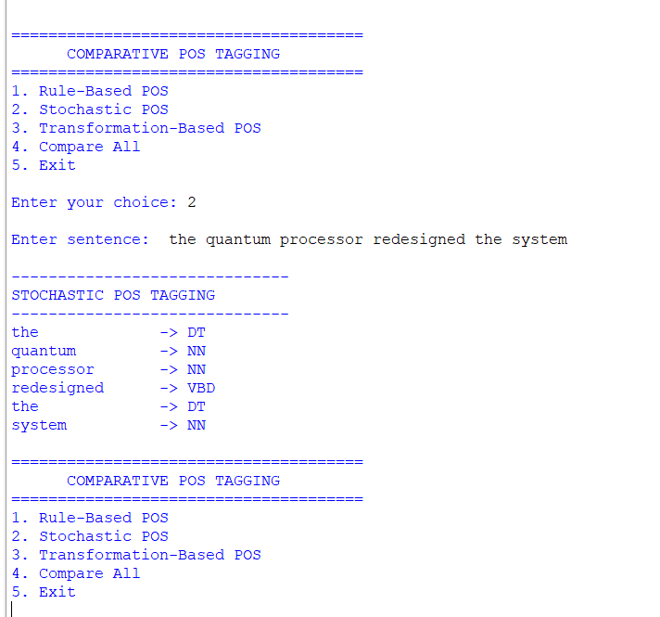

Rubrics for Calculation

Criteria | Weightage (%) | Level 4 – Exemplary (4) | Level 3 – Proficient (3) | Level 2 – Developing (2) | Level 1 – Beginning (1)
Understanding of Concept | 25% | Demonstrates complete understanding of design requirements and concepts | Good understanding with minor gaps | Basic understanding with some errors | Poor understanding or incorrect concepts
Design / Implementation | 30% | Well-structured, efficient, and responsive design implementation | Correct implementation with minor issues | Basic implementation with inconsistencies | Incorrect or incomplete implementation
Use of Tools | 20% | Effective and advanced use of tools/techniques | Appropriate use of tools | Limited or inconsistent use | Incorrect or minimal use
Analysis & Evaluation | 15% | Insightful analysis with strong justification and optimization | Good analysis with justification | Basic analysis with limited depth | Poor or no analysis
Documentation / Clarity | 10% | Clear, well-structured, and properly presented solution | Mostly clear with minor issues | Basic clarity, missing details | Poor or unclear documentation

Q. No. / Criteria Level | Understanding of Concepts | Experimental Design | Use of Tools | Analysis of Results | Documentation | Sub. Total | Total %
1
2
3
4

Faculty In-charge | Course Coordinator | Program Director
Signature: _______________ | Signature: _______________ | Signature: _______________
Date: ___________________ | Date: ___________________ | Date: ___________________

