**Lab #2**

**Objectives**

* Review lecture notes of discrete-time signal and system
* Do additional exercises on SciLab

**Report**

1. For each function or group of functions that you did, you have to capture the screen as evidence that you did by yourself.
2. Then, you add all screen captures in a single word file.
3. Finally, you upload your report to BKeL on time. You should down-size the image file to reduce the report file in order to be able to submit it in BKeL.

---------------------------------

**PART 1. REVIEW OF LECTURE NOTES**

* 1. **Elementary Signals**
* Unit sample sequence (impulse)
* Unit step signal
* Unit ramp signal
  1. **Signal Properties**
* ***Periodic signal***

A signal x(n) is periodic with a period N (N>0) if and only if x(n + N) = x(n), ∀n

* ***Signal’s energy***
* ***Signal‘s average power***
* ***Signal Symmetry***

Any arbitrary signal can be expressed by the sum of two signal components

Even signal component

Odd signal component

* 1. **Simple manipulations**
* ***Delay***
* ***Advance***
* ***Folding***
* ***Addition***
* ***Multiplication***
* ***Amplitude scaling***

---------------------------------

**PART 2. EXAMPLES & EXERCISES**

**Exercise 1.** Let investigate the following functions on Scilab and briefly report their functionalities and how to use it.

|  |  |
| --- | --- |
| **Functions** | **Description (will be filled by students)** |
| plot2d3(…) |  |
| min(…) |  |
| max(…) |  |
| subplot(…) |  |
| title(…) |  |
| xlabel(…) |  |
| ylabel(…) |  |
| bool2s(…) |  |
| deff(…) |  |

**Exercise 2.** Try the following scripts on Scilab and report what your understanding after observing the output.

scilab:> n = -5:5;

scilab:> msignal = bool2s (n >= 0);

scilab:> plot2d3(n, msignal)

bool2s , trans Boolean string value to signal representation (T => 1 and F => 0), all value n >=0 will have value in y coordinator is 1 and if n< 0 value in y coordinator is 0

**Exercise 3.** Try the following scripts on Scilab and report what your understanding after observing the output.

scilab:> n = -5:5;

scilab:> msignal = bool2s (n == 0);

scilab:> plot2d3(n, msignal)

**Exercise 4.** Use Scilab to draw the unit ramp signal ur(n) for n=-5:5

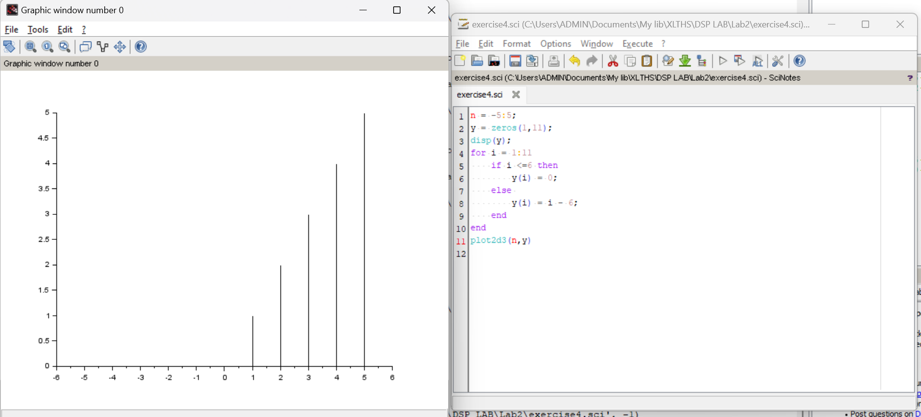

**Exercise 5.** Given a discrete-time signal **x(n)={1, 3**↑**, -2}.**

Use Scilab to draw the signal x(n), the odd signal component xo(n), and the even signal component xe(n). Each signal will be drawed by a single plot but they are displayed in a single window. Please use title(), xlabel() and ylabel() to represent the name of each plot.

**Exercise 6.** Given two discrete-time signals

**x1(n)={0**↑**, 1, 3, -2}** and **x2(n)={0, 1**↑**, 2, 3}.**

Determine **y(n) = x1(n) + x2(n)**. Then use Scilab to draw **x1(n),** **x2(n)** and **y(n).** Each signal will be drawed by a single plot but they are displayed in a single window. Please use title(), xlabel() and ylabel() to represent the name of each plot.

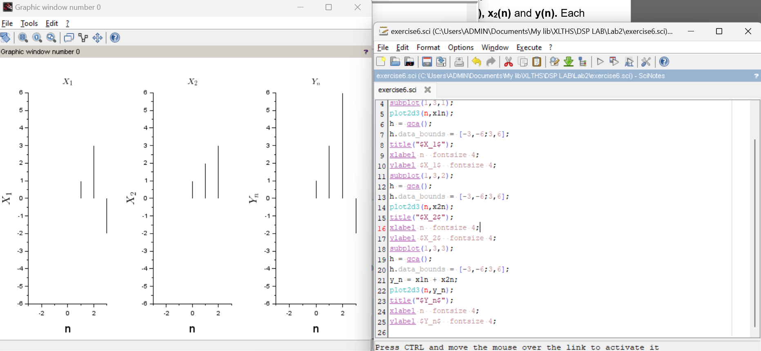

**Exercise 7.** Given two discrete-time signals

**x1(n)={0**↑**, 1, 3, -2}** and **x2(n)={0, 1**↑**, 2, 3}.**

Determine **y(n) = x1(n).x2(n)**. Then use Scilab to draw **x1(n),** **x2(n)** and **y(n).** Each signal will be drawed by a single plot but they are displayed in a single window. Please use title(), xlabel() and ylabel() to represent the name of each plot.

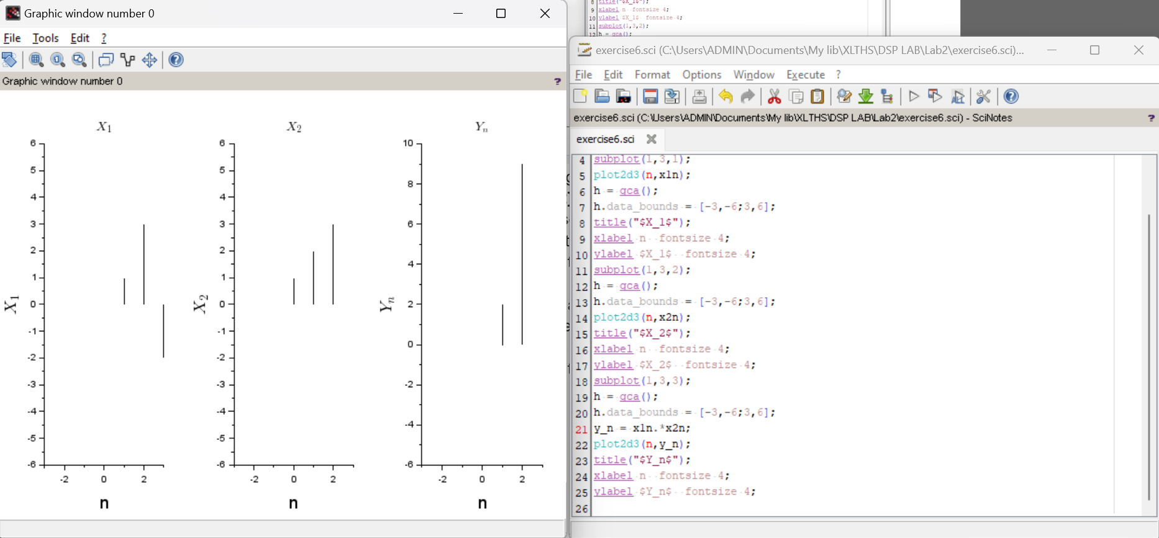

**Exercise 8.** Given a discrete-time signal **x(n)={1, -2, 3**↑**, 6}.**

Determine the following signal and then use Scilab to draw the original signal **x(n)** and the manipulated signal **yi(n**). Each pair of plots will be display in a single window. Please use title(), xlabel() and ylabel() to represent the name of each plot.

