Simulating the Price Values of TPL Stock for the Next 20 Days Using Geometric Brownian Motion
- Created the time index
The time index value corresponding to the first price value of TPL stock in the data file as t = 0, second price values of TPL is t=1 etc.
Then range of t is [0,479]
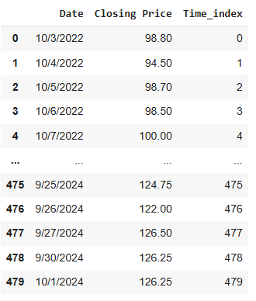

- Suppose that price values follow Geomatric Brownian motion with drift parameter μ and scale parameter σ then theoretically we can prove the distribution of log return like below,
$X_{t}=exp \left((μ-\frac{σ^{2}}{2})t+σW_{t}\right) \sim \log{normal }$ $where {\{W}_{t};t≥0\}$is standard Brownian motion.${ln⁡(X}_{t})=\left((μ-\frac{σ^{2}}{2})t+σW_{t}\right) \sim N( \left(μ-\frac{σ^{2}}{2}\right)t , σ^{2}t )$
$${ln⁡(X}_{t-1})=\left(\left(μ-\frac{σ^{2}}{2}\right)(t-1)+σW_{t-1}\right) \sim N( \left(μ-\frac{σ^{2}}{2}\right)(t-1) , σ^{2}(t-1) )$$
Then,
$$LogReturn_{t}= {ln⁡(X}_{t})-\ln\left(X_{t-1}\right)=\left(\left(μ-\frac{σ^{2}}{2}\right)+σ{( W}_{t}-W_{t-1})\right) \sim N( \left(μ-\frac{σ^{2}}{2}\right) , σ^{2} )$$
Then the Log Returns are identically and normally distributed
with mean $\left(μ-\frac{σ^{2}}{2}\right)and variance σ^{2}.$

$${ln⁡(X}_{t})-\ln\left(X_{t-1}\right) \sim N( \left(μ-\frac{σ^{2}}{2}\right) , σ^{2} )$$

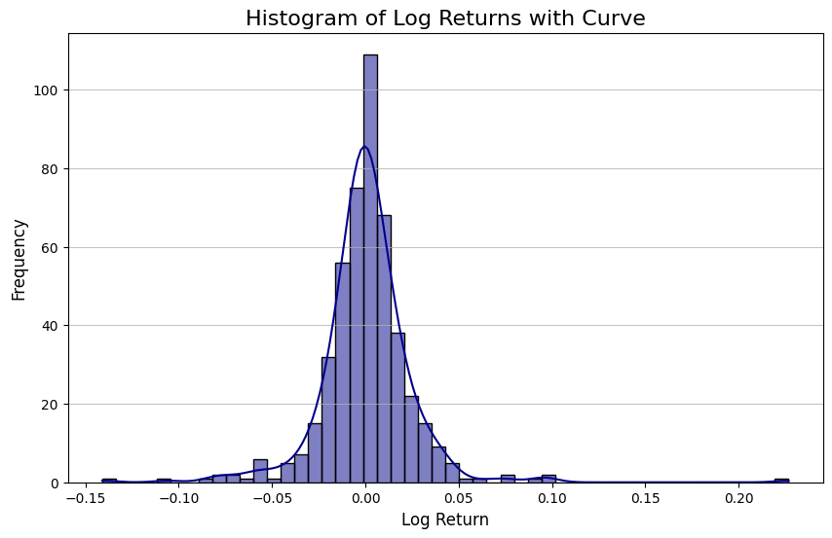
Figure 1: Log return Price values of TPL

- Parameter Estimation

drift parameter is 0.0008268 by taking means of log return values.
Scale parameter is 0.02510 by taking standard deviation of log return values.

- Is this model is appropriate?
- Check the normality by Q-Q plot

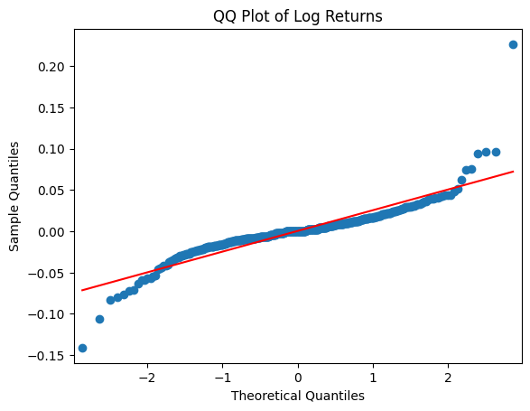
The Q-Q plot of log returns indicates a deviation from normality. In an ideal normal distribution, the points would closely follow the red reference line. However, in this plot, some points deviate noticeably from the line, particularly in the tails — both on the lower and upper ends. But most of the plotted points lies near the theoretical fitted line.
- Test the Normality by Shapiro Wilk test

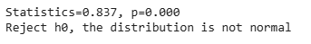
Results of the test

The Shapiro-Wilk test for normality yielded a statistically significant result (p < 0.05), leading to the rejection of the null hypothesis of normality. This suggests that while the distribution appears roughly normal upon visual inspection, it does not meet the strict statistical criteria for normality.
so, we can conclude that the log returns are approximately normally distributed, with some deviations.

- Check the Independence of Log returns
Applying hypothesis test the Ljung-Box test on the raw log-returns, the test results gives p values as 0.004086 less than 0.05 which rejects the null hypothesis of no autocorrelation.
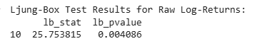
Since GBM requires both normally distributed and independent increments, the violations of these assumptions indicate that this model is not fully appropriate for simulating GBM.

- Simulate 10,000 possible sample paths for the closing price of TPL relevant to the next 20 days
Paths are simulated using BrownianG function used in reference videos.
Parameters are:
- No of sample paths = 10,000
- Total time = 20 days
- No of time steps = 20
- Sigma and drift parameters
- wo is closing price at t=479 which is 126.25
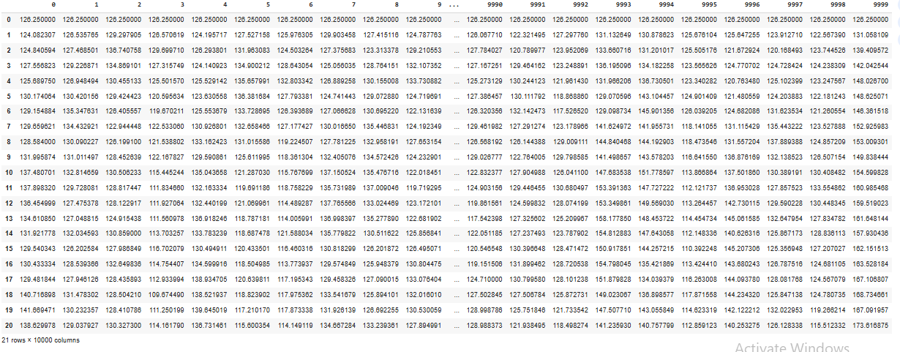
Note: here one column represent the one sample path.

- Plot the sample paths for the next 20 days.
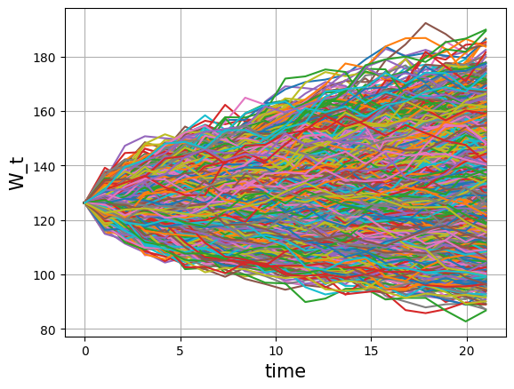

- The box plot for the possible closing price values of TPL corresponding to the last day of the next 20-day period.
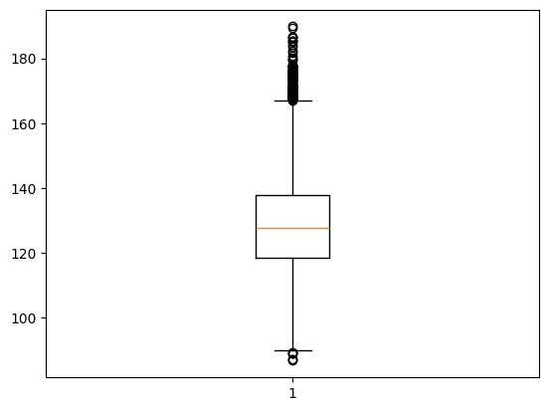
- What is the probability that the closing price corresponding to the last day of the next 20-day period is between 130 and 140?
Need to get values at last day of next 20 days which lies between 130 and 140 and divided by total no of values.
P(130<prices<140) = Number of closing prices in between 130 and 140 / total number of pries
= 0.2243

- The 95% prediction interval for the closing price value corresponding to the last day of the next 20-day period
[102.47631089, 159.1395269 ]

Python Code for the simulation:
https://github.com/thamodya2001/GBM-simulation-

