Hadoop
Definition :
Hadoop is a framework that helps to solve V’s problem. It can store and Process large amount of data.
Important Parts:
- MapReduce
- YARN
- Hive
- HDFS
- Spark
MapReduce:
- MapReduce is a data processing tool. Which is used to process the data internally in HDFS. The map takes a set of data and converts it into another set of data, where individual elements are broken down into tuples (key/value pairs). Secondly, reduce task, which takes the output from a map as an input and combines those data tuples into a smaller set of tuples. As the sequence of the name MapReduce implies, the reduce task is always performed after the map job.
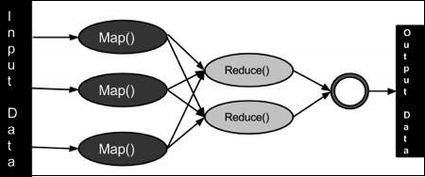

- Map() -> Collect the data, Split into (Key, Value) Pair
- Record Reader - > collect data and split
- Combiner - > Grouping into Key, value
- Partitioner - > Fetching Key, Value
- Record Writer - > To give the data tuple to reduce.

- Reduce() -> Shuffle and sort the given response to the user query request

Terminology
- PayLoad − Applications implement the Map and the Reduce functions, and form the core of the job.
- Mapper − Mapper maps the input key/value pairs to a set of intermediate key/value pairs.
- NamedNode − Node that manages the Hadoop Distributed File System (HDFS). It stores the meta data. The node where JobTracker runs and accepts client job requests. renaming, closing, and opening files and directories.
- DataNode − Node where data is presented in advance before any processing takes place. The node where Map and Reduce program runs. creation, deletion, and replication.
- JobTracker − Schedules jobs and tracks the assigned jobs to the Task tracker.
- Task Tracker − Tracks the task and reports status to JobTracker.
- Job − A program is an execution of a Mapper and Reducer across a dataset.
- Task Attempt − A particular instance of an attempt to execute a task on a SlaveNode.

YARN :
- It does 2 main jobs - Job scheduling and Resource Management
- Job Scheduler – Big task into a small task, Can track the job priority and do that at first.
- Resource Manager - It maintains the availability of resources that run the task.

HDFS (Hadoop Distributed File System):
- It is suitable for distributed storage and processing.
- Hadoop provides a command interface to interact with HDFS.
- The built-in servers of the name node and data node help users easily check the status of the cluster.
- Streaming access to file system data.
- HDFS provides file permissions and authentication.

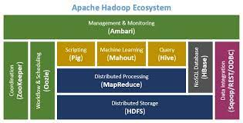

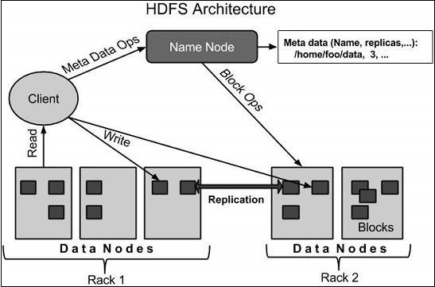
Name Node :
It is a software that can be run on commodity hardware. The system having the namenode acts as the master server and it does the following tasks −
- Manages the file system namespace.
- Regulates client’s access to files.
- It also executes file system operations such as renaming, closing, and opening files and directories.

Data Node :

For every node (Commodity hardware/System) in a cluster, there will be a datanode. These nodes manage the data storage of their system.
- Datanodes perform read-write operations on the file systems, as per client request.
- They also perform operations such as block creation, deletion, and replication according to the instructions of the namenode.

vbhjk

Block
Generally the user data is stored in the files of HDFS. The file in a file system will be divided into one or more segments and/or stored in individual data nodes. These file segments are called as blocks. In other words, the minimum amount of data that HDFS can read or write is called a Block. The default block size is 64MB, but it can be increased as per the need to change in HDFS configuration.
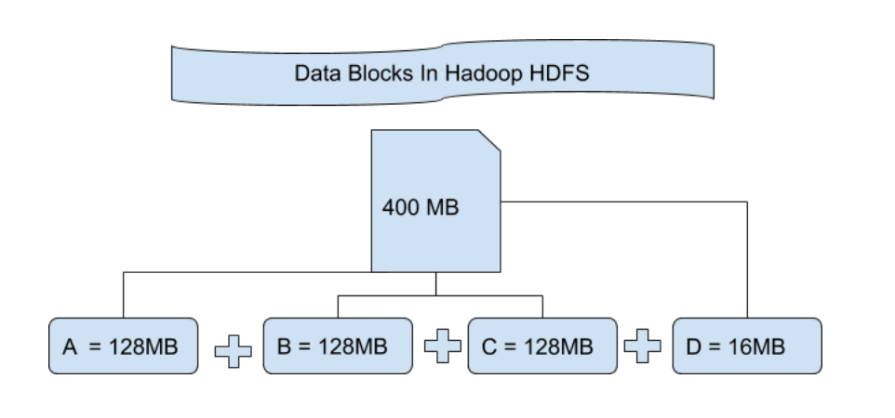
Commands :
Starting HDFS - $ hadoop namenode -format , $ start-dfs.sh
Listing Files - $ $HADOOP_HOME/bin/hadoop fs -ls <args>
Create HDFS Dir - $ $HADOOP_HOME/bin/hadoop fs -mkdir /user/input
Trans and Store - $ $HADOOP_HOME/bin/hadoop fs -put /home/file.txt /user/input
View Data - $ $HADOOP_HOME/bin/hadoop fs -cat /user/output/outfile
Get File - $ $HADOOP_HOME/bin/hadoop fs -get /user/output/ /home/hadoop_tp/
Stop HDFS - $ stop-dfs.sh

Command Reference - https://www.tutorialspoint.com/hadoop/hadoop_command_reference.htm

Spark :

Defination :
- Apache Spark is a lightning-fast cluster computing designed for fast computation. It was built on top of Hadoop MapReduce and extends the MapReduce model to efficiently use more types of computations, including Interactive Queries and Stream Processing.
- Spark uses Hadoop in two ways – one is storage and the second is Query and stream processing. Since Spark has its own cluster management computation, it uses Hadoop for storage purposes only.

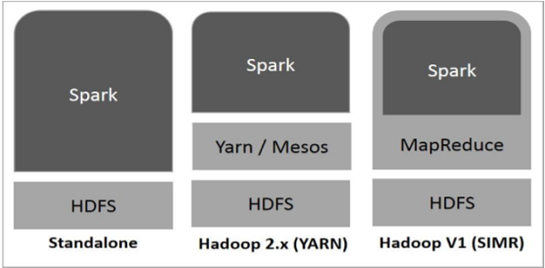

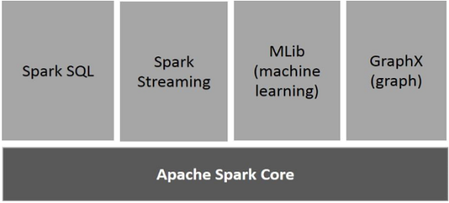

Components of Spark :

Apache Spark Core
Spark Core is the underlying general execution engine for spark platform that all other functionality is built upon. It provides In-Memory computing and referencing datasets in external storage systems.

Spark SQL
Spark SQL is a component on top of Spark Core that introduces a new data abstraction called SchemaRDD, which provides support for structured and semi-structured data.

Spark Streaming
Spark Streaming leverages Spark Core's fast scheduling capability to perform streaming analytics. It ingests data in mini-batches and performs RDD (Resilient Distributed Datasets) transformations on those mini-batches of data.

MLlib (Machine Learning Library)
MLlib is a distributed machine learning framework above Spark because of the distributed memory-based Spark architecture. It is, according to benchmarks, done by the MLlib developers against the Alternating Least Squares (ALS) implementations. Spark MLlib is nine times as fast as the Hadoop disk-based version of Apache Mahout (before Mahout gained a Spark interface).

GraphX
GraphX is a distributed graph-processing framework on top of Spark. It provides an API for expressing graph computation that can model the user-defined graphs by using Pregel abstraction API. It also provides an optimized runtime for this abstraction.

Oozie :
Define :
- Apache Oozie is a scheduler system to run and manage Hadoop jobs in a distributed environment.
- programmed to run parallel to each other.
- supporting various Hadoop jobs like Hive, Pig, Sqoop as well as system-specific jobs like Java and Shell.
- Oozie Workflow Jobs − Directed Acyclic Graphs (DAGs) to specify a sequence of actions to be executed.
- Oozie Coordinator Jobs − jobs triggered by time and data availability.
- Oozie Bundle − package of multiple coordinator and workflow jobs.
- Oozie code - Its like an XML code.

Sqoop :
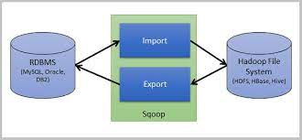

- Sqoop is a tool used to transfer bulk data between Hadoop and external data stores,
- Transfer data between RDBMS( MSSQL, MySQL ) and Hadoop.

SDC - Slowly Changing Dimension :

- This is a common approach to maintaining historical details
- SCDs refer to a data warehousing concept where dimensions contain both current AND historical data.
- This raises the question as to whether the data warehouse will store current or historical data or both.

Types :
- Type 0 : ( Full )
- This refers to attributes that never change and will not be updated in the data warehouse.
- record we would not expect to ever change such as date of birth or an employee’s start date with a company.

- Type 1 : ( Incremental - Last Modified )
- Last instance where updated without Historical any Data or add any column.
- Eg : Name is Thamotharan but mistakenly updated as thamu In this case we need to update can’t add any row.

- Type 2 : ( Incremental - Append )
- every time there is a change in the source system, a new row will be added to the data warehouse table.

- Type 3 :
- Instead of adding new rows to the table to reflect each record change, an additional column is added.

- Type 4 :
- It following type 2 but distinguish here is the history is maintain in a different table.

CDC - Change Data Capture
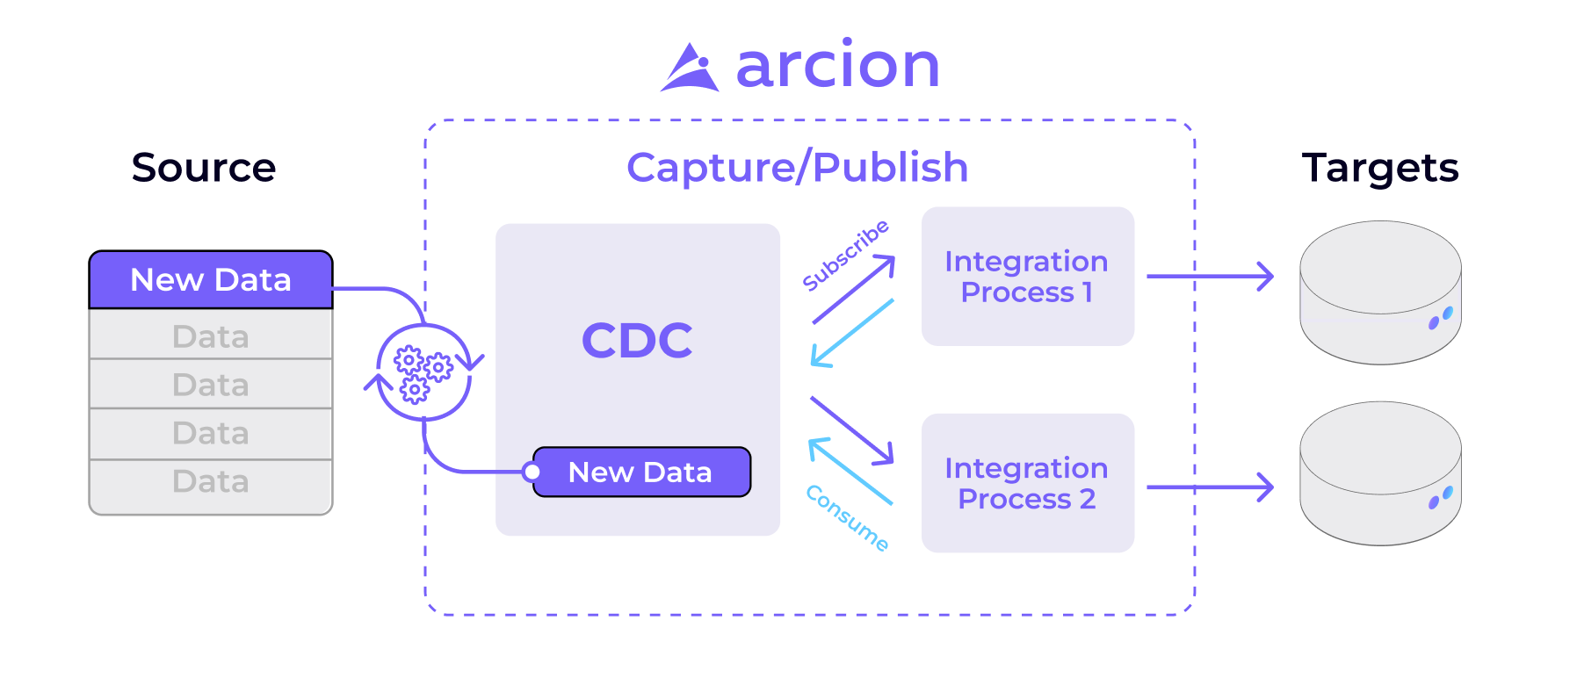
- CDC help to move data from relational database to Cloud, Data Warehouse, Data Lake.
- It monitoring the changed data and after update into data Warehouse.
- CDC methods available:
- log-based
- trigger extraction
- change codes
- lock and read

4 most common ways to implement Change Data Capture below :

- Audit column - add a column and check
- adding “LAST_UPDATED” or “DATE_MODIFIED” timestamp columns.
- disadvantages of this method are that it does require the database to handle extra load from the constant querying/scanning for changes in the data.

- Table deltas – Two more table and compare
- CDC is when a tool or script is used to compare the data in two tables to spot the differences
- disadvantage of this approach is that you will require three copies of all data. This extra storage will increase the storage costs for the data.

- Triggered based CDC – Make connection and get insect.
- Trigger-based CDC captures all insert, update and delete operations performed on tables or databases.
- disadvantage is the setup of individual triggers for each table.

- Log based CDC – Every update can logged and check.
- By reading the database’s log, you get the complete list of all data changes in their exact order of application.
- Advantages - can get a lot of additional metadata from the transaction log , there is no connection being made to the source database, no extra queries are performed on the source system,

CDC and SCD difference:

CDC:
Change Data Capture (CDC) quickly identifies and processes only data that has changed and then makes this changed data available for further use.
- Process only data that has changed and make this available.

SCD:
A Slowly Changing Dimension (SCD) is a dimension that stores and manages both current and historical data over time in a data warehouse.
- It is a procedure that store and manages current and historical data in data warehouse.

